LAB ASSIGNMENT 2
Sequential Logic & Memory Hierarchy
Bit Register • 16-bit Register • 8-Register Register File (RAM8)
Name: Harshda Kumari Roll No: 2501010218
Course: Computer Organization / Nand2Tetris Date:1st October 2026

Q1. 1-bit DFF-Based Register (Bit Chip)
Problem Statement: Build the 1-bit DFF-based register (Bit chip) in HDL and demonstrate read/write timing with a clock-cycle trace showing tick-tock behavior.

Aim
To store one bit of data using a multiplexer and a D flip-flop. When load=1, the input bit is written on the next clock cycle. When load=0, the previous value is retained.

Block Diagram
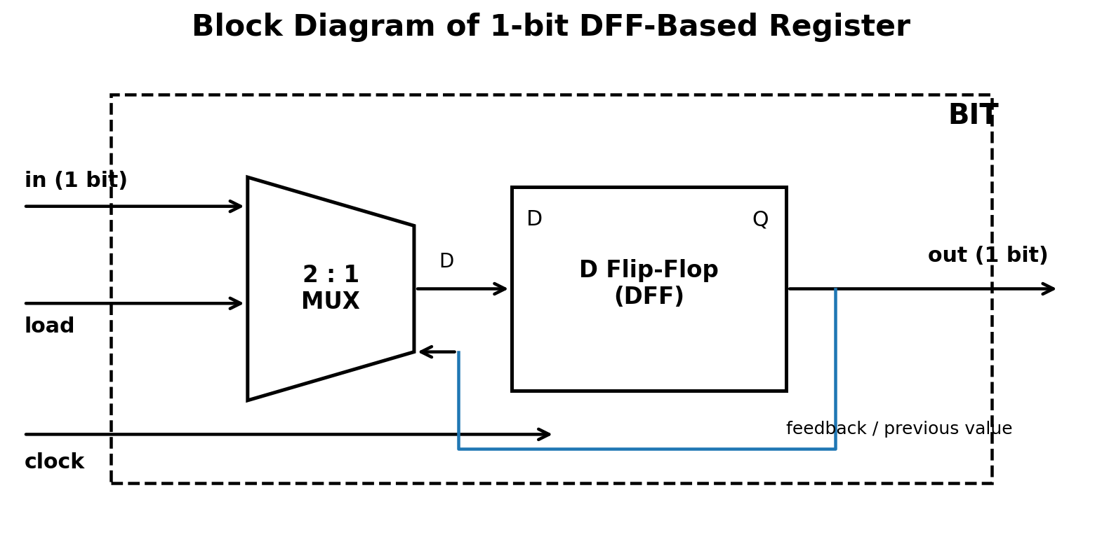
Figure 1: 1-bit register using a 2:1 MUX and DFF.

Boolean Expression
D = (~load · Q) + (load · in)
Q(next) = D
If load = 0, Q(next) = Q. If load = 1, Q(next) = in.

Truth Table
load | in | Current Q | Next Q | Operation
0 | 0 | 0 | 0 | Hold
0 | 1 | 0 | 0 | Hold
0 | 0 | 1 | 1 | Hold
0 | 1 | 1 | 1 | Hold
1 | 0 | 0 | 0 | Write 0
1 | 1 | 0 | 1 | Write 1
1 | 0 | 1 | 0 | Write 0
1 | 1 | 1 | 1 | Write 1

HDL Code
CHIP Bit {
IN in, load;
OUT out;
PARTS:
Mux(a=out, b=in, sel=load, out=d);
DFF(in=d, out=out);
}

Tick-Tock Trace
Cycle | Tick | load | in | out after tick | Meaning
0 | — | 0 | 0 | 0 | Initial state
1 | ↑ | 1 | 1 | 1 | 1 is written
2 | ↑ | 0 | 0 | 1 | Previous value retained
3 | ↑ | 1 | 0 | 0 | 0 is written
4 | ↑ | 0 | 1 | 0 | Previous value retained
Tick: the DFF captures the selected D input. Tock: the stored value is available at the output.

Q2. 16-bit Register (Register Chip)
Problem Statement: Build the 16-bit Register chip in HDL. Show read/write operations for three sample inputs and capture simulation output.

Aim
To construct a 16-bit register by connecting sixteen 1-bit Bit chips in parallel. The same load signal controls all sixteen bits.

Block Diagram
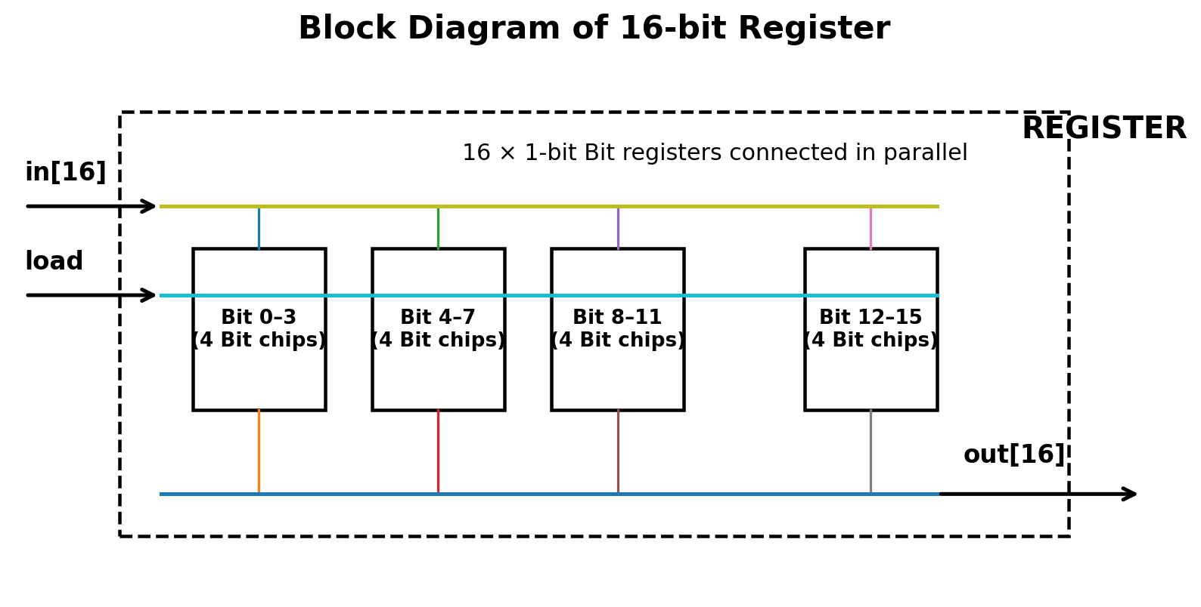
Figure 2: Sixteen 1-bit registers working in parallel.

Boolean Expression
For each bit i (0 ≤ i ≤ 15):
D[i] = (~load · Q[i]) + (load · in[i])
Q[i](next) = D[i]
Q(next) = load ? in[16] : Q

Truth Table
load | in[15..0] | Previous out | Next out | Operation
0 | any | Q | Q | Hold entire 16-bit word
1 | D | Q | D | Load/write entire 16-bit word

HDL Code
CHIP Register {
IN in[16], load;
OUT out[16];
PARTS:
Bit(in=in[0], load=load, out=out[0]);
Bit(in=in[1], load=load, out=out[1]);
Bit(in=in[2], load=load, out=out[2]);
Bit(in=in[3], load=load, out=out[3]);
Bit(in=in[4], load=load, out=out[4]);
Bit(in=in[5], load=load, out=out[5]);
Bit(in=in[6], load=load, out=out[6]);
Bit(in=in[7], load=load, out=out[7]);
Bit(in=in[8], load=load, out=out[8]);
Bit(in=in[9], load=load, out=out[9]);
Bit(in=in[10], load=load, out=out[10]);
Bit(in=in[11], load=load, out=out[11]);
Bit(in=in[12], load=load, out=out[12]);
Bit(in=in[13], load=load, out=out[13]);
Bit(in=in[14], load=load, out=out[14]);
Bit(in=in[15], load=load, out=out[15]);
}

Sample Read/Write Trace
Cycle | load | Input | Output after tick | Operation
1 | 1 | 0000 0000 0000 1010 | 0000 0000 0000 1010 | Write 10
2 | 0 | 1111 1111 1111 1111 | 0000 0000 0000 1010 | Read/hold 10
3 | 1 | 0000 0000 0011 1100 | 0000 0000 0011 1100 | Write 60
4 | 0 | 0000 0000 0000 0000 | 0000 0000 0011 1100 | Read/hold 60

Q3. 8-Register Register File (RAM8)
Problem Statement: Build the 8-register Register File chip in HDL. Trace read/write operations after at least four different addresses and show all register states after each write.

Aim
To construct an 8-register memory using eight 16-bit Register chips. A 3-bit address selects one register for writing and selects one register for reading.

Block Diagram
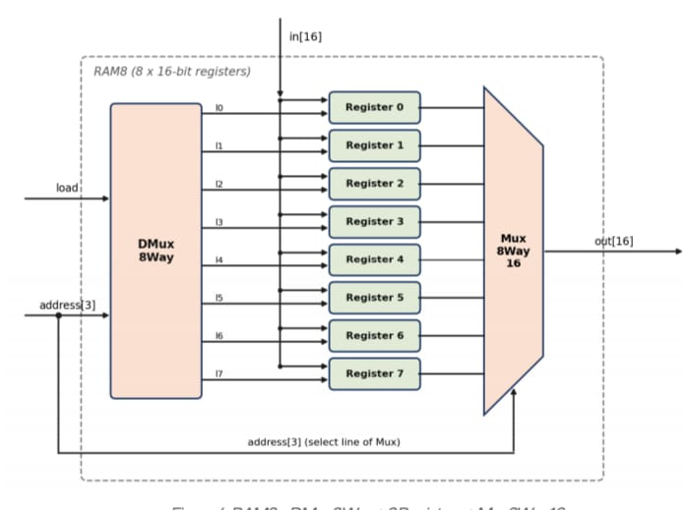
Figure 3: RAM8 with DMux8Way write selection and Mux8Way16 read selection.

Boolean / Selection Expressions
load0 = load · ~a2 · ~a1 · ~a0
load1 = load · ~a2 · ~a1 · a0
load2 = load · ~a2 · a1 · ~a0
load3 = load · ~a2 · a1 · a0
load4 = load · a2 · ~a1 · ~a0
load5 = load · a2 · ~a1 · a0
load6 = load · a2 · a1 · ~a0
load7 = load · a2 · a1 · a0
out = Mux8Way16(r0,r1,r2,r3,r4,r5,r6,r7, sel=address)

Address Selection Truth Table
address[2..0] | Selected register | Write enable | Read output
000 | R0 | R0 | R0
001 | R1 | R1 | R1
010 | R2 | R2 | R2
011 | R3 | R3 | R3
100 | R4 | R4 | R4
101 | R5 | R5 | R5
110 | R6 | R6 | R6
111 | R7 | R7 | R7

RAM8 Write/Read Truth Table
load | address | Operation | Selected register after clock
0 | 000–111 | No register changes | Previous state
1 | 000 | Write in to R0 | R0 = in
1 | 001 | Write in to R1 | R1 = in
1 | 010 | Write in to R2 | R2 = in
1 | 011 | Write in to R3 | R3 = in
1 | 100 | Write in to R4 | R4 = in
1 | 101 | Write in to R5 | R5 = in
1 | 110 | Write in to R6 | R6 = in
1 | 111 | Write in to R7 | R7 = in

HDL Code
CHIP RAM8 {
IN in[16], load, address[3];
OUT out[16];
PARTS:
DMux8Way(in=load, sel=address,
a=l0, b=l1, c=l2, d=l3,
e=l4, f=l5, g=l6, h=l7);
Register(in=in, load=l0, out=r0);
Register(in=in, load=l1, out=r1);
Register(in=in, load=l2, out=r2);
Register(in=in, load=l3, out=r3);
Register(in=in, load=l4, out=r4);
Register(in=in, load=l5, out=r5);
Register(in=in, load=l6, out=r6);
Register(in=in, load=l7, out=r7);
Mux8Way16(a=r0, b=r1, c=r2, d=r3,
e=r4, f=r5, g=r6, h=r7,
sel=address, out=out);
}

Register State Trace – Four Different Addresses
Cycle | load | address | Input | R0 | R1 | R2 | R3 | R4 | R5 | R6 | R7
0 | 0 | --- | 0000 | 0000 | 0000 | 0000 | 0000 | 0000 | 0000 | 0000 | 0000
1 | 1 | 000 | 000A | 000A | 0000 | 0000 | 0000 | 0000 | 0000 | 0000 | 0000
2 | 1 | 011 | 003C | 000A | 0000 | 0000 | 003C | 0000 | 0000 | 0000 | 0000
3 | 1 | 101 | 00F0 | 000A | 0000 | 0000 | 003C | 0000 | 00F0 | 0000 | 0000
4 | 1 | 111 | 1234 | 000A | 0000 | 0000 | 003C | 0000 | 00F0 | 0000 | 1234

Read Trace
Address | Binary | Output
0 | 000 | 000A
3 | 011 | 003C
5 | 101 | 00F0
7 | 111 | 1234

Conclusion
The three chips show the hierarchy of sequential memory components. The Bit chip stores one bit using a DFF and load-controlled MUX. Sixteen Bit chips form a 16-bit Register. Eight 16-bit Registers, together with a DMux8Way for write selection and a Mux8Way16 for read selection, form RAM8.

