LAB ASSIGNMENT

Arithmetic Operations Using
Hack Assembly Language

1. Aim
To write, assemble and execute a Hack Assembly Language program in the NAND2Tetris CPU Emulator to perform three arithmetic operations—addition, subtraction and multiplication—using the input values 5 and 15.

2. Software and Requirements
- NAND2Tetris CPU Emulator (web-based IDE).
- Hack Assembly source file with the .asm extension.
- A computer with a web browser.

3. Basic Concept
Hack Assembly is the assembly language used by the Hack computer in the NAND2Tetris course. The A-register stores an address or a constant, while the D-register is used for data calculations. The M symbol refers to the RAM location whose address is currently stored in the A-register.
The program stores the results in RAM so that they can be inspected in the RAM panel of the CPU Emulator. Multiplication is implemented through repeated addition because the Hack instruction set does not provide a direct multiply instruction.

4. Input Values and Expected Results
Operation | Calculation | Expected result
Addition | 5 + 15 | 20
Subtraction | 5 - 15 | -10
Increment | 5 + 1 | 6
Decrement | 5 - 1 | 4

5. Hack Assembly Program
.
// Addition

@5
D=A
@15
D=D+A
M=D

// Subtraction

@5
D=A
@15
D=D-A
M=D

//Increment

@5
D=A
@15
D=D+1
M=D

//Decrement

@5
D=A
@15
D=D-1
M=D

6. Explanation of the Program

A. Addition
The instruction @5 selects the constant 5 and D=A copies it into the D-register. Then @15 selects 15 and D=D+A adds it to the value in D. Finally, @0 and M=D store the sum, 20, in RAM[0].

B. Subtraction
The program loads 5 into D, selects 15, and executes D=D-A. This subtracts 15 from 5. The result, -10, is stored in RAM[1]. In a 16-bit Hack computer, negative values are represented using two's complement.

C. Increment
The instruction @5 selects the constant 5, and D=A copies it into the D-register. The instruction D=D+1 increases the value by 1. Finally, @2 and M=D store the incremented result, 6, in RAM[2].

D. Decrement
Decrement is used in countdown timers, loop control, inventory management and counters to decrease a value by one.

7. Procedure to Run the Program
- Open the NAND2Tetris CPU Emulator in a web browser.
- Create or open a Hack Assembly (.asm) file.
- Paste the complete program from Section 5 into the ROM/assembly editor.
- Load or assemble the .asm file so that the instructions appear in the ROM panel.
- Run the program. If needed, use the step controls to observe execution.
- Select decimal display in the RAM panel and inspect RAM addresses 0, 1 and 4.
- Capture a screenshot showing the loaded program and the final RAM values.

8. IDE Screenshot Provided
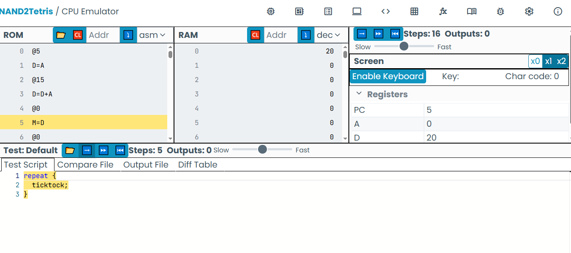Figure 1: NAND2Tetris CPU Emulator screenshot (addition result visible).

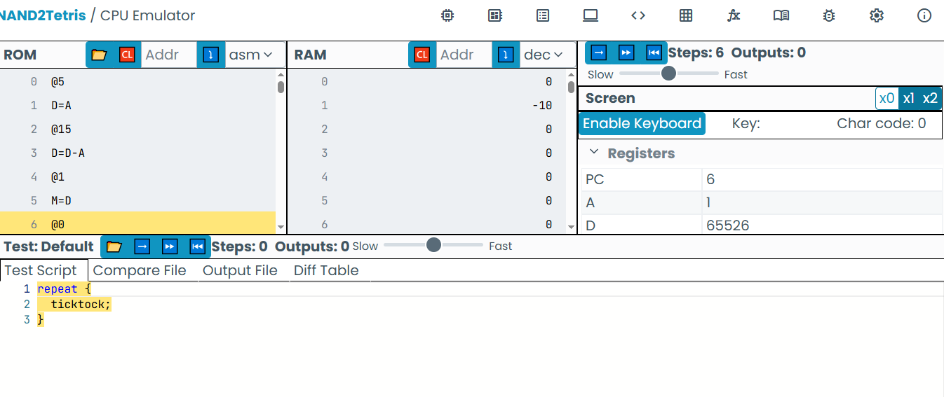
Figure 2: NAND2Tetris CPU Emulator screenshot (subtraction result visible).

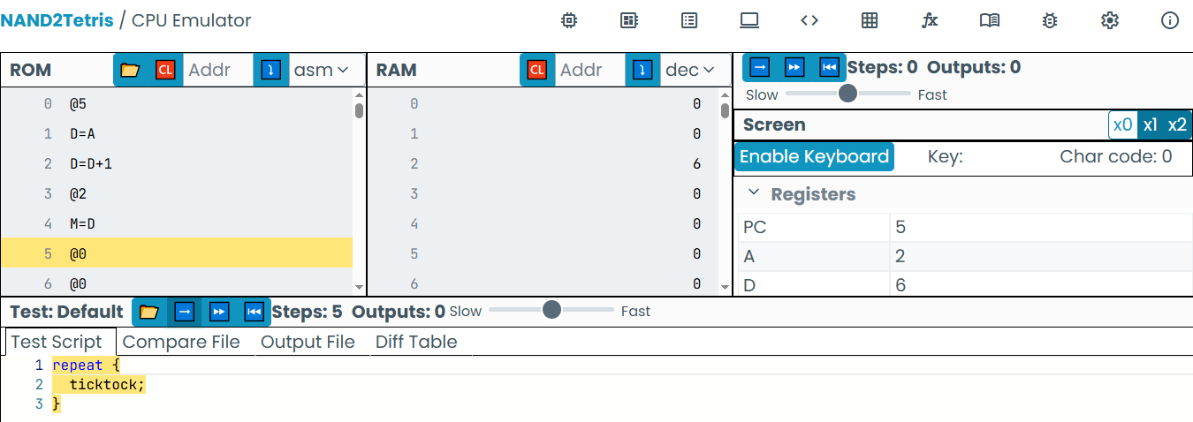
Figure 3: NAND2Tetris CPU Emulator screenshot (increment result visible).

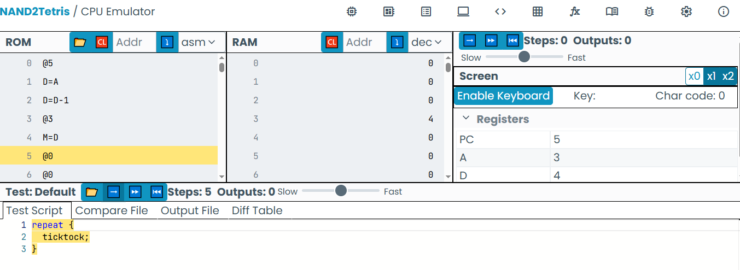
Figure 4: NAND2Tetris CPU Emulator screenshot (decrement result visible).

9. Output Record
After running the complete program, the expected decimal values in the RAM panel are:
RAM address | Purpose | Expected decimal value
RAM[0] | Addition result | 20
RAM[1] | Subtraction result | -10
RAM[2] | Increment result | 6
RAM[3] | Decrement result | 4

