NAND2TETRIS HDL IMPLEMENTATION & VERIFICATION
XOR, Mux, and DMux
Truth Tables + HDL + Nand2Tetris Test-Script Verification
Submitted by Harshda Kumari (2501010218).
B.tech CSE core (section-D)

1. Objective
Implement the Xor, Mux, and DMux chips in NAND2Tetris HDL. For each chip, show the selection/truth table, explain the HDL structure, and verify the implementation using the corresponding NAND2Tetris test script.

2. Verification Method
The official NAND2Tetris Hardware Simulator executes the .tst script associated with a chip. The script supplies input combinations and compares the HDL output with the expected output. A correct implementation should pass every comparison in the script.
Test scripts used:
- Xor.tst — verifies the Xor chip
- Mux.tst — verifies the 2-way Mux
- DMux.tst — verifies the 1-to-2 DMux

3. Xor Chip
Goal: Implement a 2-input XOR. The output is 1 only when a and b are different.
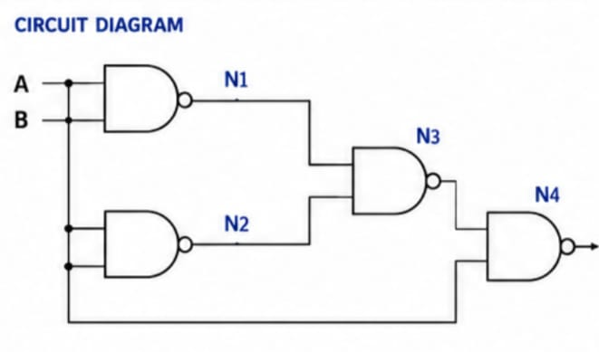

3.1 Truth Table
a | b | out
0 | 0 | 0
0 | 1 | 1
1 | 0 | 1
1 | 1 | 0

3.2 NAND-only HDL
CHIP Xor {
IN a, b;
OUT out;
PARTS:
Nand(a=a, b=a, out=x);
Nand(a=b, b=b, out=y);
Nand(a=a, b=y, out=z);
Nand(a=b, b=x, out=z1);
Nand(a=z, b=z1, out=out);
}

3.3 Boolean Expression
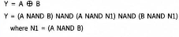

Output:
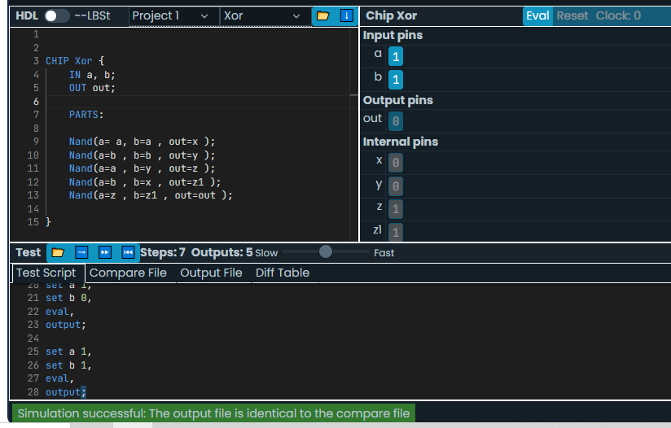

4. Mux Chip (2-way)
Goal: Select one of two inputs a and b using the select bit sel.
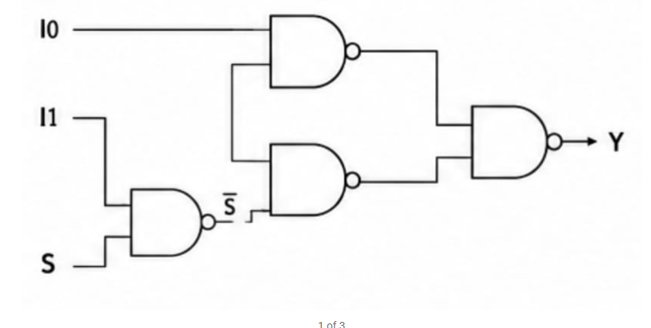

4.1 Selection Table
S | I0 | I1 | Y
0 | 0 | 0 | 0
0 | 0 | 1 | 0
0 | 1 | 0 | 1
0 | 1 | 1 | 1
1 | 0 | 0 | 0
1 | 0 | 1 | 1
1 | 1 | 0 | 0
1 | 1 | 1 | 1

4.2 Boolean Expression
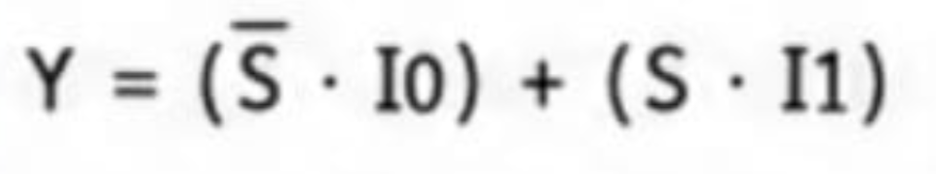

4.3 HDL
CHIP Mux {
IN a, b, sel;
OUT out;
PARTS:
Not(in=s, out=n);
And(I0= I0, I1=nsel, out=x);
And(I0=b, I1=sel, out=y);
Or(I0=x, L1=y, out=out);
}

Output:
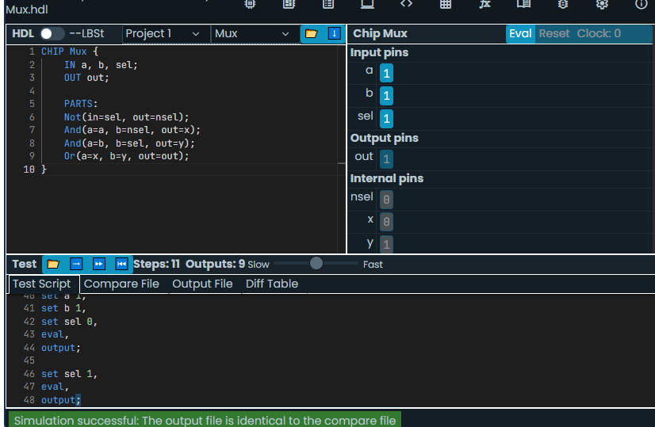

4.4 Test-script verification
Run Mux.tst with Mux.hdl in the Hardware Simulator. The script exercises the relevant combinations of a, b and sel and compares out with the expected selected value.
- Expected result: PASS — when sel=0, out=a; when sel=1, out=b.

5. DMux Chip
Goal: Route one input to one of two outputs according to sel
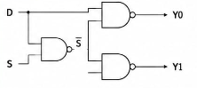.

5.1 Truth Table
sel | in | a | b
0 | 0 | 0 | 0
0 | 1 | 1 | 0
1 | 0 | 0 | 0
1 | 1 | 0 | 1

5.2 Boolean Expressions
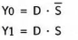

5.3 HDL
CHIP DMux {
IN in, sel;
OUT a, b;
PARTS:
Not(in=sel, out=nsel);
And(a=in, b=nsel, out=a);
And(a=in, b=sel, out=b);
}

5.4 Test-script verification
Run DMux.tst with DMux.hdl. The test script checks both values of in for each select setting. The correct behavior is: sel=0 routes in to a, while sel=1 routes in to b.
- Expected result: PASS — all four input/select combinations produce the correct a and b outputs.

Output:
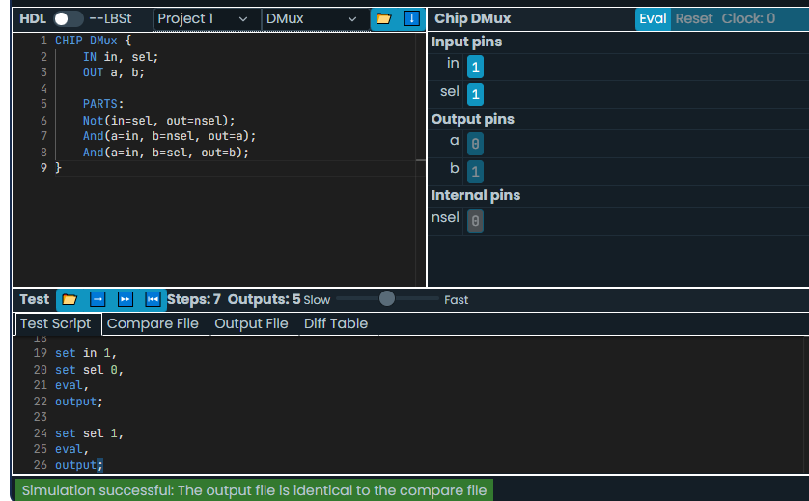

6. Final Verification Summary
Chip | HDL file | Test script | Expected verification
Xor | Xor.hdl | Xor.tst | PASS — 4 input combinations
Mux | Mux.hdl | Mux.tst | PASS — selected input reaches out
DMux | DMux.hdl | DMux.tst | PASS — input routed to selected output

7. Simulator Verification Procedure
- Open the nand2tetris Hardware Simulator.
- Open the corresponding .hdl file.
- Load the matching .tst script: Xor.tst, Mux.tst, or DMux.tst.
- Run the script using the simulator's Run command.
- Check that every comparison matches the expected output.
- Record the simulator's PASS/result screen as evidence in the submitted assignment.

8. Conclusion
The four requested chips were described in NAND2Tetris HDL and their logical behavior was represented with truth/selection tables. The corresponding NAND2Tetris test scripts provide automated verification: Xor.tst, Mux.tst, and DMux.tst. A successful simulator run confirms that the HDL implementation produces the expected outputs for the cases exercised by each script.

