Hands-On

1. Creating database name Sales and load tables in sql server.

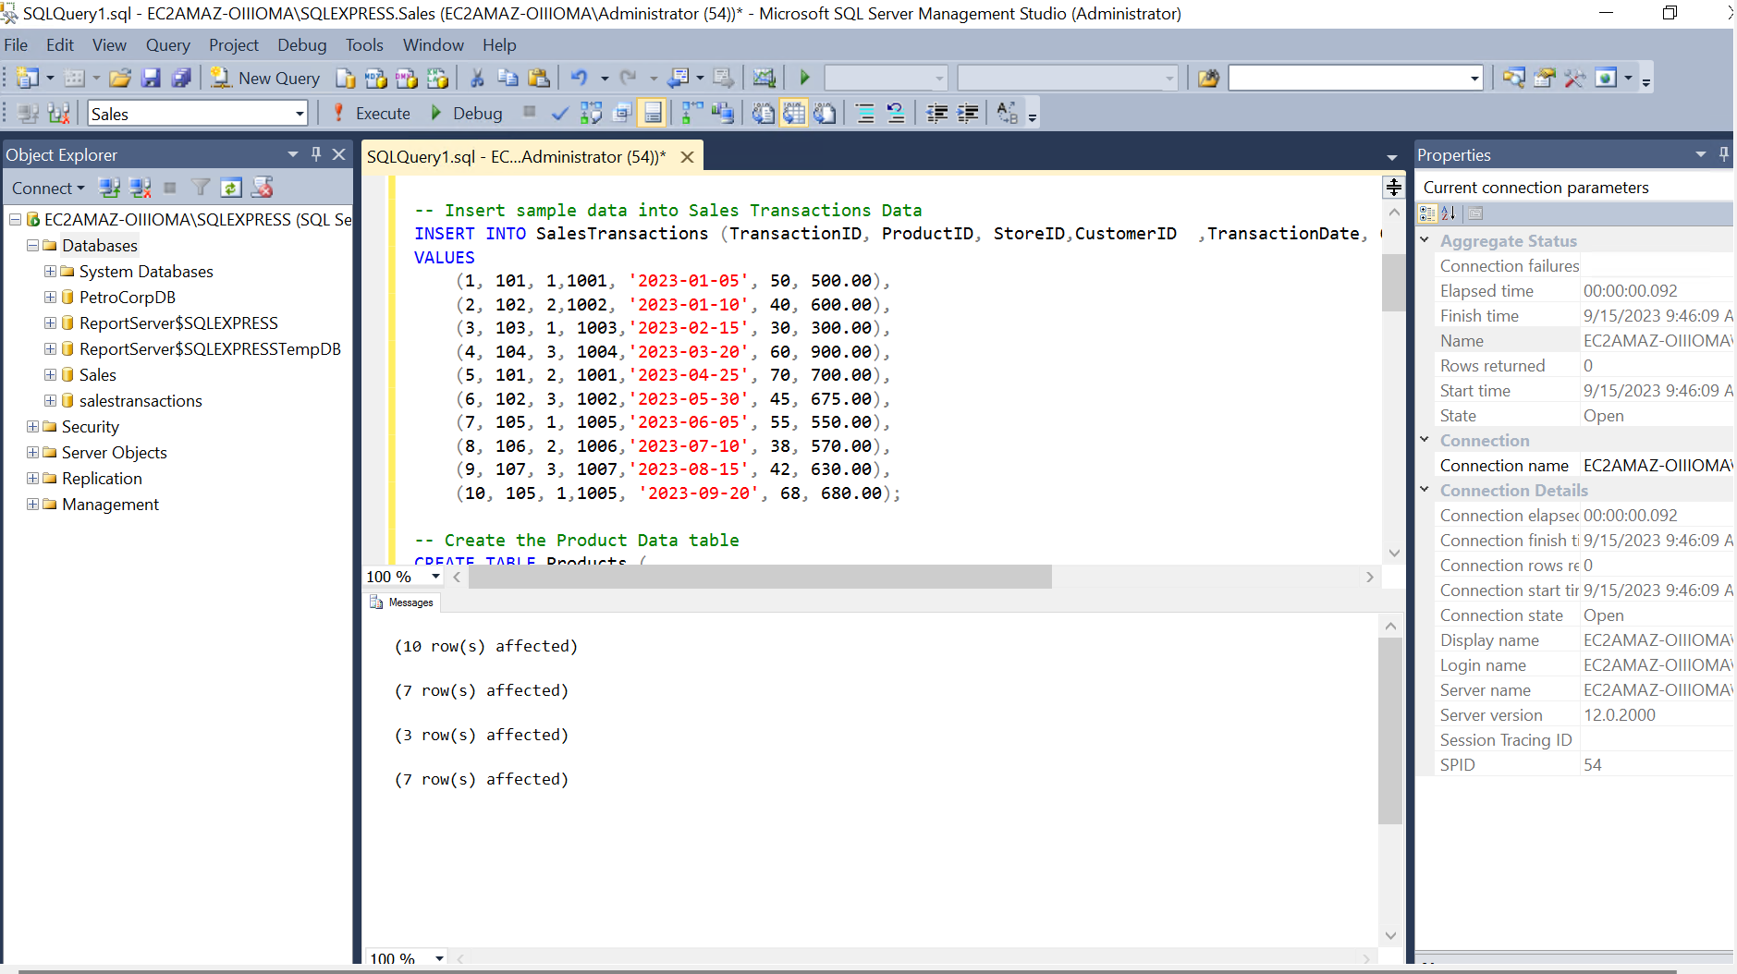

1. Successfully loaded data in power bi.

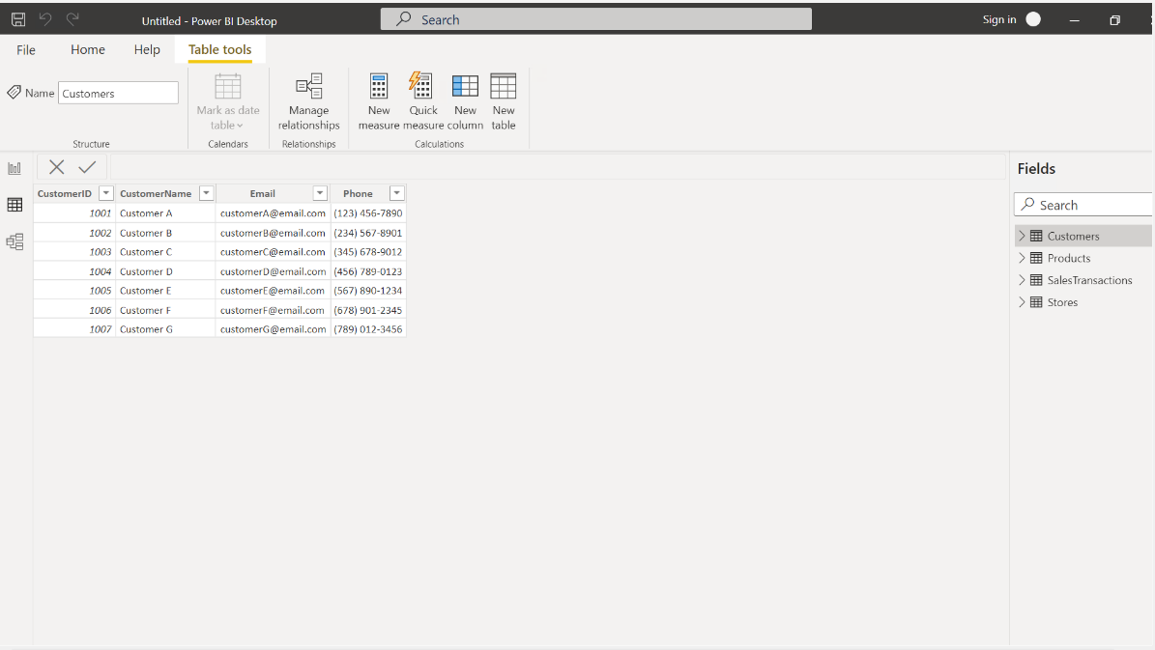

1. Merging two tables customer table and sales transactions into one i.e. Customer_transactions.

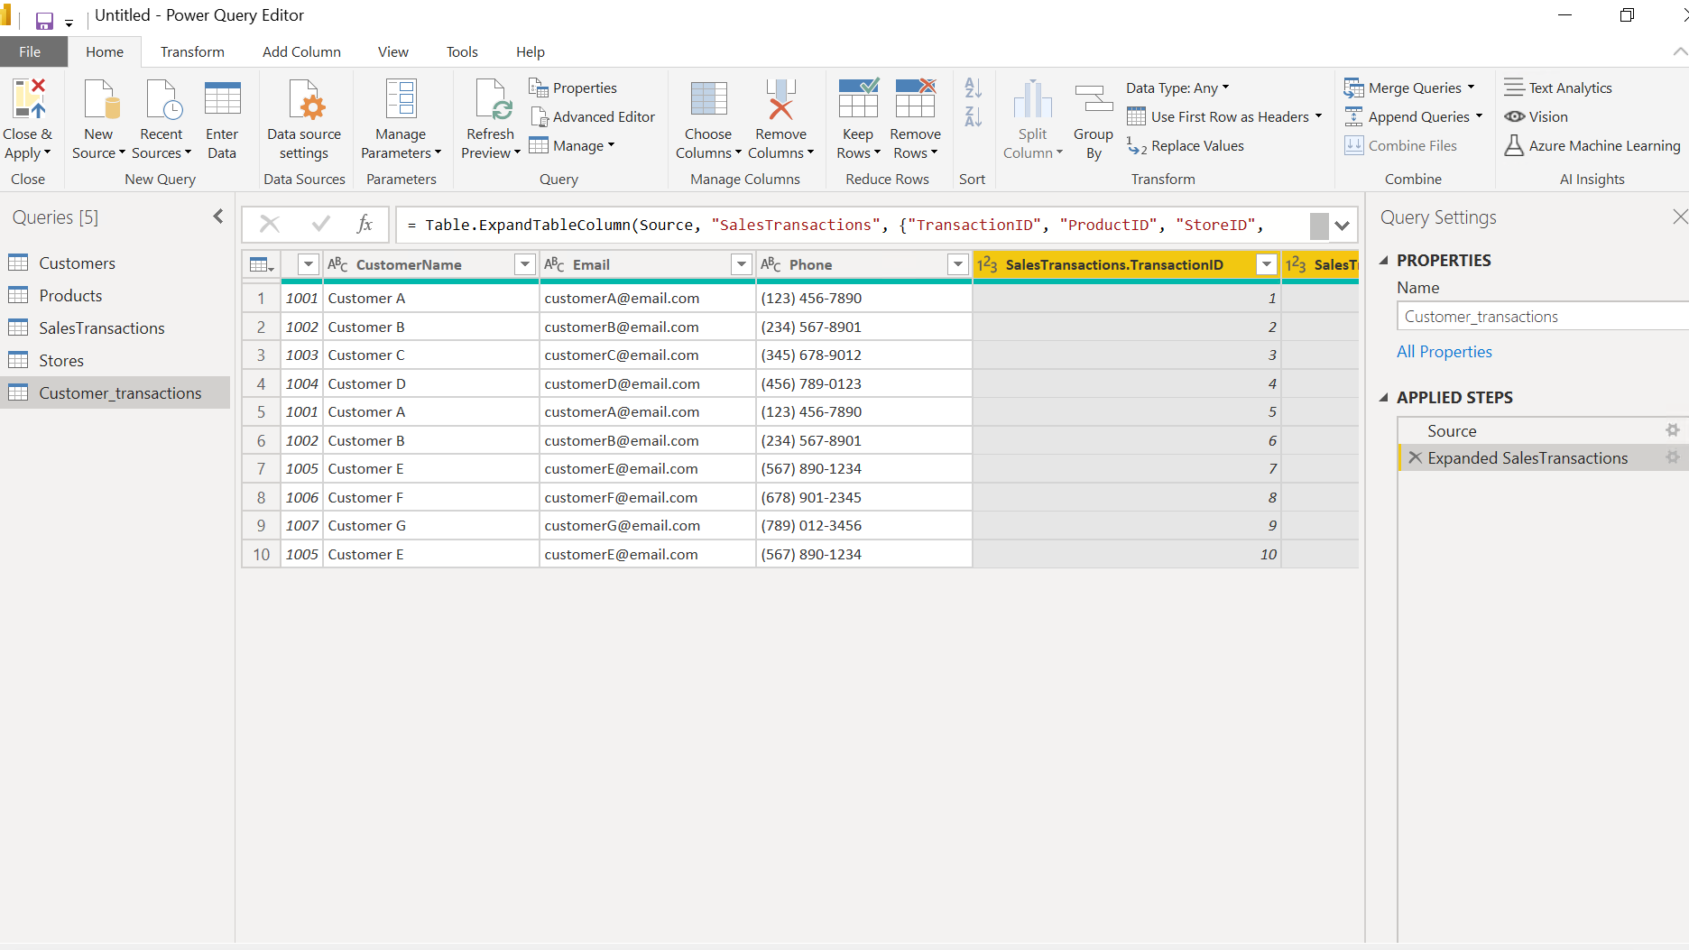

1. Created all the relationships between the tables.

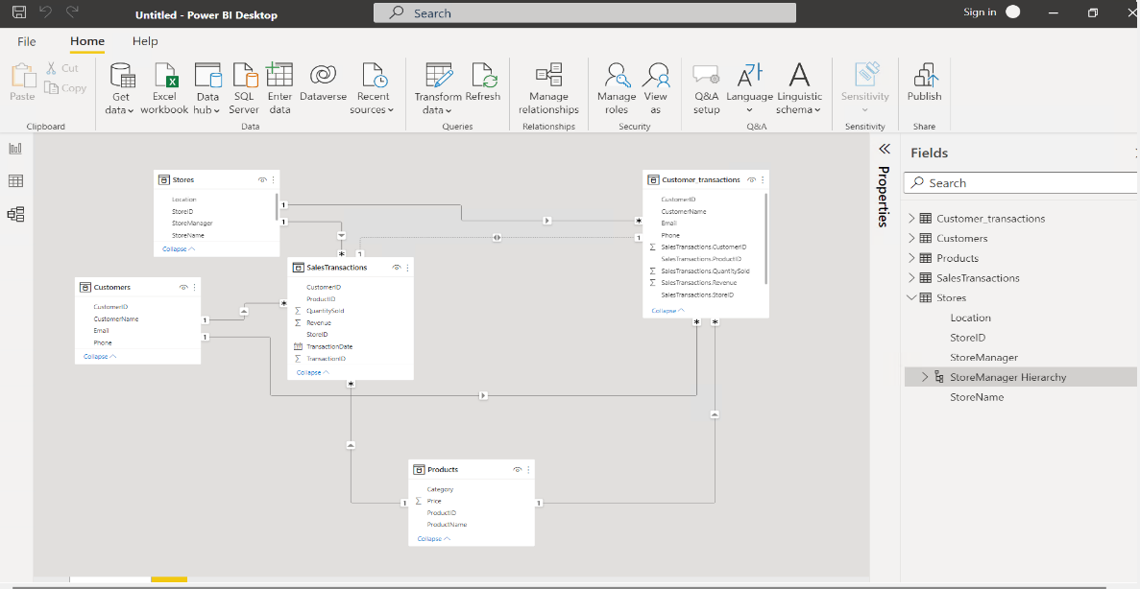

1. Creating a hierarchy in stores table as store manager hierarchy where Store manager is above the store name .

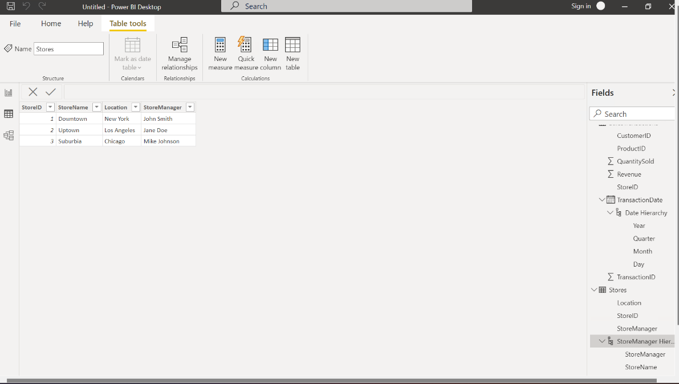

Business Queries and analysis

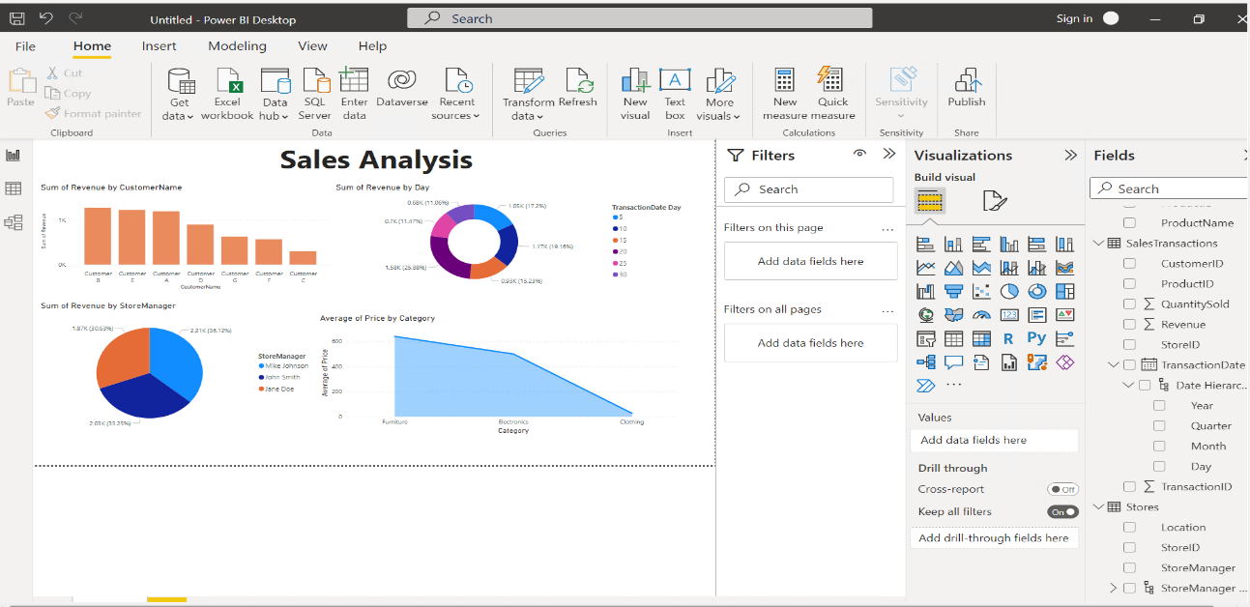

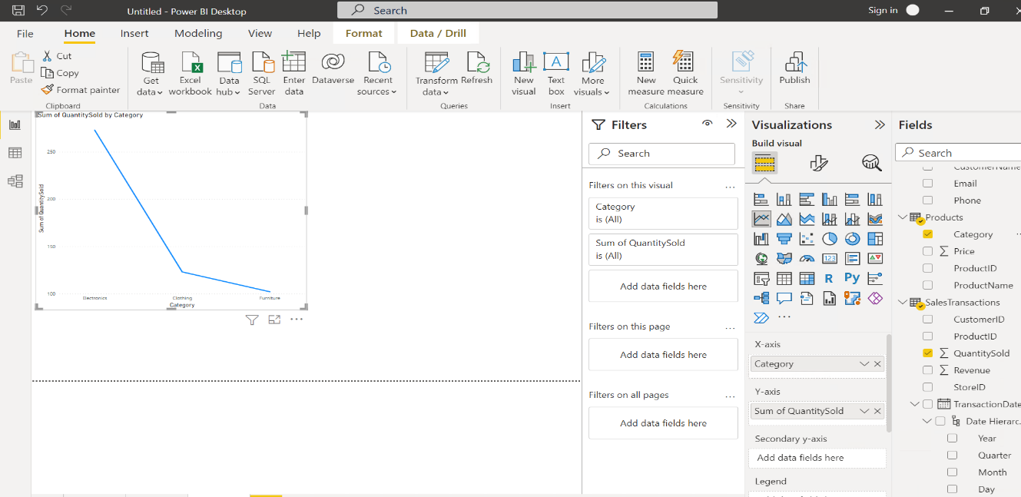

Data Insights and Recommendations

• Observing that Customer B exhibits greater expenditures on products, consider sending promotional emails to top-spending clientele in order to boost revenue.

• Noticing that the 20th day of each month consistently records heightened spending, consider deploying discount or sales emails ahead of this date to stimulate higher expenditures.

• Ensure that stores with a substantial customer base maintain sufficient stock levels to guarantee enhanced revenue.

• Recognize that the Electronics category proves to be the most lucrative, attributed to a confluence of substantial sales volume and higher product pricing.