WA01

Weekly Assignment 1  
BME 121, Fall 2018

Due Tue Sep 11 at 4:30 pm

# Assignment

Write a C# program to perform the following tasks.

* Repeatedly ask the user to enter a positive integer number.
* Report the number and the largest number seen so far.
* Stop when the user enters zero.

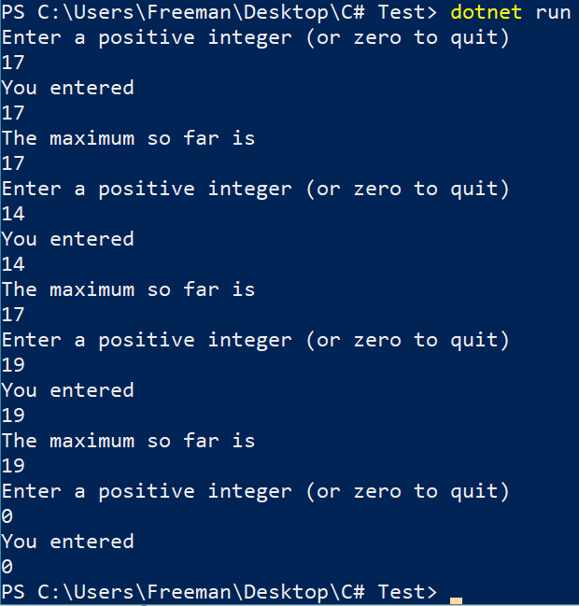Match the sample output shown below.

# Submission

Name your C# program file as wa01.cs and submit at the following url.

<http://bme121.fileupload.ca>