Q2 [40 marks, Stage 2]

Final Examination  
BME 121, Fall 2018

Wednesday, December 12

# Question

Construct your solution in the provided file q2.cs.

This problem is motivated by a statistical calculation in the following paper (the matrix at the bottom right of page 667).

* S. Jeong, Y. M. Jo, S.-O. Shim, Y.-J. Choi, and C.-H. Youn, “A novel method for metabolic syndrome risk quantification based on areal similarity degree,” *IEEE Transactions on Biomedical Engineering*, Volume 61, Number 3, Pages 665–679, March 2014.

In the ‘Main’ method, create a loop which will prompt the user to enter the prevalence for each risk factor and store the entered prevalence as a numerical value in an array. The given code defines string arrays holding the long and short names of each risk factor. (Prevalence of a risk factor appears to mean the fraction of a population displaying the risk factor.)

Add a helper method which will receive a one-dimensional array of risk prevalances and return a two-dimensional array of risk-prevalence ratios. In the returned array, the element in row ‘i’ and column ‘j’ is the prevalence of risk ‘i’ divided by the prevalence of risk ‘j’. This is the matrix formed in the paper on page 667. Your helper method should determine the returned array size from the passed array size. If passed a meaningless argument array, it can return a two-dimensional array with zero rows and zero columns.

Add code in the ‘Main’ method to call your helper method and display the resulting matrix.

Arrange for your program to match the formatting and spacing shown in the examples below. One example uses the actual risk prevalences from the paper and the other uses test values which are much easier to enter. Use meaningful names for your variables and helper method.

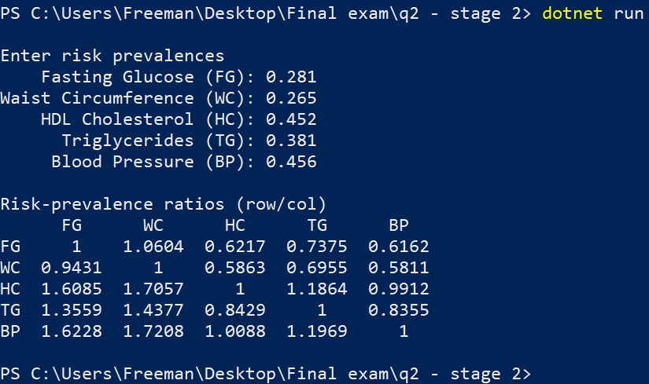

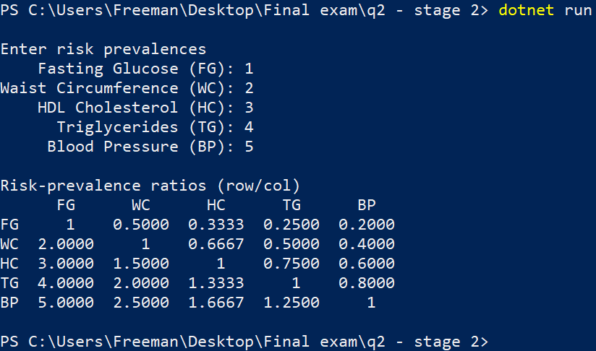

# Submission

Submit q2.cs at the following url.

<https://fileupload.ca>