Q3 [40 marks, Stage 2]

Final Examination  
BME 121, Fall 2018

Wednesday, December 12

# Question

Construct your solution in the provided file q3.cs.

Complete the provided ‘Disorder’ method so it computes the disorder (unsortedness) of the passed array ‘a’. There are many ways to characterize disorder in an array. Here, motivated by cycle sort, we consider the disorder of one array element as its distance from where it would appear in the sorted array. If a value is in position 6 but would be sorted to position 8, this distance is 2. Similarly, if a value is in position 6 but would be sorted to position 4, this distance is also 2. If a value is in position 6 and would be sorted to position 6, its disorder is 0. To get the disorder of the whole array, we sum the disorders of its elements.

If an array element has a unique value (not duplicated in the array), we know its sorted position from its rank (the count of elements which compare as less than its value). Thus, a good start to the ‘Dispose’ method is to borrow some code from the ‘Rank’ method of Weekly Asignment 6. Use the provided ‘Compare’ method for all element comparisons.

Array elements with duplicate values are sorted to a range of positions starting at their rank. An element already positioned in this range has disorder zero. For other elements, we use the distance to the closest edge of the range. If duplicate values sort to positions 3, 4, 5, 6, a value in position 1 has disorder 2, a value in position 8 has disorder 2, and a value in position 5 has disorder 0..

The given ‘Main’ method tests the ‘Disorder’ calculation on random unsorted and sorted arrays with and without unique values. For debugging, we have specified a seed for the ‘Random’ object so your arrays will always show the same “random” values.

Once your ‘Disorder’ method is working properly, your output should be as shown below. It may be easier to first think about calculating disorder when all array values are unique (no repeated values) then modify your code to handle repeated values.

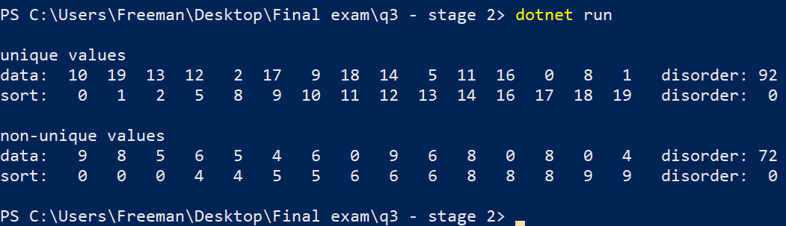

# Submission

Submit q3.cs at the following url.

<https://fileupload.ca>