Q4 [40 marks, Stage 2]

Final Examination  
BME 121, Fall 2018

Wednesday, December 12

# Question

Construct your solution in the provided file q4.cs.

The provided file “TheEnd.txt” contains subtitles for a music video called “The End” by Lena Park. It was obtained by cutting and pasting from the transcript at the URL https://www.youtube.com/watch?v=PRBpYVn0uAo (using the “...” menu below the video). I assume copyright for these lyrics is held by Loen Entertainment.

The file comprises pairs of lines like the following (colour shading is added for explanation).

00:13

The happy moments become pictures

00:21

They are compiled into our own book

In each pair, the first line is the time (minute:second) when the subtitle should appear. The second line is the subtitle text.

If you have a copy of the video, this file is not sufficient to add subtitles during playback. Instead, we need to convert it to another representation called “SubRip” text format.

The “SubRip” representation of the first two subtitles above might look like the following.

1

00:00:13,000 --> 00:00:21,000

The happy moments become pictures

2

00:00:21,000 --> 00:00:29,000

They are compiled into our own book

Here, the first line is just an index number for the subtitle which begins at one and increments by one for each new subtitle. The next line indicates the times at which the subtitle should appear and disappear (hour:minute:second,millisecond). Following that is the subtitle text (there can be any number of these text lines but we will have only one). Finally, there is a blank line to indicate the end of the subtitle text.

Since the input file contains only start times, the end time for each subtitle is assumed to be the same as the start time of the next subtitle. This doesn’t work for the last subtitle in the input file. For that case, the end time is made 999 milliseconds later than the start time. This is illustrated below.

28

00:04:05,000 --> 00:04:05,999

In the end, we're "The End"

Notice that the times can remain as string data since we don’t do any numeric manipulation of time values. The colour shading above is an attempt to indicate the relevant string pieces being used or modified.

Write the ‘Main’ method so it opens and reads the input file “TheEnd.srt” and produces the “SubRip” text format as output to the console.

Note that you can approach this in phases such as the following. Read the file in pairs of lines, displaying the time and text to the console. Add code to produce the index number. Modify so the time is shown in the “SubRip” format using the start time as both the start and end time. Modify the code to include logic so the desired end times are used.

The input file may have extra spaces at the ends of the lines. You can remove these using the ‘Trim’ method of the string class.

Output should look like the following.

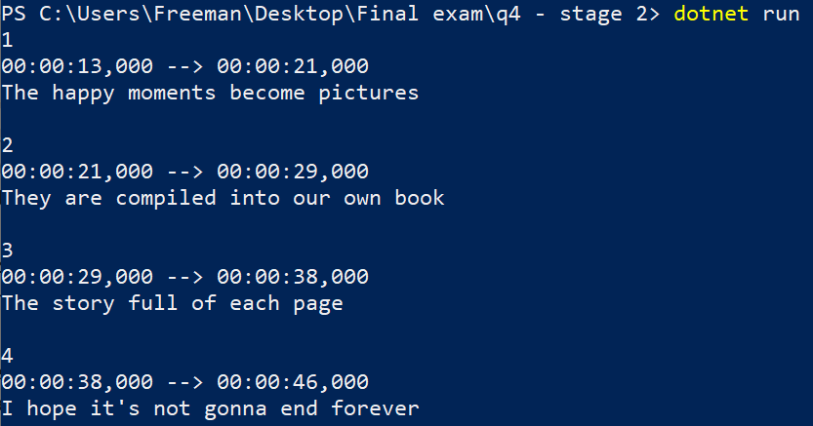 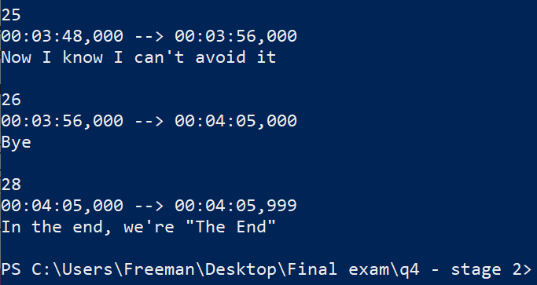

# Submission

Submit q4.cs at the following url.

<https://fileupload.ca>