aaMOBee - Phase II Delivery Summary
Project Title: aaMOBee
Version: 2.0
Target Audience: Traders, Manufacturers combine
Prepared by: Team aaMOBee
Team Members: # Harsh Dubey [Project Lead] [Fullstack developer]
# Rohit Saini [Fullstack Developer]
# Swapnil Shrivastava [Team lead]

📝 Overview
Phase II of the aaMOBee platform was initially scoped to introduce advanced features targeting manufacturers, firm-level settings, and integrated payment workflows. However, due to evolving business requirements and system alterations, several modules and functionalities originally scheduled for later phases were completed and delivered ahead of plan.
This document outlines both the planned and additionally delivered features in Phase II, summarizing the total progress made.
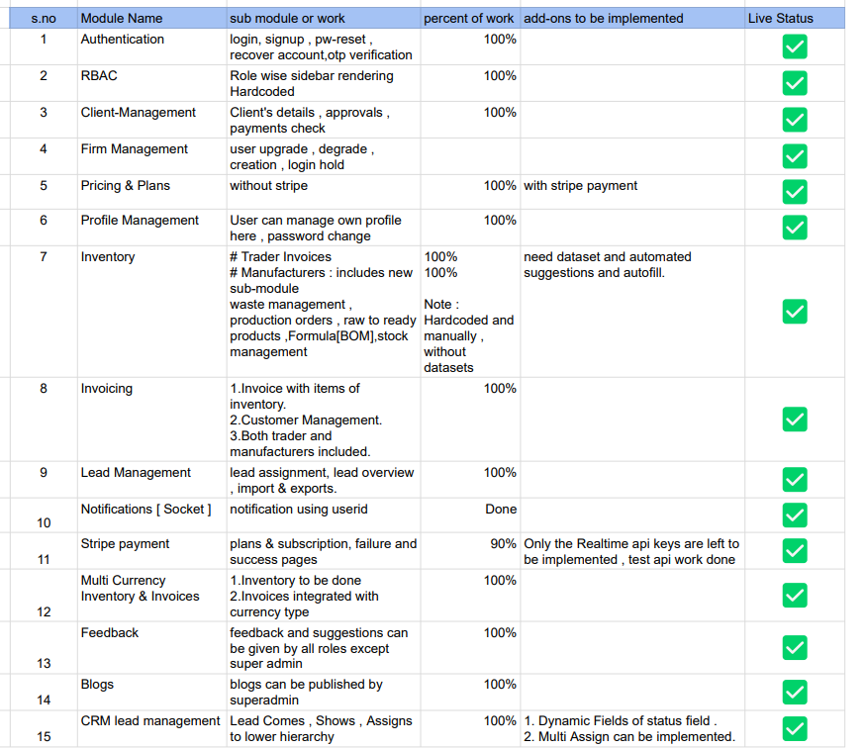
https://docs.google.com/spreadsheets/d/1tL3V20nLOjhPJU7f7WQUyKjhxnOu2Q4lCEvrVGUZWns/edit?usp=sharing

🚀 Extra Features Delivered Ahead of Schedule
S. No | Module Name | Description
1 | Manufacturer Inventory | Includes raw-to-final product workflows, production orders, BOM, stock mgmt
2 | Combined Invoicing | Unified invoice logic for traders and manufacturers.
3 | Payment Integration | Secure and functional Stripe integration framework setup.
4 | Notification Settings | Configurable notifications for critical actions and updates.
5 | Testing & Deployment | Finalized module testing and deployment to live environment.

📌 Notes
- Stripe payment is Done with real-time testing API implementation.
- Manufacturer modules were manually created without automation; data population logic and dataset suggestions are planned for upcoming iterations.
Conclusion:
The delivery of several key modules and additional enhancements in this phase showcases the flexibility and capability of the aaMOBee team to adapt to evolving requirements while ensuring timely delivery of mission-critical features.

