**WWS 2013 – Vibration Sensing Line Follower**

***DOCUMENTATION OF DAY 1***

There are mainly two parts in this bot :

1) Hardware

2) Coding

Hardware is again sub divided into two components :-

1) Electrical components

2) Mechanical components

The things that come under the electrical components are :-

* Motor driver
* Sensor circuit(IR/LED-LDR)
* Rhino development board(ATMEGA 16)

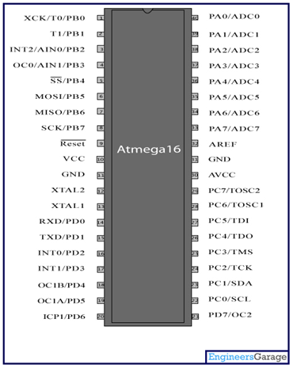

* Accelerometer

CODING : * AVR Studio

· Rhino IDE

· Rhino Programmer

The processing of the bot is done as :

Sensor -> ATMEGA 16 -> Motor Driver (organised by the H bridge ) -> which gives the effect.

Running modes of a motor :

· Free run mode (both low)

· Breaking mode (both high,shorted)

· Clockwise

· Anti clockwise

This whole process is done by the H bridge.

By the step down transformer the normal 220 v Ac current is brought down to 12v Ac current and then the rectifier converts it into 12v Dc current.

Rectifiers are of three types :-

· Full wave rectifier

· Half wave rectifier

· Centre tap rectifier( generally we will be using this as the amount of output is being double)

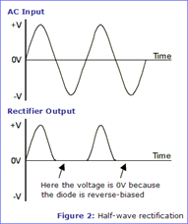 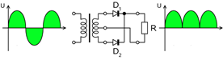

Generally the IC 78** is used.

** à the integer in the place of this represents the voltage of the thing we are using

We generally do use IC 7812

But for the purposes of censor circuit and the development board IC 7805 is used.

When the voltage is decreased the the RPM rate decreases.

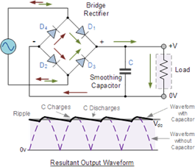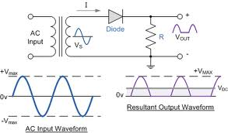

Bridge full wave rectifier Half wave rectifier

To avoid the use of the jumper we can the connect the junction terminals.

Bread board:

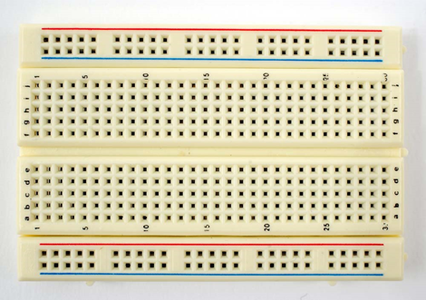

Shorted and has floating values.

LED-LDR Sensors: infrared receiver(photo diode)/transmitter(IR light emitting diode).

LDR-LIGHT DEPENDENT RESISTOR

Cadmium sulphide is used

Higher the intensity of the light on.......lower is the resistance given.

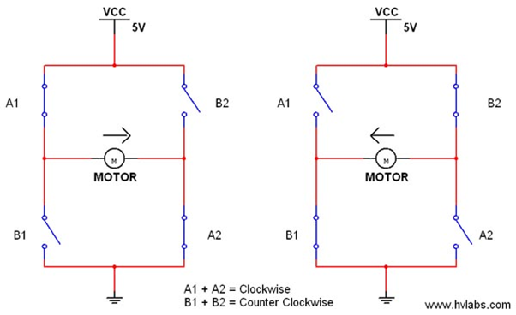

When all are open the result is the free mode .

When all are closed both the terminals are high which results in a breaking circuit.

...............................................................................................................................................

The works that were given are:

· Rippling effect

· Datasheet

· Pwm

***DAY 2:***

**DOCUMENTATION ROBOTICS**

Todays topic:

· Comparator circuit

· Motor driver circuit

· AVR programing

**COMPARATOR CIRCUIT**

Comparator is a circuit generally used to convert analog input to digital input.The basic concept of comparator is that input voltage is compared to a provided reference voltage ,that is ,if input voltage is higher than

Vref ,we get output as high (floating potential of the point remains high)

Whereas if Vin is less than Vref the output we get is low,

thus analog input is digitalized with repect to a refrence voltage.

Comparator circuit is one of the applications of OP-AMP (operational amplifiers) which is a differential amplifier generally using IC 741 to amplify signals.

For op amp

Vout=A(V-Vref)

Below is schematic representation of comparator circuit and waveforms

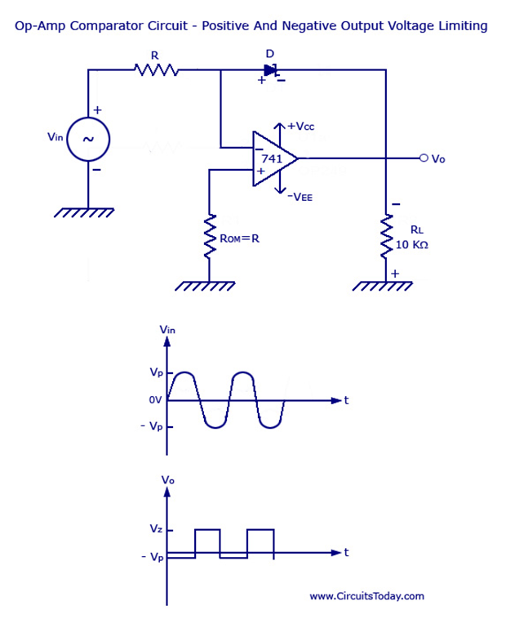

**Comparator ICs**

LM339 is IC having total of 14 terminals ,out of which 2 are of Vcc and ground, and having 4 comparators

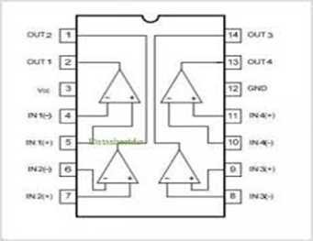

Comparator is used in simple line follower circuit using LED and LDR

Circuit diagram for such a line follower is as below:

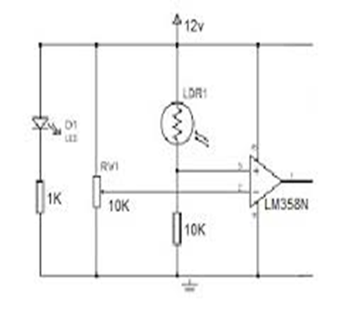

**MOTOR DRIVER**

IC L293D is the IC used for motor driver

The IC has 16 pins out of which central four ics are plated to minimise dissipation of heat as well as common ground .

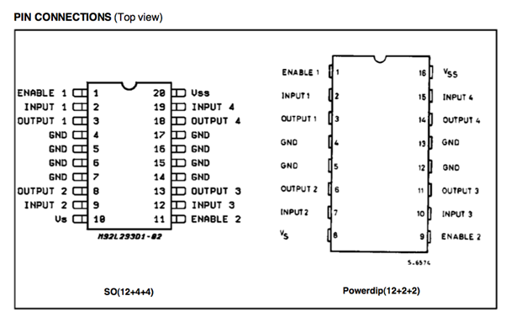

The enable refers to the terminal which when high activates the chip .

Whereas when the input receives high ,the output supplies the motor with voltage to run the motor.

***DAY 3:***

**TOPICS:**

· **Bit operations**

· **Registers**

**Bit operations:**

· **Checking a bit**

Syntax: number&(1<<x)

· **Setting a bit**

Number/(1<<x)

· **Clearing a bit**

Number&(~(1<<x))

· **Toggling a bit**

Number^(1<<x)

**Registers:**

**DDRx**

**PORTx**

**PINx**

**ADMUX**

**ADCSRA**

**ADMUX:**

**REFS1 REFS0 ADLAR MUX4 MUX3 MUX2 MUX1 MUX0**

**0 0 0 0 0 0 0 0**

Voltage Reference Selections for ADC

REFS1 REFS0 Voltage Reference Selection

0 0 AREF, Internal Vref turned off

0 1 AVCC with external capacitor at AREF pin

1 0 Reserved

1 1 Internal 2.56V Voltage Reference with external capacitor at AREF pin

**ADLAR:**

· **ADC left adjusted results**

· **ADC gives 10 bit resolution**

· **ADC is stored in 16 bit**

· **ADLAR**

**Table 22-5.** ADC Prescaler Selections

**ADPS2 ADPS1 ADPS0 Division Factor**

0 0 0 2

0 0 1 2

0 1 0 4

0 1 1 8

1 0 0 16

1 0 1 32

1 1 0 64

1 1 1 128

*ADLAR = 0*

**– – – – – – ADC9 ADC8 ADCH**

**ADC7 ADC6 ADC5 ADC4 ADC3 ADC2 ADC1 ADC0** ADCL

*ADLAR = 1*

**ADC9 ADC8 ADC7 ADC6 ADC5 ADC4 ADC3 ADC2 ADCH**

**ADC1 ADC0 – – – – – –** ADCL

**ADCSRA – ADC Control and Status Register A**

ADEN ADSC ADATE ADIF ADIE ADPS2 ADPS1 ADPS

0 0 0 0 0 0 0 0

**ADEN: It powers the ADC circuit**

**ADSC: It starts the conversion into digital log**

**ADPS2, ADPS1, ADPS0 : These determine the division factor to set the XTAL frequency into ADC working frequency.**

**DOCUMENTATION OF DAY4 and DAY 5**

**Topics:**

 PWM

 Timers

Making of Sensor Circuit with PWM

Line Follower Code with PWM

Accelerometer

**PWM :** Pulse Width Modulation

**Pulse-width modulation** (**PWM**), or **pulse-duration modulation** (**PDM**), is a modulation technique that conforms the width of the pulse, formally the pulse duration, based on modulator signal information. Although this modulation technique can be used to encode information for transmission, its main use is to allow the control of the power supplied to electrical devices, especially to inertial loads such as motors.

The average value of voltage (and current) fed to the [load](http://en.wikipedia.org/wiki/Electrical_load) is controlled by turning the switch between supply and load on and off at a fast pace. The longer the switch is on compared to the off periods, the higher the power supplied to the load is.

The PWM switching frequency has to be much faster than what would affect the load, which is to say the device that uses the power.

The term [*duty cycle*](http://en.wikipedia.org/wiki/Duty_cycle) describes the proportion of 'on' time to the regular interval or 'period' of time; a low duty cycle corresponds to low power, because the power is off for most of the time. Duty cycle is expressed in percent, 100% being fully on.

The main advantage of PWM is that power loss in the switching devices is very low. When a switch is off there is practically no current, and when it is on, there is almost no voltage drop across the switch. Power loss, being the product of voltage and current, is thus in both cases close to zero. PWM also works well with digital controls, which, because of their on/off nature, can easily set the needed duty cycle.

**ATMEGA PWM MODES:**

1. Normal Mode

2. Clear Timer on Compare (CTC mode)

3. Fast PWM

4. Phase Correct PWM

**ATMEGA 16A has three timers**: Two 8-bit timers & one 16-bit timer

Timer 0 and Timer 2 are 8-bit timers and Timer1 is a 16-bit timer.

**Registers Description:**

**TCCR : Timer Counter Control Register**

**Register to activate the counter.**

**TCCR0**

Bit 7 6 5 4 3 2 1 0

**FOC0 WGM00 COM01 COM00 WGM01 CS02 CS01 CS00**

Write R/W R/W R/W R/W R/W R/W R/W

Initial Value 0 0 0 0 0 0 0 0

FOC0 used to set non-PWM mode active.

WGM00 and WGM01(Wavw Generation Mode Bits)

Waveform Generation Mode Bit Description

**Mode WGM01 WGM00 Timer Mode of Operation**

0 0 0 Normal

1 0 1 PWM, Phase Correct

2 1 0 CTC OCR0

3 1 1 Fast PWM

Compare Output Mode, non-PWM Mode

**COM01 COM00 Description**

0 0 Normal port operation, OC0 disconnected.

0 1 Toggle OC0 on compare match

1 0 Clear OC0 on compare match

1 1 Set OC0 on compare match

Compare Output Mode, Fast PWM Mode

**COM01 COM00 Description**

0 0 Normal port operation, OC0 disconnected.

0 1 Reserved

1 0 Clear OC0 on compare match, set OC0 at BOTTOM,(non-inverting mode)

1 1 Set OC0 on compare match,clear OC0

Compare Output Mode, Phase Correct PWM Mode

**COM01 COM00 Description**

0 0 Normal port operation, OC0disconnected.

0 1 Reserved

1 0 Clear OC0 on compare match when up-counting. Set OC0 on compare match

when downcounting.

1 1 Set OC0 on compare match when up-counting. Clear OC0 on compare match

when downcounting

**TCNT0 Timer/ Counter Register**

The Timer/Counter Register gives direct access, both for read and write operations, to the

Timer/Counter unit 8-bit counter. Writing to the TCNT0 Register blocks (removes) the compare

match on the following timer clock. Modifying the counter (TCNT0) while the counter is running,

introduces a risk of missing a compare match between TCNT0 and the OCR0 Register

***OCR0 Output Compare Register***

The Output Compare Register contains an 8-bit value that is continuously compared with the

counter value (TCNT0). A match can be used to generate an output compare interrupt, or to

generate a waveform output on the OC0 pin.

DOCUMENTATION OF DAY 6

ACCELEROMETER

*accelerometer is a device which measures acceleration.

*accelerometer has three pins:

pin x: gives voltage corresponding to the acceleration sensed along the X axis.

pin y : gives voltage corresponding to the acceleration sensed along the Y axis.

pin z : gives voltage corres ponding to the acceleration sensed along the Z axis.

Graph between ADCH and time:

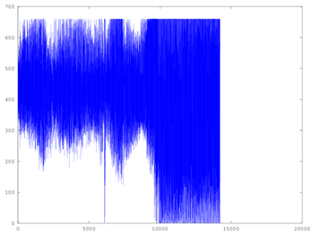

t

16 bit Timer Counter Register :

Timer Counter 1 Controll Register A=10100001:

Timer Counter 1 Controll Register B=00001001;