***A Mini Project Report on***

**E-Commerce Website for Pharmacy**

**S.E. - I.T Engineering**

**Submitted By**

**Harsh Gajera**  **22104099**

**Sekhar Gauda 22104044**

**Aditya Gupta**  **22104155**

**Paresh Gupta 22104089**

**Under The Guidance Of**

**Prof. Geetanjali Kalme**



**DEPARTMENT OF INFORMATION TECHNOLOGY**

**A.P.SHAH INSTITUTE OF TECHNOLOGY**

**G.B. Road, Kasarvadavali, Thane (W), Mumbai-400615**

**UNIVERSITY OF MUMBAI**

**Academic year : 2023-24**

**CERTIFICATE**

This to certify that the Mini Project report on **E-commerce website for Pharmacy** has been submitted by **Harsh Gajera** **(22104099)**, **Sekar Gauda (22104044)**,**Aditya Gupta (22104155)** and **Paresh Gupta (22104089)** who are a Bonafede students of A. P. Shah Institute of Technology, Thane, Mumbai, as a partial fulfillment of the requirement for the degree in **Information Technology**, during the academic year **2023-2024** in the satisfactory manner as per the curriculum laid down by University of Mumbai.

Prof.Geetanjali Kalme

Guide

Dr. Kiran Deshpande Dr. Uttam D.Kolekar

Head of Department of Information Technology Principal

External Examiner(s)

1.

2.

Place: A.P.Shah Institute of Technology, Thane

Date:

**ACKNOWLEDGEMENT**

This project would not have come to fruition without the invaluable help of our guide **Prof.Geetanjali Kalme**. Expressing gratitude towards our HoD, **Dr. Kiran Deshpande**, and the Department of Information Technology for providing us with the opportunity as well as the support required to pursue this project. We would also like to thank our teacher Ms. Yaminee Patil who gave us her valuable suggestions and ideas when we were in need of them. We would also like to thank our peers for their helpful suggestions.

**ABSTRACT**

E-commerce's rapid growth has spurred demand for convenient online access to pharmaceuticals. Our E-Pharmacy Website offers a user-friendly shopping experience, including a "Product Request Form" for unavailable items. It provides more than just shopping, with user reviews, FAQs, health resources, and COVID-19 updates. We aim to expand into underserved areas and support local suppliers, bridging the gap between pharmaceuticals and healthcare. Our platform revolutionizes online pharmaceutical retail, enhancing access to vital healthcare products while prioritizing security and user satisfaction.

**TABLE OF CONTENTS**

1. Introduction…………………………………………………………………...…..1
   1. Purpose........................................................................................................... 1
   2. Problem Statement……………………………………………………......…2
   3. Objectives....................................................................................................... 3
   4. Scope.............................................................................................................. 3
2. Literature Review………………………………………………………………....4
3. Proposed System……….........................................................................................7
   1. Features and Functionality……………………………………………….....7
4. Requirements Analysis.......................................................................................... 9
5. Project Design.......................................................................................................10
   1. DFD (Data Flow Diagram) ……………………………………….....……..11
   2. System Architecture………………………………………………........…..12
6. Technical specification……………...…………………………………………...13
7. Project Scheduling.................................................................................................15
8. Implementation…………………………………………………………………..16
9. Result and Discussion…………..……………………………………….........….17
10. Conclusion and Future Scope.................................................................................18

References

**1.INTRODUCTION**

**1.1.Purpose**

The COVID-19 pandemic has brought to light the critical need to address healthcare crises, especially in remote and underserved villages. During lockdowns and times of crisis, individuals are confined to their homes, and local stores often remain closed, revealing a stark lack of healthcare access. The inability to procure necessary medications becomes a significant challenge for people in remote areas. In response to this pressing issue, an innovative solution has emerged - the development of e-commerce websites for pharmacies. This essay explores the profound impact of these platforms in ensuring uninterrupted access to essential healthcare products, even in the face of the most trying circumstances. It goes beyond being just a response to emergencies; it is designed to be a sustainable solution that meets the ongoing healthcare needs of these communities, with a commitment to maintaining a well-stocked and accessible online pharmacy.

**a. The Healthcare Crisis in Underserved Villages:** Remote and underserved villages have long struggled with inadequate access to healthcare. The COVID-19 pandemic exacerbated these challenges, laying bare the vulnerabilities of such communities. During lockdowns, individuals found themselves cut off from essential medical supplies, and the consequences of this dearth of healthcare access were glaringly apparent. The inability to procure necessary medications posed a significant challenge, especially for those with chronic illnesses. It became evident that traditional brick-and-mortar pharmacies, already scarce in these regions, were often inaccessible during lockdowns, leaving residents without a lifeline to essential medicines.

**b. The Emergence of E-commerce Pharmacies:** In response to this crisis, the concept of e-commerce pharmacies gained traction. These platforms were conceptualized with the primary objective of ensuring that individuals in remote areas could access vital medicines from the comfort of their homes. E-commerce pharmacies represent a beacon of hope, as they empower people to effortlessly order medications and healthcare products online. With a few clicks, patients can have their prescriptions filled and essential supplies delivered to their doorstep. This level of accessibility is a game-changer, particularly during emergencies like the COVID-19 pandemic. It not only ensures that individuals receive the care they need but also minimizes the risk of virus transmission by reducing the need for in-person visits to physical pharmacies.

**c. A Sustainable Solution:** The significance of e-commerce pharmacies goes beyond being a temporary response to emergencies. These platforms are designed to be a sustainable solution that addresses the ongoing healthcare needs of remote and underserved communities. They offer a lifeline that remains intact not just during pandemics but every day. This sustainability is achieved through several key features:

**d. Accessibility:** E-commerce pharmacies are accessible 24/7, 365 days a year. They are not constrained by business hours or holidays. This constant availability ensures that individuals can order medicines whenever the need arises.

**e. Wide Range of Medications:** These platforms strive to maintain a well-stocked inventory, covering a wide range of medications, from over-the-counter drugs to prescription medications. This ensures that individuals can find the specific treatments they require.

**f. Delivery Services:** The commitment to maintaining a well-stocked and accessible online pharmacy extends to efficient delivery services. Medications and healthcare products are delivered to the doorstep of the customer, often with expedited shipping options for urgent needs.

**g. Health Information and Support:** E-commerce pharmacies often provide valuable health information and support services, such as virtual consultations with healthcare professionals, ensuring that patients have access to guidance and advice.

**h. Data Security and Privacy:** These platforms prioritize the security and privacy of user data, ensuring that personal health information is protected in accordance with relevant regulations.

**1.2.Problem Statement**

**Problem statement :**​

It overcomes the basic problem of limited access to healthcare products by providing a convenient online platform for purchasing and requesting medical-related products. Furthermore, it eliminates the need for individuals to leave their homes to purchase medicines, ensuring a more accessible and hassle-free healthcare experience.​

**The Solution:**

A User-Driven E-commerce Pharmacy Platform: To tackle this pressing challenge, our proposed solution is an innovative web application that introduces the "Request for a Medicine" feature. This feature empowers users to easily request medicines that are not currently available in the platform's inventory. Once a request is submitted, our dedicated admin team verifies and evaluates each request before adding the requested medicine to the website. This proactive approach ensures that users have a direct hand in expanding our product offerings, making it a more comprehensive and user-driven platform for accessing essential healthcare products.

The Holistic Impact of the Solution: The implementation of this solution is expected to have a transformative impact on healthcare access in remote and underserved communities. By eliminating the need for individuals to leave their homes to purchase medicines, it ensures a more accessible and hassle-free healthcare experience. Moreover, it engages the community in shaping the platform, making it more responsive to their specific needs and requirements. This user-driven approach fosters a sense of ownership and community involvement in healthcare access, further strengthening the solution's sustainability.

**1.3. Objectives**

* To simplify the process for amateur person.​
* To build trust between user and supplier by providing product details and ratings while viewing a product.​
* To let users easily request unavailable medicines, enhancing convenience.​
* To ensure efficient request verification and add requested medicines, expanding our product catalog based on user needs.​

**1.4.Scope**

* It can be used in various E-commerce domain.
* It can be also used by a local medical to supply medicine distributor to expand their business.
* User can create profiles to manage their personal information, prescription history and preferences
* The scope can extend to serving customers in specific regions like villages

**2.LITERATURE REVIEW:**

| **Sr no.** | **Title of Research Paper** | **Author** | **Publication Year** | **Key findings** |
| --- | --- | --- | --- | --- |
| 1. | The rise of E-pharmacy in India | Alison C. Dcruz, Vinay N. Mokashi, Sreedhar Ranganath Pai and Dharmagadda Sreedhar | 2022 | This research paper explores the growth of the E-pharmacy sector in India over the past 3–5 years, examining the distinctions between online and offline pharmacies |
| 2. | Consumer Preference and Buying pattern of Medicines through E-Pharmacy during the COVID-19 pandemic | Dipankar Dutta, Bedanta Bhattacharjee | 2021 | This research paper introduces a study on consumer behaviour and buying patterns related to e-pharmacies website in the context of the COVID-19 pandemic in India. |
| 3 | E-Pharmacy: A Study of the Growth of Digital App-Based Pharmacy Delivery Services | Harshali Bhalerao , Dr. Dhananjay Mandalik | 2022 | This study explores the growth and impact of digital app-based pharmacy delivery services, commonly known as e-pharmacies. |

**3.PROPOSED SYSTEM:**

The proposed E-Pharmacy website is designed to provide a seamless and comprehensive online pharmaceutical shopping experience, addressing the unique needs and expectations of customers. This section outlines the key features and functionality of the website.

**3.1 Features and Functionality**

The E-Pharmacy website will encompass the following features:

**a. Product Description:**

Detailed product information, including specifications, features, and benefits for informed purchasing decisions.

User-friendly product pages with clear and concise descriptions, images, and pricing.

**b. Product Request Form:**

A "Product Request Form" that allows users to submit requests for products that are currently unavailable.

Requests are processed by the website's admin team for possible addition to the product inventory.

**c. Shopping Cart and Checkout:**

User-friendly shopping cart for adding and managing selected items.

A secure and streamlined checkout process, including multiple payment options such as credit/debit cards, digital wallets, and cash on delivery.

**d. User Reviews and Ratings:**

A user review and rating system to gather feedback on products and services.

Customer-generated reviews and ratings that enhance transparency and trust in product quality.

**4.REQUIREMENT ANALYSIS:**

**1. Product Description:**

Objective: To provide detailed information about products, enabling customers to make informed purchasing decisions.

Requirements:

* Product Details Page: Each product should have a dedicated product details page.
* Description Section: Include a description section on the product details page to provide comprehensive product information.
* High-Quality Images: High-resolution images should be available to accompany the product description.
* Specifications and Features: Display specifications, features, benefits, and pricing on the product page.
* User-Friendly Design: Ensure that the product details page has an intuitive and user-friendly layout.

**2. Product Request Form:**

Objective: To allow users to request products that are currently unavailable in the product catalog.

Requirements:

* Product Request Form: Implement a dedicated "Product Request Form" accessible to users.
* User Submissions: Users should be able to submit requests for products not currently listed.
* Admin Review: Designate an admin team to review and evaluate product requests.
* Adding Requested Products: Admins should have the ability to add requested products to the website inventory.

**3. Shopping Cart and Checkout:**

Objective: To enable users to add items to their cart and provide a secure checkout process with multiple payment options.

Requirements:

* Shopping Cart: Users must be able to add, view, and manage items in their shopping cart.
* Secure Checkout: Implement a secure and user-friendly checkout process.
* Multiple Payment Options: Include various payment methods, such as credit/debit cards, digital wallets, and cash on delivery.
* Order Confirmation: Display order summaries, including products, quantities, and prices, before finalizing the purchase.
* Payment Gateways: Ensure integration with trusted payment gateways for secure transactions.

**4. User Reviews and Ratings:**

Objective: To create a comprehensive FAQ section to address common user queries and provide an avenue for customers to review and rate products.

Requirements:

* User Review System: Implement a user review and rating system for products.
* User-Generated Content: Allow users to rate and write reviews for products.
* Integration: Display user-generated reviews and ratings on product pages.
* FAQ Section: Create a dedicated FAQ section with answers to common user queries.
* Moderation: Implement moderation features to manage and ensure the quality of user reviews.

**Non-Functional Requirements:**

**Security:** Implement encryption and data protection measures to safeguard user data and payment details.

**Delivery and Logistics:** Ensure reliable and efficient delivery services with order tracking.

Customer Support: Maintain a dedicated customer support team to address inquiries and issues.

**5.PROJECT DESIGN**

**5.1.DFD (Data Flow Diagram)**

**Fig. 5.1.1. Data Flow Diagram for E-Pharmacy**

**5.2.System Architecture:**

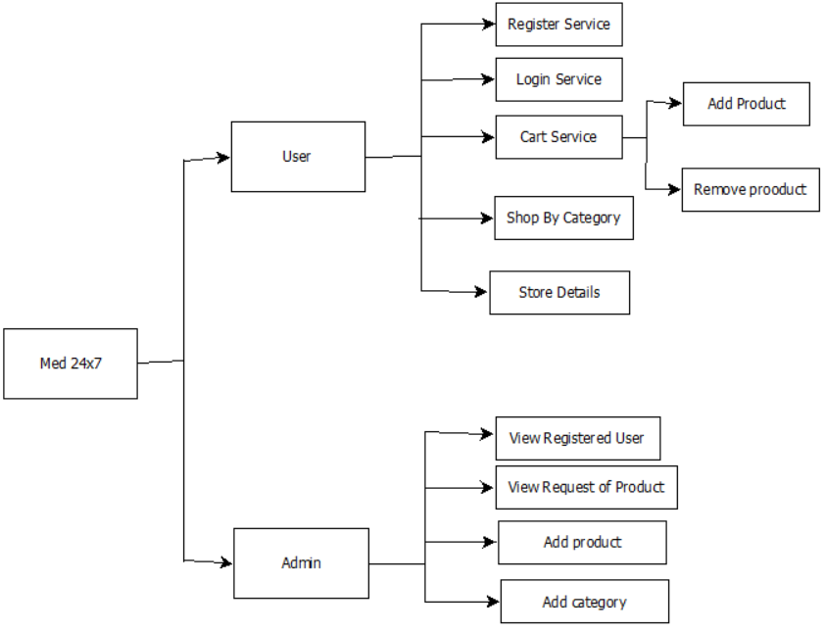

**Fig. 5.1.1. System Architecture of E-Pharmacy**

**6.TECHNICAL SPECIFICATION**  
In this Technical Specification section, we provide a detailed overview of the technical aspects and tools used in the development of the E-Pharmacy website. The project leverages a combination of frontend, backend, database, and server-side technologies to create a secure and efficient online pharmacy platform.

**6.1. Frontend Technologies:**

* **HTML (Hypertext Markup Language):**HTML is used to structure the website's content and layout.
* **CSS (Cascading Style Sheets):**CSS is responsible for the website's visual presentation and styling.It controls the design, layout, and formatting, ensuring a user-friendly interface.
* **JavaScript: JavaScript** adds interactivity and dynamic features to the website.It enables functionalities like real-time validation, interactive forms, and user-friendly navigation.

**6.2. Backend Technologies:**

* **Java Servlets:**Java Servlets provide the foundation for server-side logic and request handling.They handle user requests, process data, and facilitate dynamic content generation.
* **JSP (JavaServer Pages):**It allows embedding Java code within HTML to create dynamic content.
* **JDBC (Java Database Connectivity):**JDBC enables connectivity to the MySQL database.It manages the retrieval and storage of data, ensuring seamless database interactions.
* **Database Management:**MySQL serves as the primary database system for storing and managing data.

**6.3. Server and Hosting:**

* **Apache Tomcat 8.5** functions as the web server and servlet container for hosting the Java-based web application.It handles the deployment and execution of Java Servlets and JSP pages, ensuring smooth operation of the e-pharmacy website.

**7.PROJECT SCHEDULING**

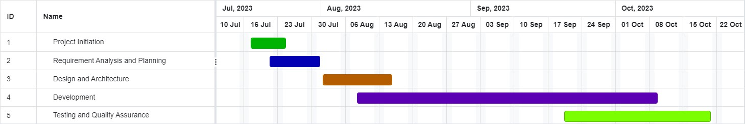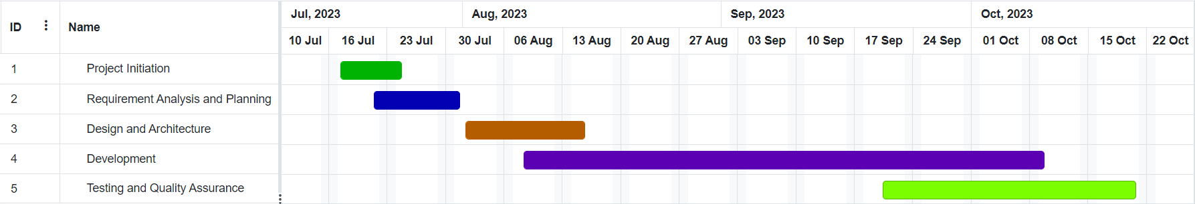

**Fig.7.1.Gantt Chart for Project Scheduling for E-Pharmacy.**

**8.IMPLEMENTATION**

**8.1. Home Page (Home.jsp):**

<%@ page language="java" contentType="text/html; charset=ISO-8859-1" pageEncoding="ISO-8859-1"%>

<%@ page import="javaapplication.controller.JWAView" %>

<%@ page import="javawebapplication.bean.ProductBean" %>

<%@ page import="javawebapplication.model.ProductModel" %>

<%@ page import="javaapplication.controller.JWAView" %>

<%@ page import="java.util.List" %>

<%@ page import="javawebapplication.utility.JDBCDataSource" %>

<%

ProductModel pd = new ProductModel(JDBCDataSource.getConnection());

List<ProductBean> products = pd.getAllProducts();

%>

<!DOCTYPE html>

<html lang="en">

<head>

<meta charset="UTF-8">

<meta http-equiv="X-UA-Compatible" content="IE-edge">

<meta name="viewport" content="width=device-width, initial-scale=1.0">

<title>MED 24x7</title>

<link rel="stylesheet" href="/JavaWebApplication/css/style.css" />

<link rel="stylesheet" href="https://cdnjs.cloudflare.com/ajax/libs/font-awesome/6.2.0/css/all.min.css" integrity="sha512-xh6O/CkQoPOWDdYTDqeRdPCVd1SpvCA9XXcUnZS2FmJNp1coAFzvtCN9BmamE+4aHK8yyUHUSCcJHgXloTyT2A==" crossorigin="anonymous" referrerpolicy="no-referrer" media="screen" />

<link href="https://unpkg.com/tailwindcss@^2/dist/tailwind.min.css" rel="stylesheet">

</head>

<body>

<%

String userSession = (String) session.getAttribute("fullname");

%>

<!-- BANNER -->

<div class="header">

<div class="logo">

<img class="logo-img" src="./image/logo.png" alt="">

</div>

<div class="nav">

<%

if (userSession == null) {

%>

<a href="<%= JWAView.SignUpCTL %>"><span>SignUp</span></a>

<a href="<%= JWAView.LoginCTL %>"><span>Login</span></a>

<%

} else {

%>

<a href="<%= JWAView.UserListCTL %>"><span>User List</span></a>

<a href=<%= JWAView.LoginCTL + "?operation=logout" %>"><span>Log Out</span></a>

<%= session.getAttribute("fullname") %>

<%

}

%>

<a><span><i class="fa-regular fa-user fa-lg"></i></span></a>

<a><span><i class="fa-regular fa-bell fa-lg"></i></span></a>

<a href="/JavaWebApplication/jsp/cart.jsp"><span><i class="fa-solid fa-cart-shopping fa-lg"></i></span></a>

</div>

</div>

<!-- MAIN CONTAINER -->

<div class="main">

<!-- chota nav -->

<div class="chota-nav">

<a href="/JavaWebApplication/jsp/Medicine.jsp">Medicine</a>

<a href="#">Lab tests</a>

<a href="#">Offers</a>

<a href="#">PLUS</a>

<a href="#">Health Blogs</a>

</div>

<!-- Search bar -->

<div class="container">

<form>

<i class="fa-solid fa-magnifying-glass fa-lg"></i>

<input type="text" placeholder="What are you looking for ?">

<button type="submit">Search</button>

</form>

</div>

<!-- Welcome message -->

<%

if (userSession != null) {

%>

<h4 style="color: green; text-align: center">Welcome User! Login Successful</h4>

<%

}

%>

<!-- Shop categories start -->

<div class="shop-categories container-0">

<h1 class="title">Shop by categories</h1>

<div>

<!-- Add your category items here -->

</div>

</div>

<!-- Shop categories end -->

<!-- Deals of the Day -->

<div class="deals-of-the-day container-0">

<h1 class="title">Deals of the Day <span class="timer"><i class="fa-regular fa-clock"></i> 06:00 HOURS LEFT, HURRY!</span></h1>

<div class="product-cards">

<%

if (!products.isEmpty()) {

for (ProductBean p : products) {

%>

<div>

<img src="<%= p.getImage() %>" />

<div>

<h4 class="name"><%= p.getName() %></h4>

<p>MRP <span>$<%= p.getDprice() %></span></p>

<h4>$<%= p.getPrice() %> <span> 10% OFF</span></h4>

<a href="AddToCartCTL?id=<%= p.getId() %>" class="add-to-cart-button btn-cart" onclick="alert('Product Added Successfully')">Add to Cart</a>

</div>

</div>

<%

}

}

%>

</div>

</div>

<!-- Products Ends Here -->

<!-- FOOTER -->

<div class="footer">

<h1>Med 24x7</h1>

<div class="footer-nav">

<span>About</span>

<span>Policy Info</span>

<span>Need Help</span>

</div>

<div class="icons">

<i class="fa-brands fa-pinterest fa-lg"></i>

<i class="fa-brands fa-facebook fa-lg"></i>

<i class="fa-brands fa-instagram fa-lg"></i>

<i class="fa-brands fa-twitter fa-lg"></i>

</div>

</div>

</div>

<script src="script.js"></script>

</body>

</html>

**9.RESULT AND DISCUSSION:**

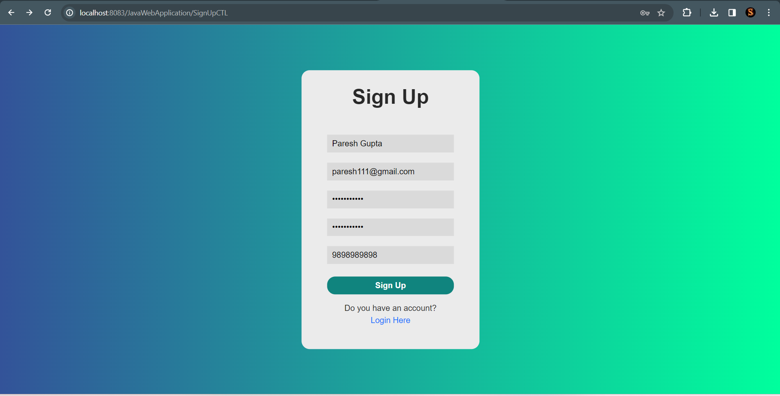

**Fig 9.1. Signup Page.**

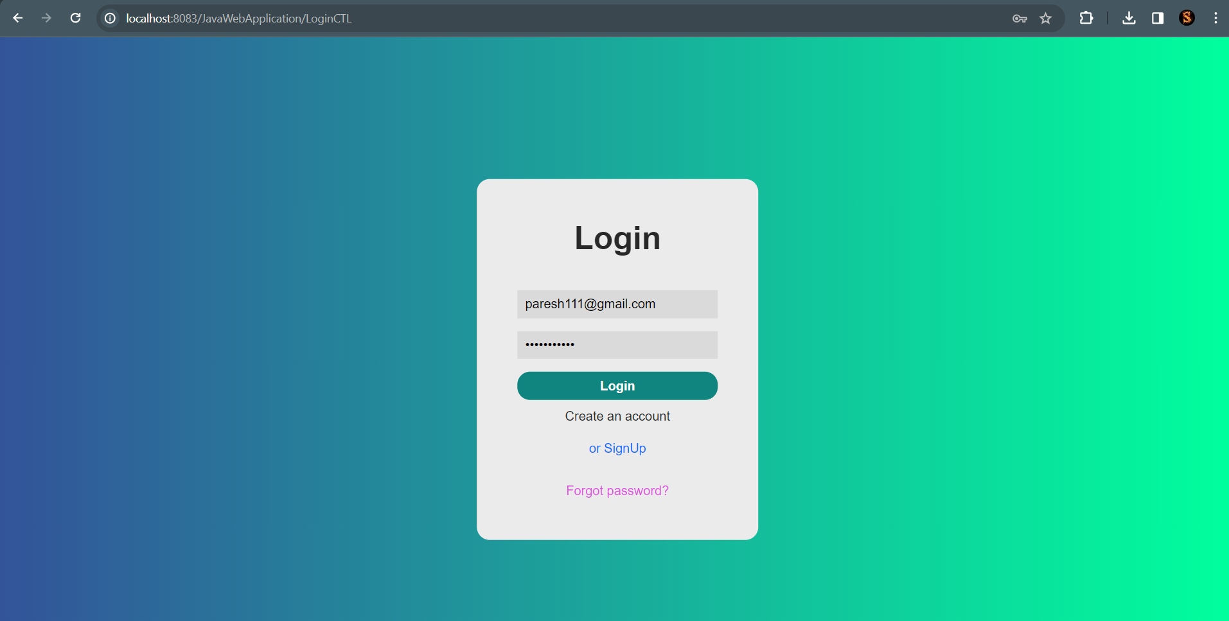

**Fig9.2. Login Page.**

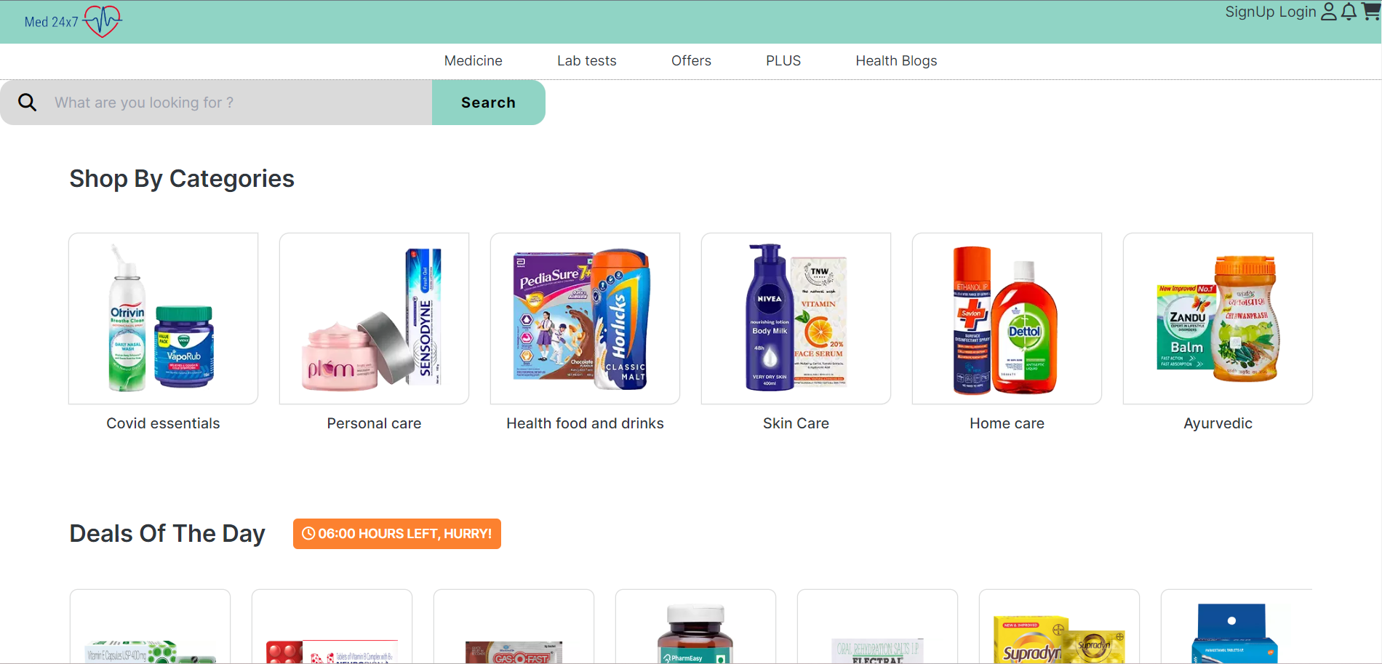

**Fig 9.3. Home Page.**

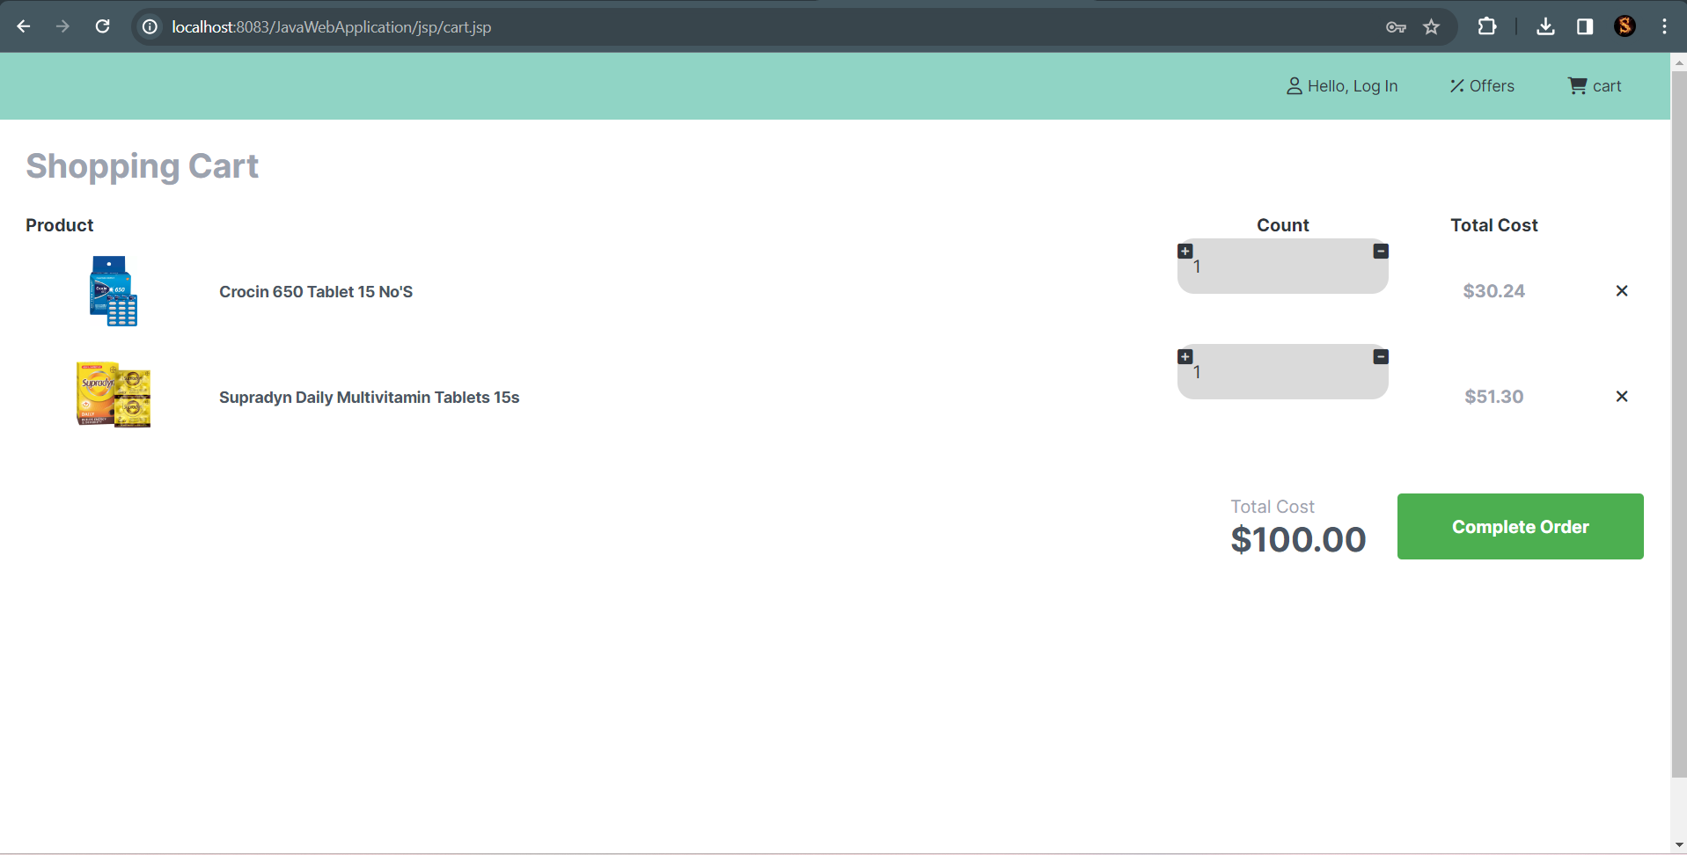

**Fig9.4. Cart Page.**

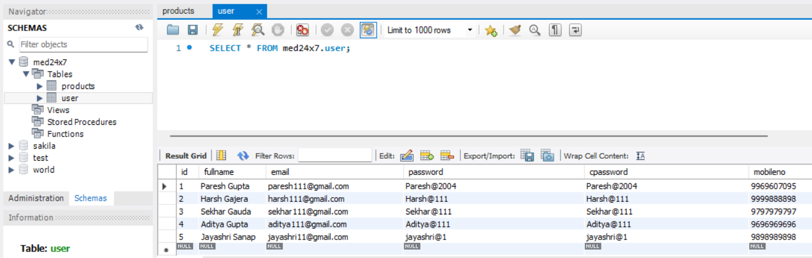

**Fig 9.5. Registered user Database.**

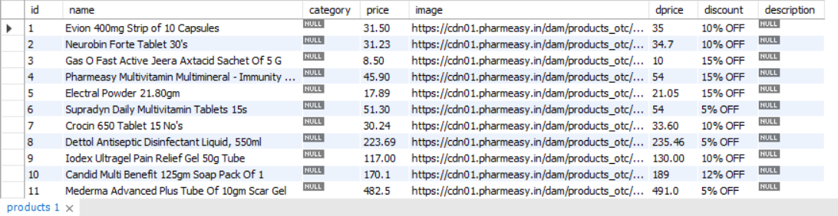

**Fig 9.6. Product Database.**

**10.CONCLUSION**

The E-Pharmacy Website project has demonstrated significant success in the implementation of essential features, addressing various aspects of pharmaceutical product procurement. These results contribute to a user-friendly and informative platform, expanding its usability in e-commerce and local medical supply domains, and ultimately benefiting both customers and healthcare suppliers.

**Future Scope:**

AI-Powered Recommendations: Implement AI algorithms to provide personalized product recommendations based on user preferences, purchase history, and health conditions. This feature can enhance user engagement and increase sales.

Expanded Geographic Coverage: Extend the reach of the e-pharmacy website to cover even more remote and underserved areas, facilitating the delivery of pharmaceutical products and healthcare information to a wider population.

Inventory Management System: Implement an advanced inventory management system to ensure the availability of a wider range of pharmaceutical products and reduce instances of product unavailability.

Health Monitoring Features: Consider adding health monitoring features such as tracking and reminders for medication schedules, vaccination alerts, and health data storage for users. This can promote long-term customer engagement.

Pharmacist Consultation: Introduce a feature that allows users to chat with licensed pharmacists for medication-related queries and advice, enhancing the credibility of the website.

Blockchain for Drug Authentication: Explore the use of blockchain technology to authenticate the sources and authenticity of pharmaceutical products, increasing trust and safety for users.

**REFERENCES**

1. Laudon KC, Traver CG (2021) ‘*E-commerce 2020–2021’*- business—technology—society.Pearson Education Limited, United Kingdom. Available from: *https://thelatestbook.com/download/4803333-laudon-traver-e-commerce-test-bank*

2.W3Schools ([*https://www.w3schools.com/*](https://www.w3schools.com/)): A comprehensive resource for learning web development, including HTML, CSS, and JavaScript.

3. Desai C. *Online pharmacies: A boon or bane?* Indian J Pharmacol 2016;48:615-6

4. Kunz MB, Osborne P. *A preliminary examination of the readability of consumer pharmaceutical web pages.* J Mark Dev Compet 2010;5:33-41.

5. Anwar W, Gupta T. 2020. *Factors Leading to Preference for buying Online Medicines and their Effects on Actual buying Behaviour*. Zeichen Journal. 6: ISSN No: 0932-4747

(https://www.pnrjournal.com/index.php/home/article/download/7947/10554/9648)