**Department of Information Technology**

**Academic Year: 2024-25 Name of Student: Harsh Gajera**

**Semester: VI Student ID: 22104099**

**Class / Branch / Div: TE- IT A Roll No. 34**

**Subject: MAD & PWA Lab Date of Submission: 4-4-25**

**Name of Instructor:**

**Experiment No.:9**

**Aim:** To Construct meta data for PWA in a Web app manifest file to enable “add to homescreen feature”

**Prerequisites:** HTML, JavaScript, JSON**.**

**Software:** VS code, Browser**.**

**Code:**

**Index.html**

<!DOCTYPE html>

<html>

<head>

<!-- Responsive -->

<meta charset="utf-8">

<meta name="viewport" content="width=device-width, initial-scale=1">

<meta http-equiv="X-UA-Compatible" content="ie=edge">

<!-- Title -->

<title>PWA Tutorial</title>

<!-- Meta Tags required for Progressive Web App -->

<meta name= "apple-mobile-web-app-status-bar" content="#aa7700">

<meta name="theme-color" content="black">

<!-- Manifest File link -->

<link rel="manifest" href="manifest.json">

<script>

window.addEventListener('load', () => {

registerSW();

});

// Register the Service Worker

async function registerSW() {

if ('serviceWorker' in navigator) {

try {

await navigator

.serviceWorker

.register('serviceworker.js');

}

catch (e) {

console.log('SW registration failed');

}

}

}

</script>

</head>

<body>

<h1 style="color: green;"> TE-IT Name: Yaminee Patil Moodle no: </h1>

<p>

This is a simple tutorial for creating a PWA application.

</p>

</body>

</html>

**serviceworker.js**

var staticCacheName = "pwa";

self.addEventListener("install", function (e) {

e.waitUntil(

caches.open(staticCacheName).then(function (cache) {

return cache.addAll(["/"]);

})

);

});

self.addEventListener("fetch", function (event) {

console.log(event.request.url);

event.respondWith(

caches.match(event.request).then(function (response) {

return response || fetch(event.request);

})

);

});

**Manifest.json**

{

"name":"PWA Tutorial",

"short_name":"PWA",

"start_url":"index.html",

"display":"standalone",

"background_color":"#5900b3",

"theme_color":"black",

"scope": ".",

"description":"This is a PWA tutorial.",

"icons":[

{

"src":"images/icon-192x192.png",

"sizes":"192x192",

"type":"image/png"

},

{

"src":"images/icon-512x512.png",

"sizes":"512x512",

"type":"image/png"

}

]

}

**Output:**

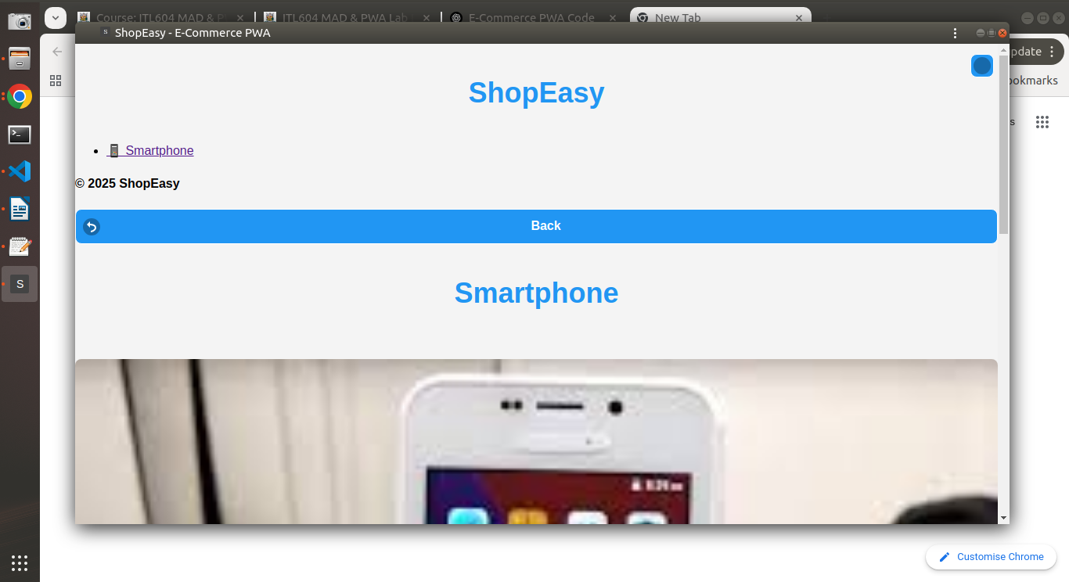

**Conclusion:** In this experiment we have designed PWA in a Web app manifest file to enable “add to homescreen feature”