**Sending Data From Sensor Node To Cloud Via Wingz Gateway**

**Cec**-**Lab Assignment**

**Group Members :**

| Sanket | MWC2022005 |
| --- | --- |
| Anurag Negi | IEC2020098 |
| Harsh Garg | IIT2020082 |
| Vansh Narang | IIT2020165 |
| Trisha Mistry | IIT2020167 |
| Thanmai Deepthi | IIT2020184 |
| Jayesh Ginnare | IIT2020191 |

**1. Receive data from sensor nodes on Gateway (specific to your device <Mac_id and Node_id>)**

Data is continuously sent to the gateway by the mode, at gateway we will run a server **sensor2Gateway_G10.py** on it which continuously receives the data and writes into the temporary **group_10.txt** which will act as a buffer file.

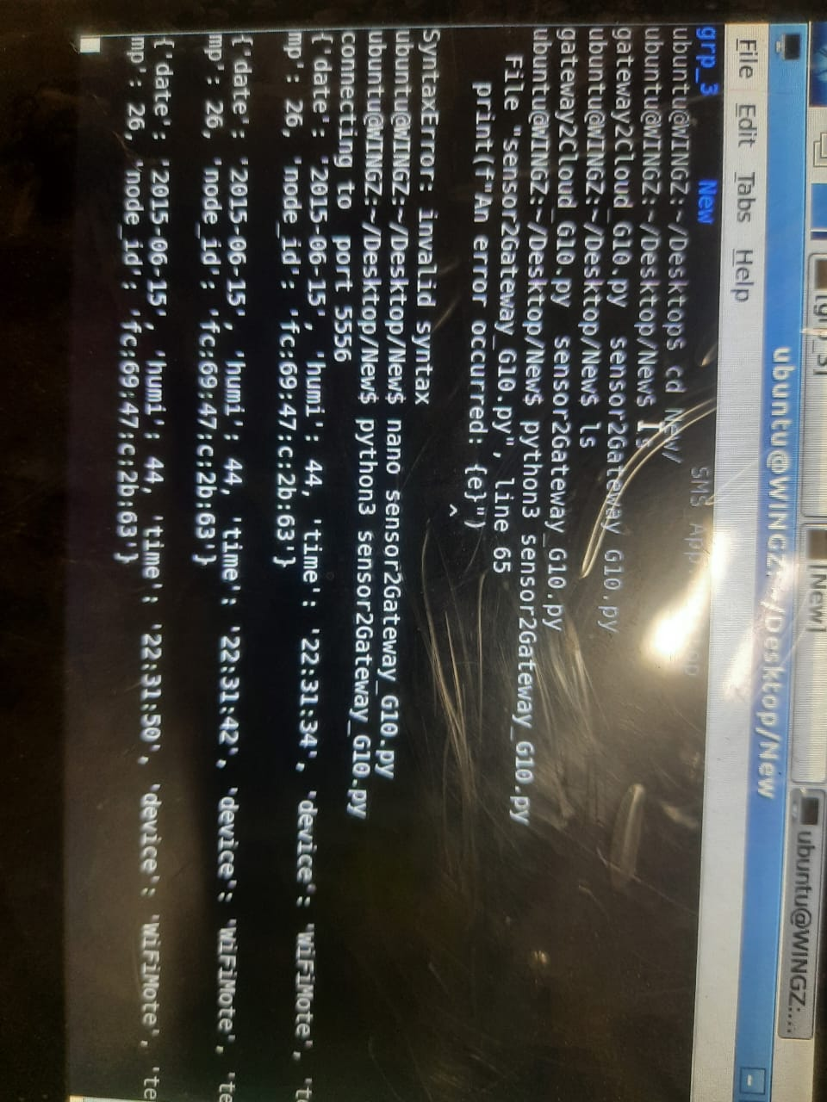

**2. Send data from Gateway to VM on OpenStack Cloud.**

Now, to send data from gateway to vm we run **gateway2Cloud_G10.py** on gateway which will read each line , send it to the VM then, delete it from the **group_10.txt**

group_10.txt file acting as a buffer storage

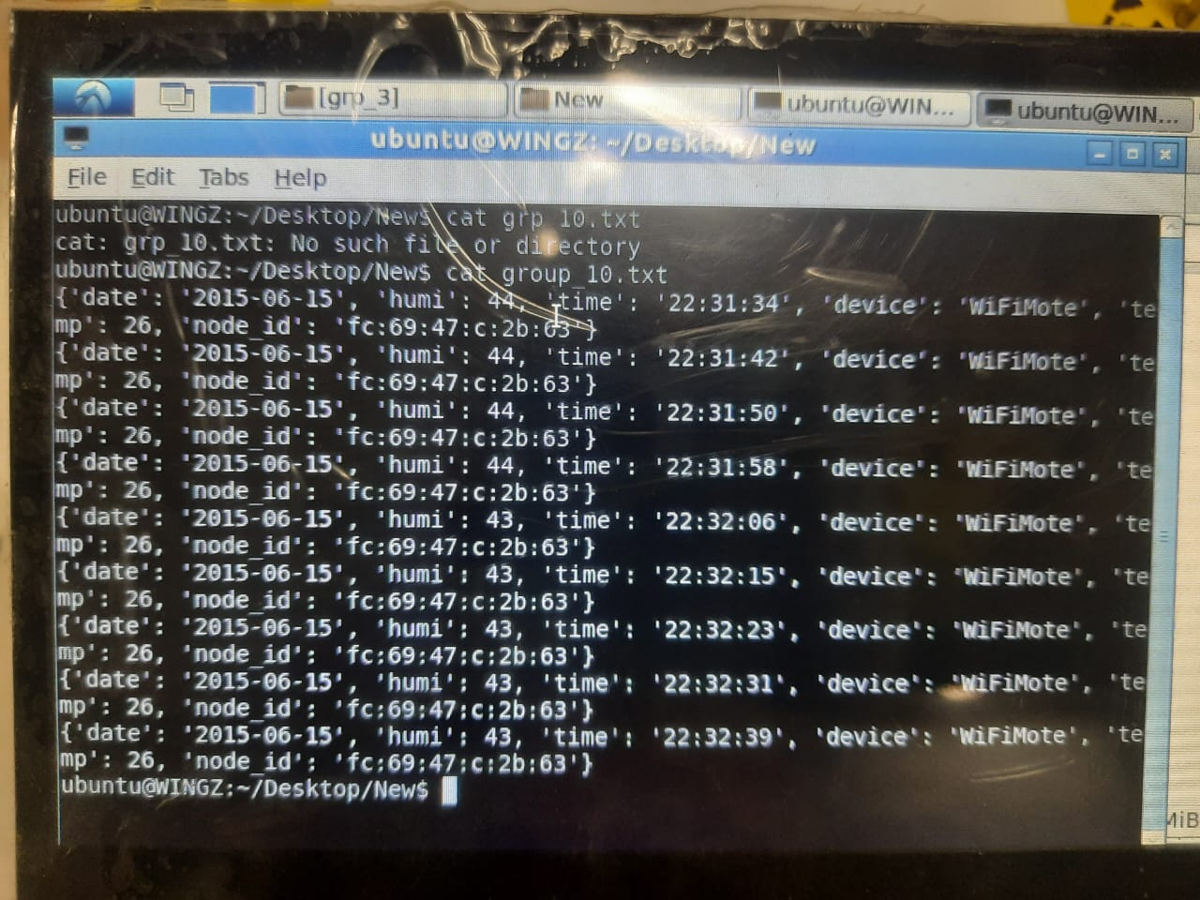

Sending data to the cloud.

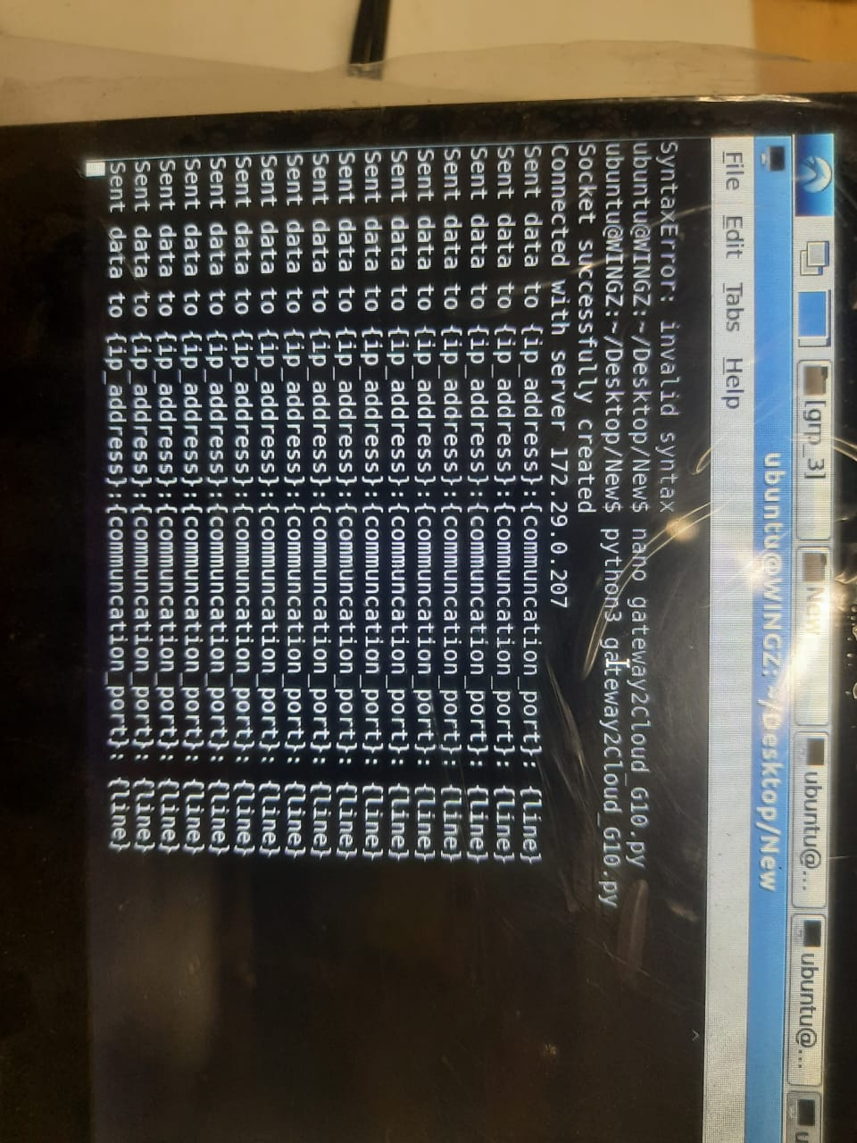

**3. Receive data on VM (OpenStack Cloud) from Gateway.**

Now, to receive the data at vm we hosted a server which will receive data on vm and write the data into a database (postgreusql).

**a. Receive data (1 entry at a time).**

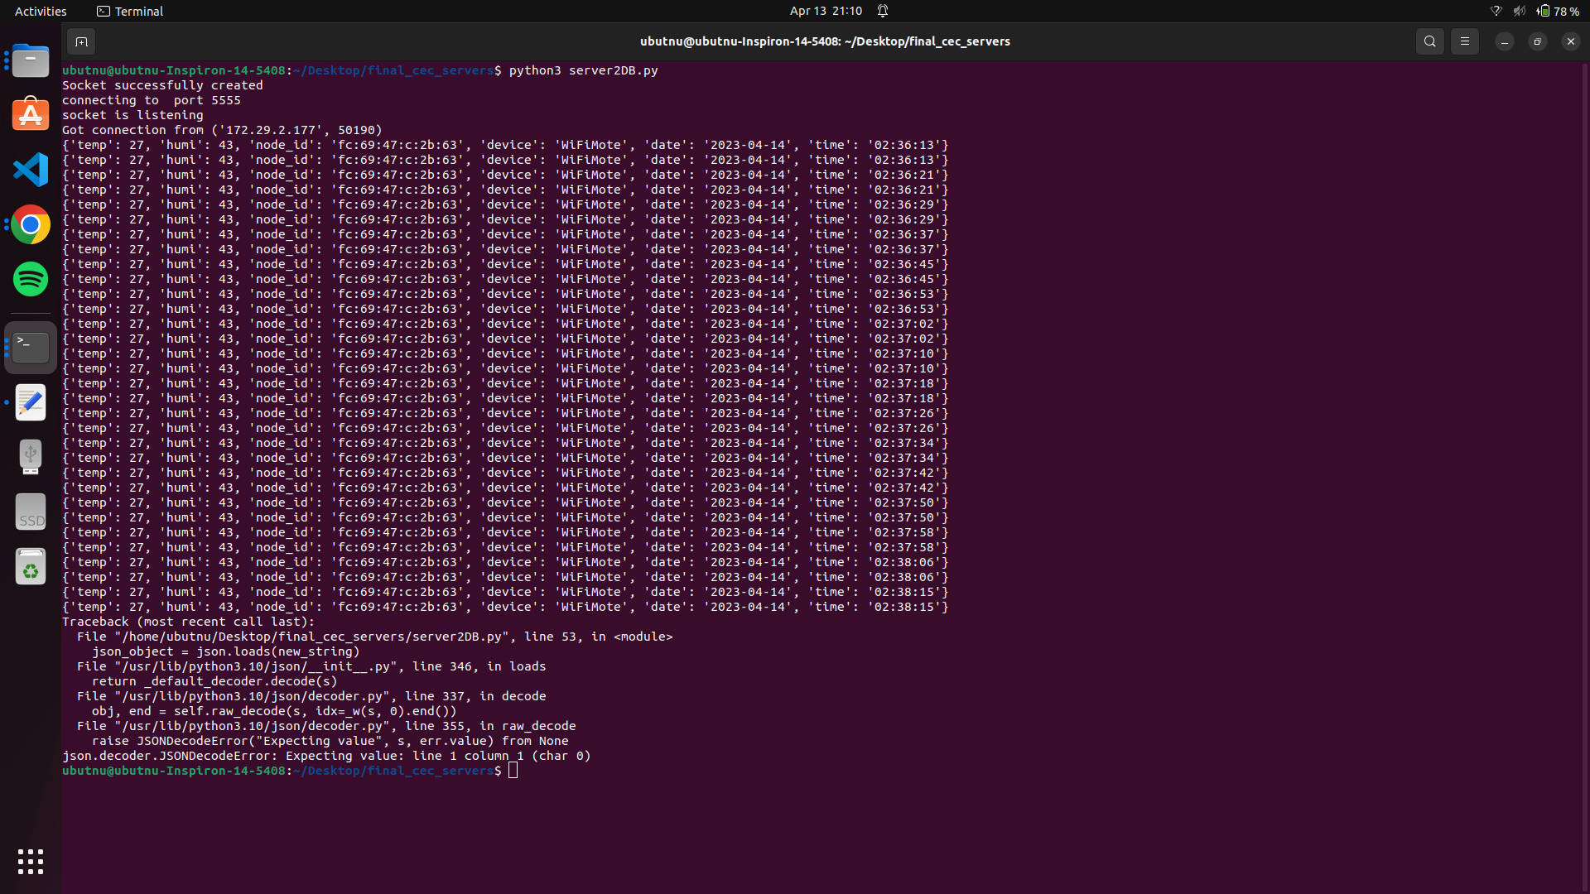

**b. Store it in the database.**

**Database output:**

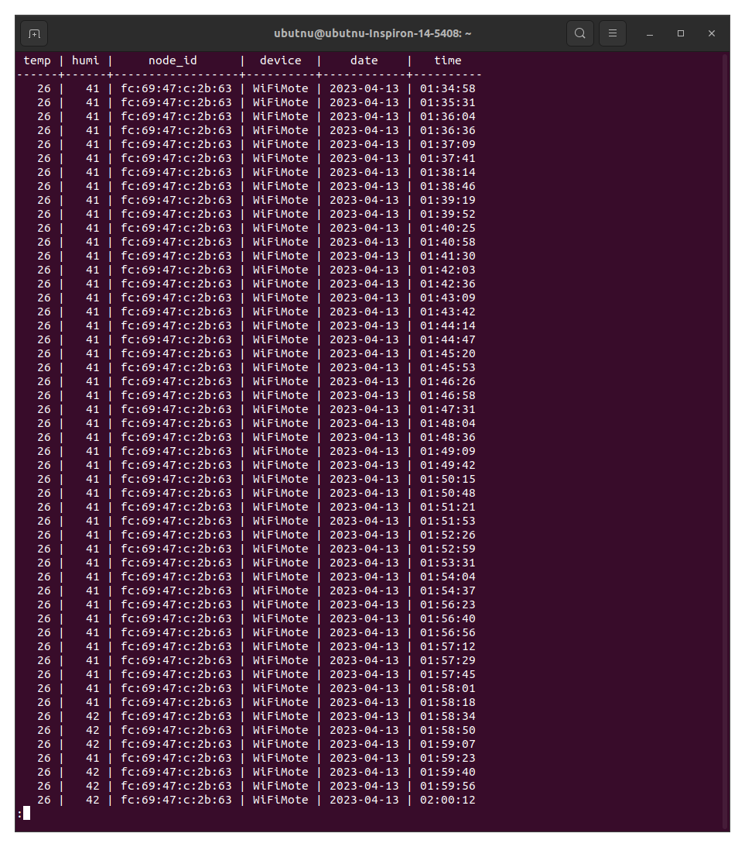

**c. Run queries to fetch data:**

* Manually running queries on database:

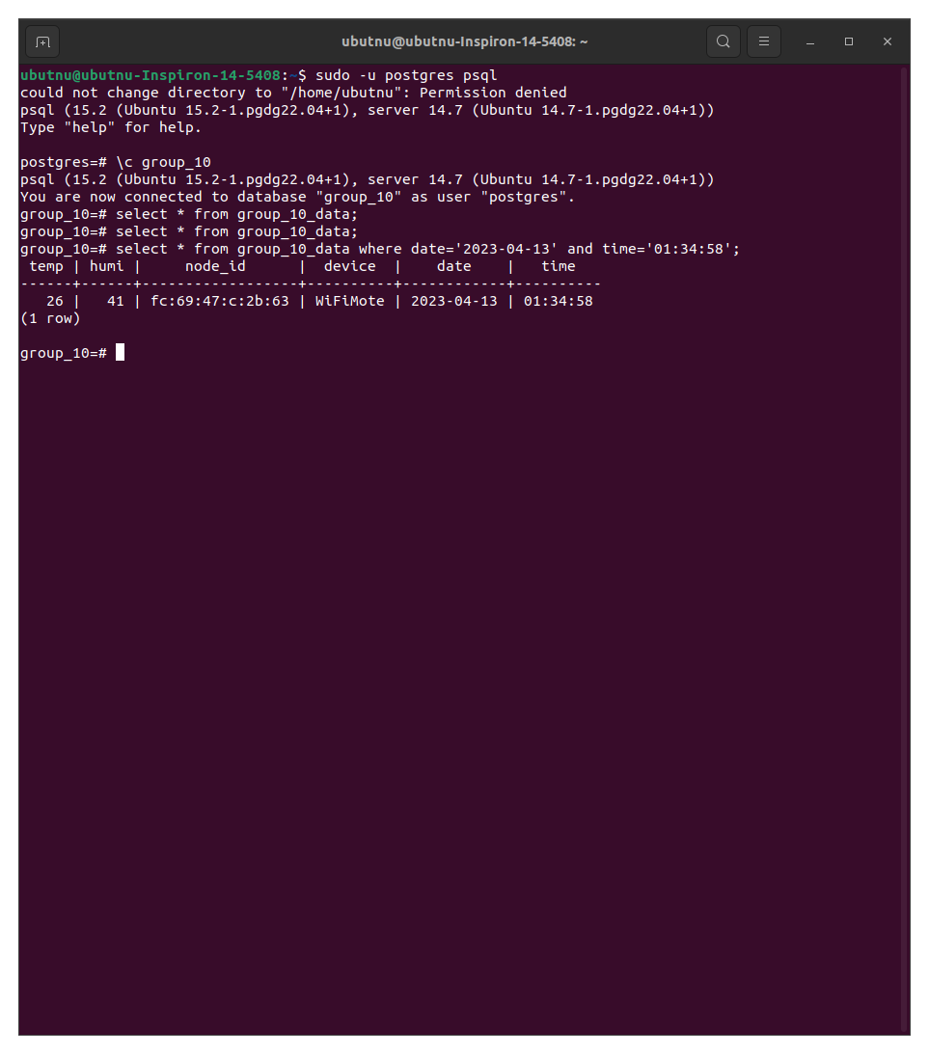

* Query from web server

* **Json format**

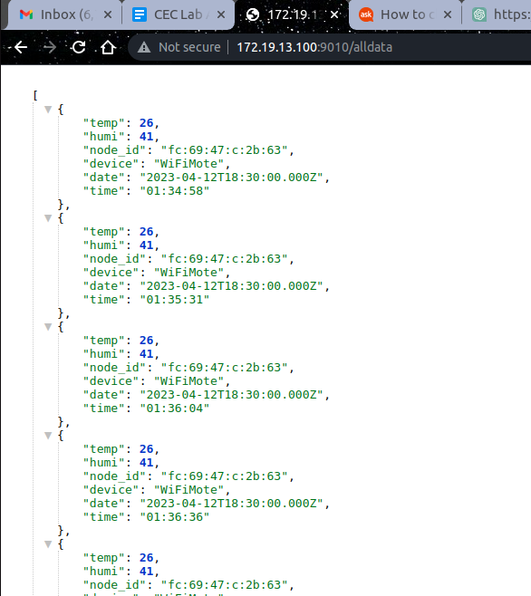

* **Table format**

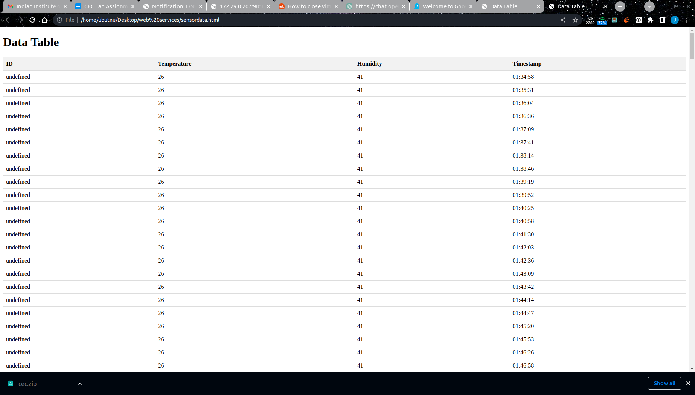

* **latest date and time query**

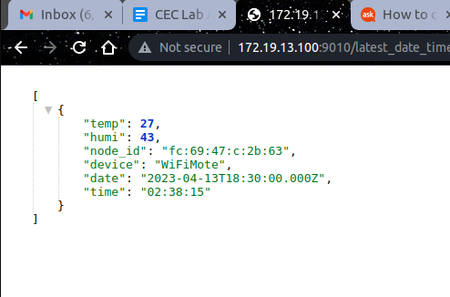

* **specific column value**

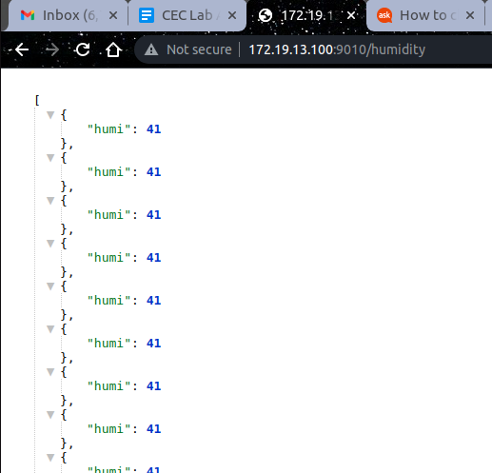

* **Range query**

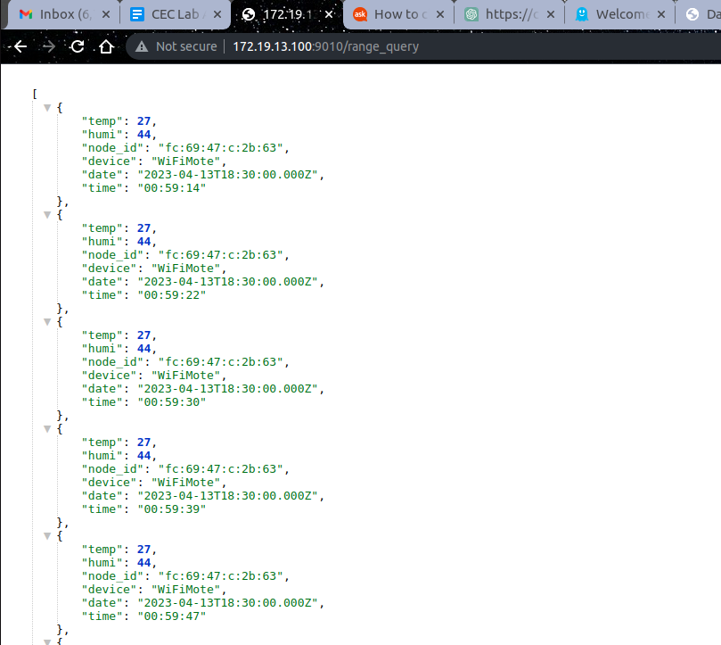

**Setup Required For Above Services.**

**Installation of Putty**

1. First install putty to receive data from wifi node: **sudo apt install putty**

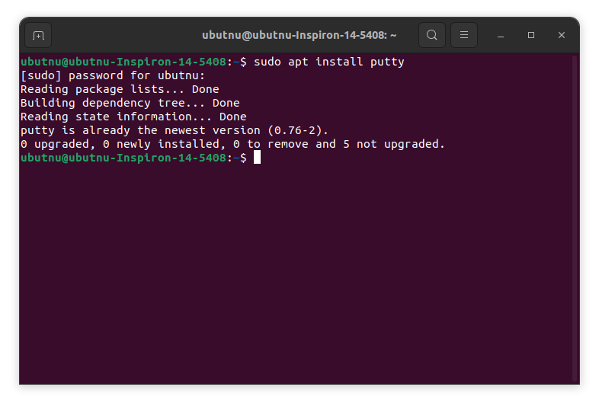

1. Run Putty : **sudo putty**

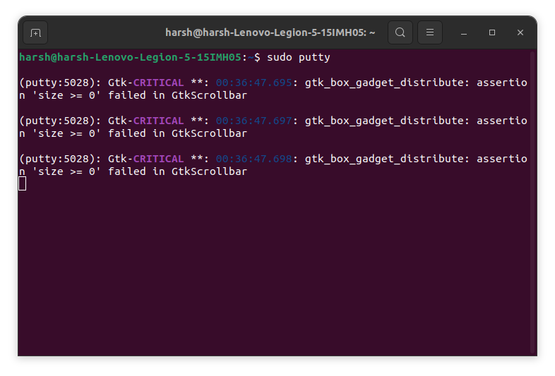

Now, an interactive putty terminal is opened, putty as a **serial connection** to receive data from wifi node at **115200** speed, modify the serial line as **/dev/ttyUSB0** then press **open**.

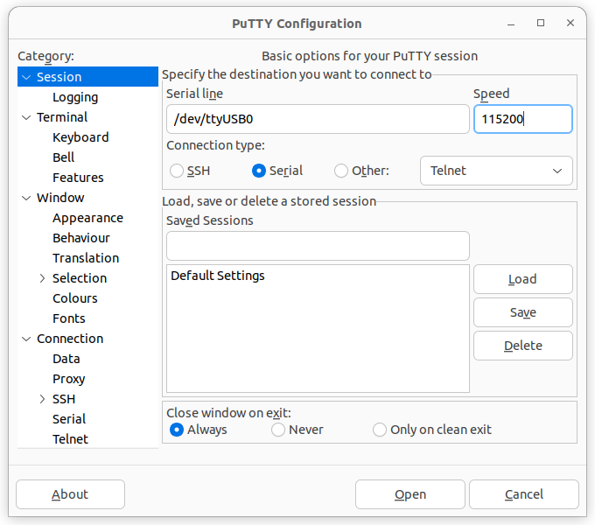

* Now, an interactive putty terminal is opened,
* Enter the SSID name to be connected write : **IIITA**
* Select the security type: **0**
* IP address of the station: **172.20.43.197[Enter the gateway ip]**

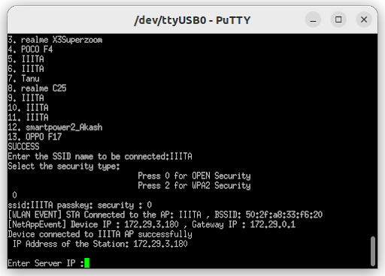

* Final sending of data

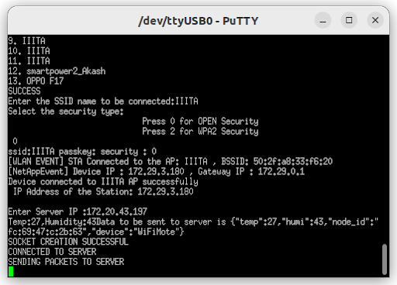

**Installation of Postgres:**

### Add Official Repository

Installation of required certificates.

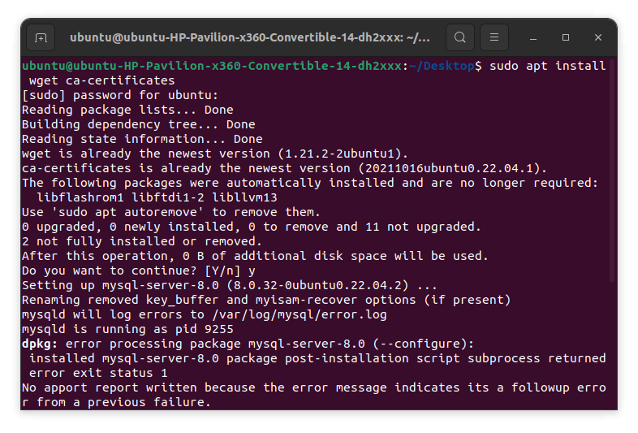

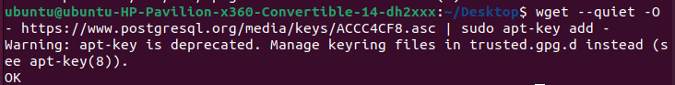



### 

### Install PostgreSQL

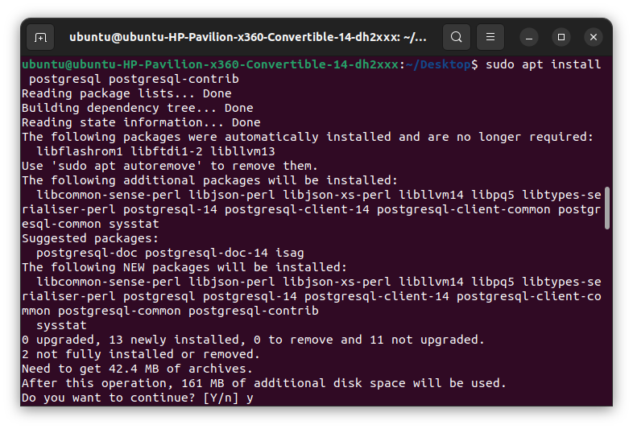

1. Check PostgreSQL status

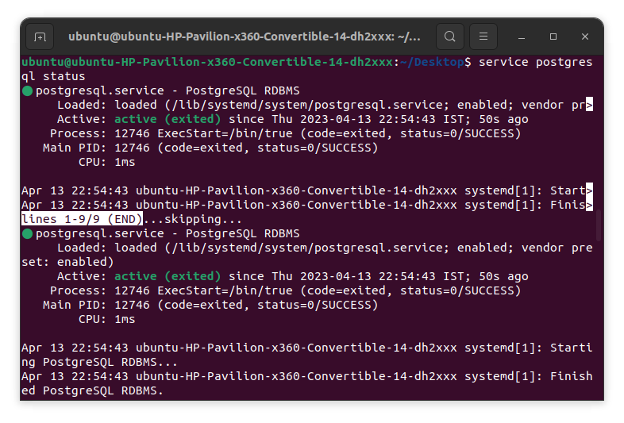

### 4. Start Using PostgreSQL Command Line Tool

### 

### **5.** Create and Populate a New Database

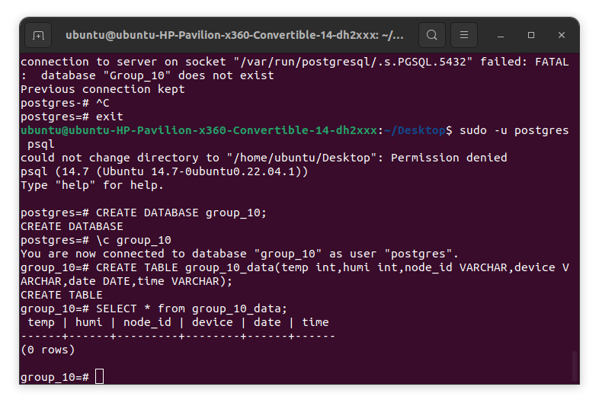

### **6.** Setup PostgreSQL server

* **Sudo nano /etc/postgresql/14/main/postgresql.conf**

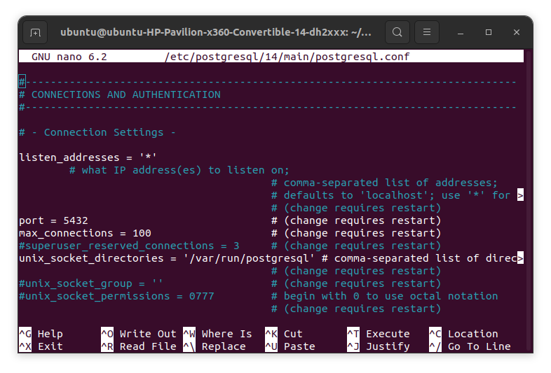

* **Sudo nano /etc/postgresql/14/main/pg_hba.conf**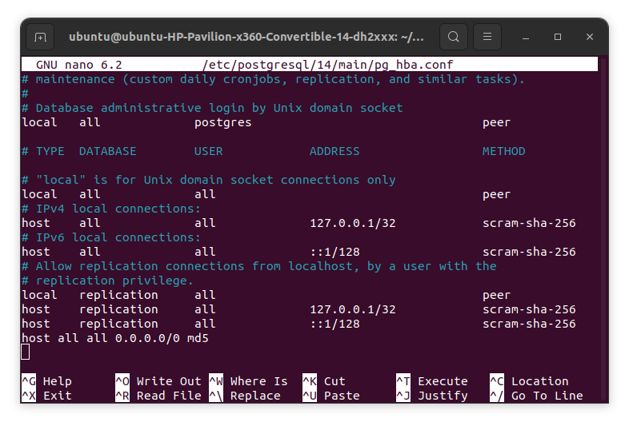
* **Restart postgresql to save all the changes**



**Now, our database ready for remote access**

**Installation of Node js**

sudo apt install nodejs

**Installation of NodeMon**

Sudo apt install npm

**Installation of NodeMon**

sudo npm install -g nodemon

**Installation of Express**

Sudo npm install express