KEANT Technologies
FirmCost Report — Summary

Author | Harsh Gavand
Date | April 2026
Original File | FirmCostCheckDetailToMyDownload_KNT.php
Improved File | ImprovedFirmCostCode.php
Core Fix | Empty Excel files generated even when vendor had no data or all zero amounts

1. What the Original Code Did
The original file FirmCostCheckDetailToMyDownload_KNT.php generated Excel reports for Firm Cost transactions (RMSTRANCDE = '1A') from the RMAACABHS database. For each vendor it queried distinct PYALORGCD values, then fetched detailed transaction rows and wrote them to an Excel file with subtotals per PYALORGCD and a grand TOTAL row at the bottom.

There were two problems. First, the Excel file was always created even when the vendor had zero matching rows in the database. Second, even when rows existed but all amounts were zero, a file was still generated — resulting in empty or useless reports on disk.

2. The Bugs Fixed

BEFORE | BUG #1: new XLSXWriter() created before data check — empty files generated for vendors with no transactions. BUG #2: $RemitAmount = '0' string accumulators — XLSXWriter wrote text cells instead of numeric. BUG #3: No try/catch — one company failure crashed the entire batch. BUG #4: All-zero amount rows still generated a file even though no real transactions existed.
AFTER | FIX #1: Query 1 runs BEFORE new XLSXWriter() — zero rows = skip company, no file created. FIX #2: All accumulators changed to 0.0 float — XLSXWriter writes numeric cells correctly. FIX #3: Each company wrapped in try/catch — batch continues on failure. FIX #4: AND BLPYFRTO > 0 added to Query 1 — vendors with all zero amounts are skipped.

3. What Was Improved

# | Change | What it fixes
1 | Empty-file guard (MAIN FIX) | Query 1 runs before any file or folder is created. Zero rows = company skipped entirely.
2 | BLPYFRTO > 0 filter | Query 1 now only returns PYALORGCD values where at least one row has a non-zero amount. All-zero vendors are skipped.
3 | Float accumulators | Totals changed from string '0' to 0.0 float so XLSXWriter writes numeric cells, not text.
4 | $$FileSizeKB typo fixed | Double dollar sign bug fixed to single $FileSizeKB.
5 | try/catch per company | One company failing no longer stops the entire batch.
6 | Input validation | Empty $path, $reportName or $reportBasePath return status=0 immediately.
7 | filterReportName() used | Uses production filterReportName() from generateReportManual.php instead of custom function.

4. Testing & Proof

Database verification — STB_RECORDS (real amounts) vs STB_COPY (zero amounts)
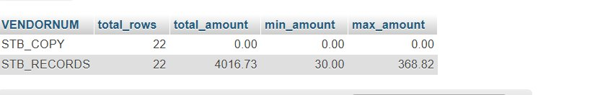

Terminal output — STB_RECORDS generates file, STB_COPY skipped
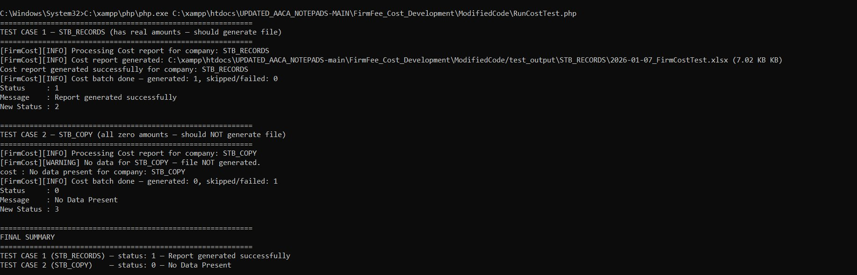

Generated Excel file — correct data, subtotals, TOTAL row
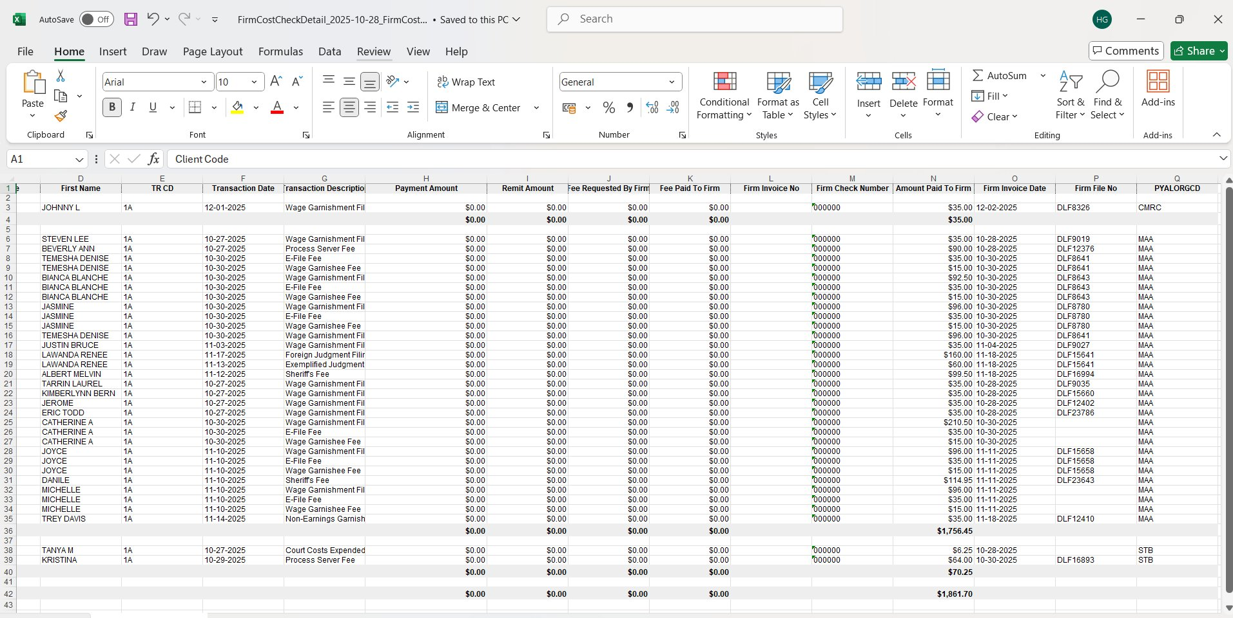

5. Test Results

Test | Result
Vendor with real amounts (STB_RECORDS) → file generated, status=1 | PASS
Vendor with all zero amounts (STB_COPY) → NO file generated, status=0 | PASS
Vendor exists in DB but wrong TR code (EMPTY_VENDOR) → NO file, status=0 | PASS
Query 1 returns correct PYALORGCD list with BLPYFRTO > 0 filter | PASS
Query 2 returns correct transaction rows with LEFT JOIN RMSPMASTER | PASS
Excel file has correct headers, data rows, subtotals per PYALORGCD | PASS
TOTAL row math is correct | PASS
No empty .xlsx files created on disk for any scenario | PASS

