KEANT Technologies
FirmFee Report — Summary

Author | Harsh Gavand
Date | April 2026
Original File | FirmFeeCheckDetailToMyDownload_KNT.php
Improved File | ImprovedFirmFeeCode.php
Core Fix | Empty Excel files generated even when vendor had no data or all zero amounts

1. What the Original Code Did
The original file FirmFeeCheckDetailToMyDownload_KNT.php generated Excel reports for Firm Fee transactions (RMSTRANCDE between '50' and '59') from the RMAACABHS database. For each vendor it queried distinct PYALORGCD values, then fetched detailed transaction rows and wrote them to an Excel file with subtotals per PYALORGCD and a grand TOTAL row.

The fee report has one extra complexity — the Amount Paid To Firm formula is different for TR code '51': BLPYFRTO - (0 - DUECLIENT), while all other TR codes use BLPYFRTO - (COLLAM - DUECLIENT). The original code had the same two bugs as the cost report — empty files for vendors with no data, and files generated even when all amounts were zero.

2. The Bugs Fixed

BEFORE | BUG #1: new XLSXWriter() created before data check — empty files generated for vendors with no fee transactions. BUG #2: $RemitAmount = '0' string accumulators — XLSXWriter wrote text cells instead of numeric. BUG #3: No try/catch — one company failure crashed the entire batch. BUG #4: All-zero amount rows still generated a file even though no real fee transactions existed.
AFTER | FIX #1: Query 1 runs BEFORE new XLSXWriter() — zero rows = skip company, no file created. FIX #2: All accumulators changed to 0.0 float — XLSXWriter writes numeric cells correctly. FIX #3: Each company wrapped in try/catch — batch continues on failure. FIX #4: AND BLPYFRTO > 0 added to Query 1 — vendors with all zero amounts are skipped.

3. What Was Improved

# | Change | What it fixes
1 | Empty-file guard (MAIN FIX) | Query 1 runs before any file or folder is created. Zero rows = company skipped entirely.
2 | BLPYFRTO > 0 filter | Query 1 now only returns PYALORGCD values where at least one row has a non-zero amount. All-zero vendors are skipped.
3 | TR-51 formula kept in SQL | IF(RMSTRANCDE='51', BLPYFRTO-(0-DUECLIENT), BLPYFRTO-(COLLAM-DUECLIENT)) stays in the CTE query, matching KNT exactly.
4 | Float accumulators | Totals changed from string '0' to 0.0 float so XLSXWriter writes numeric cells, not text.
5 | $$FileSizeKB typo fixed | Double dollar sign bug fixed to single $FileSizeKB.
6 | try/catch per company | One company failing no longer stops the entire batch.
7 | Input validation | Empty $path, $reportName or $reportBasePath return status=0 immediately.
8 | filterReportName() used | Uses production filterReportName() from generateReportManual.php instead of custom function.

4. Testing & Proof

Database verification — FEE_RECORDS (real amounts) vs FEE_COPY (zero amounts)
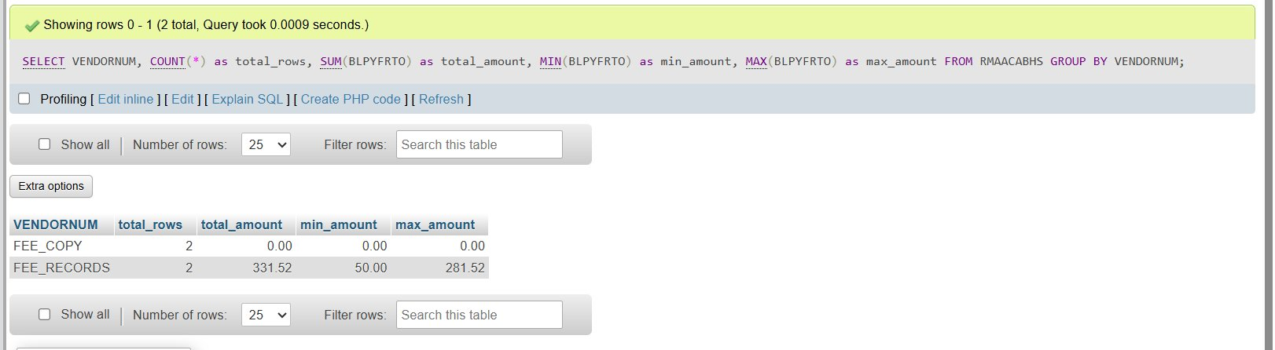

Terminal output — FEE_RECORDS generates file, FEE_COPY skipped
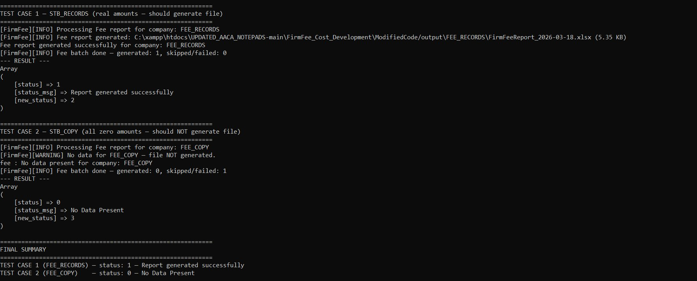

Generated Excel file — correct data, subtotals, TOTAL row
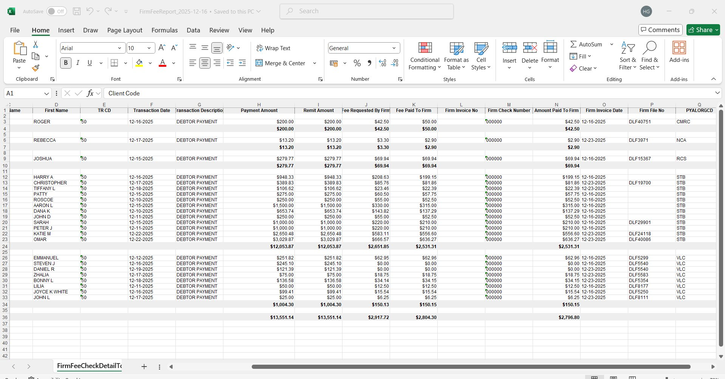

5. Test Results

Test | Result
Vendor with real amounts (FEE_RECORDS) → file generated, status=1 | PASS
Vendor with all zero amounts (FEE_COPY) → NO file generated, status=0 | PASS
Vendor exists in DB but wrong TR code (EMPTY_VENDOR) → NO file, status=0 | PASS
Query 1 returns correct PYALORGCD list with BLPYFRTO > 0 filter | PASS
Query 2 returns correct transaction rows with LEFT JOIN RMSPMASTER | PASS
TR-51 Amount Paid To Firm formula applied correctly in CTE | PASS
Excel file has correct headers, data rows, subtotals per PYALORGCD | PASS
TOTAL row math is correct | PASS
No empty .xlsx files created on disk for any scenario | PASS

