13.1.1 Fibonacci Sequence using Modules
Algorithm :
Main Program
- Start
- Input integer n
- Check if n > 0
  - If Yes, go to Step 4
  - If No, go to Step 7
- Call function
generate_fibonacci_sequence(n)
- Store result in fib_series
- Print elements of fib_series separated by space
- Display message: "Please enter a positive integer" (if n ≤ 0)
- Stop
generate_fibonacci_sequence(max_value)
- Start
- If max_value < 0
- Return empty list []
- Initialize:
- seq = []
- a = 0, b = 1
- Repeat while a ≤ max_value
- Add a to seq
- Update values:
  - a = b
  - b = a + b
- Return seq
- Stop

Flowchart :

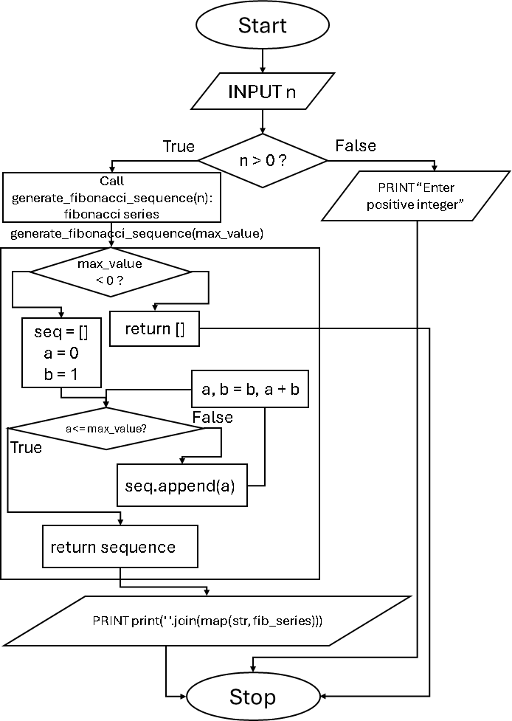

Code :
main.py
import fibonacci_module n = int(input())
if n > 0:
fib_series = fibonacci_module.generate_fibonacci_sequence( n)
print(' '.join(map(str, fib_series))) else:
print("Please enter a positive integer")

fibonacci_module.py
def generate_fibonacci_sequence(max_value): if max_value < 0:
return [] seq = []
a = 0
b = 1
while a <= max_value: seq.append(a)
a, b = b, a + b return seq
Execution :