**Practical No : 04**

**Problem Statement:**

1). Execute any 2 mathematical operations in Prolog using Arithmetic operators

2). Execute any 2 mathematical operations in Prolog using Arithmetic and comparison operators. Print the answer along with the statement using write()

3). Write a Prolog predicate count_up/1 that prints numbers from 1 up to a number X.

4). Write a Prolog Predicate for Checking if a number is even or odd.

5) Find maximum of 3 numbers using IF-ELSE in Prolog

6) Find minimum of 3 numbers using IF-ELSE in Prolog

7) Check given number is positive/negative

8) Calculate factorial of given number

9) Print nth Fibonacci series number

10) Print Fibonacci series upto give number

1). Execute any 2 mathematical operations in Prolog using Arithmetic operators

**Code:**

add(X, Y, Result) :- Result is X + Y.

mul(X, Y, Result) :- Result is X * Y.

**Output:**

?- add(2, 3, Result).

Result = 5.

?- mul(3, 4, Result).

Result = 12.

?- min(5, 2, Result).

Result = 3.

?- div(9, 2, Result).

Result = 4.5.

2). Execute any 2 mathematical operations in Prolog using Arithmetic and comparison operators. Print the answer along with the statement using write()

**Code:**

add1(X, Y, Result) :- Result is X + Y.

mul1(X, Y, Result) :- Result is X * Y.

min1(X, Y, Result) :- Result is X - Y.

div1(X, Y, Result) :- Y =\= 0, Result is X / Y.

compare(X, Y) :-

( X > Y

-> write(X), write('>'), write(Y), nl,

add1(X, Y, Result),

write('The sum is: '), write(Result), nl

; X =:= Y

-> write(X), write('='), write(Y), nl,

mul1(X, Y, Result),

write('The product is: '), write(Result), nl

; write(X), write('<'), write(Y), nl,

min1(X, Y, Result),

write('The difference is: '), write(Result), nl

).

**Output:**

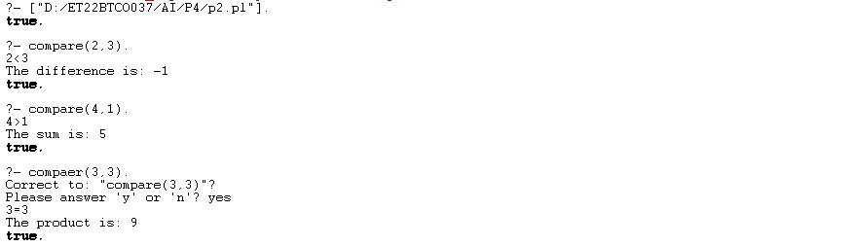

3). Write a Prolog predicate count_up/1 that prints numbers from 1 up to a number X.

**Code:**

count_up(X) :-

count_up_recursive(1, X).

count_up_recursive(Current, X) :-

Current =< X,

write(Current), nl,

Next is Current + 1,

count_up_recursive(Next, X).

count_up_recursive(Current, X) :-

Current > X.

**Output:**

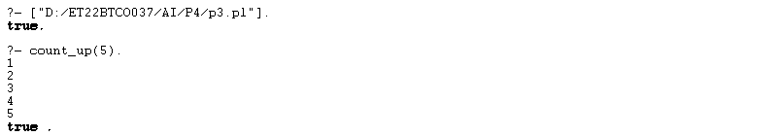

4). Write a Prolog Predicate for Checking if a number is even or odd.

**Code:**

even_number(N) :-

N mod 2 =:= 0.

odd_number(N) :-

N mod 2 =\= 0.

**Output:**

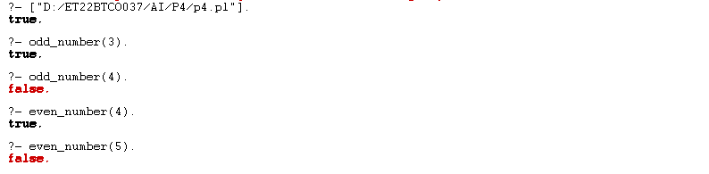

5) Find maximum of 3 numbers using IF-ELSE in Prolog

**Code:**

max_of_three(X, Y, Z, Max) :-

X >= Y,

X >= Z,

Max is X.

max_of_three(X, Y, Z, Max) :-

Y >= X,

Y >= Z,

Max is Y.

max_of_three(X, Y, Z, Max) :-

Z >= X,

Z >= Y,

Max is Z.

**Output:**

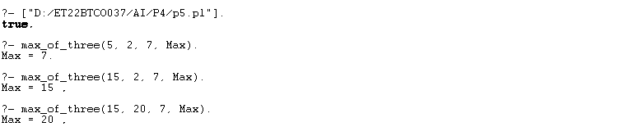

6) Find minimum of 3 numbers using IF-ELSE in Prolog

**Code:**

min_of_three(X, Y, Z, Min) :-

X =< Y,

X =< Z,

Min is X.

min_of_three(X, Y, Z, Min) :-

Y =< X,

Y =< Z,

Min is Y.

min_of_three(X, Y, Z, Min) :-

Z =< X,

Z =< Y,

Min is Z.

**Output:**

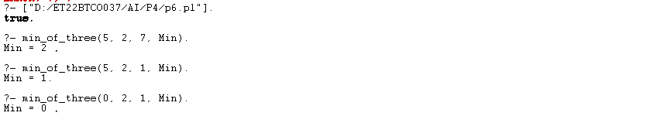

7) Check given number is positive/negative

**Code:**

check_positive_negative(X) :-

( X > 0 ->

write('Positive')

; X < 0 ->

write('Negative')

; write('Zero')

),

write(' value'), nl.

**Output:**

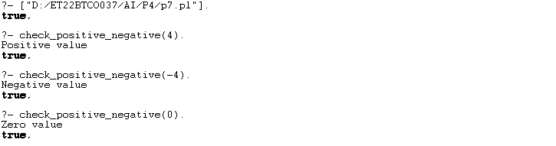

8) Calculate factorial of given number

**Code:**

factorial(0, 1).

factorial(N, Result) :-

N > 0,

N1 is N - 1,

factorial(N1, SubResult),

Result is N * SubResult.

**Output:**

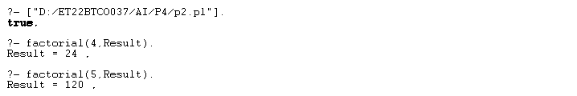

9) Print nth Fibonacci series number

**Code:**

fibonacci(0, 0).

fibonacci(1, 1).

fibonacci(N, Result) :-

N > 1,

N1 is N - 1,

N2 is N - 2,

fibonacci(N1, F1),

fibonacci(N2, F2),

Result is F1 + F2.

**Output:**

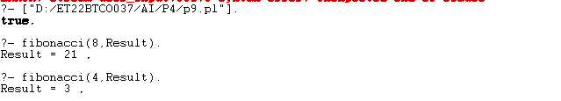

10) Print Fibonacci series upto give number

**Code:**

fib(0, 0).

fib(1, 1).

fib(N, F) :-

N > 1,

N1 is N - 1,

N2 is N - 2,

fib(N1, F1),

fib(N2, F2),

F is F1 + F2.

print_fib_series(N) :-

print_fib_series(0, N).

print_fib_series(Current, N) :-

Current =< N,

fib(Current, F),

write(F), write(' '),

Next is Current + 1,

print_fib_series(Next, N).

print_fib_series(Current, N) :-

Current > N.

**Output:**

