**Practical No : 01**

**Date:** 08/07/2024

**Problem Statement:**

1. Write a JAVA program which retrieves the IP address of a website entered by a user.(Use InetAddress Class)

2. Write a program to implement the connection oriented echo client server application.

3. Write a program to implement the connectionless echo client server application.

**Code:**

**1. Write a JAVA program which retrieves the IP address of a website entered by a user.(Use InetAddress Class)**

import java.util.Scanner;

import java.net.*;

public class hostToIP {

public static void main(String[] args) throws UnknownHostException {

// TODO Auto-generated method stub

Scanner sc = new Scanner(System.in);

System.out.print("Enter hostname: ");

// Take hostname as input

String hostname = sc.nextLine();

InetAddress ip = InetAddress.getByName(hostname);

System.out.println("IP: " + ip);

sc.close();

}

}

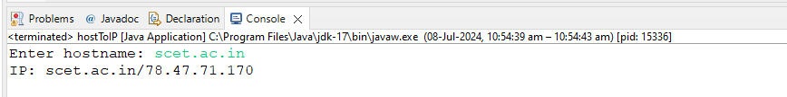

**2. Write a program to implement the connection oriented echo client server application.**

**Client.java**

import java.io.DataInputStream;

import java.io.DataOutputStream;

import java.io.IOException;

import java.net.Socket;

import java.net.UnknownHostException;

import java.util.Scanner;

class TestSend{

Socket s;

DataOutputStream ds;

DataInputStream di;

//Constructor

TestSend() throws UnknownHostException, IOException{

s = new Socket("localhost", 9977);

}

//Method to send message

public void doSend(String msg) throws IOException {

ds = new DataOutputStream(s.getOutputStream());

ds.writeUTF(msg);

}

//Method to receive message

public void doReceive() throws IOException {

di = new DataInputStream(s.getInputStream());

String rcv_msg = di.readUTF();

System.out.println("Server: " + rcv_msg);

}

}

public class Client {

public static void main(String arg[]) throws UnknownHostException, IOException {

TestSend ts1;

while(true) {

ts1 = new TestSend();

Scanner sc = new Scanner(System.in);

System.out.print("Client: ");

String msg = sc.nextLine();

ts1.doSend(msg);

ts1.doReceive();

System.out.println();

}

}

}

**Server.java**

import java.io.DataInputStream;

import java.io.DataOutputStream;

import java.io.IOException;

import java.net.ServerSocket;

import java.net.Socket;

class TestReceive{

ServerSocket ss;

DataInputStream di;

DataOutputStream ds;

Socket s;

TestReceive() throws IOException {

ss = new ServerSocket(9977);

}

public void doReceive() throws IOException {

while(true) {

s = ss.accept();

di = new DataInputStream(s.getInputStream());

ds = new DataOutputStream(s.getOutputStream());

String msg = di.readUTF();

System.out.println(msg);

ds.writeUTF(msg);

}

}

}

public class Server {

public static void main(String[] args) throws IOException {

// Server Main

TestReceive tr1 = new TestReceive();

tr1.doReceive();

}

}

**Output:**

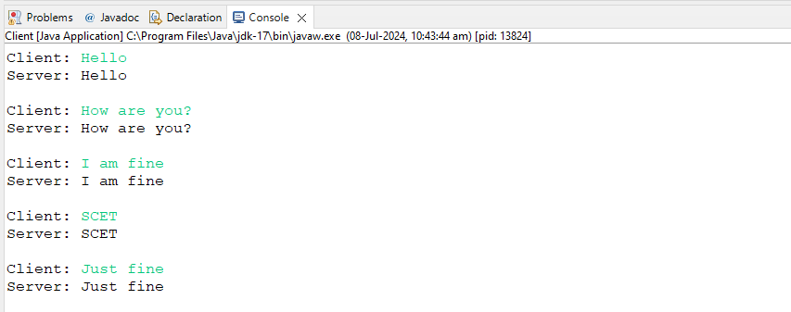

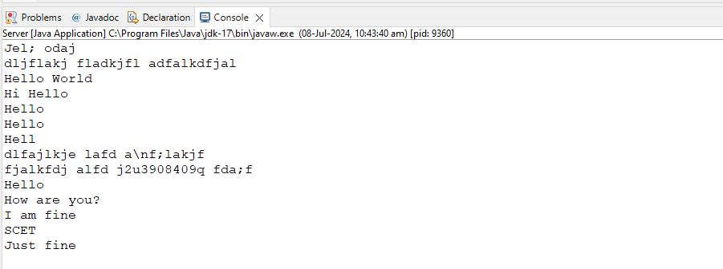

**3. Write a program to implement the connectionless echo client server application.**

**Client.java**

package p1_Connectionless;

import java.io.BufferedReader;

import java.io.IOException;

import java.io.InputStreamReader;

import java.net.*;

class TestSend {

DatagramSocket ds;

DatagramPacket dp;

byte[] sendData;

TestSend() throws SocketException {

ds = new DatagramSocket();

sendData = new byte[1024];

}

public void doSend(String msg) throws IOException {

InetAddress ip = InetAddress.getByName("localhost");

sendData = msg.getBytes();

dp = new DatagramPacket(sendData, msg.length(), ip, 3000);

ds.send(dp);

}

}

public class Client {

public static void main(String[] args) throws Exception {

// TODO Auto-generated method stub

TestSend ts = new TestSend();

BufferedReader br = new BufferedReader(new InputStreamReader(System.in));

while(true) {

System.out.print("Enter Message: ");

String msg = br.readLine();

ts.doSend(msg);

}

}

}

**Server.java**

package p1_Connectionless;

import java.io.IOException;

import java.net.DatagramPacket;

import java.net.DatagramSocket;

import java.net.InetAddress;

import java.net.SocketException;

class TestReceive {

DatagramSocket ds;

DatagramPacket dp;

byte[] receiveData;

InetAddress addr;

TestReceive() throws SocketException {

ds = new DatagramSocket(3000);

receiveData = new byte[1024];

}

public void doReceive() throws IOException {

dp = new DatagramPacket(receiveData, receiveData.length);

ds.receive(dp);

String msg = new String(dp.getData(), 0, dp.getLength());

addr = dp.getAddress();

System.out.println(msg.trim());

System.out.println("Ip of Client: " + addr);

}

}

public class Server {

public static void main(String args[]) throws IOException {

TestReceive tr = new TestReceive();

while(true) {

tr.doReceive();

}

}

}

**Output:**

