**Practical No : 07**

**Date:** 23/09/2024

**Problem Statement:**

**A Implement the shopping cart for users for the online shopping. Apply the concept of session.**

**Code:**

**index.jsp**

<%@ page language="java" contentType="text/html; charset=UTF-8" pageEncoding="UTF-8" %>

<!DOCTYPE html>

<html lang="en">

<head>

<meta charset="UTF-8">

<meta name="viewport" content="width=device-width, initial-scale=1.0">

<title>Shopping Cart</title>

</head>

<body>

<h2>Online Shop</h2>

<form action="AddToCart" method="post">

<label for="item">Enter item to add:</label>

<input type="text" id="item" name="item" placeholder="Enter item" required>

<input type="submit" value="Add to Cart">

</form>

<a href="ViewCart">View Cart</a>

</body>

</html>

**cart.jsp**

<%@ page language="java" contentType="text/html; charset=UTF-8" pageEncoding="UTF-8" %>

<!DOCTYPE html>

<html lang="en">

<head>

<meta charset="UTF-8">

<meta name="viewport" content="width=device-width, initial-scale=1.0">

<title>Your Shopping Cart</title>

</head>

<body>

<h2>Your Shopping Cart</h2>

<ul>

<%

java.util.List<String> cart = (java.util.List<String>) request.getAttribute("cart");

if (cart != null && !cart.isEmpty()) {

for (String item : cart) {

%>

<li><%= item %></li>

<%

}

} else {

%>

<li>No items in cart</li>

<%

}

%>

</ul>

<a href="index.jsp">Continue Shopping</a>

</body>

</html>

**AddToCart.java**

import java.io.IOException;

import java.util.ArrayList;

import java.util.List;

import javax.servlet.ServletException;

import javax.servlet.annotation.WebServlet;

import javax.servlet.http.HttpServlet;

import javax.servlet.http.HttpServletRequest;

import javax.servlet.http.HttpServletResponse;

import javax.servlet.http.HttpSession;

@WebServlet("/AddToCart")

public class AddToCart extends HttpServlet {

private static final long serialVersionUID = 1L;

@Override

protected void doPost(HttpServletRequest request, HttpServletResponse response)

throws ServletException, IOException {

String item = request.getParameter("item");

HttpSession session = request.getSession();

List<String> cart = (List<String>) session.getAttribute("cart");

if (cart == null) {

cart = new ArrayList<>();

}

if (item != null && !item.trim().isEmpty()) {

cart.add(item);

}

session.setAttribute("cart", cart);

response.sendRedirect("index.jsp");

}

}

**ViewCart.java**

import java.io.IOException;

import java.util.List;

import javax.servlet.ServletException;

import javax.servlet.annotation.WebServlet;

import javax.servlet.http.HttpServlet;

import javax.servlet.http.HttpServletRequest;

import javax.servlet.http.HttpServletResponse;

import javax.servlet.http.HttpSession;

@WebServlet("/ViewCart")

public class ViewCart extends HttpServlet {

private static final long serialVersionUID = 1L;

@Override

protected void doGet(HttpServletRequest request, HttpServletResponse response)

throws ServletException, IOException {

HttpSession session = request.getSession();

List<String> cart = (List<String>) session.getAttribute("cart");

if (cart == null) {

request.setAttribute("cart", null);

} else {

request.setAttribute("cart", cart);

}

request.getRequestDispatcher("cart.jsp").forward(request, response);

}

}

**Output:**

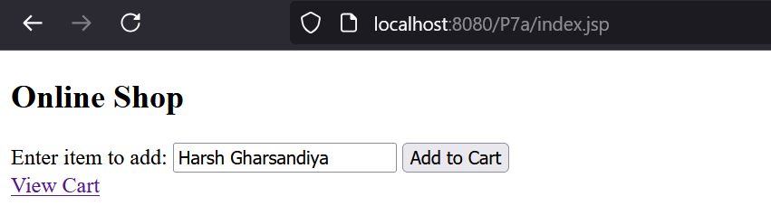

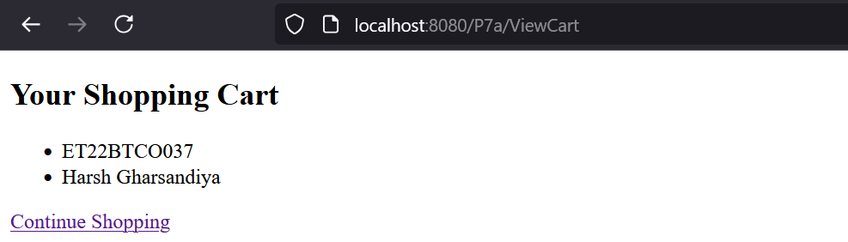

**B Implement Authentication filter using filter API.**

**Code:**

**login.jsp**

<%@ page import="java.sql.*" %>

<%

String username = request.getParameter("username");

String password = request.getParameter("password");

if (username != null && password != null) {

// Your logic to validate username and password

// Assume a simple hardcoded check for demonstration

if ("harshgharsandiya".equals(username) && "admin".equals(password)) {

HttpSession session1 = request.getSession();

session1.setAttribute("user", username);

response.sendRedirect("protected/dashboard.jsp"); // Redirect to a protected page

return;

} else {

out.println("Invalid credentials. Please try again.");

}

}

%>

<!DOCTYPE html>

<html>

<head>

<title>Login</title>

</head>

<body>

<h1>Login</h1>

<form method="post" action="login.jsp">

Username: <input type="text" name="username" required /><br>

Password: <input type="password" name="password" required /><br>

<input type="submit" value="Login" />

</form>

</body>

</html>

**AuthFilter.java**

import java.io.IOException;

import javax.servlet.Filter;

import javax.servlet.FilterChain;

import javax.servlet.FilterConfig;

import javax.servlet.ServletException;

import javax.servlet.ServletRequest;

import javax.servlet.ServletResponse;

import javax.servlet.http.HttpServletRequest;

import javax.servlet.http.HttpServletResponse;

import javax.servlet.http.HttpSession;

import javax.servlet.annotation.WebFilter;

@WebFilter("/protected/*") // Specify the URL pattern to protect

public class AuthFilter implements Filter {

@Override

public void init(FilterConfig filterConfig) throws ServletException {

// Initialization code, if needed

}

@Override

public void doFilter(ServletRequest request, ServletResponse response, FilterChain chain)

throws IOException, ServletException {

HttpServletRequest httpRequest = (HttpServletRequest) request;

HttpServletResponse httpResponse = (HttpServletResponse) response;

// Get the session object

HttpSession session = httpRequest.getSession(false);

// Check if the user is logged in

if (session == null || session.getAttribute("user") == null) {

// User is not logged in, redirect to the login page

httpResponse.sendRedirect("login.jsp");

} else {

// User is logged in, proceed with the request

chain.doFilter(request, response);

}

}

@Override

public void destroy() {

// Cleanup code, if needed

}

}

**dashboard.jsp**

<%@ page language="java" contentType="text/html; charset=UTF-8" pageEncoding="UTF-8"%>

<!DOCTYPE html>

<html>

<head>

<title>Dashboard</title>

</head>

<body>

<h1>Welcome to the Dashboard</h1>

<p>You are successfully logged in!</p>

<a href="../logout.jsp">Logout</a>

</body>

</html>

**logout.jsp**

<%@ page language="java" contentType="text/html; charset=UTF-8" pageEncoding="UTF-8"%>

<%

// Invalidate the current session

HttpSession session3 = request.getSession(false);

if (session3 != null) {

session.invalidate(); // Log the user out

}

// Redirect to the login page

response.sendRedirect("login.jsp");

%>

**Output:**

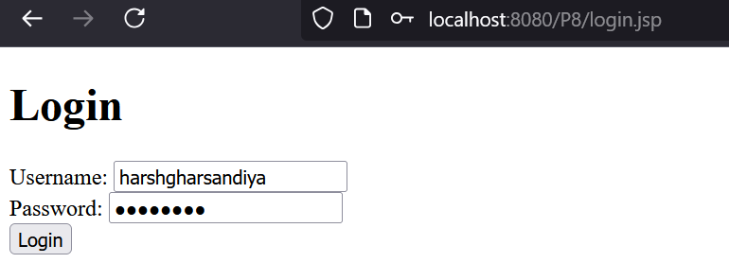

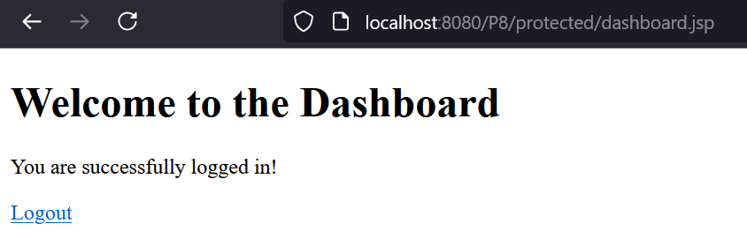

Access without login it will not access

