**Practical No : 08**

**Date:** 23/09/2024

**Problem Statement:**

**A. Write a Java application for Student registration form using JSP. (Add, Modify, Delete)**

**Code:**

**index.jsp**

<%@ page import="java.sql.*" %>

<!DOCTYPE html>

<html>

<head>

<title>Student Registration</title>

</head>

<body>

<h1>Student Registration Form</h1>

<form action="addStudent.jsp" method="post">

Name: <input type="text" name="name" required /><br>

Email: <input type="email" name="email" required /><br>

Age: <input type="number" name="age" required /><br>

<input type="submit" value="Add Student" />

</form>

<h2>Registered Students</h2>

<table border="1">

<tr>

<th>ID</th>

<th>Name</th>

<th>Email</th>

<th>Age</th>

<th>Action</th>

</tr>

<%

String url = "jdbc:mysql://localhost:3306/p8"; // Update your database details here

String username = "root"; // Your DB username

String password = ""; // Your DB password

Connection conn = null;

try {

Class.forName("com.mysql.cj.jdbc.Driver");

conn = DriverManager.getConnection(url, username, password);

Statement stmt = conn.createStatement();

ResultSet rs = stmt.executeQuery("SELECT * FROM students");

while (rs.next()) {

%>

<tr>

<td><%= rs.getInt("id") %></td>

<td><%= rs.getString("name") %></td>

<td><%= rs.getString("email") %></td>

<td><%= rs.getInt("age") %></td>

<td>

<a href="editStudent.jsp?id=<%= rs.getInt("id") %>">Edit</a> |

<a href="deleteStudent.jsp?id=<%= rs.getInt("id") %>">Delete</a>

</td>

</tr>

<%

}

rs.close();

stmt.close();

} catch (ClassNotFoundException e) {

out.println("Database Driver not found.");

} catch (SQLException e) {

out.println("Database error: " + e.getMessage());

} finally {

if (conn != null) try { conn.close(); } catch (SQLException e) {}

}

%>

</table>

</body>

</html>

**addStudent.jsp**

<%@ page import="java.sql.*" %>

<%

String name = request.getParameter("name");

String email = request.getParameter("email");

int age = Integer.parseInt(request.getParameter("age"));

String url = "jdbc:mysql://localhost:3306/p8"; // Update your database details here

String username = "root"; // Your DB username

String password = ""; // Your DB password

Connection conn = null;

PreparedStatement pstmt = null;

try {

Class.forName("com.mysql.cj.jdbc.Driver");

conn = DriverManager.getConnection(url, username, password);

String sql = "INSERT INTO students (name, email, age) VALUES (?, ?, ?)";

pstmt = conn.prepareStatement(sql);

pstmt.setString(1, name);

pstmt.setString(2, email);

pstmt.setInt(3, age);

int rowsAffected = pstmt.executeUpdate();

if (rowsAffected > 0) {

response.sendRedirect("index.jsp");

} else {

out.println("Error adding student.");

}

} catch (ClassNotFoundException e) {

out.println("Database Driver not found.");

} catch (SQLException e) {

out.println("Database error: " + e.getMessage());

} finally {

if (pstmt != null) try { pstmt.close(); } catch (SQLException e) {}

if (conn != null) try { conn.close(); } catch (SQLException e) {}

}

%>

**editStudent.jsp**

<%@ page import="java.sql.*" %>

<%

int studentId = Integer.parseInt(request.getParameter("id"));

String url = "jdbc:mysql://localhost:3306/p8"; // Update your database details here

String username = "root"; // Your DB username

String password = ""; // Your DB password

Connection conn = null;

PreparedStatement pstmt = null;

ResultSet rs = null;

try {

Class.forName("com.mysql.cj.jdbc.Driver");

conn = DriverManager.getConnection(url, username, password);

String sql = "SELECT * FROM students WHERE id = ?";

pstmt = conn.prepareStatement(sql);

pstmt.setInt(1, studentId);

rs = pstmt.executeQuery();

if (rs.next()) {

String name = rs.getString("name");

String email = rs.getString("email");

int age = rs.getInt("age");

%>

<!DOCTYPE html>

<html>

<head>

<title>Edit Student</title>

</head>

<body>

<h1>Edit Student</h1>

<form action="editStudentHandler.jsp" method="post">

<input type="hidden" name="id" value="<%= studentId %>" />

Name: <input type="text" name="name" value="<%= name %>" required /><br>

Email: <input type="email" name="email" value="<%= email %>" required /><br>

Age: <input type="number" name="age" value="<%= age %>" required /><br>

<input type="submit" value="Update Student" />

</form>

<br>

<a href="index.jsp">Back to Home</a>

</body>

</html>

<%

} else {

out.println("Student not found.");

}

} catch (ClassNotFoundException e) {

out.println("Database Driver not found.");

} catch (SQLException e) {

out.println("Database error: " + e.getMessage());

} finally {

if (rs != null) try { rs.close(); } catch (SQLException e) {}

if (pstmt != null) try { pstmt.close(); } catch (SQLException e) {}

if (conn != null) try { conn.close(); } catch (SQLException e) {}

}

%>

**editStudentHandler.jsp**

<%@ page import="java.sql.*" %>

<%

int studentId = Integer.parseInt(request.getParameter("id"));

String name = request.getParameter("name");

String email = request.getParameter("email");

int age = Integer.parseInt(request.getParameter("age"));

String url = "jdbc:mysql://localhost:3306/p8"; // Update your database details here

String username = "root"; // Your DB username

String password = ""; // Your DB password

Connection conn = null;

PreparedStatement pstmt = null;

try {

Class.forName("com.mysql.cj.jdbc.Driver");

conn = DriverManager.getConnection(url, username, password);

String sql = "UPDATE students SET name = ?, email = ?, age = ? WHERE id = ?";

pstmt = conn.prepareStatement(sql);

pstmt.setString(1, name);

pstmt.setString(2, email);

pstmt.setInt(3, age);

pstmt.setInt(4, studentId);

int rowsAffected = pstmt.executeUpdate();

if (rowsAffected > 0) {

response.sendRedirect("index.jsp");

} else {

out.println("Error updating student.");

}

} catch (ClassNotFoundException e) {

out.println("Database Driver not found.");

} catch (SQLException e) {

out.println("Database error: " + e.getMessage());

} finally {

if (pstmt != null) try { pstmt.close(); } catch (SQLException e) {}

if (conn != null) try { conn.close(); } catch (SQLException e) {}

}

%>

**deleteStudent.jsp**

<%@ page import="java.sql.*" %>

<%

int studentId = Integer.parseInt(request.getParameter("id"));

String url = "jdbc:mysql://localhost:3306/p8"; // Update your database details here

String username = "root"; // Your DB username

String password = ""; // Your DB password

Connection conn = null;

PreparedStatement pstmt = null;

try {

Class.forName("com.mysql.cj.jdbc.Driver");

conn = DriverManager.getConnection(url, username, password);

String sql = "DELETE FROM students WHERE id = ?";

pstmt = conn.prepareStatement(sql);

pstmt.setInt(1, studentId);

int rowsAffected = pstmt.executeUpdate();

if (rowsAffected > 0) {

response.sendRedirect("index.jsp");

} else {

out.println("Error deleting student.");

}

} catch(ClassNotFoundException e) {

out.println("Database Driver not found.");

} catch (SQLException e) {

out.println("Database error: " + e.getMessage());

} finally {

if (pstmt != null) try { pstmt.close(); } catch (SQLException e) {}

if (conn != null) try { conn.close(); } catch (SQLException e) {}

}

%>

**Output:**

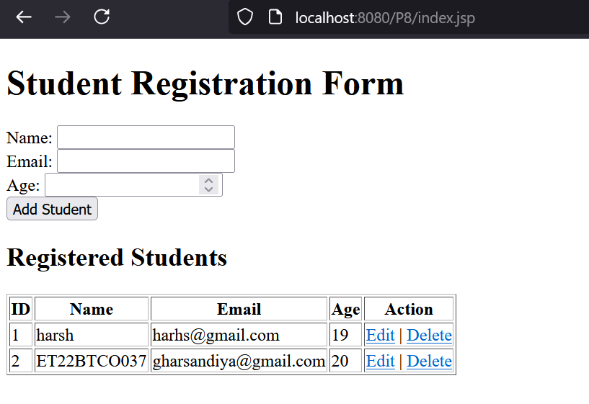

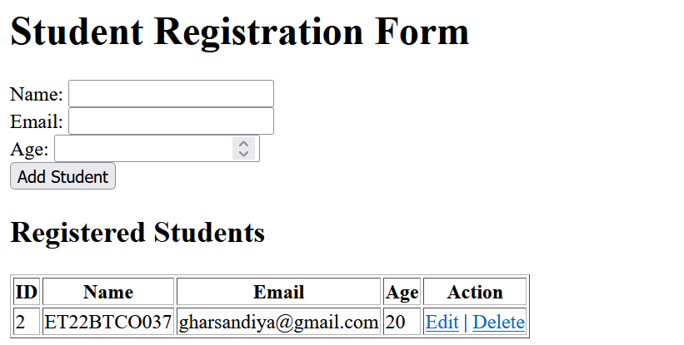

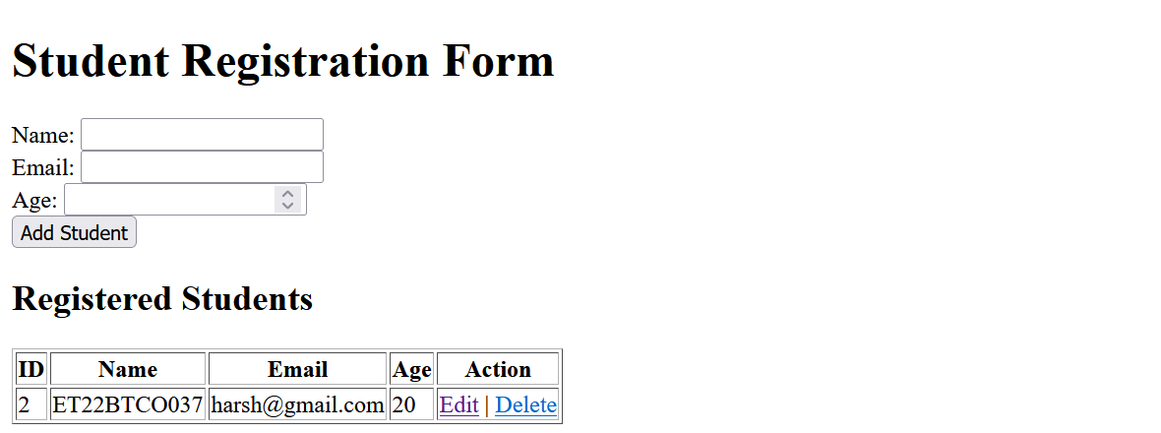

**B. Modify the above application and design a Beans class to calculate age, and another bean class to find the grade (Distinction, First, Second, Third and Fail) of students.**

**Code:**

**DatabaseConnection.java**

package P8b;

import java.sql.Connection;

import java.sql.DriverManager;

import java.sql.SQLException;

public class DatabaseConnection {

public static String driverPath = "com.mysql.cj.jdbc.Driver";

public static String host = "localhost";

public static String username = "root";

public static String password = "";

public static String dbname = "p8";

public static int portNo = 3306;

public static String url = "jdbc:mysql://" + host + ":" + portNo + "/" + dbname;

public static Connection getConnection() {

Connection conn = null;

try {

Class.forName(driverPath);

conn = DriverManager.getConnection(url, username, password);

} catch (ClassNotFoundException | SQLException e) {

e.printStackTrace();

}

return conn;

}

}

**AgeCalculator.java**

package P8b;

import java.util.Calendar;

import java.sql.Date;

public class AgeCalculator {

public int calculateAge(Date birthDate) {

Calendar birth = Calendar.getInstance();

birth.setTime(birthDate);

Calendar today = Calendar.getInstance();

int age = today.get(Calendar.YEAR) - birth.get(Calendar.YEAR);

if (today.get(Calendar.MONTH) < birth.get(Calendar.MONTH) ||

(today.get(Calendar.MONTH) == birth.get(Calendar.MONTH) &&

today.get(Calendar.DAY_OF_MONTH) < birth.get(Calendar.DAY_OF_MONTH))) {

age--;

}

return age;

}

}

**GradeCalculator.java**

package P8b;

public class GradeCalculator {

public String calculateGrade(int marks) {

if (marks >= 60) {

return "Distinction";

} else if (marks >= 50) {

return "First";

} else if (marks >= 40) {

return "Second";

} else if (marks >= 33) {

return "Third";

} else {

return "Fail";

}

}

}

**registration.java**

<%@ page language="java" contentType="text/html; charset=UTF-8" pageEncoding="UTF-8"%>

<%@ page import="java.sql.*" %>

<%@ page import="P8b.AgeCalculator" %>

<%@ page import="P8b.GradeCalculator" %>

<%@ page import="P8b.DatabaseConnection" %>

<!DOCTYPE html>

<html>

<head>

<title>Student Registration</title>

</head>

<body>

<h1>Student Registration Form</h1>

<form action="addStudent.jsp" method="post">

Name: <input type="text" name="name" required /><br>

Email: <input type="email" name="email" required /><br>

Birth Date: <input type="date" name="birthDate" required /><br>

Marks: <input type="number" name="marks" required /><br>

<input type="submit" value="Add Student" />

</form>

<h2>Registered Students</h2>

<table border="1">

<tr>

<th>ID</th>

<th>Name</th>

<th>Email</th>

<th>Age</th>

<th>Grade</th>

<th>Action</th>

</tr>

<%

Connection conn = DatabaseConnection.getConnection();

Statement stmt = conn.createStatement();

ResultSet rs = stmt.executeQuery("SELECT * FROM students");

AgeCalculator ageCalc = new AgeCalculator();

GradeCalculator gradeCalc = new GradeCalculator();

while (rs.next()) {

java.sql.Date birthDate = rs.getDate("birthDate");

int marks = rs.getInt("marks");

int age = ageCalc.calculateAge(birthDate);

String grade = gradeCalc.calculateGrade(marks);

%>

<tr>

<td><%= rs.getInt("id") %></td>

<td><%= rs.getString("name") %></td>

<td><%= rs.getString("email") %></td>

<td><%= age %></td>

<td><%= grade %></td>

<td>

<a href="editStudent.jsp?id=<%= rs.getInt("id") %>">Edit</a> |

<a href="deleteStudent.jsp?id=<%= rs.getInt("id") %>">Delete</a>

</td>

</tr>

<%

}

rs.close();

stmt.close();

conn.close();

%>

</table>

</body>

</html>

**addStudent.java**

<%@ page language="java" contentType="text/html; charset=UTF-8" pageEncoding="UTF-8"%>

<%@ page import="java.sql.*" %>

<%@ page import="P8b.DatabaseConnection" %>

<%@ page import="P8b.AgeCalculator" %>

<%@ page import="P8b.GradeCalculator" %>

<%

String name = request.getParameter("name");

String email = request.getParameter("email");

Date birthDate = null; // Initialize birthDate to null

int marks = -1; // Initialize marks to an invalid value

// Retrieve and validate birth date

String birthDateStr = request.getParameter("birthDate");

if (birthDateStr != null && !birthDateStr.isEmpty()) {

birthDate = java.sql.Date.valueOf(birthDateStr); // Convert String to java.sql.Date

}

// Retrieve and validate marks

String marksStr = request.getParameter("marks");

if (marksStr != null && !marksStr.isEmpty()) {

marks = Integer.parseInt(marksStr);

}

// Check if required fields are valid

if (name != null && !name.isEmpty() && email != null && !email.isEmpty() && birthDate != null && marks >= 0) {

try {

// Calculate age using AgeCalculator

AgeCalculator ageCalc = new AgeCalculator();

int age = ageCalc.calculateAge(birthDate);

// Calculate grade using GradeCalculator

GradeCalculator gradeCalc = new GradeCalculator();

String grade = gradeCalc.calculateGrade(marks);

// Database connection and insert statement

Connection conn = DatabaseConnection.getConnection();

PreparedStatement pstmt = conn.prepareStatement("INSERT INTO students (name, email, birthDate, marks, age) VALUES (?, ?, ?, ?, ?)");

pstmt.setString(1, name);

pstmt.setString(2, email);

pstmt.setDate(3, birthDate);

pstmt.setInt(4, marks);

pstmt.setInt(5, age); // Set calculated age

pstmt.executeUpdate();

pstmt.close();

conn.close();

// Redirect to registration page after adding

response.sendRedirect("registration.jsp");

} catch (SQLException e) {

e.printStackTrace(); // Log the SQL exception

out.println("An error occurred while adding the student: " + e.getMessage());

}

} else {

// Output an error message for missing fields

out.println("Please fill in all fields correctly.");

}

%>

**editStudent.java**

<%@ page language="java" contentType="text/html; charset=UTF-8" pageEncoding="UTF-8"%>

<%@ page import="java.sql.*" %>

<%@ page import="P8b.DatabaseConnection" %>

<%

int id = Integer.parseInt(request.getParameter("id"));

Connection conn = DatabaseConnection.getConnection();

PreparedStatement pstmt = conn.prepareStatement("SELECT * FROM students WHERE id = ?");

pstmt.setInt(1, id);

ResultSet rs = pstmt.executeQuery();

rs.next();

%>

<!DOCTYPE html>

<html>

<head>

<title>Edit Student</title>

</head>

<body>

<h1>Edit Student</h1>

<form action="updateStudent.jsp?id=<%= id %>" method="post">

Name: <input type="text" name="name" value="<%= rs.getString("name") %>" required /><br>

Email: <input type="email" name="email" value="<%= rs.getString("email") %>" required /><br>

Birth Date: <input type="date" name="birthDate" value="<%= rs.getDate("birthDate") %>" required /><br>

Marks: <input type="number" name="marks" value="<%= rs.getInt("marks") %>" required /><br>

<input type="submit" value="Update Student" />

</form>

<%

rs.close();

pstmt.close();

conn.close();

%>

</body>

</html>

**updateStudent.java**

<%@ page language="java" contentType="text/html; charset=UTF-8" pageEncoding="UTF-8"%>

<%@ page import="java.sql.*" %>

<%@ page import="P8b.DatabaseConnection" %>

<%

int id = Integer.parseInt(request.getParameter("id"));

String name = request.getParameter("name");

String email = request.getParameter("email");

Date birthDate = Date.valueOf(request.getParameter("birthDate"));

int marks = Integer.parseInt(request.getParameter("marks"));

Connection conn = DatabaseConnection.getConnection();

PreparedStatement pstmt = conn.prepareStatement("UPDATE students SET name = ?, email = ?, birthDate = ?, marks = ? WHERE id = ?");

pstmt.setString(1, name);

pstmt.setString(2, email);

pstmt.setDate(3, birthDate);

pstmt.setInt(4, marks);

pstmt.setInt(5, id);

pstmt.executeUpdate();

pstmt.close();

conn.close();

// Redirect back to the registration page

response.sendRedirect("registration.jsp");

%>

**deleteStudent.java**

<%@ page language="java" contentType="text/html; charset=UTF-8" pageEncoding="UTF-8"%>

<%@ page import="java.sql.*" %>

<%@ page import="P8b.DatabaseConnection" %>

<%

int id = Integer.parseInt(request.getParameter("id"));

Connection conn = DatabaseConnection.getConnection();

PreparedStatement pstmt = conn.prepareStatement("DELETE FROM students WHERE id = ?");

pstmt.setInt(1, id);

pstmt.executeUpdate();

pstmt.close();

conn.close();

// Redirect back to the registration page

response.sendRedirect("registration.jsp");

%>

**Output:**

