**Practical No : 01**

**Problem Statement:**

Write a program to implement Caesar cipher.

**Program:**

**caesar.py**

import sys

def encryption(f, key):

pt = f.read()

ct = ""

for i in pt:

#To check special character in string

if not i.isalpha():

ct = ct + i

continue

base = ord('a') if i.islower() else ord('A')

if i != '\n':

v = chr(base + (ord(i) - base + key) % 26)

ct = ct + str(v)

else:

ct = ct + i

#write cipher into file

with open('encryption_cipher.txt', 'w') as f1:

f1.write(ct)

def decryption(f, key):

ct = f.read()

pt = ''

for i in ct:

#To check special character in string

if not i.isalpha():

pt = pt + i

continue

base = ord('a') if i.islower() else ord('A')

if i!= '\n':

v = chr(base + (ord(i) - base - key) % 26)

pt = pt + str(v)

else:

pt = pt + '\n'

#write plain into file

with open('decryption_plain.txt', 'w') as f1:

f1.write(pt)

def user_menu():

print("[1]. Encryption of plain text")

print("[2]. Decryption of cipher text")

print("[0]. To Terminate Program ")

choice = int(input("Enter Your Choice: "))

return choice

def main():

while True:

choice = user_menu()

#Take User Input Key

key = int(input("Enter key: "))

if choice == 1:

with open("encryption_plain.txt","r") as f:

encryption(f, key)

elif choice == 2:

with open("decryption_cipher.txt","r") as f:

decryption(f, key)

elif choice == 0:

print("Program Terminated...")

sys.exit()

else:

print("Invalid Choice")

continue

if __name__ == "__main__":

main()

print("\nPlain Text")

with open('enc_plain.txt' , 'r') as f:

print(f.read())

print("Encrypted Text")

with open('enc_cipher.txt' , 'r') as f:

print(f.read())

print("Decrypted Text")

with open('dec_plain.txt' , 'r') as f:

print(f.read())

**Output:**

**1. Encryption of plain text**

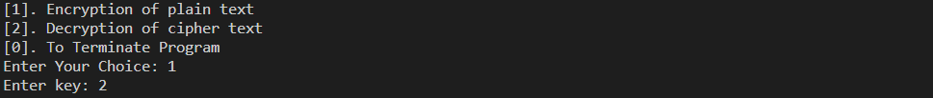

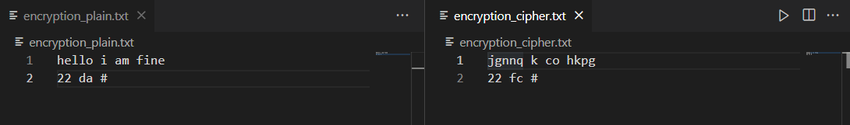

**2. Decryption of cipher text**

  
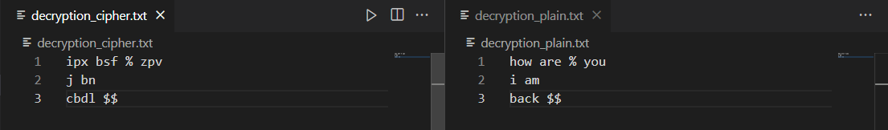

**3. Program Terminated**

