**Practical No : 02**

**Problem Statement:**

Write a program to implement Caesar cipher.

**Program:**

**key_value.py**

import random

import string

letters = list(string.ascii_lowercase + string.ascii_uppercase)

random.shuffle(letters)

key_value = {}

for i, letter in enumerate(string.ascii_letters):

key_value[letter] = letters[i]

with open("key_value.txt", "w") as f:

for key, val in key_value.items():

f.write(f"{key}-{val}\n")

**key_value dict**

mappings = { 'a': 'f', 'b': 'Y', 'c': 'X', 'd': 'J', 'e': 'P', 'f': 's', 'g': 'N', 'h': 'q', 'i': 'r', 'j': 'E', 'k': 'j', 'l': 'y', 'm': 'C', 'n': 'o', 'o': 'U', 'p': 'b', 'q': 'K', 'r': 'D', 's': 'w', 't': 'l', 'u': 'g', 'v': 'R', 'w': 'L', 'x': 'e', 'y': 'i', 'z': 'I', 'A': 'O', 'B': 'c', 'C': 'n', 'D': 'T', 'E': 'z', 'F': 'Q', 'G': 'H', 'H': 'F', 'I': 'd', 'J': 'S', 'K': 'h', 'L': 'V', 'M': 'v', 'N': 't', 'O': 'x', 'P': 'k', 'Q': 'a', 'R': 'Z', 'S': 'u', 'T': 'A', 'U': 'M', 'V': 'p', 'W': 'W', 'X': 'm', 'Y': 'B', 'Z': 'G' }

**mono_cipher.py**

#Write a program to implement Monoalphabetic Cipher.

import sys

def encryption(f):

key_value = {}

with open("key_value.txt") as f1:

for line in f1:

(key, val) = line.rstrip('\n').split("-")

key_value[key] = val

plain_text = f.read()

cipher_text = ""

for ch in plain_text:

if ch.isalpha():

cipher_text += key_value[ch]

elif ch == "\n":

cipher_text += "\n"

else:

cipher_text += ch

with open("encryption_cipher.txt","w") as f1:

f1.write(cipher_text)

def decryption(f):

key_value = {}

with open("key_value.txt") as f1:

for line in f1:

(val, key) = line.rstrip('\n').split("-")

key_value[key] = val

cipher_text = f.read()

plain_text = ""

for ch in cipher_text:

if ch.isalpha():

plain_text += key_value[ch]

elif ch == "\n":

plain_text += "\n"

else:

plain_text += ch

with open("decryption_plain.txt","w") as f1:

f1.write(plain_text)

print(plain_text)

def user_menu():

print("[1]. Encryption of plain text")

print("[2]. Decryption of cipher text")

print("[0]. To Terminate Program ")

choice = int(input("Enter Your Choice: "))

return choice

def main():

while True:

choice = user_menu()

if choice == 1:

with open("encryption_plain.txt","r") as f:

encryption(f)

elif choice == 2:

with open("decryption_cipher.txt","r") as f:

decryption(f)

elif choice == 0:

print("Program Terminated...")

sys.exit()

else:

print("Invalid Choice")

continue

if __name__ == "__main__":

main()

**Output:**

**1. Encryption of plain text**

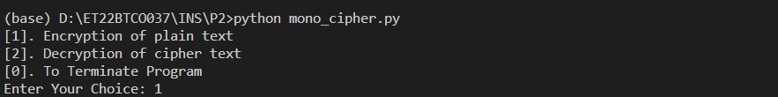

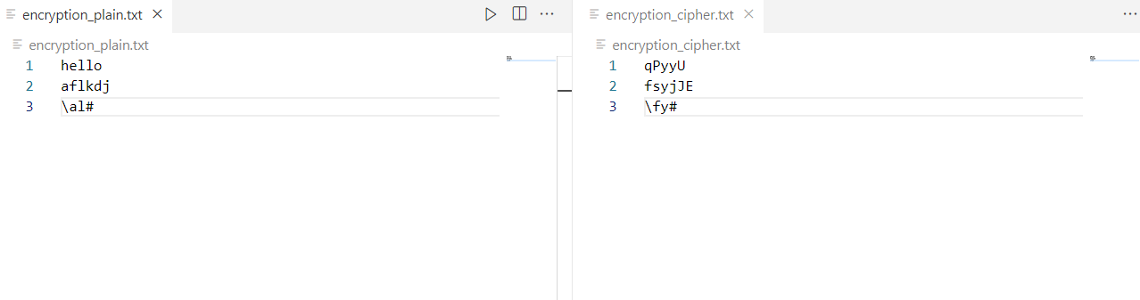

**2. Decryption of cipher text**

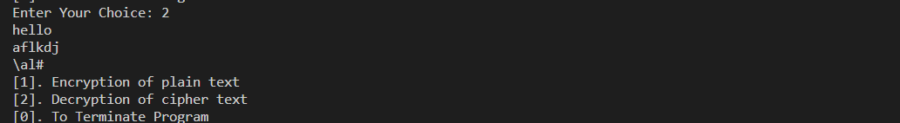

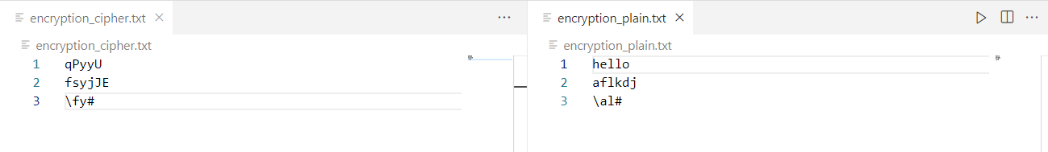

**3. Program Terminated**

