**Practical No : 09**

**Problem Statement:**

Implement RSA

**Program:**

import random

def extended_gcd(a, b):

if a == 0:

return b, 0, 1

gcd, x1, y1 = extended_gcd(b % a, a)

return gcd, y1 - (b // a) * x1, x1

def char_to_number(char):

return str(ord(char) - ord('a')).zfill(2) if 'a' <= char <= 'z' else \

str(ord(char) - ord('A') + 26).zfill(2) if 'A' <= char <= 'Z' else \

'66' if char == '?' else '62'

def number_to_char(num_str):

num = int(num_str)

if 0 <= num <= 25:

return chr(num + ord('a'))

elif 26 <= num <= 51:

return chr(num - 26 + ord('A'))

return '?' if num == 66 else ' '

# Binary Exponentiation

def mod_exp(a, e, n):

f = 1

while e > 0:

if e % 2 == 1:

f = (f * a) % n

a = (a * a) % n

e //= 2

return f

def crt_decrypt(C, d, n, p, q):

dp, dq = d % (p - 1), d % (q - 1)

Vp = mod_exp(C, dp, p)

Vq = mod_exp(C, dq, q)

Xp = q * (extended_gcd(q, p)[1] % p)

Xq = p * (extended_gcd(p, q)[1] % q)

return (Vp * Xp + Vq * Xq) % n

# Function to select e

def select_e(phi_n):

for e in [3, 17, 65537]:

if e < phi_n and extended_gcd(e, phi_n)[0] == 1:

return e

while True:

e = random.randrange(2, phi_n)

if extended_gcd(e, phi_n)[0] == 1:

return e

# Calculate d

def calculate_d(e, phi_n):

gcd, x, _ = extended_gcd(e, phi_n)

return None if gcd != 1 else x % phi_n

# Key Generation

def rsa_key():

p, q = 73, 151

n = p * q

phi_n = (p - 1) * (q - 1)

e = select_e(phi_n)

d = calculate_d(e, phi_n)

return [d, n], [e, n], p, q

def rsa_encryption(plain_text, public_key):

cipher_text = []

for i in range(0, len(plain_text), 2):

p1 = char_to_number(plain_text[i])

p2 = char_to_number(plain_text[i + 1]) if (i + 1 < len(plain_text)) else '66'

P = int(p1 + p2)

C = mod_exp(P, public_key[0], public_key[1])

cipher_text.append(str(C))

return cipher_text

def rsa_decryption(cipher_text, private_key, p, q):

plain_text = ""

for C in cipher_text:

P = crt_decrypt(int(C), private_key[0], private_key[1], p, q)

plain_text += number_to_char(str(P).zfill(4)[:2]) + number_to_char(str(P).zfill(4)[2:])

return plain_text

if __name__ == "__main__":

private_key, public_key, p, q = rsa_key()

# Plaintext Block consists of 4 decimal digits or 2 alphanumeric chars

plain_text = "How are you?"

cipher_text = rsa_encryption(plain_text, public_key)

decrypted_text = rsa_decryption(cipher_text, private_key, p, q)

# Print results

print(f"p = {p}\nq = {q}")

print(f"φ(n) = {(p - 1) * (q - 1)}")

print(f"e = {public_key[0]}\nd = {private_key[0]}")

print(f"Encrypted Cipher Text: {cipher_text}")

print(f"Decrypted Plain Text: {decrypted_text}")

**Output:**

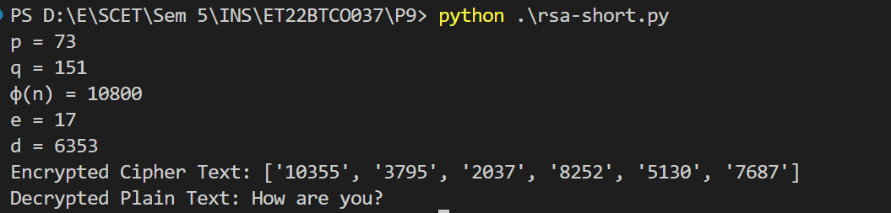

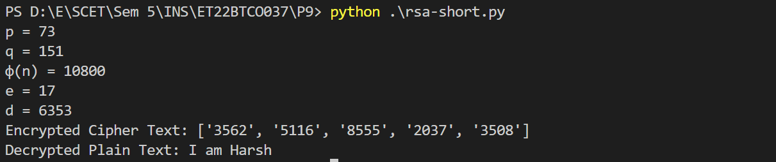

**Conclusion:**

I implemented the RSA algorithm in Python. It secures data by using a public-private key pair based on large prime numbers, making decryption without the private key difficult. However, if the private key is exposed or if the keys are too small, it can be compromised. This shows the need to combine RSA with other cryptographic techniques for better security.