**Lab 1**

**Aim:** Write a program to do the following:

1. A LED is connected on a pin of Arduino UNO board. WAP to blink the led with delay of 1 second.

2. A DC motor is connected with Arduino UNO. WAP to rotate motor in Clockwise direction for 1 second and then anti-clockwise direction for 1 second.

**Exercise:**

1. Differentiate Microcontroller and Microprocessor

| **Features** | **Microcontroller** | **Microprocessor** |
| --- | --- | --- |
| Definition | Integrated circuit designed to perform specific tasks | Integrated circuit designed to perform general tasks |
| Components | Includes CPU, memory (RAM, ROM), I/O ports, timers, etc. on a single chip | Consists of CPU; memory and I/O ports are external |
| Use Case | Embedded systems, specific control-oriented applications | General-purpose computing, running operating systems |
| Power Consumption | Low power consumption | Higher power consumption |
| Cost | Generally low-cost | Generally higher cost |
| Programming Environment | Typically programmed in C/C++ or assembly | Can be programmed in various high-level languages |
| Memory Capacity | Limited onboard memory (KB to MB) | Larger, expandable memory (GB) |
| Examples | Arduino, PIC, ARM Cortex-M series | Intel Core i7, AMD Ryzen |

2. Features of Arduino UNO R3 development board

* The Arduino UNO R3 is a popular development board based on the ATmega328P microcontroller. Some of its features are as following:
* *Microcontroller*: It is powered by ATmega328P,which operates at 16MHz and has 32KB of flash memory for program storage
* *Digital and Analog I/O pins*: The board has 14 digital input/output pins of which 6 can be used as Pulse width modulation (PWM) outputs. It also features 6 analog input pins.
* *USB Interface*: The Arduino UNO R3 can be connected to a computer via a USB interface, allowing easy programming and communication with the board.
* *Power Supply*: It can be powered through a USB connection or an external power supply.
* *Reset Button*: The board includes a reset button that allows you to restart the program running on the microcontroller.

**Simulation:**

**1. A LED is connected on a pin of Arduino UNO board. WAP to blink the led with delay of 1 second.**

*Proteus Schematic*

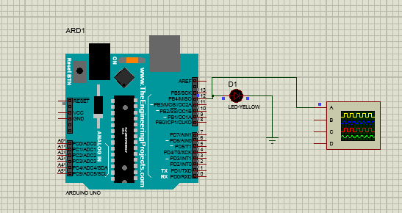

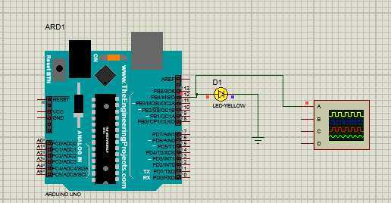

***Arduino Code:***

| void setup() {  pinmode(12, OUTPUT);  }  void loop() {  digitalwrite(12, HIGH);  delay(1000);  digitalwrite(12, LOW);  delay(1000);  } |
| --- |

***Working:***

The code sets the LED to be connected to pin 12 on the Arduino UNO board. In an infinite

loop, it turns the LED on for 1 second, then off for 1 second, creating a blinking effect. The

`delay()` function is used to pause the program, causing the LED to remain on or off for the

specified duration.

**2. A DC motor is connected with Arduino UNO. WAP to rotate motor in Clockwise direction for 1 second and then anti-clockwise direction for 1 second.**

*Proteus Schematic*

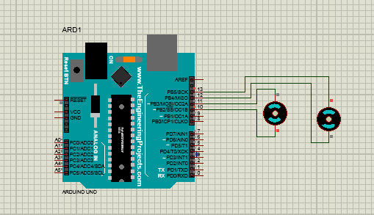

***Arduino Code:***

| #define pin1 10  #define pin2 11  #define pin3 12  #define pin4 13  void setup() {  pinMode(pin1, OUTPUT);  pinMode(pin2, OUTPUT);  pinMode(pin3, OUTPUT);  pinMode(pin4, OUTPUT);  }  void clockwise() {  digitalWrite(pin1, HIGH);  digitalWrite(pin2, LOW);  } | void anticlockwise() {  digitalWrite(pin3, LOW);  digitalWrite(pin4, HIGH);  }  void loop() {  clockwise();  delay(1000);  anticlockwise();  delay(1000);  } |
| --- | --- |

***Working:***

This Arduino code is designed to control the rotation direction of a motor or similar device using four defined pins (10, 11, 12, and 13). In the setup function, these pins are configured as outputs. The clockwise function sets pin 10 high and pin 11 low, initiating a clockwise rotation, while the anticlockwise function sets pin 12 low and pin 13 high, initiating an anticlockwise rotation. In the loop function, the motor alternates between clockwise and anticlockwise rotation every second, with a delay of 1000 milliseconds between each change in direction.

**Conclusion:**

From this practical, I have learned how to control an LED using an Arduino UNO and the Arduino IDE, and how to simulate the circuit using Proteus software