**CSS Assignment No: 1**

**Date:** 12/08/2024

**Problem Statement:**

1. Design Login and Registration Page using CSS.

2. Design your own website / portfolio / blog using bootstrap.

**1. Design Login and Registration Page using CSS.**

<!DOCTYPE html>

<html lang="en">

<head>

<meta charset="UTF-8">

<meta name="viewport" content="width=device-width, initial-scale=1.0">

<style>

body {

font-family: Arial, sans-serif;

background: linear-gradient(to right, #3498db, #8e44ad);

display: flex;

justify-content: center;

align-items: center;

height: 100vh;

margin: 0;

}

.container {

width: 400px;

background-color: white;

padding: 30px;

border-radius: 10px;

box-shadow: 0px 4px 10px rgba(0, 0, 0, 0.1);

}

h1 {

text-align: center;

color: #333;

margin-bottom: 30px;

}

form {

display: flex;

flex-direction: column;

}

input {

padding: 10px;

margin-bottom: 15px;

border: 1px solid #ccc;

border-radius: 5px;

font-size: 16px;

}

.btn {

background-color: #3498db;

color: white;

padding: 10px;

border: none;

border-radius: 5px;

font-size: 18px;

cursor: pointer;

transition: background-color 0.3s;

}

.btn:hover {

background-color: #2980b9;

}

.toggle-link {

text-align: center;

margin-top: 10px;

color: #3498db;

cursor: pointer;

}

</style>

<title>Login and Registration Page</title>

</head>

<body>

<div class="container">

<h1 id="form-title">Login</h1>

<!-- Login Form -->

<form id="login-form">

<input type="email" placeholder="Email" required>

<input type="password" placeholder="Password" required>

<button type="submit" class="btn">Login</button>

</form>

<!-- Registration Form (Initially Hidden) -->

<form id="registration-form" style="display: none;">

<input type="text" placeholder="Username" required>

<input type="email" placeholder="Email" required>

<input type="password" placeholder="Password" required>

<input type="password" placeholder="Confirm Password" required>

<button type="submit" class="btn">Register</button>

</form>

<!-- Toggle between forms -->

<div class="toggle-link" id="toggle-link">Don't have an account? Register</div>

</div>

<script>

// Toggle between Login and Registration forms

const loginForm = document.getElementById('login-form');

const registrationForm = document.getElementById('registration-form');

const toggleLink = document.getElementById('toggle-link');

const formTitle = document.getElementById('form-title');

toggleLink.addEventListener('click', () => {

if (loginForm.style.display === 'none') {

loginForm.style.display = 'block';

registrationForm.style.display = 'none';

formTitle.textContent = 'Login';

toggleLink.textContent = "Don't have an account? Register";

} else {

loginForm.style.display = 'none';

registrationForm.style.display = 'block';

formTitle.textContent = 'Register';

toggleLink.textContent = "Already have an account? Login";

}

});

</script>

</body>

</html>

**Output:**

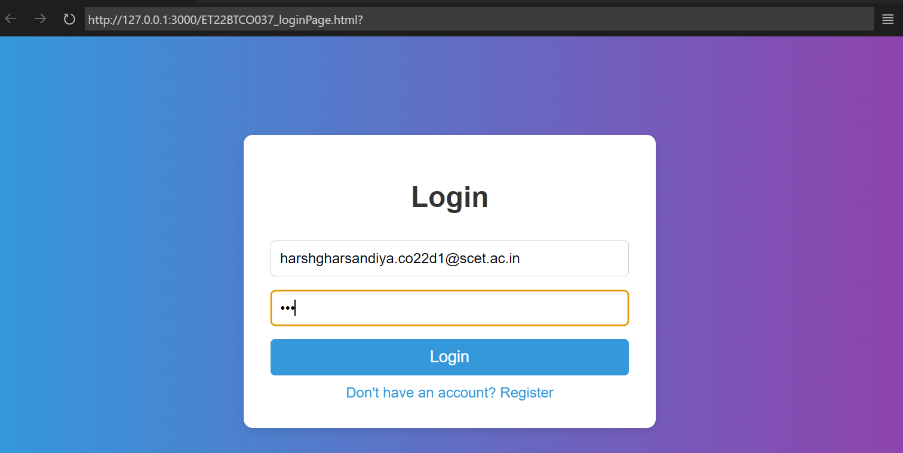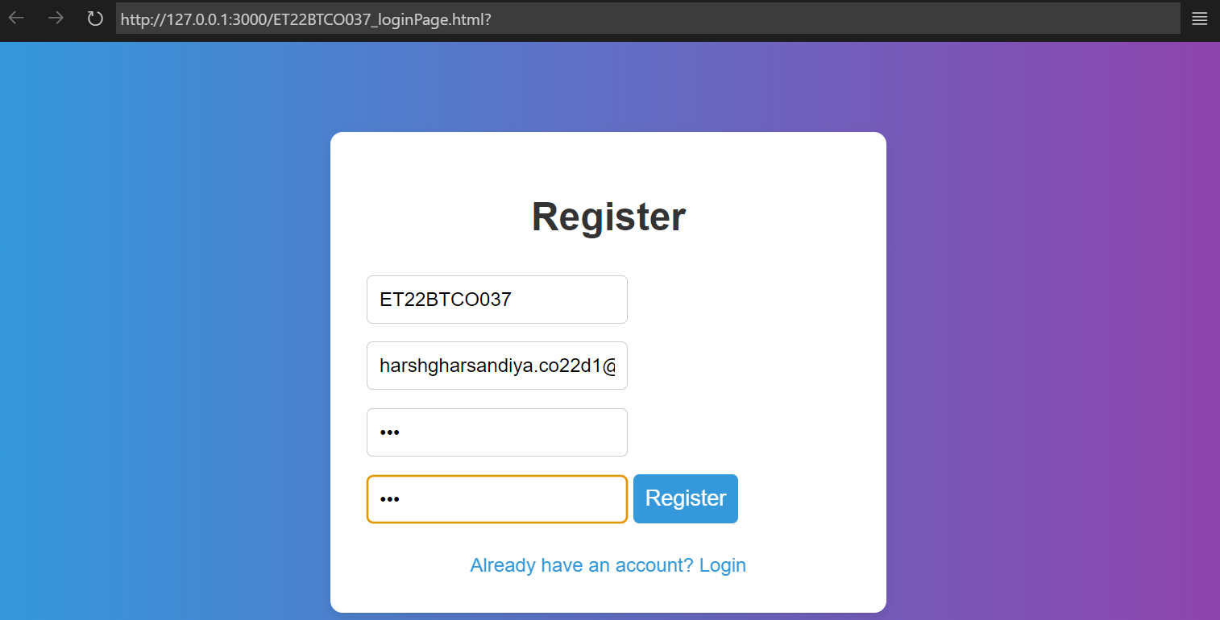

**2. Design your own website / portfolio / blog using bootstrap.**

<!DOCTYPE html>

<html lang="en">

<head>

<meta charset="UTF-8">

<meta name="viewport" content="width=device-width, initial-scale=1.0">

<title>Harsh Gharsandiya's Portfolio</title>

<link rel="stylesheet" href="https://stackpath.bootstrapcdn.com/bootstrap/4.5.2/css/bootstrap.min.css">

<style>

body {

padding-top: 56px;

font-family: 'Roboto Mono', monospace;

}

.hero {

background-image: url('bg.jpg');

background-size: cover;

background-position: center;

color: white;

padding: 100px 0;

opacity: 0.9;

}

</style>

</head>

<body>

<nav class="navbar navbar-expand-lg navbar-light bg-light fixed-top">

<div class="container">

<a class="navbar-brand" href="#">Harsh Gharsandiya</a>

<button class="navbar-toggler" type="button" data-toggle="collapse" data-target="#navbarNav" aria-controls="navbarNav" aria-expanded="false" aria-label="Toggle navigation">

<span class="navbar-toggler-icon"></span>

</button>

<div class="collapse navbar-collapse" id="navbarNav">

<ul class="navbar-nav ml-auto">

<li class="nav-item active">

<a class="nav-link" href="#">Home</a>

</li>

<li class="nav-item">

<a class="nav-link" href="#about">About</a>

</li>

<li class="nav-item">

<a class="nav-link" href="#projects">Projects</a>

</li>

<li class="nav-item">

<a class="nav-link" href="#contact">Contact</a>

</li>

</ul>

</div>

</div>

</nav>

<header class="hero text-center">

<div class="container">

<h1 class="display-4">Welcome to My Portfolio</h1>

<p class="lead">Explore my passions, projects, and how to connect with me.</p>

</div>

</header>

<section id="about" class="py-5">

<div class="container">

<h2>About Me</h2>

<p>

Hi there! I'm Harsh Gharsandiya, a passionate Computer Engineering professional with a knack for Cyber Security. I have a background in computer science and have worked on various projects, ranging from small personal websites to larger web applications.

</p>

<p>

My areas of expertise include HTML, CSS, JavaScript, and various security practices. I believe in the power of clean design and seamless functionality, striving to provide an excellent user experience in all my projects. When I'm not coding, I enjoy exploring new technologies and contributing to open-source projects.

</p>

</div>

</section>

<section id="projects" class="py-5 bg-light">

<div class="container">

<h2>Projects</h2>

<div class="row">

<div class="col-md-4">

<div class="card mb-4">

<img src="keylogger.webp" class="card-img-top" alt="Key Logger">

<div class="card-body">

<h5 class="card-title">Key Logger</h5>

<p class="card-text">A tool designed to monitor and record keystrokes on a device, allowing for the analysis of user behavior and potential security threats.</p>

</div>

</div>

</div>

<div class="col-md-4">

<div class="card mb-4">

<img src="password.jpg" class="card-img-top" alt="Password Strength Checker">

<div class="card-body">

<h5 class="card-title">Password Strength Checker</h5>

<p class="card-text">A web application that evaluates the strength of user-generated passwords, providing feedback on how to create more secure passwords to enhance account protection.</p>

</div>

</div>

</div>

<div class="col-md-4">

<div class="card mb-4">

<img src="vuln.png" class="card-img-top" alt="Basic Vulnerability Scanner">

<div class="card-body">

<h5 class="card-title">Basic Vulnerability Scanner</h5>

<p class="card-text">A lightweight scanner that checks for common security vulnerabilities in web applications, helping developers identify and address potential security issues.</p>

</div>

</div>

</div>

</div>

</div>

</section>

<section id="contact" class="py-5">

<div class="container">

<h2>Contact Me</h2>

<form>

<div class="form-group">

<label for="name">Name</label>

<input type="text" class="form-control" id="name" placeholder="Your Name" required>

</div>

<div class="form-group">

<label for="email">Email</label>

<input type="email" class="form-control" id="email" placeholder="Your Email" required>

</div>

<div class="form-group">

<label for="message">Message</label>

<textarea class="form-control" id="message" rows="4" placeholder="Your Message" required></textarea>

</div>

<button type="submit" class="btn btn-primary">Send Message</button>

</form>

<h3 class="mt-4">Connect with Me</h3>

<p>Email: <a href="mailto:harshgharsandiya.co22d1@scet.ac.in">harshgharsandiya.co22d1@scet.ac.in</a></p>

<p>GitHub: <a href="https://github.com/harshgharsandiya" target="_blank">@harshgharsandiya</a></p>

<p>Twitter: <a href="https://twitter.com/harshgharsandia" target="_blank">@harshgharsandia</a></p>

</div>

</section>

<footer class="text-center py-4">

<div class="container">

<p>&copy; 2024 Harsh Gharsandiya. All Rights Reserved.</p>

</div>

</footer>

<script src="https://code.jquery.com/jquery-3.5.1.slim.min.js"></script>

<script src="https://cdn.jsdelivr.net/npm/@popperjs/core@2.5.2/dist/umd/popper.min.js"></script>

<script src="https://stackpath.bootstrapcdn.com/bootstrap/4.5.2/js/bootstrap.min.js"></script>

</body>

</html>

**Output:**