**CSS Practical No : 1**

**Date:** 29/07/2024

**Problem Statement:**

1. Demonstrate the use of Element Selector, ID selector, Class Selector

2. Demonstrate Grouping Selectors and Universal Selector

3. Write a program to show three ways to insert CSS in HTML page

4. Write a program to show working of background properties

background-color

background-image

background-repeat

background-attachment

background-position

5. Change the background-color, text color , border color of elements using CSS Colors

6. Style the links in different ways depending upon their state

7. Demonstrate CSS Box Model

8. Demonstrate CSS Text Formats and Effects

9. Style Lists (UL, OL) using CSS

10. Demonstrate different CSS Positioning using DIV tag

**1. Demonstrate the use of Element Selector, ID selector, Class Selector**

<!DOCTYPE html>

<html lang="en">

<head>

<title>CSS Selector</title>

<style>

p {

text-align: center;

background: bisque;

}

#p1 {

text-align: left;

background-color: aquamarine;

}

.c1 {

text-align: right;

background-color: aliceblue;

}

</style>

</head>

<body>

<!-- 1. Demonstrate the use of Element Selector, ID selector, Class Selector -->

<h3>Element Selector</h3>

<p>Hello My name is Harsh Gharsandiya</p>

<p>Enrollment = ET22BTCO037</p>

<h3>ID Selector</h3>

<p id="p1">Hello My name is Harsh Gharsandiya</p>

<p id="p1">Enrollment = ET22BTCO037</p>

<h3>Class Selector</h3>

<p class="c1">Hello My name is Harsh Gharsandiya</p>

<p class="c1">Enrollment = ET22BTCO037</p>

</body>

</html>

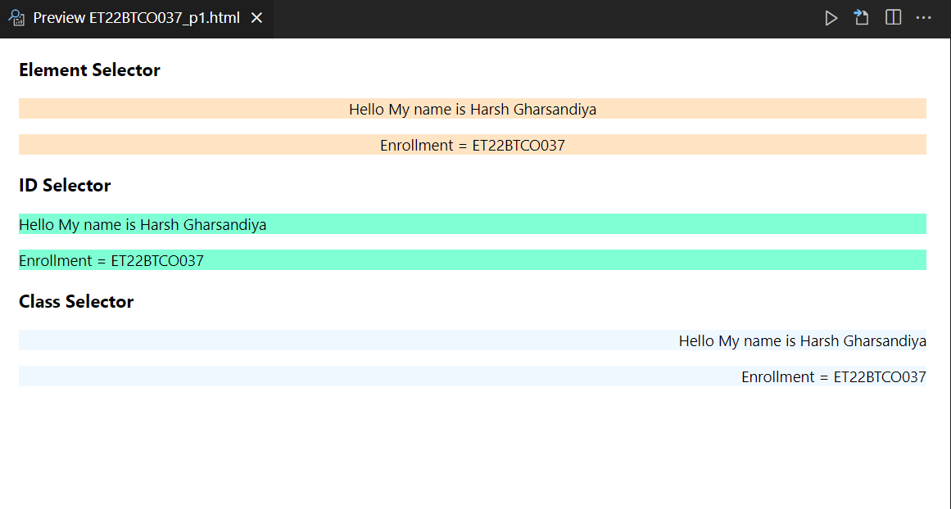

**2. Demonstrate Grouping Selectors and Universal Selector**

<!DOCTYPE html>

<html lang="en">

<head>

<title>Document</title>

<style>

h5,

h6,

p {

background: bisque;

text-align: left;

}

* {

text-align: center;

}

</style>

</head>

<body>

<!-- 2. Demonstrate Grouping Selectors and Universal Selector-->

<h3>Grouping Selector</h3>

<h5>Hello My name is Harsh Gharsandiya</h5>

<h6>Web Technology</h6>

<p>Enrollment = ET22BTCO037</p>

<h3>Universal Selector</h3>

<div>

<h4>Hello My name is Harsh Gharsandiya</h5>

<strong>Enrollment = ET22BTCO037</strong>

</div>

</body>

</html>

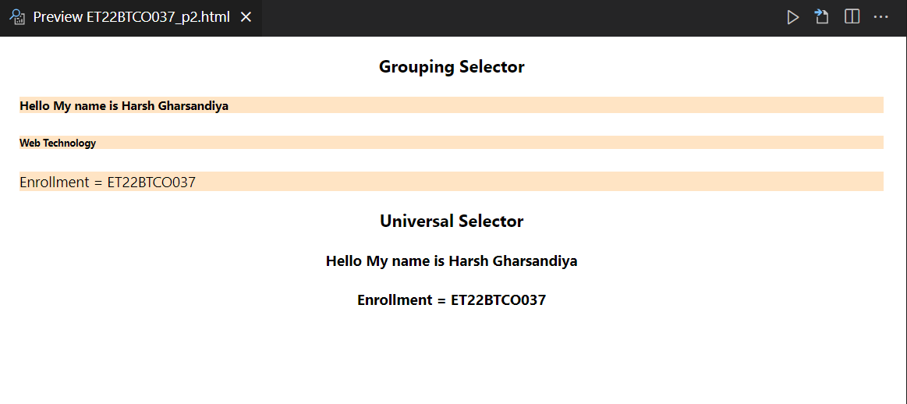

**3. Write a program to show three ways to insert CSS in HTML page**

<!DOCTYPE html>

<html lang="en">

<head>

<title>CSS</title>

</head>

<body>

<!-- 3. Write a program to show three ways to insert CSS in HTML page-->

<h1>Inline CSS</h1>

<h1 style="color: grey">A Grey Heading</h1>

<p style="color: blue">A blue paragraph.</p>

</body>

</html>

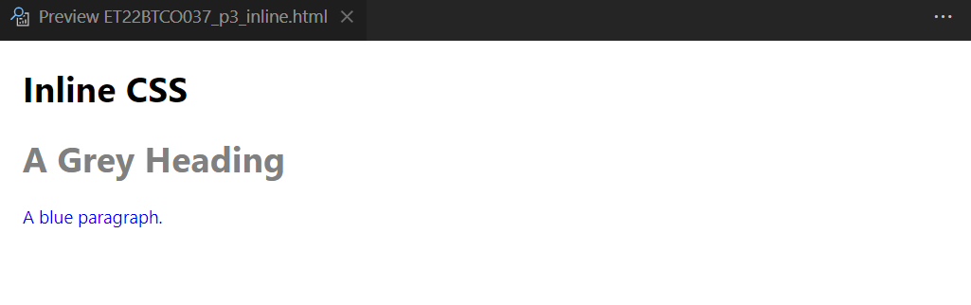

<!DOCTYPE html>

<html lang="en">

<head>

<style>

body {

background-color: pink;

}

h2 {

color: blue;

}

p {

color: rgb(193, 102, 178);

}

</style>

</head>

<body>

<!-- 3. Write a program to show three ways to insert CSS in HTML page-->

<h1>Internal CSS</h1>

<h2>Blue Heading</h2>

<p>Purple Paragraph.</p>

</body>

</html>

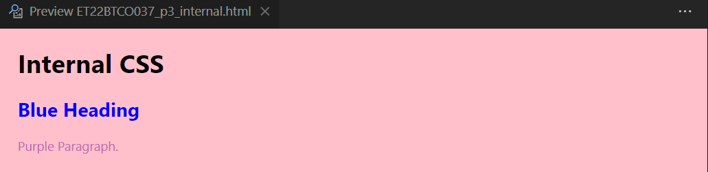

<!DOCTYPE html>

<html lang="en">

<head>

<title>CSS</title>

<link rel="stylesheet" href="style.css" />

</head>

<body>

<!-- 3. Write a program to show three ways to insert CSS in HTML page-->

<h1>External CSS</h1>

<h2>A Blue Heading</h2>

<p>A Red paragraph.</p>

</body>

</html>

**Style.css**

body {

background-color: bisque;

}

h2 {

color: blue;

}

p {

color: red;

}

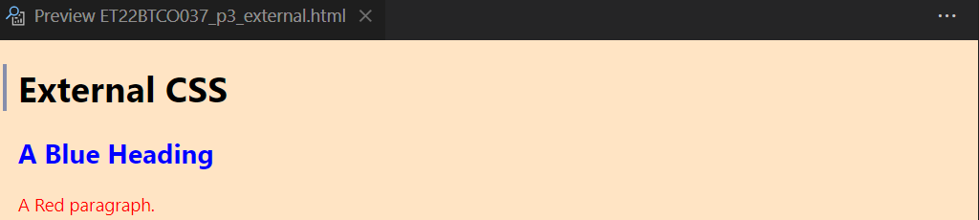

**4. Write a program to show working of background properties**

**background-color**

**background-image**

**background-repeat**

**background-attachment**

**background-position**

<!DOCTYPE html>

<html lang="en">

<head>

<meta charset="UTF-8">

<meta name="viewport" content="width=device-width, initial-scale=1.0">

<title>Background Properties Example</title>

<style>

body {

margin: 0;

font-family: Arial, sans-serif;

}

.background-example {

height: 100vh;

background-color: rgba(96, 33, 159, 0.5);

background-image: url('itachi.jpg');

background-repeat: no-repeat;

background-attachment: fixed;

background-position: center;

display: flex;

justify-content: center;

text-align: center;

color: rgb(4, 18, 27);

}

</style>

</head>

<body>

<div class="background-example">

<h1>Background Properties in CSS</h1>

</div>

</body>

</html>

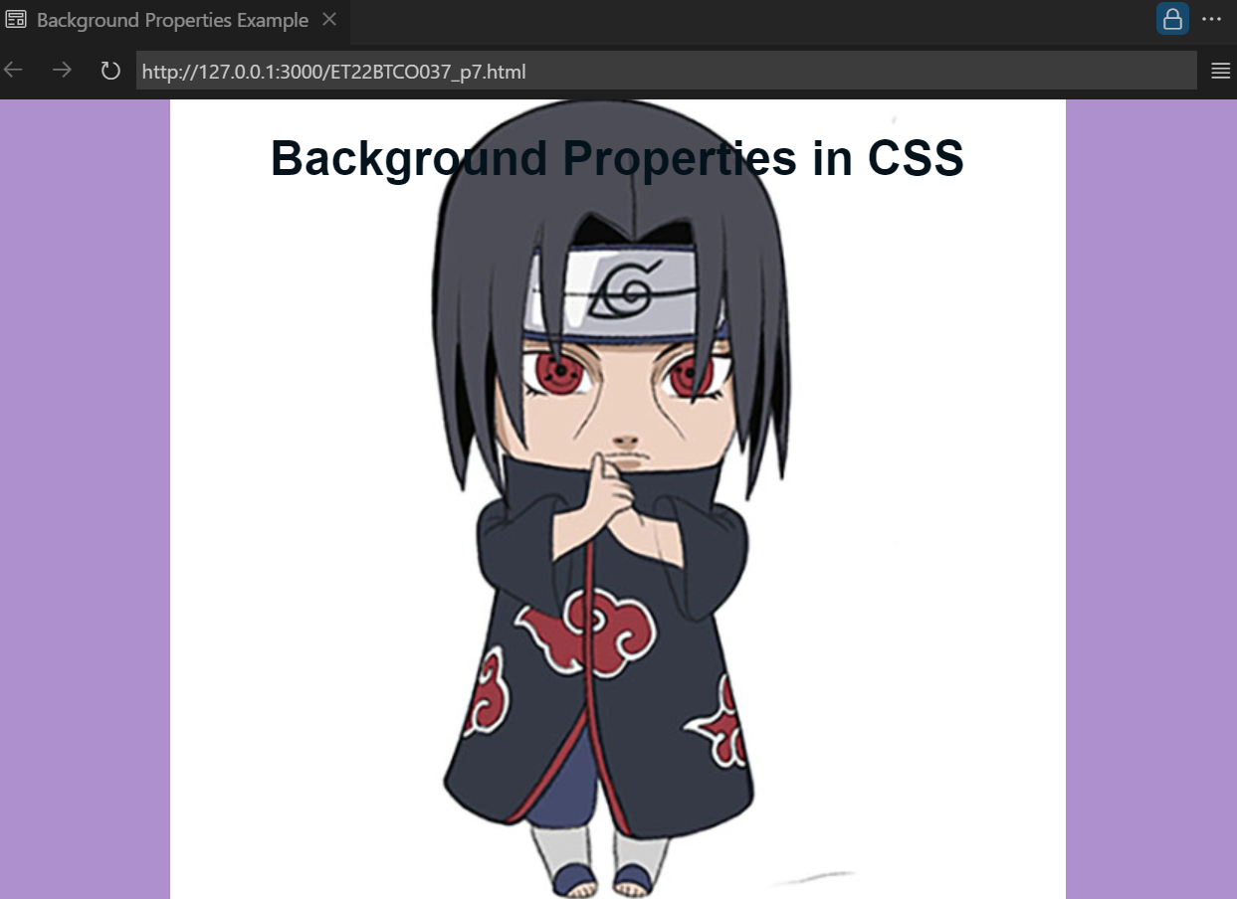

**5. Change the background-color, text color , border color of elements using CSS Colors**

<!DOCTYPE html>

<html lang="en">

<head>

<title>css</title>

<style>

/* background-color */

.bg-color {

background-color: #f2f2f2;

padding: 20px;

}

/* border-color */

.text-color {

color: red;

}

/* border-color */

.border-color {

padding: 20px;

border: 2px solid #0f7361;

}

</style>

</head>

<body>

<!-- 5. Change the background-color, text color , border color of elements using CSS Color. -->

<h2>Background Properties Example</h2>

<h3>background-color</h3>

<div class="bg-color">This is div of bg color.</div>

<h3>text-color</h3>

<div class="text-color">This is div of text color.</div>

<h3>border-color</h3>

<div class="border-color">This is div of border color.</div>

</body>

</html>

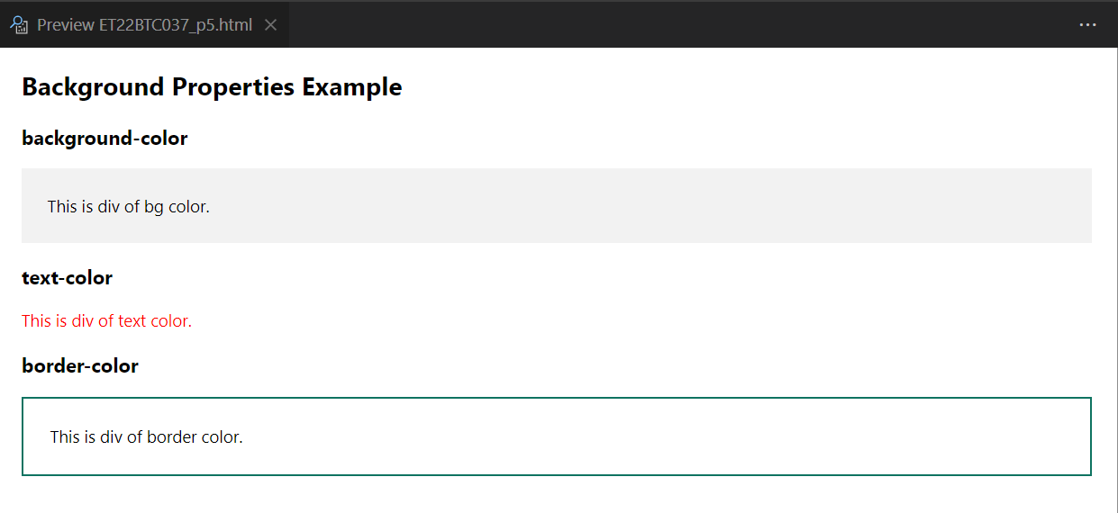

**6. Style the links in different ways depending upon their state**

<!DOCTYPE html>

<html lang="en">

<head>

<title>Document</title>

<style>

a:link,

a:visited {

background-color: #21231b;

color: white;

padding: 14px 25px;

text-align: center;

text-decoration: none;

display: inline-block;

}

a:hover,

a:active {

background-color: bisque;

}

</style>

</head>

<body>

<!-- Style the links in different ways depending upon their state -->

<h2>Link Style</h2>

<a href="ET22BTCO037_p1.html">Hey Go to Profile of Harsh</a>

</body>

</html>



**7. Demonstrate CSS Box Model**

<!DOCTYPE html>

<html lang="en">

<head>

<title>Document</title>

<style>

div {

width: 320px;

height: 50px;

padding: 10px;

border: 5px solid rgb(97, 59, 5);

margin: 0;

}

</style>

</head>

<body>

<!-- Demonstrate CSS Box Model -->

<h2>CSS Box Model</h2>

<div>

Lorem ipsum dolor sit amet, consectetur adipiscing elit, sed do eiusmod

tempor incididunt ut labore et dolore magna aliqua.

</div>

</body>

</html>

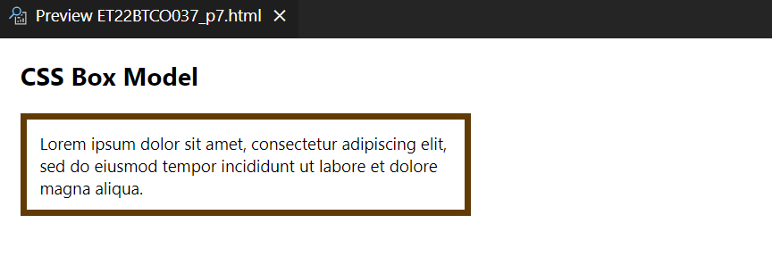

**8. Demonstrate CSS Text Formats and Effects**

<!DOCTYPE html>

<html lang="en">

<head>

<title>Document</title>

<style>

p {

white-space: nowrap;

width: 400px;

border: 2px solid #26127b;

overflow: hidden;

text-overflow: ellipsis;

text-decoration: underline;

letter-spacing: 2px;

color: blue;

}

</style>

</head>

<body>

<!-- Demonstrate CSS Text Formats and Effects -->

<h2>CSS Text Formats & Effects</h2>

<p>

This paragraph contains a very long word:

supercalifragilisticexpialidocious.

</p>

</body>

</html>

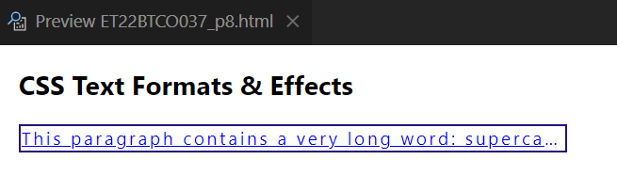

**9. Style Lists (UL, OL) using CSS**

<!DOCTYPE html>

<html lang="en">

<head>

<title>Document</title>

<style>

ol {

background: #ff9999;

padding: 20px;

}

ul {

background: #3399ff;

padding: 20px;

}

ol li {

background: #ffe5e5;

color: darkred;

padding: 5px;

margin-left: 35px;

}

ul li {

background: #cce5ff;

color: darkblue;

margin: 5px;

}

</style>

</head>

<body>

<!-- Style Lists (UL, OL) using CS -->

<h2>Style Lists (UL, OL) using CSS</h2>

<ul>

<li>Coffee</li>

<li>Tea</li>

<li>Coca Cola</li>

</ul>

<ol>

<li>Coffee</li>

<li>Tea</li>

<li>Coca Cola</li>

</ol>

</body>

</html>

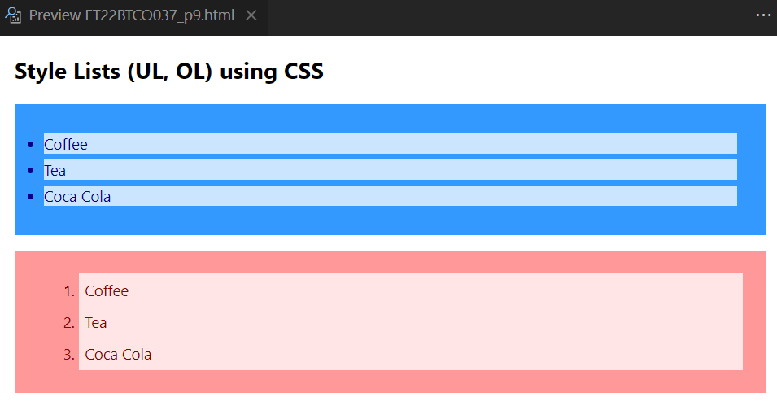

**10. Demonstrate different CSS Positioning using DIV tag**

<!DOCTYPE html>

<html lang="en">

<head>

<title>Document</title>

<style>

h4.static {

position: static;

right: 4px;

border: 3px solid #73ad21;

}

h4.relative {

position: relative;

left: 30px;

border: 3px solid #cfc91c;

}

h4.fixed {

position: fixed;

bottom: 0;

right: 10;

width: 300px;

border: 3px solid #490662;

}

h4.absolute {

position: absolute;

top: 80px;

right: 0;

width: 200px;

height: 20px;

border: 3px solid #2198ad;

}

h4.sticky {

position: -webkit-sticky; /* Safari */

position: sticky;

top: 0;

background-color: green;

border: 2px solid #4caf50;

}

</style>

</head>

<body>

<!-- Demonstrate different CSS Positioning using DIV tag -->

<h2>CSS Positioning using DIV tag</h2>

<h4 class="static">static Positioning</h4>

<h4 class="relative">relative Positioning</h4>

<h4 class="fixed">fixed Positioning</h4>

<h4 class="absolute">absolute Positioning</h4>

<h4 class="sticky">sticky Positioning</h4>

</body>

</html>

