**CSS Practical No : 2**

**Date:** 05/08/2024

**Problem Statement:**

1. Perform CSS 2D transforms such as move , rotate , scale , and skew elements

2. Perform CSS 3D transforms

3. Perform CSS Animation on any element

4. Use CSS to style images

5. Demonstrate the use of Media Queries

6. Demonstrate the use of Linear Gradient and Radial Gradient

**1. Demonstrate the use of Element Selector, ID selector, Class Selector**

<!DOCTYPE html>

<html lang="en">

<head>

<meta charset="UTF-8">

<meta name="viewport" content="width=device-width, initial-scale=1.0">

<style>

.box {

width: 100px;

height: 100px;

background-color: coral;

transform: translate(50px, 20px) rotate(45deg) scale(1.5) skew(20deg);

}

</style>

<title>2D Transform</title>

</head>

<body>

<h4>CSS 2D Transforms (Move, Rotate, Scale, Skew)</h4><br><br>

<div class="box"></div>

</body>

</html>

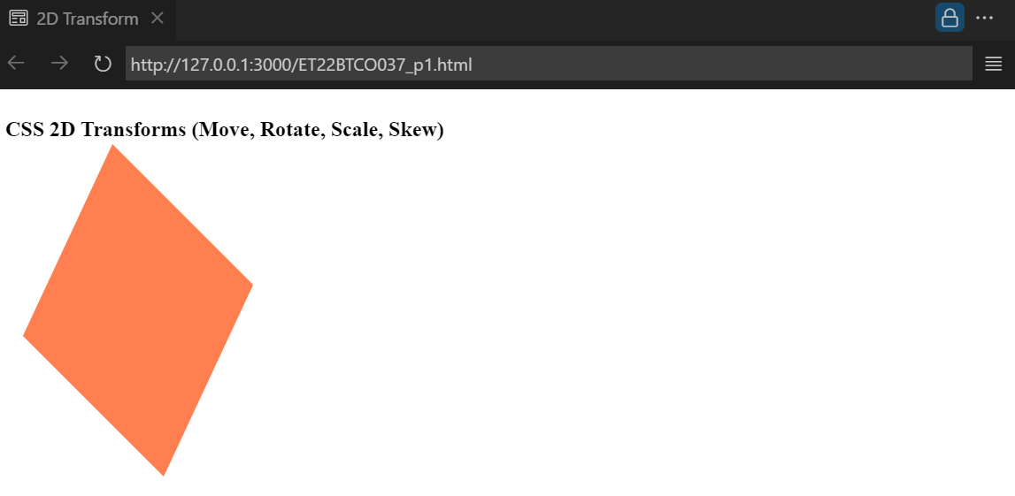

**2. Perform CSS 3D transforms**

<!DOCTYPE html>

<html lang="en">

<head>

<meta charset="UTF-8">

<meta name="viewport" content="width=device-width, initial-scale=1.0">

<style>

.cube {

width: 100px;

height: 100px;

background-color: lightblue;

transform: rotateX(45deg) rotateY(30deg) rotateZ(15deg);

}

</style>

<title>3D Transform</title>

</head>

<body>

<h1>CSS 3D Transforms</h1>

<div class="cube"></div>

</body>

</html>

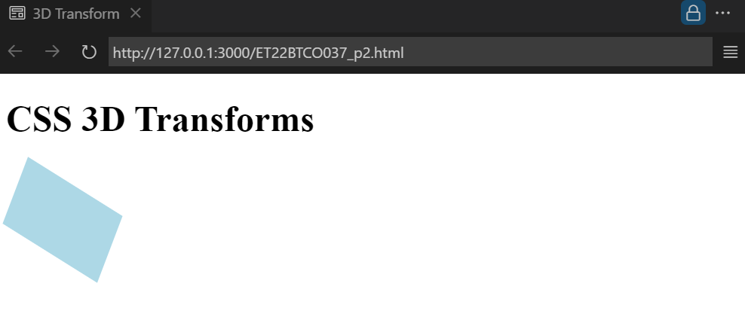

**3. Perform CSS Animation on any element**

<!DOCTYPE html>

<html lang="en">

<head>

<meta charset="UTF-8">

<meta name="viewport" content="width=device-width, initial-scale=1.0">

<title>Document</title>

</head>

<body>

</body>

</html><!DOCTYPE html>

<html lang="en">

<head>

<meta charset="UTF-8">

<meta name="viewport" content="width=device-width, initial-scale=1.0">

<style>

.ball {

width: 50px;

height: 50px;

background-color: tomato;

border-radius: 50%;

animation: bounce 2s infinite;

}

@keyframes bounce {

0% { transform: translateY(0); }

50% { transform: translateY(-100px); }

100% { transform: translateY(0); }

}

</style>

<title>CSS Animation</title>

</head>

<body>

<h1>CSS Animation</h1>

<div class="ball"></div>

</body>

</html>

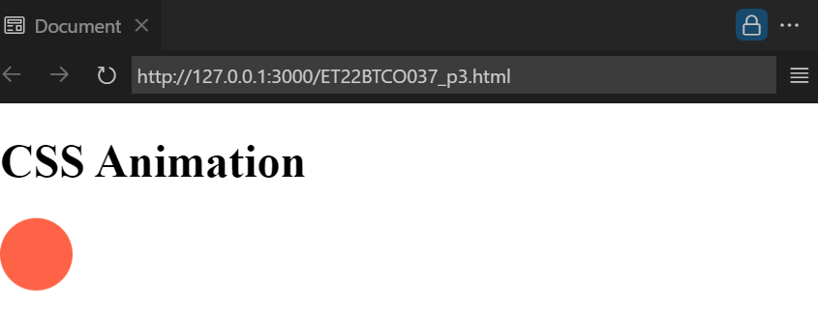

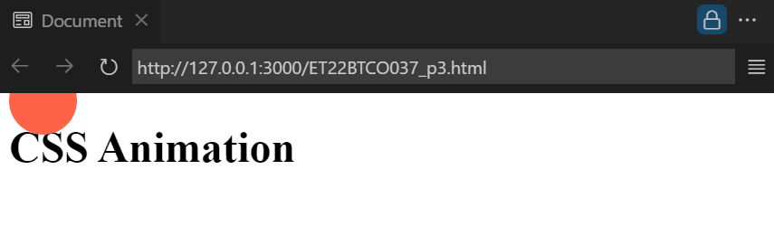

**4. Use CSS to style images**

<!DOCTYPE html>

<html lang="en">

<head>

<meta charset="UTF-8">

<meta name="viewport" content="width=device-width, initial-scale=1.0">

<style>

.image {

width: 150px;

height: auto;

border: 5px solid darkblue;

border-radius: 20px;

box-shadow: 5px 5px 10px rgba(0,0,0,0.5);

}

</style>

<title>Styled Image</title>

</head>

<body>

<h1>Styling Images with CSS</h1>

<img class="image" src="image1.jpg" alt="Styled Image">

</body>

</html>

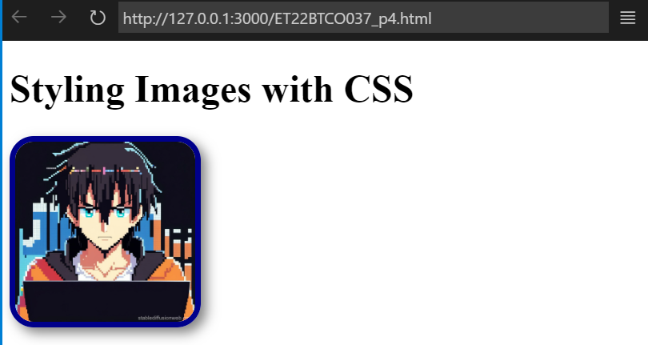

**5. Demonstrate the use of Media Queries**

<!DOCTYPE html>

<html lang="en">

<head>

<meta charset="UTF-8">

<meta name="viewport" content="width=device-width, initial-scale=1.0">

<style>

.container {

width: 80%;

height: 100px;

background-color: lightcoral;

}

@media screen and (max-width: 600px){

.container {

background-color: lightgreen;

flex-wrap: nowrap;

}

}

</style>

<title>Media Queries</title>

</head>

<body>

<h1>CSS Media Queries</h1>

<div class="container"></div>

</body>

</html>

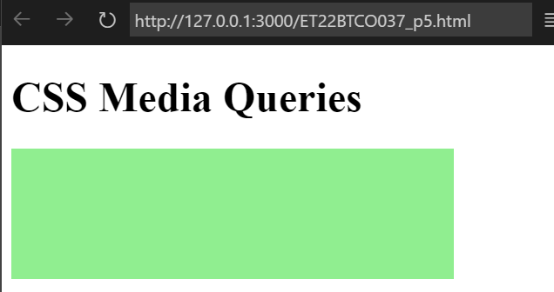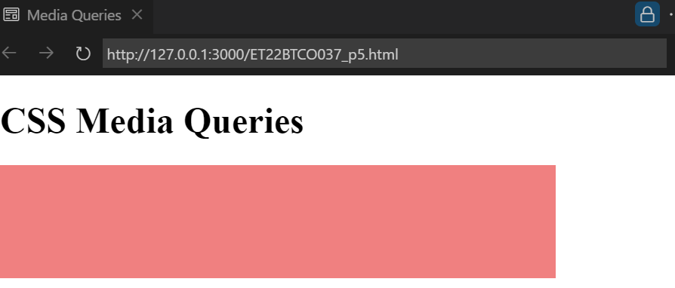

**6. Demonstrate the use of Linear Gradient and Radial Gradient**

<!DOCTYPE html>

<html lang="en">

<head>

<meta charset="UTF-8">

<meta name="viewport" content="width=device-width, initial-scale=1.0">

<style>

.linear {

width: 200px;

height: 100px;

background: linear-gradient(to right, red, yellow);

}

.radial {

width: 200px;

height: 100px;

background: radial-gradient(circle, lightblue, blue);

}

</style>

<title>Gradients</title>

</head>

<body>

<h1>CSS Linear and Radial Gradients</h1>

<h4>Linear Gradient</h4>

<div class="linear"></div>

<h4>Radial Gradient</h4>

<div class="radial"></div>

</body>

</html>

