**JS Practical No : 5.1**

**Date:** 12/08/2024

**Problem Statement:**

1. Write a javascript program to display “hello world” using internal javascript and external javascript.

2. Write a javascript program to demo of local and global variables.

3. Write a javascript program to demo alert box, conditional box and prompt box.

4. Write a javascript program to take user input as integer from user and find out that number is prime or not.

5. Write a javascript program to calculate of a person age. Take user's birthdate from user and current date from system.

6. Write a javascript program to print Fibonacci series using function.

7. Write a javascript function to find factorial of a given number and return the answer.

8. Create different variables of Array and string objects. And use all the functions related to that.

**1. Write a javascript program to display “hello world” using internal javascript and external javascript.**

<!DOCTYPE html>

<html lang="en">

<head>

<meta charset="UTF-8">

<meta name="viewport" content="width=device-width, initial-scale=1.0">

<title>Document</title>

<style>

#demo1,#demo2{

background-color:antiquewhite;

}

</style>

</head>

<body>

<h1>Internal JS</h1>

<span id="demo1"></span>

<script> document.getElementById("demo1").innerHTML = "Hello World";</script>

<h1>External JS</h1>

<span id="demo2"></span>

<script src="myScript.js"></script>

</body>

</html>

**myScript.java**

document.getElementById("demo2").innerHTML = "Hello World";

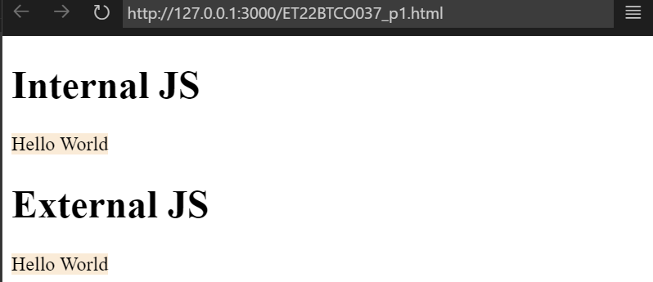

**2. Write a javascript program to demo of local and global variables.**

<!DOCTYPE html>

<html lang="en">

<head>

<meta charset="UTF-8">

<meta name="viewport" content="width=device-width, initial-scale=1.0">

<title>Local and Global Variables Demo</title>

</head>

<body>

<h1>JS Local and Global Variables Demo</h1>

<p id="demo"></p>

<script>

// Global variable

var globalVar = "I am a global variable";

function demoLocalAndGlobalVariables() {

// Local variable

var localVar = "I am a local variable";

console.log(localVar);

document.getElementById("demo").innerHTML = localVar;

console.log(globalVar);

document.getElementById("demo").innerHTML += "<br>" + globalVar;

}

demoLocalAndGlobalVariables();

console.log("Outside function:", globalVar);

console.log("Outside function:", localVar); // Error: localVar is not defined

</script>

</body>

</html>

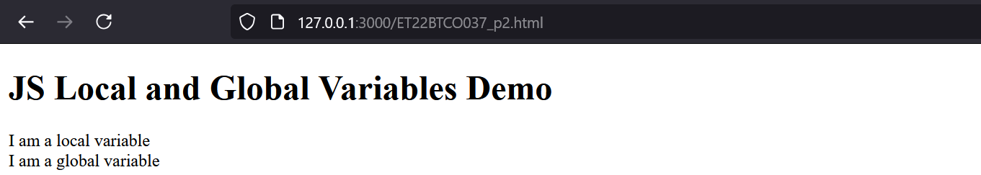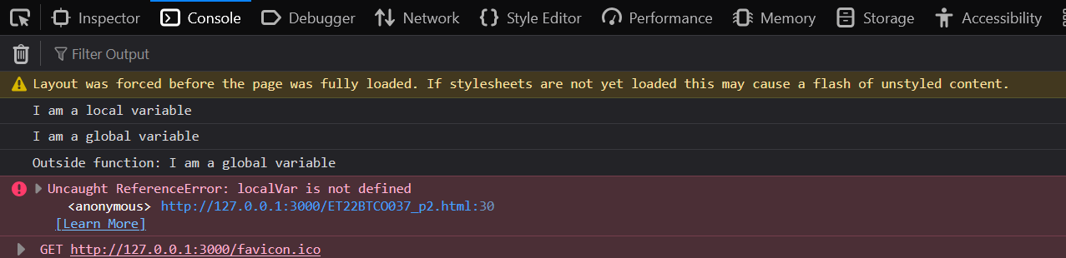

**3. Write a javascript program to demo alert box, conditional box and prompt box.**

<!DOCTYPE html>

<html lang="en">

<head>

<meta charset="UTF-8">

<meta name="viewport" content="width=device-width, initial-scale=1.0">

<title>Alert, Confirm, and Prompt Demo</title>

</head>

<body>

<h1>JS Alert, Confirm, and Prompt Boxes Demo</h1>

<button onclick="showAlert()">Show Alert</button>

<button onclick="showConfirm()">Show Confirm</button>

<button onclick="showPrompt()">Show Prompt</button>

<p id="result"></p>

<script>

function showAlert() {

alert("This is an alert box!");

}

function showConfirm() {

const result = confirm("Do you want to proceed?");

const resultText = result ? "You pressed OK." : "You pressed Cancel.";

document.getElementById("result").innerText = resultText;

}

function showPrompt() {

const name = prompt("Please enter your name:", "Guest");

if (name !== null && name.trim() !== "") {

document.getElementById("result").innerText = `Hello, ${name}!`;

} else {

document.getElementById("result").innerText = "You didn't enter a name.";

}

}

</script>

</body>

</html>

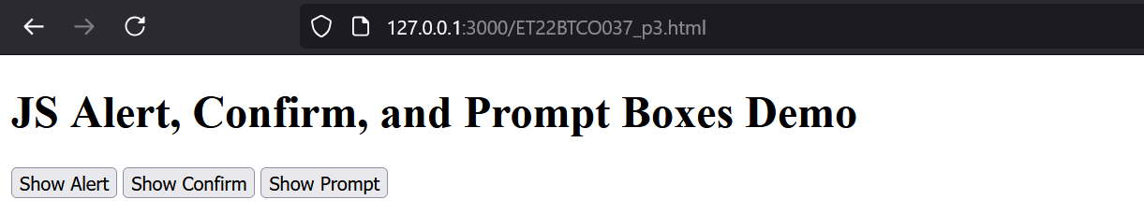

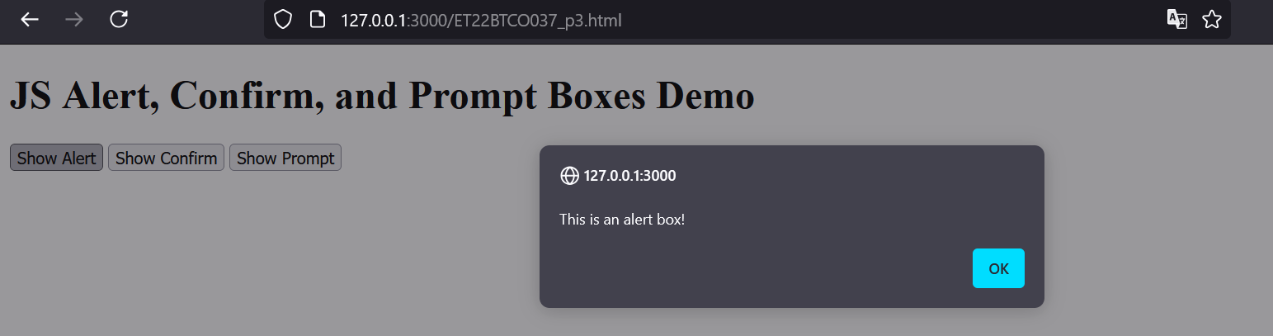

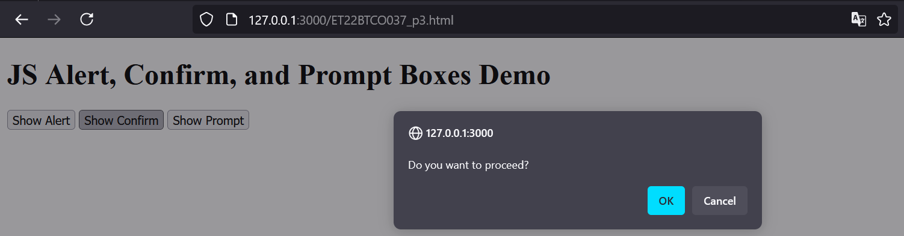

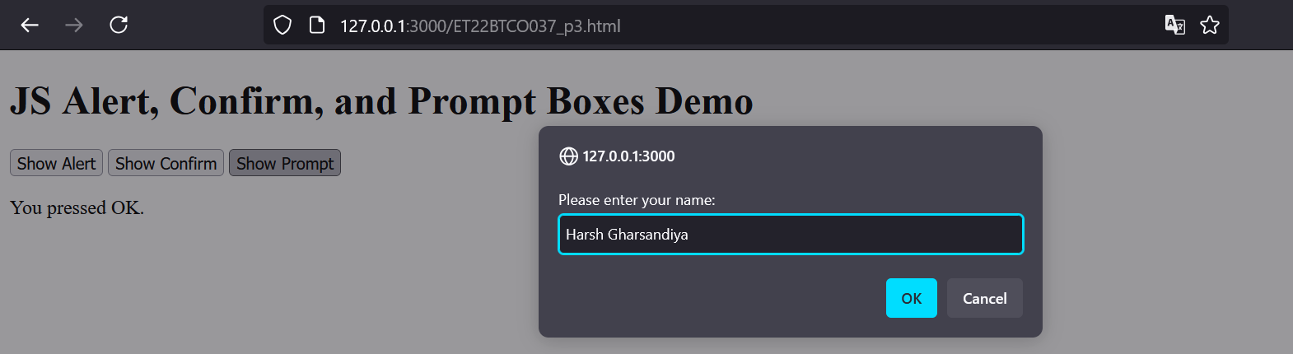

**4. Write a javascript program to take user input as integer from user and find out that number is prime or not.**

<!DOCTYPE html>

<html lang="en">

<head>

<meta charset="UTF-8">

<meta name="viewport" content="width=device-width, initial-scale=1.0">

<title>Prime Number Check</title>

</head>

<body>

<h1>Prime Number Checker</h1>

<button onclick="checkPrime()">Check if Prime</button>

<p id="result"></p>

<script>

function checkPrime() {

// Prompt the user to enter a integer number

const input = prompt("Enter an integer to check if it's a prime number:");

const number = parseInt(input);

if (isNaN(number) || number <= 1) {

document.getElementById("result").innerText = "Please enter a valid integer greater than 1.";

return;

}

function isPrime(n) {

if (n <= 1) return false;

if (n === 2) return true;

if (n % 2 === 0) return false;

for (let i = 3; i <= Math.sqrt(n); i += 2) {

if (n % i === 0) return false;

}

return true;

}

const resultText = isPrime(number) ? `${number} is a prime number.` : `${number} is not a prime number.`;

document.getElementById("result").innerText = resultText;

}

</script>

</body>

</html>

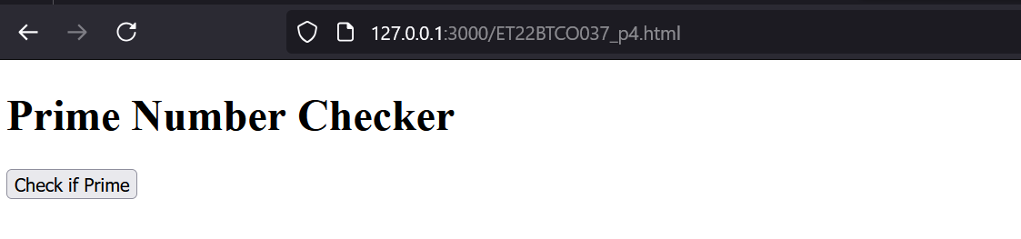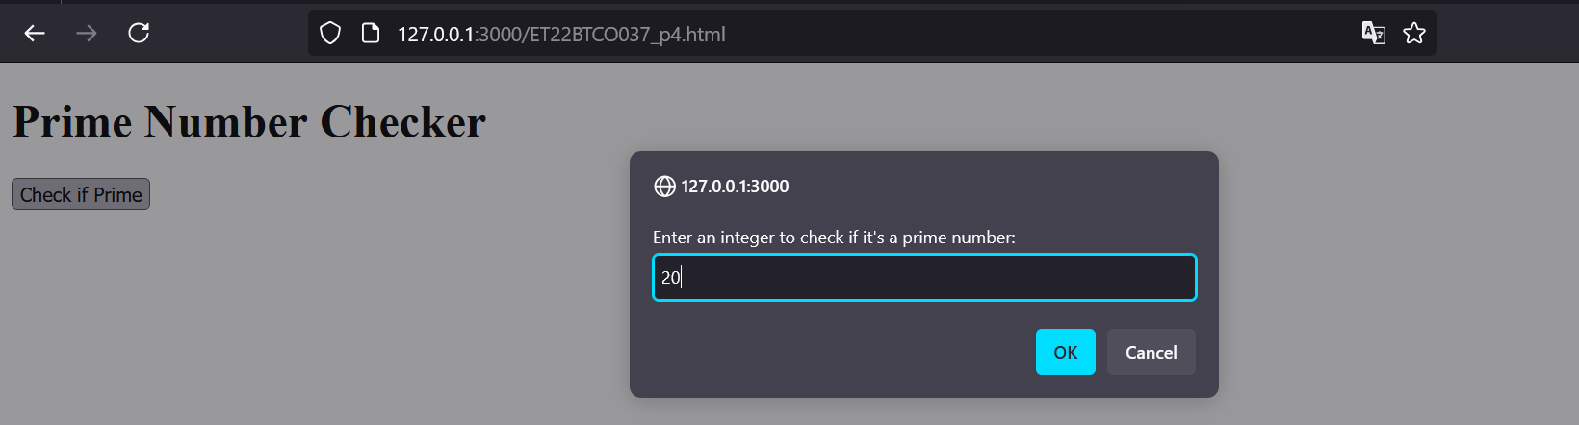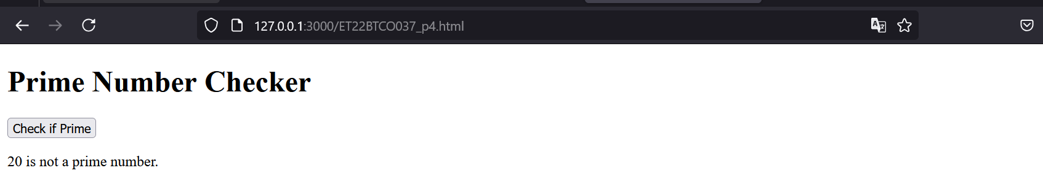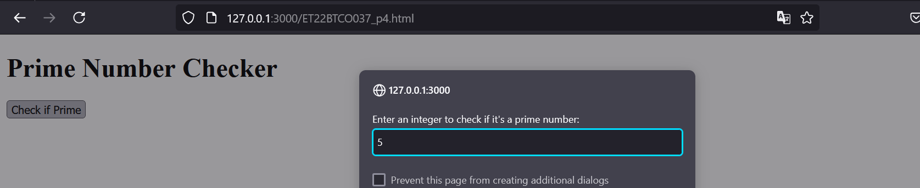

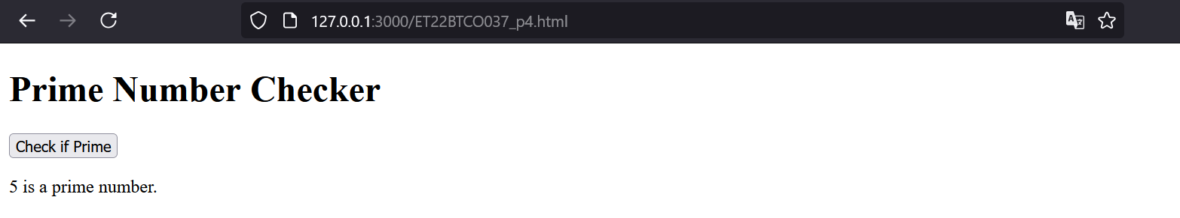

**5. Write a javascript program to calculate of a person age. Take user's birthdate from user and current date from system.**

<!DOCTYPE html>

<html lang="en">

<head>

<meta charset="UTF-8">

<meta name="viewport" content="width=device-width, initial-scale=1.0">

<title>Age Calculator</title>

</head>

<body>

<h1>Age Calculator</h1>

<button onclick="calculateAge()">Calculate Age</button>

<p id="result"></p>

<script>

function calculateAge() {

const birthdateInput = prompt("Enter your birthdate (YYYY-MM-DD):");

const birthdate = new Date(birthdateInput);

const today = new Date();

if (isNaN(birthdate.getTime()) || birthdate > today) {

document.getElementById("result").innerText = "Please enter a valid past date in the format YYYY-MM-DD.";

return;

}

let age = today.getFullYear() - birthdate.getFullYear();

const monthDifference = today.getMonth() - birthdate.getMonth();

if (monthDifference < 0 || (monthDifference === 0 && today.getDate() < birthdate.getDate())) {

age--;

}

document.getElementById("result").innerText = `You are ${age} years old.`;

}

</script>

</body>

</html>

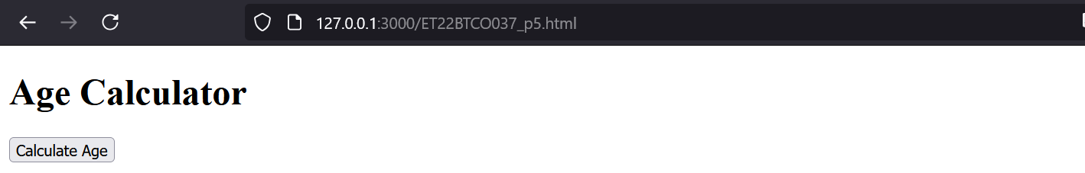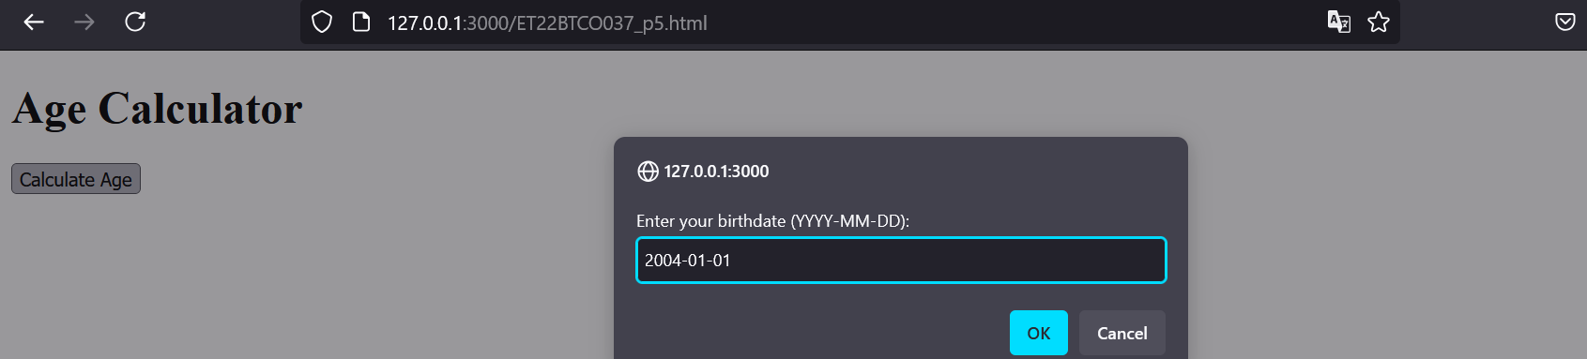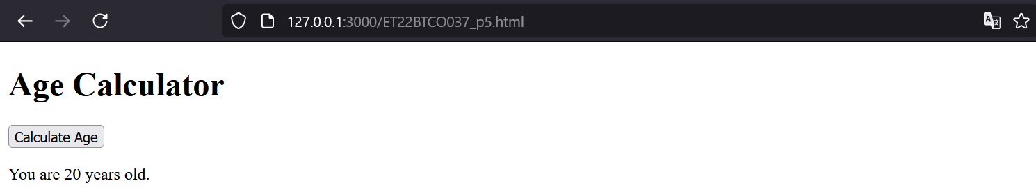

**6. Write a javascript program to print Fibonacci series using function.**

<!DOCTYPE html>

<html lang="en">

<head>

<meta charset="UTF-8">

<meta name="viewport" content="width=device-width, initial-scale=1.0">

<title>Fibonacci Series</title>

</head>

<body>

<h1>Fibonacci Series Generator</h1>

<button onclick="generateFibonacci()">Generate Fibonacci Series</button>

<p id="result"></p>

<script>

function generateFibonacci() {

const numTerms = parseInt(prompt("Enter the number of terms for the Fibonacci series:"));

if (isNaN(numTerms) || numTerms <= 0) {

document.getElementById("result").innerText = "Please enter a valid positive integer.";

return;

}

const fibonacciSeries = fibonacci(numTerms);

document.getElementById("result").innerText = `Fibonacci Series: ${fibonacciSeries.join(', ')}`;

}

function fibonacci(n) {

const series = [];

let a = 0, b = 1;

for (let i = 0; i < n; i++) {

series.push(a);

const nextTerm = a + b;

a = b;

b = nextTerm;

}

return series;

}

</script>

</body>

</html>

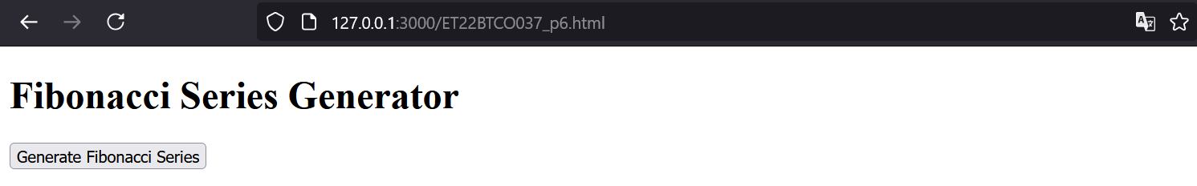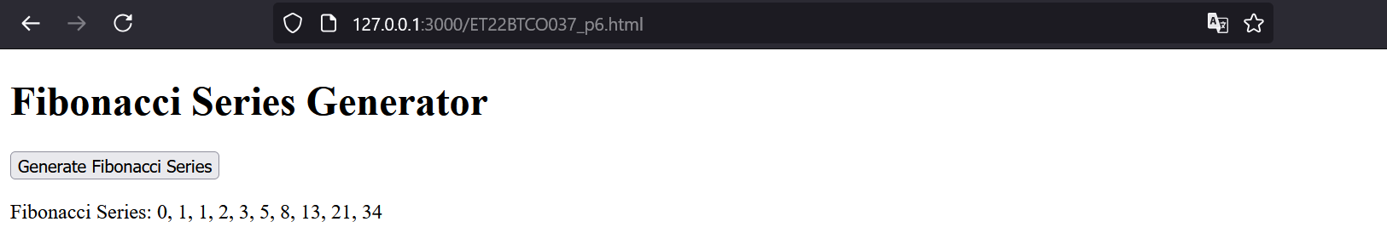

**7. Write a javascript function to find factorial of a given number and return the answer.**

<!DOCTYPE html>

<html lang="en">

<head>

<meta charset="UTF-8">

<meta name="viewport" content="width=device-width, initial-scale=1.0">

<title>Factorial Calculator</title>

</head>

<body>

<h1>Factorial Calculator</h1>

<button onclick="calculateFactorial()">Calculate Factorial</button>

<p id="result"></p>

<script>

function calculateFactorial() {

const number = parseInt(prompt("Enter a positive integer:"));

if (isNaN(number) || number < 0) {

document.getElementById("result").innerText = "Please enter a valid non-negative integer.";

return;

}

const factorialResult = factorial(number);

document.getElementById("result").innerText = `Factorial of ${number} is ${factorialResult}.`;

}

function factorial(n) {

if (n === 0 || n === 1) return 1;

return n * factorial(n - 1);

}

</script>

</body>

</html>

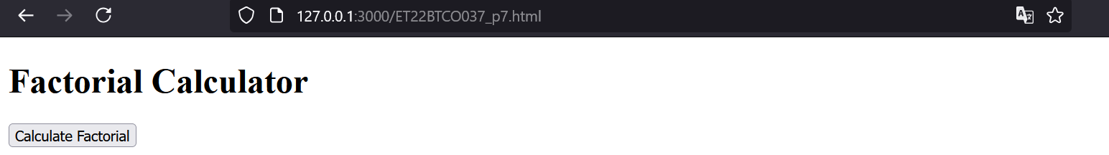

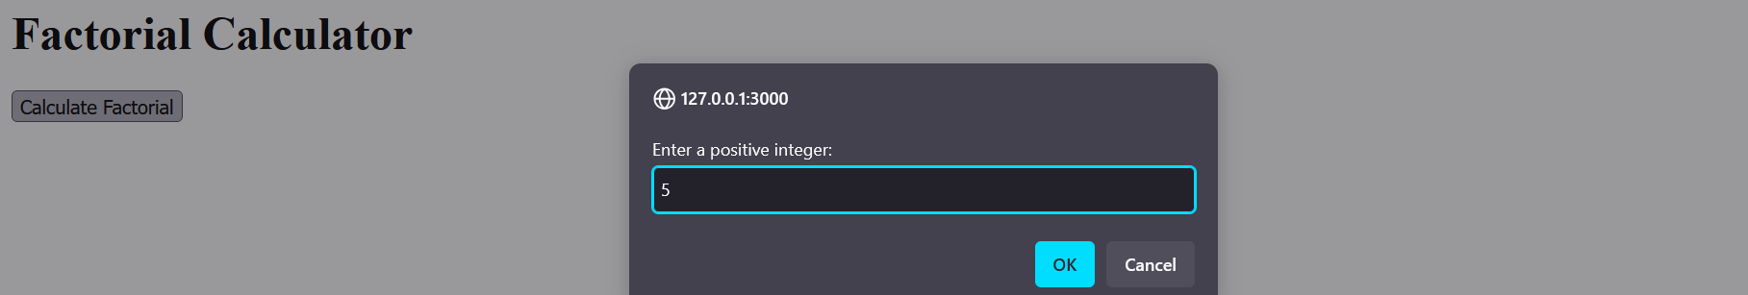

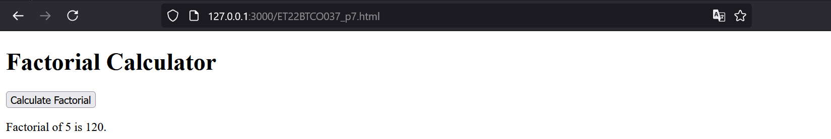

**8. Create different variables of Array and string objects. And use all the functions related to that.**

<!DOCTYPE html>

<html lang="en">

<head>

<meta charset="UTF-8">

<meta name="viewport" content="width=device-width, initial-scale=1.0">

<title>Array and String Operations</title>

</head>

<body>

<h1>Array and String Operations</h1>

<button onclick="performArrayOperations()">Array Operations</button>

<button onclick="performStringOperations()">String Operations</button>

<p id="result"></p>

<script>

function performArrayOperations() {

let numbers = [5, 3, 8, 1, 2];

let fruits = ["Apple", "Banana", "Cherry"];

// Array functions

numbers.push(6); // Add element to the end

fruits.pop(); // Remove last element

let mergedArray = numbers.concat(fruits); // Merge arrays

let sortedNumbers = numbers.sort((a, b) => a - b); // Sort numbers array

let sortedFruits = fruits.sort(); // Sort fruits alphabetically

let sortedMergedArray = mergedArray.sort(); // Sort merged array as strings

document.getElementById("result").innerHTML = `

Numbers Array: ${numbers}<br>

Fruits Array: ${fruits}<br>

Merged Array: ${mergedArray}<br>

Sorted Numbers Array: ${sortedNumbers}<br>

Sorted Fruits Array: ${sortedFruits}<br>

Sorted Merged Array: ${sortedMergedArray}<br>

Array Length: ${mergedArray.length}

`;

}

function performStringOperations() {

let text = "Hello, world!";

let greeting = "Hello";

// String functions

let upperCaseText = text.toUpperCase(); // Convert to uppercase

let lowerCaseText = text.toLowerCase(); // Convert to lowercase

let replacedText = text.replace("world", "JavaScript"); // Replace substring

let textLength = text.length; // Length of the string

let substring = text.substring(0, 5); // Extract substring

document.getElementById("result").innerHTML = `

Original Text: ${text}<br>

Uppercase Text: ${upperCaseText}<br>

Lowercase Text: ${lowerCaseText}<br>

Replaced Text: ${replacedText}<br>

Text Length: ${textLength}<br>

Substring: ${substring}<br>

Concatenated String: ${text.concat(" How are you?")}

`;

}

</script>

</body>

</html>

