**JS Practical No : 5.2**

**Date:** 02/09/2024

**Problem Statement:**

**9. Create javascript that scroll some message in Status window of browser.**

<!DOCTYPE html>

<html lang="en">

<head>

<meta charset="UTF-8">

<meta name="viewport" content="width=device-width, initial-scale=1.0">

<title>Document</title>

</head>

<body>

<h1>JavaScript 5.2</h1>

<p>Create javascript that scroll some message in Status window of browser</p>

<script>

let message = "Scrolling Message in Browser Title ";

let index = 0;

function scrollMessage() {

document.title = message.substring(index) + message.substring(0, index);

index = (index + 1) % message.length;

setTimeout(scrollMessage, 200); // Adjust scrolling speed by changing the time

}

scrollMessage();

</script>

</body>

</html>

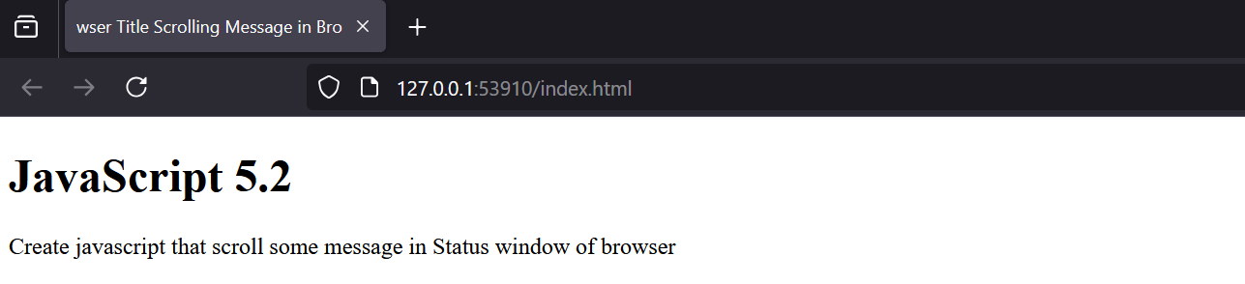

**10. Write a javascript program to change the background color of web page repeatedly.**

<!DOCTYPE html>

<html lang="en">

<head>

<meta charset="UTF-8">

<meta name="viewport" content="width=device-width, initial-scale=1.0">

<title>Document</title>

<link rel="stylesheet" href="style.css">

</head>

<body>

<h1>JavaScript 5.2</h1>

<p>Write a javascript program to change the background color of web page repeatedly.</p>

<script>

let colors = ["red", "blue", "green", "yellow", "purple", "orange"];

let index = 0;

function changeBackgroundColor() {

document.body.style.backgroundColor = colors[index];

index = (index + 1) % colors.length;

setTimeout(changeBackgroundColor, 1000);

}

changeBackgroundColor();

scrollMessage();

</script>

<footer>Author: ET22BTCO037</footer>

</body>

</html>

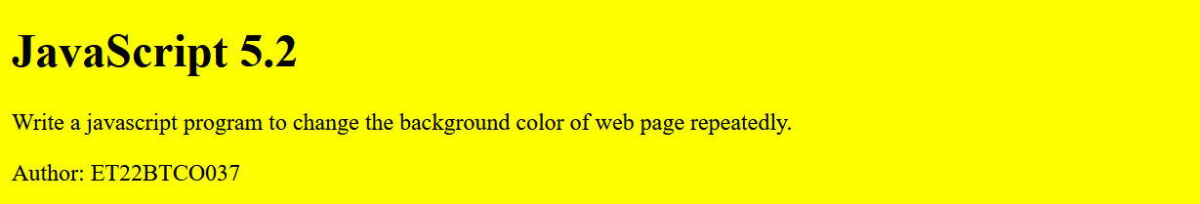



**11. Create a webpage containing one button. clicking on this button change the size of the window & position.**

<!DOCTYPE html>

<html lang="en">

<head>

<meta charset="UTF-8">

<meta name="viewport" content="width=device-width, initial-scale=1.0">

<title>Resize and Move Window</title>

<script>

function openNewWindow() {

const newWindow = window.open("", "", "width=400,height=300");

newWindow.resizeTo(800, 600);

newWindow.moveTo(100, 100);

}

</script>

</head>

<body>

<h1>Click the button to open, resize, and move a new window</h1>

<button onclick="openNewWindow()">Open and Resize Window</button>

<footer>Author: ET22BTCO037</footer>

</body>

</html>

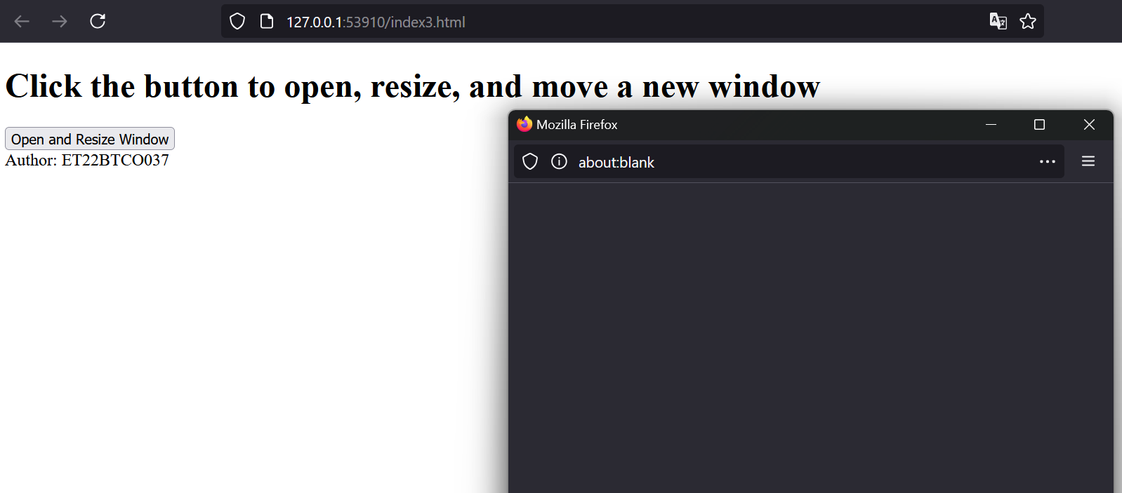

**12. Put three button “OPEN NEW WINDOW”,”CLOSE CHILD WINDOW”,”CLOSE MAIN WINDOW” in main HTML page, on click of first button, execute some JavaScript code that will open one child window. Clicking on second button child window will close and third button main html page will close.**

<!DOCTYPE html>

<html lang="en">

<head>

<title>Main Window</title>

<script>

let childWindow;

function openChildWindow() {

childWindow = window.open("", "Child Window", "width=400,height=300");

childWindow.document.write("<h1>This is the Child Window</h1>");

childWindow.document.write("<p>Click outside to close me or use the button in the main window.</p>");

}

function closeChildWindow() {

if (childWindow) {

childWindow.close();

}

document.getElementById("p").textContent = "Child Window Close";

}

function closeMainWindow() {

window.close();

}

</script>

</head>

<body>

<h1>Main Window</h1>

<button onclick="openChildWindow()">OPEN NEW WINDOW</button>

<button onclick="closeChildWindow()">CLOSE CHILD WINDOW</button>

<button onclick="closeMainWindow()">CLOSE MAIN WINDOW</button>

<p id="p"></p>

<footer>Author: ET22BTCO037</footer>

</body>

</html>

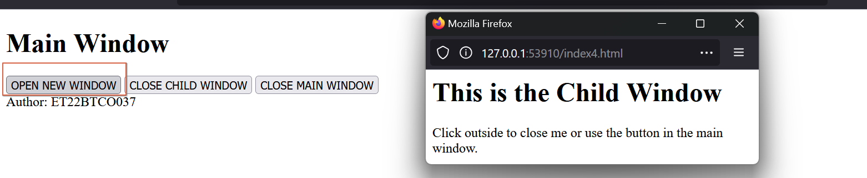

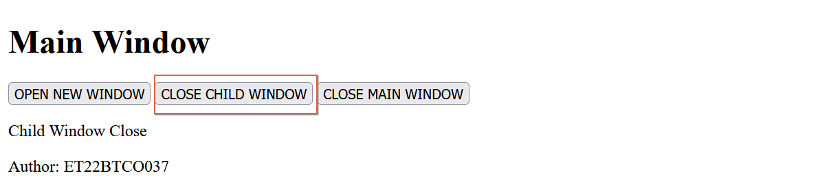

**13. Write a javascript to get details from visitors browser.**

<!DOCTYPE html>

<html lang="en">

<head>

<title>Browser Details</title>

<script>

function getBrowserDetails() {

const browserDetails = {

userAgent: navigator.userAgent,

appName: navigator.appName,

appVersion: navigator.appVersion,

platform: navigator.platform,

language: navigator.language,

}

document.getElementById('details').innerHTML = `

<h2>Browser Details:</h2>

<p><strong>User Agent:</strong> ${browserDetails.userAgent}</p>

<p><strong>App Name:</strong> ${browserDetails.appName}</p>

<p><strong>App Version:</strong> ${browserDetails.appVersion}</p>

<p><strong>Platform:</strong> ${browserDetails.platform}</p>

<p><strong>Language:</strong> ${browserDetails.language}</p>

`;

}

</script> </head>

<body>

<h1>Get Visitor's Browser Details</h1>

<button onclick="getBrowserDetails()">Get Browser Details</button>

<div id="details"></div>

<footer>Author: ET22BTCO037</footer>

</body>

</html>

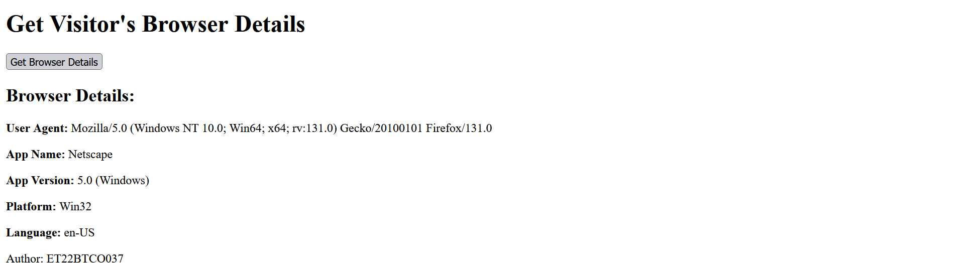

**14. Write a javascript program to rotate images.**

<!DOCTYPE html>

<html lang="en">

<head>

<title>Image Rotation</title>

<style>

#image {

width: 150px;

height: auto;

transition: transform 0.5s;

}

</style>

<script>

let rotation = 0;

function rotateImage() {

rotation += 90;

document.getElementById('image').style.transform = `rotate(${rotation}deg)`;

}

</script>

</head>

<body>

<h1>Rotate Image</h1>

<img id="image" src="itachi.jpg" alt="Placeholder Image">

<br>

<button onclick="rotateImage()">Rotate Image</button>

<footer>Author: ET22BTCO037</footer>

</body>

</html>

|  |  |
| --- | --- |

**15. Write a javascript program to zoom out the image. use mouseover event for the same.**

<!DOCTYPE html>

<html lang="en">

<head>

<title>Image Zoom Out on Mouseover</title>

<style>

#image {

width: 150px;

transition: transform 0.3s;

}</style>

<script>

function zoomOutImage() {

const image = document.getElementById('image');

image.style.transform = 'scale(0.5)';

}

function resetImage() {

const image = document.getElementById('image');

image.style.transform = 'scale(1)';

}

</script> </head>

<body>

<h1>Zoom Out Image on Mouseover</h1>

<img id="image" src="itachi.jpg" alt="Placeholder Image"

onmouseover="zoomOutImage()" onmouseout="resetImage()">

<footer>Author: ET22BTCO037</footer>

</body>

</html>

|  |  |
| --- | --- |

**16. Create a page that includes a select object to change the background color of the current page. The property that needs to be set is bgColor,Similar things for foreground color.**

<!DOCTYPE html>

<html lang="en">

<head>

<title>Change Colors</title>

<script>

function changeColor() {

document.body.bgColor = document.getElementById('bgColorSelect').value;

document.body.style.color = document.getElementById('fgColorSelect').value;

}

</script> </head>

<body>

<h1>Change Colors</h1>

<label>Background:

<select id="bgColorSelect" onchange="changeColor()">

<option value="white">White</option>

<option value="lightblue">Light Blue</option>

<option value="lightgreen">Light Green</option>

</select>

</label>

<label>Foreground:

<select id="fgColorSelect" onchange="changeColor()">

<option value="black">Black</option>

<option value="blue">Blue</option>

<option value="red">Red</option>

</select>

</label>

<footer>Author: ET22BTCO037</footer>

</body>

</html>

|  |  |
| --- | --- |

**17. A document contains two forms, named form1 and form2. In the form1 is a field named acc1(type=text) and form2 contains field select(type=text). Write a program that will copy values of acc1 to select .**

<!DOCTYPE html>

<html lang="en">

<head>

<title>Copy Value Between Forms</title>

<script>

function copyValue() {

const acc1Value = document.forms['form1']['acc1'].value;

document.forms['form2']['select'].value = acc1Value;

}

</script></head>

<body>

<h1>Copy Value Between Forms</h1>

<form name="form1">

<label for="acc1">Account Name:</label>

<input type="text" name="acc1" id="acc1">

</form>

<form name="form2">

<label for="select">Select Account:</label>

<select name="select" id="select">

<option value="">--Select an account--</option>

<option value="Account1">Account1</option>

<option value="Account2">Account2</option>

</select>

</form>

<button onclick="copyValue()">Copy to Select</button>

<footer>Author: ET22BTCO037</footer>

</body>

</html>

|  |  |
| --- | --- |

**18. Create a webpage contains two textbox as userid and password and one submit button. Check for validation for userid as mobile number and password should contains minimum 8 character,with special symbol and one upper case letter.**

<!DOCTYPE html>

<html lang="en">

<head>

<meta charset="UTF-8">

<meta name="viewport" content="width=device-width, initial-scale=1.0">

<title>Login Validation</title>

<style>

.message {

color: red;

}

</style>

<script>

function validateForm(event) {

event.preventDefault();

const userId = document.getElementById('userid').value;

const password = document.getElementById('password').value;

const messageDiv = document.getElementById('message');

messageDiv.innerHTML = '';

const phonePattern = /^[0-9]{10}$/;

const passwordPattern = /^(?=.*[A-Z])(?=.*[!@#$%^&*])(?=.*[0-9])(?=.{8,})/;

if (!phonePattern.test(userId)) {

messageDiv.innerHTML = "Invalid mobile number!";

return false;

}

if (!passwordPattern.test(password)) {

messageDiv.innerHTML = "Password must be at least 8 characters long, contain one uppercase letter, one special character, and one number.";

return false;

}

messageDiv.innerHTML = "Form submitted successfully!";

messageDiv.style.color = "green";

return true;

}

function togglePassword() {

const passwordField = document.getElementById('password');

passwordField.type = passwordField.type === 'password' ? 'text' : 'password';

}

</script>

</head>

<body>

<h1>Login</h1>

<form onsubmit="validateForm(event)">

<label for="userid">User ID (Mobile Number):</label>

<input type="text" id="userid" required><br>

<label for="password">Password:</label>

<input type="password" id="password" required>

<input type="checkbox" onclick="togglePassword()"> Show Password<br>

<button type="submit">Submit</button>

</form>

<div id="message" class="message"></div>

<footer>Author: ET22BTCO037</footer>

</body>

</html>

|  |  |
| --- | --- |
|  |  |

**19. Perform javascript validation for HTML assignment 1: Question No:5**

<!DOCTYPE html>

<html lang="en">

<head>

<title>Javascript Practical</title>

<style>

.message { color: red; }

</style>

<script>

function validateForm(event) {

event.preventDefault();

const fields = {

regId: document.getElementById('regId').value,

userName: document.getElementById('userName').value,

firstName: document.getElementById('firstName').value,

lastName: document.getElementById('lastName').value,

password: document.getElementById('password').value,

gender: document.querySelector('input[name="gender"]:checked'),

dobDay: document.getElementById('dobDay').value,

dobMonth: document.getElementById('dobMonth').value,

dobYear: document.getElementById('dobYear').value,

address: document.getElementById('address').value,

city: document.getElementById('city').value,

state: document.getElementById('state').value,

country: document.getElementById('country').value,

hobbies: document.querySelectorAll('input[name="hobby"]:checked'),

mobile: document.getElementById('mobile').value,

cv: document.getElementById('cv').value

};

let messageDiv = document.getElementById('message');

messageDiv.innerHTML = '';

if (!fields.regId) messageDiv.innerHTML += "Registration ID is required.<br>";

if (!fields.userName) messageDiv.innerHTML += "User Name is required.<br>";

if (!fields.firstName) messageDiv.innerHTML += "First Name is required.<br>";

if (!fields.lastName) messageDiv.innerHTML += "Last Name is required.<br>";

if (!fields.password || !/^(?=.*[A-Z])(?=.*[!@#$%^&*])(?=.*[0-9])(?=.{8,})/.test(fields.password)) {

messageDiv.innerHTML += "Password must be at least 8 characters long, contain one uppercase letter, one special character, and one number.<br>";

}

if (!fields.gender) messageDiv.innerHTML += "Gender must be selected.<br>";

if (!fields.dobDay || !fields.dobMonth || !fields.dobYear) messageDiv.innerHTML += "Date of Birth must be selected.<br>";

if (!fields.address) messageDiv.innerHTML += "Address is required.<br>";

if (fields.city = "") messageDiv.innerHTML += "City is required.<br>";

if (fields.state = "") messageDiv.innerHTML += "State is required.<br>";

if (fields.country = "") messageDiv.innerHTML += "Country is required.<br>";

if (fields.hobbies.length === 0) messageDiv.innerHTML += "At least one hobby must be selected.<br>";

if (!fields.mobile || !/^[0-9]{10}$/.test(fields.mobile)) messageDiv.innerHTML += "Mobile No must be a valid 10-digit number.<br>";

if (!fields.cv) messageDiv.innerHTML += "Attach C.V. is required.<br>";

if (messageDiv.innerHTML === '') {

messageDiv.innerHTML = "Form submitted successfully!";

messageDiv.style.color = "green";

} else {

messageDiv.style.color = "red";

}

}

</script>

</head>

<body>

<table border="1" cellspacing="2" align="center" bgcolor="#fabdf9" style="border: 2px solid blue;">

<tr align="center"><td colspan="2" style="border: 2px solid blue;"><h1>Registration Page</h1></td></tr>

<tr><td style="border: 2px solid blue;">Registration id:</td><td style="border: 2px solid blue;"><input type="text" id="regId"></td></tr>

<tr><td style="border: 2px solid blue;">User Name:</td><td style="border: 2px solid blue;"><input type="text" id="userName"></td></tr>

<tr><td style="border: 2px solid blue;">First Name:</td><td style="border: 2px solid blue;"><input type="text" id="firstName"></td></tr>

<tr><td style="border: 2px solid blue;">Last Name:</td><td style="border: 2px solid blue;"><input type="text" id="lastName"></td></tr>

<tr><td style="border: 2px solid blue;">Password:</td><td style="border: 2px solid blue;"><input type="password" id="password"></td></tr>

<tr><td style="border: 2px solid blue;">Gender</td><td style="border: 2px solid blue;"><input type="radio" name="gender">Male<input type="radio" name="gender">Female</td></tr>

<tr><td style="border: 2px solid blue;">Date of Birth:</td>

<td style="border: 2px solid blue;">

<select id="dobDay"><option value="">Day</option><option value="1">1</option><option value="2">2</option></select>

<select id="dobMonth"><option value="">Month</option><option value="1">January</option><option value="2">February</option></select>

<select id="dobYear"><option value="">Year</option><option value="2000">2000</option><option value="1999">1999</option></select>

</td>

</tr>

<tr><td style="border: 2px solid blue;">Address:</td><td style="border: 2px solid blue;"><textarea id="address" rows="3" cols="20"></textarea></td></tr>

<tr><td style="border: 2px solid blue;">City:</td><td style="border: 2px solid blue;"><select id="city"><option value="">Surat</option></select></td></tr>

<tr><td style="border: 2px solid blue;">State:</td><td style="border: 2px solid blue;"><select id="state"><option value="">Gujarat</option></select></td></tr>

<tr><td style="border: 2px solid blue;">Country:</td><td style="border: 2px solid blue;"><select id="country"><option value="">India</option></select></td></tr>

<tr><td style="border: 2px solid blue;">Hobbies:</td><td style="border: 2px solid blue;"><input type="checkbox" name="hobby">Playing<input type="checkbox" name="hobby">Editing<input type="checkbox" name="hobby">Singing</td></tr>

<tr><td style="border: 2px solid blue;">Mobile No:</td><td style="border: 2px solid blue;"><input type="text" id="mobile"></td></tr>

<tr><td style="border: 2px solid blue;">Attach C.V.:</td><td style="border: 2px solid blue;"><input type="file" id="cv"></td></tr>

<tr align="center"><td colspan="2" style="border: 2px solid blue;"><button onclick="validateForm(event)">Submit</button><button type="reset">Reset</button></td></tr>

<tr><td colspan="2" class="message" id="message"></td></tr>

</table>

</body>

</html>

|  |  |
| --- | --- |

|  |  |
| --- | --- |