**JS Practical No : 6.1**

**Date:** 23/09/2024

**Problem Statement:**

**1) Write PHP Script to print Fibonacci series.**

<?php

function fibonacci($n) {

$a = 0; $b = 1;

echo "Fibonacci Series: ";

for ($i = 0; $i < $n; $i++) {

echo $a . " ";

$next = $a + $b;

$a = $b;

$b = $next;

}

}

$n = (int)readline("Enter the number of terms: ");

fibonacci($n);

?>

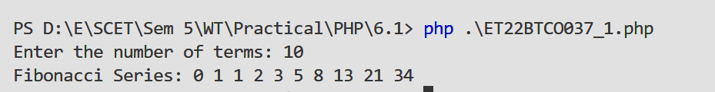



**2) Write PHP Script to find maximum number out of three given numbers.**

<?php

function maxOfThree($a, $b, $c) {

return max($a, $b, $c);

}

$a = (int)readline("Enter first number: ");

$b = (int)readline("Enter second number: ");

$c = (int)readline("Enter third number: ");

echo "Maximum number is: " . maxOfThree($a, $b, $c) . PHP_EOL;

?>

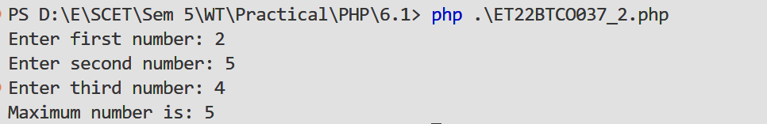

**3) Write a PHP program to compute the sum of the prime numbers less than 100.**

<?php

function isPrime($num) {

if ($num < 2) return false;

for ($i = 2; $i <= sqrt($num); $i++) {

if ($num % $i == 0) return false;

}

return true;

}

$sum = 0;

for ($i = 2; $i < 100; $i++) {

if (isPrime($i)) $sum += $i;

}

echo "Sum of prime numbers less than 100 is: " . $sum . PHP_EOL;

?>



**4) Find the Transpose of a matrix, Multiplication of two matrices and Addition of two matrices.**

<?php

function printMatrix($matrix) {

foreach ($matrix as $row) {

echo implode("\t", $row) . "\n";

}

}

function transposeMatrix($matrix) {

return array_map(null, ...$matrix);

}

function addMatrices($a, $b) {

$result = [];

for ($i = 0; $i < count($a); $i++) {

for ($j = 0; $j < count($a[0]); $j++) {

$result[$i][$j] = $a[$i][$j] + $b[$i][$j];

}

}

return $result;

}

function multiplyMatrices($a, $b) {

$result = [];

for ($i = 0; $i < count($a); $i++) {

for ($j = 0; $j < count($b[0]); $j++) {

$result[$i][$j] = 0;

for ($k = 0; $k < count($b); $k++) {

$result[$i][$j] += $a[$i][$k] * $b[$k][$j];

}

}

}

return $result;

}

$matrixA = [[1, 2], [3, 4]];

$matrixB = [[5, 6], [7, 8]];

echo "Matrix A:\n";

printMatrix($matrixA);

echo "\nMatrix B:\n";

printMatrix($matrixB);

echo "\nTranspose of Matrix A:\n";

printMatrix(transposeMatrix($matrixA));

echo "\nAddition of Matrices:\n";

printMatrix(addMatrices($matrixA, $matrixB));

echo "\nMultiplication of Matrices:\n";

printMatrix(multiplyMatrices($matrixA, $matrixB));

?>

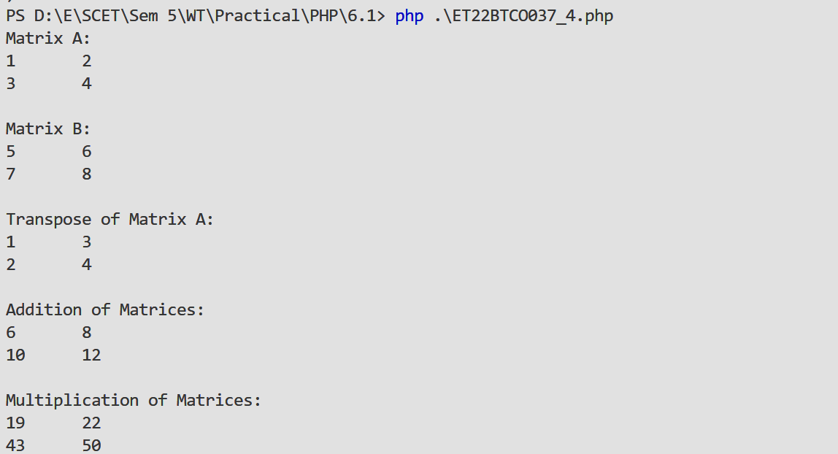

**5) Write PHP script Using user defined function.**

<?php

function greetUser($name) {

return "Hello, " . $name . "!";

}

$name = readline("Enter your name: ");

echo greetUser($name);

?>



**6) Create form using text box, check box, radio button, select, submit button. And display user inserted value in new PHP page.**

**form.php**

<!DOCTYPE html>

<html lang="en">

<head>

<title>User Input Form</title>

</head>

<body>

<form action=ET22BTCO037_6.php method="post">

<label for="name">Name:</label>

<input type="text" id="name" name="name" required><br><br>

<label for="hobby">Hobbies:</label>

<input type="checkbox" name="hobby[]" value="Reading"> Reading

<input type="checkbox" name="hobby[]" value="Gaming"> Gaming<br><br>

<label>Gender:</label>

<input type="radio" name="gender" value="Male" required> Male

<input type="radio" name="gender" value="Female" required> Female<br><br>

<label for="country">Country:</label>

<select id="country" name="country" required>

<option value="India">India</option>

<option value="USA">USA</option>

</select><br><br>

<input type="submit" value="Submit">

</form>

</body>

</html>

**ET22BTCO037_6.php**

<?php

$name = $_POST['name'];

$hobbies = isset($_POST['hobby']) ? implode(", ", $_POST['hobby']) : "None";

$gender = $_POST['gender'];

$country = $_POST['country'];

echo "Name: " . $name . "<br>";

echo "Hobbies: " . $hobbies . "<br>";

echo "Gender: " . $gender . "<br>";

echo "Country: " . $country . "<br>";

?>



