**JS Practical No : 6.2**

**Date:** 30/09/2024

**Problem Statement:**

**1) Write PHP Script to display content of file and display total number of lines, words and characters.**

<?php

$filename = 'file.txt';

if (file_exists($filename)) {

$content = file_get_contents($filename);

$lines = substr_count($content, "\n") + 1;

$words = str_word_count($content);

$characters = strlen($content);

echo "Content of the file:<br>";

echo $content . "<br><br>";

echo "Total number of lines: $lines<br>";

echo "Total number of words: $words<br>";

echo "Total number of characters: $characters<br>";

} else {

echo "File does not exist.";

}

?>

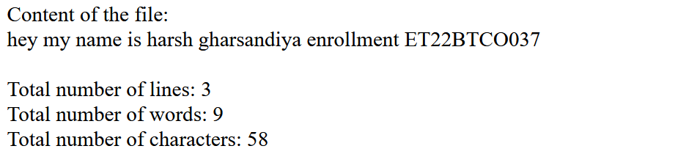

**2) Write a Program to upload image with extension gif or jpeg having size less than 200kB.**

<?php

$uploadOk = 1;

if ($_SERVER["REQUEST_METHOD"] == "POST") {

$targetDir = "uploads/";

$targetFile = $targetDir . basename($_FILES["image"]["name"]);

$imageFileType = strtolower(pathinfo($targetFile, PATHINFO_EXTENSION));

if (getimagesize($_FILES["image"]["tmp_name"]) === false) $uploadOk = 0;

if ($_FILES["image"]["size"] > 200 * 1024) $uploadOk = 0;

if (!in_array($imageFileType, ["gif", "jpeg", "jpg"])) $uploadOk = 0;

if ($uploadOk && move_uploaded_file($_FILES["image"]["tmp_name"], $targetFile)) {

echo "File uploaded: " . htmlspecialchars(basename($_FILES["image"]["name"]));

} else {

echo "Upload failed.";

}

}

?>

<!DOCTYPE html>

<html lang="en">

<head>

<meta charset="UTF-8">

<title>Image Upload</title>

</head>

<body>

<h1>Upload Image</h1>

<form action="" method="post" enctype="multipart/form-data">

<input type="file" name="image" accept=".gif, .jpeg, .jpg" required>

<input type="submit" value="Upload Image">

</form>

</body>

</html>

|  |  |
| --- | --- |

**3) A web application that takes a name as input and on submit it shows a hello page where name is taken from the request. It shows the start time at the right top corner of the page and provides a logout button. On clicking this button, it should show a logout page with Thank You message with the duration of usage (hint: Use session to store name and time).**

**index3.php**

<?php

session_start();

if ($_SERVER["REQUEST_METHOD"] == "POST") {

$_SESSION['name'] = $_POST['name'];

$_SESSION['start_time'] = time();

header("Location: hello.php");

exit();

}

?>

<!DOCTYPE html>

<html lang="en">

<head>

<meta charset="UTF-8">

<title>Input Name</title>

</head>

<body>

<form method="post">

<input type="text" name="name" placeholder="Enter Your Name" required><br>

<input type="submit" value="Submit">

</form>

</body>

</html>

**hello.php**

<?php

session_start();

if (!isset($_SESSION['name'])) header("Location: index3.php");

?>

<!DOCTYPE html>

<html lang="en">

<head>

<meta charset="UTF-8">

<title>Hello</title>

</head>

<body>

<h1>Hello,

<?php echo htmlspecialchars($_SESSION['name']); ?>!</h1>

<div><b>Start Time:

<?php echo date("H:i:s", $_SESSION['start_time']); ?></b>

</div>

<form method="post" action="logout.php">

<input type="submit" value="Logout"></form>

</body>

</html>

|  |  |
| --- | --- |
|  |  |

**4) Write PHP script to demonstrate variables with cookies.**

**index4.php**

<?php

session_start();

if ($_SERVER["REQUEST_METHOD"] == "POST") {

$name = $_POST['name'];

setcookie("user", $name, time() + 3600);

header("Location: welcome.php");

exit();

}

?>

<!DOCTYPE html>

<html lang="en">

<head>

<meta charset="UTF-8">

<title>Set Cookie</title>

</head>

<body>

<form method="post">

<input type="text" name="name" placeholder="Enter your name" required>

<input type="submit" value="Submit">

</form><br><br>

<footer>Author: ET22BTCO037</footer>

</body>

</html>

**welcome.php**

<?php

session_start();

$user = isset($_COOKIE['user']) ? $_COOKIE['user'] : 'Guest';

?>

<!DOCTYPE html>

<html lang="en">

<head>

<meta charset="UTF-8">

<title>Welcome</title>

</head>

<body>

<h1>Welcome, <?php echo htmlspecialchars($user); ?>!</h1>

<p>Your cookie has been set.</p>

<form method="post" action="logout4.php"><input type="submit" value="Logout"></form>

<br><br>

<footer>Author: ET22BTCO037</footer>

</body>

</html>

**logout4.php**

<?php

setcookie("user", "", time() - 3600); // Delete the cookie

header("Location: index4.php");

exit();

?>

|  |  |
| --- | --- |

**After Cookie is set** (Inspect Tab):



**After Logout** (Redirect to index4.php):  
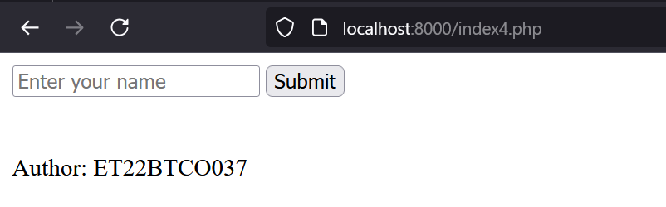

**5) Write a program to keep track of how many times a visitor has loaded the page.**

<?php

session_start();

if (!isset($_SESSION['count'])) {

$_SESSION['count'] = 0;

}

$_SESSION['count']++;

?>

<!DOCTYPE html>

<html lang="en">

<head>

<meta charset="UTF-8">

<title>Page Load Counter</title>

</head>

<body>

<h1>Welcome!</h1>

<p>You have loaded this page <?php echo $_SESSION['count']; ?> times.</p>

<br><br>

<footer>Author: ET22BTCO037</footer>

</body>

</html>

|  |  |
| --- | --- |