**JS Practical No : 6.3**

**Date:** 07/10/2024

**Problem Statement:**

**1. Understand the PHP interface, Study PHPMyAdmin and Perform following:**

**a. Write a PHP script to create a database StudentDB**

<?php

$servername = "localhost";

$username = "root";

$password = "";

$conn = new mysqli($servername, $username, $password);

if ($conn->connect_error) {

die("Connection failed: " . $conn->connect_error);

}

$sql = "CREATE DATABASE StudentDB";

if ($conn->query($sql) === TRUE) {

echo "Database created successfully";

} else {

echo "Error creating database: " . $conn->error;

}

$conn->close();

?>

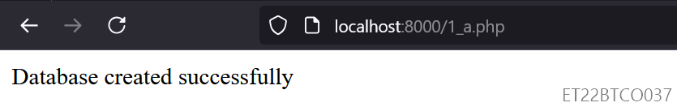

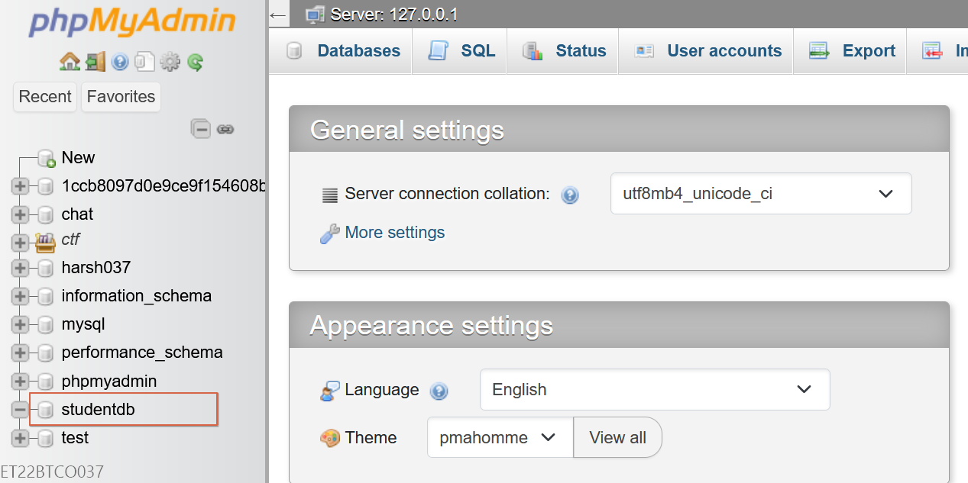

**b. Write a PHP script to list all the databases available in mysql.**

<?php

$servername = "localhost";

$username = "root";

$password = "";

$conn = new mysqli($servername, $username, $password);

if ($conn->connect_error) {

die("Connection failed: " . $conn->connect_error);

}

$result = $conn->query("SHOW DATABASES");

if ($result->num_rows > 0) {

while ($row = $result->fetch_assoc()) {

echo $row['Database'] . "<br>";

}

} else {

echo "No databases found.";

}

$conn->close();

?>

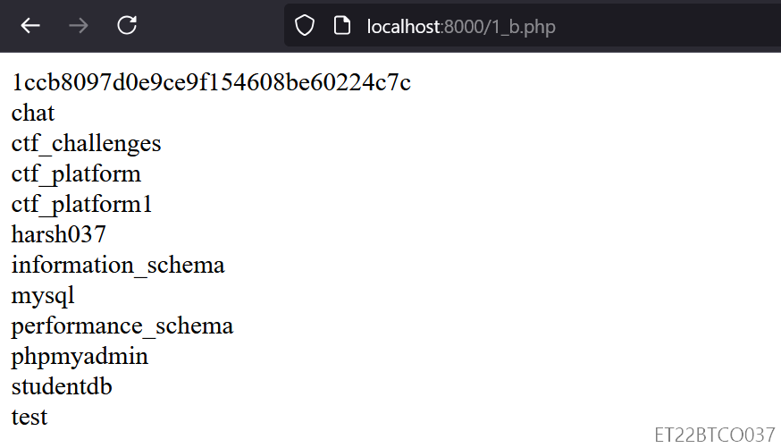

**c. Write a PHP script to list all the tables available in a particular database.**

<?php

$servername = "localhost";

$username = "root";

$password = "";

$database = "harsh037";

$conn = new mysqli($servername, $username, $password, $database);

if ($conn->connect_error) {

die("Connection failed: " . $conn->connect_error);

}

$result = $conn->query("SHOW TABLES");

if ($result->num_rows > 0) {

while ($row = $result->fetch_row()) {

echo $row[0] . "<br>";

}

} else {

echo "No tables found.";

}

$conn->close();

?>

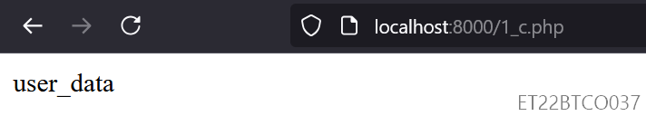

**d. Write a PHP script to create a table student(Enroll_no,name,age,marks) in the database StudentDB.**

<?php

$servername = "localhost";

$username = "root";

$password = "";

$database = "StudentDB";

$conn = new mysqli($servername, $username, $password, $database);

if ($conn->connect_error) {

die("Connection failed: " . $conn->connect_error);

}

$sql = "CREATE TABLE student (

Enroll_no INT PRIMARY KEY,

name VARCHAR(50),

age INT,

marks INT

)";

if ($conn->query($sql) === TRUE) {

echo "Table created successfully";

} else {

echo "Error creating table: " . $conn->error;

}

$conn->close();

?>

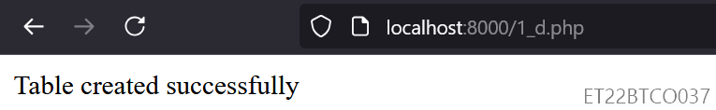

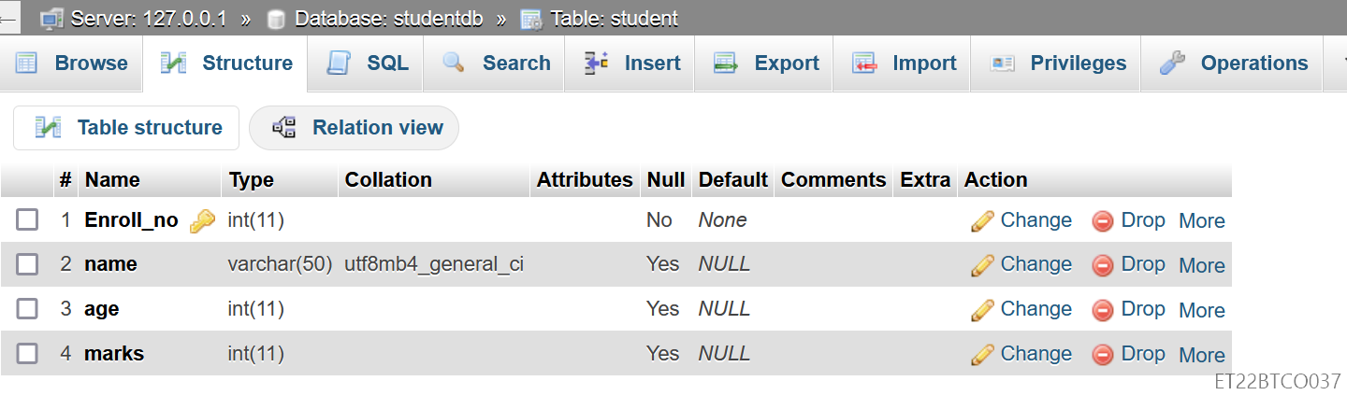

**e. Write a PHP script to insert a row into the table student. The values to be inserted are taken from a HTML page.**

<?php

$servername = "localhost";

$username = "root";

$password = "";

$database = "StudentDB";

$conn = new mysqli($servername, $username, $password, $database);

if ($conn->connect_error) {

die("Connection failed: " . $conn->connect_error);

}

if ($_SERVER["REQUEST_METHOD"] == "POST") {

$enroll_no = $_POST['enroll_no'];

$name = $_POST['name'];

$age = $_POST['age'];

$marks = $_POST['marks'];

$sql = "INSERT INTO student (Enroll_no, name, age, marks) VALUES ('$enroll_no', '$name', '$age', '$marks')";

if ($conn->query($sql) === TRUE) {

echo "New record created successfully";

} else {

echo "Error: " . $sql . "<br>" . $conn->error;

}

}

$conn->close();

?>

<!DOCTYPE html>

<html>

<head>

<title>Insert Student</title>

</head>

<body>

<form action="1_e.php" method="post">

Enroll No: <input type="text" name="enroll_no" required><br>

Name: <input type="text" name="name" required><br>

Age: <input type="number" name="age" required><br>

Marks: <input type="number" name="marks" required><br>

<input type="submit" value="Submit">

</form>

</body>

</html>

|  |  |
| --- | --- |

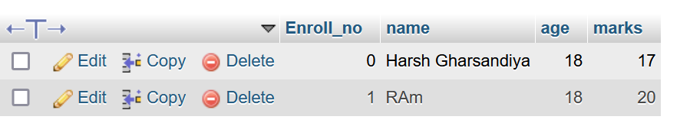

**f. Write a PHP script to list all the records in the student table in tabular format.**

<?php

$servername = "localhost";

$username = "root";

$password = "";

$database = "StudentDB";

$conn = new mysqli($servername, $username, $password, $database);

if ($conn->connect_error) {

die("Connection failed: " . $conn->connect_error);

}

$result = $conn->query("SELECT * FROM student");

if ($result->num_rows > 0) {

echo "<table border='1'><tr><th>Enroll No</th><th>Name</th><th>Age</th><th>Marks</th></tr>";

while ($row = $result->fetch_assoc()) {

echo "<tr><td>" . $row["Enroll_no"] . "</td><td>" . $row["name"] . "</td><td>" . $row["age"] . "</td><td>" . $row["marks"] . "</td></tr>";

}

echo "</table>";

} else {

echo "No records found.";

}

$conn->close();

?>

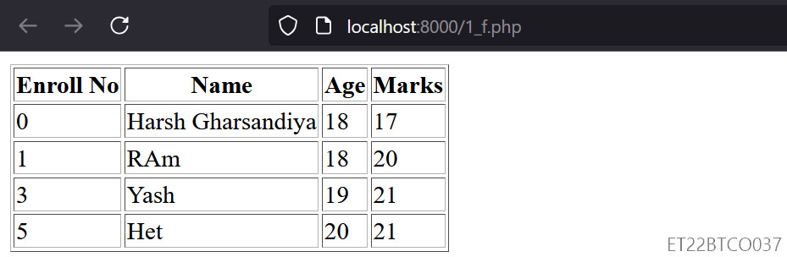

**g. Write a PHP script to delete all rows from student table whose Enroll_no numbers are between 1 and 3.**

<?php

$servername = "localhost";

$username = "root";

$password = "";

$database = "StudentDB";

$conn = new mysqli($servername, $username, $password, $database);

if ($conn->connect_error) {

die("Connection failed: " . $conn->connect_error);

}

$sql = "DELETE FROM student WHERE Enroll_no BETWEEN 1 AND 3";

if ($conn->query($sql) === TRUE) {

echo "Records deleted successfully";

} else {

echo "Error deleting records: " . $conn->error;

}

$conn->close();

?>



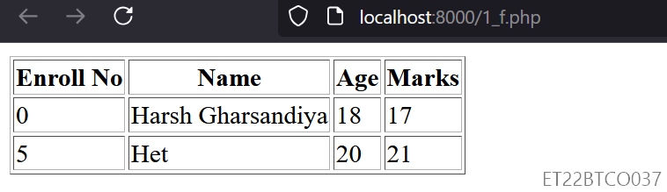

**h. Write a PHP script to display all rows from student table whose marks are >=35.**

<?php

$servername = "localhost";

$username = "root";

$password = "";

$database = "StudentDB";

$conn = new mysqli($servername, $username, $password, $database);

if ($conn->connect_error) {

die("Connection failed: " . $conn->connect_error);

}

$result = $conn->query("SELECT * FROM student WHERE marks >= 35");

if ($result->num_rows > 0) {

echo "<table border='1'><tr><th>Enroll No</th><th>Name</th><th>Age</th><th>Marks</th></tr>";

while ($row = $result->fetch_assoc()) {

echo "<tr><td>" . $row["Enroll_no"] . "</td><td>" . $row["name"] . "</td><td>" . $row["age"] . "</td><td>" . $row["marks"] . "</td></tr>";

}

echo "</table>";

} else {

echo "No records found.";

}

$conn->close();

?>

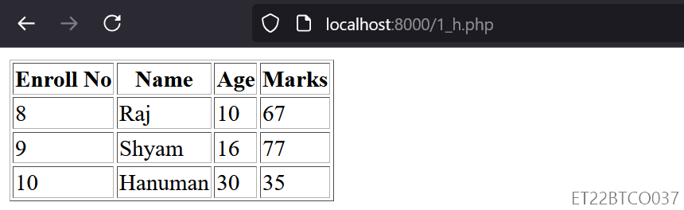

**i. Write a PHP script to update row from the table student whose age is 30.**

<?php

$servername = "localhost";

$username = "root";

$password = "";

$database = "StudentDB";

$conn = new mysqli($servername, $username, $password, $database);

if ($conn->connect_error) {

die("Connection failed: " . $conn->connect_error);

}

$sql = "UPDATE student SET marks = marks + 5 WHERE age = 30";

if ($conn->query($sql) === TRUE) {

echo "Record updated successfully";

} else {

echo "Error updating record: " . $conn->error;

}

$conn->close();

?>

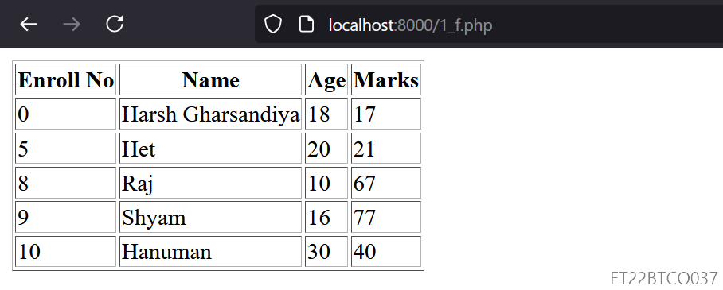



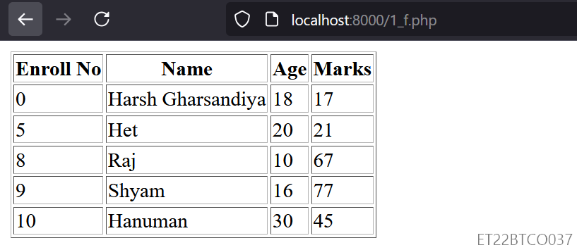

**j. Write a PHP script to drop the table student and drop the database StudentDB.**

<?php

$servername = "localhost";

$username = "root";

$password = "";

$database = "StudentDB";

$conn = new mysqli($servername, $username, $password);

if ($conn->connect_error) {

die("Connection failed: " . $conn->connect_error);

}

$conn->select_db($database);

// Drop the table

$sql = "DROP TABLE IF EXISTS student";

if ($conn->query($sql) === TRUE) {

echo "Table dropped successfully<br>";

} else {

echo "Error dropping table: " . $conn->error;

}

// Drop the database

$sql = "DROP DATABASE IF EXISTS $database";

if ($conn->query($sql) === TRUE) {

echo "Database dropped successfully";

} else {

echo "Error dropping database: " . $conn->error;

}

$conn->close();

?>

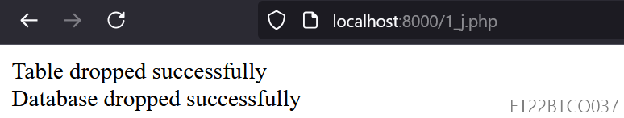

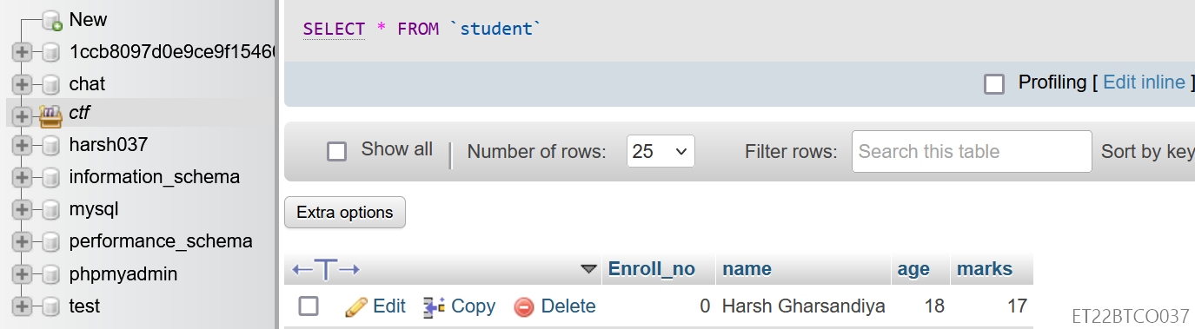

**2. Write a web application code using PHP, HTML and MySql for Employees that stores employee’s id, name, department, designation, etc. in database. Create proper GUI including buttons that run separate .php file for each database operation like insert, update, delete, select etc.**

**SQL Query:**

CREATE DATABASE EmployeeDB;

USE EmployeeDB;

CREATE TABLE employees (

id INT AUTO_INCREMENT PRIMARY KEY,

name VARCHAR(100) NOT NULL,

department VARCHAR(100) NOT NULL,

designation VARCHAR(100) NOT NULL

);

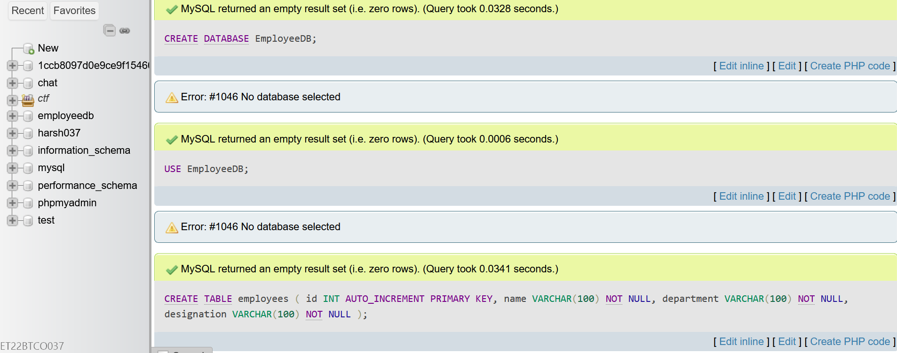

**db/config.php :** database connection file

<?php

$servername = "localhost";

$username = "root";

$password = "";

$database = "EmployeeDB";

$conn = new mysqli($servername, $username, $password, $database);

if ($conn->connect_error) {

die("Connection failed: " . $conn->connect_error);

}

?>

**header.php**

<!DOCTYPE html>

<html lang="en">

<head>

<meta charset="UTF-8">

<meta name="viewport" content="width=device-width, initial-scale=1.0">

<title>Employee Management System</title>

<link rel="stylesheet" href="style.css">

</head>

<body>

<div class="container">

<h1>Employee Management System</h1>

<nav>

<a href="index.php">Home</a>

<a href="view.php">View Employees</a>

<a href="insert.php">Add Employee</a>

<a href="update.php">Update Employee</a>

<a href="delete.php">Delete Employee</a>

</nav>

</div>

**footer.php**

<div class="footer">

<p>&copy; 2024 Employee Management System | Author: ET22BTCO037</p>

</div>

</body>

</html>

**index.php**

<?php include 'header.php'; ?>

<div class="main">

<h2>Welcome to the Employee Management System</h2>

<p>Use the navigation bar to manage employee records.</p>

</div>

<?php include 'footer.php'; ?>

**insert.php**

<?php include 'header.php'; ?>

<div class="main">

<h2>Add Employee</h2>

<form action="insert_employee.php" method="post">

<label for="name">Name:</label>

<input type="text" id="name" name="name" required>

<label for="department">Department:</label>

<input type="text" id="department" name="department" required>

<label for="designation">Designation:</label>

<input type="text" id="designation" name="designation" required>

<input type="submit" value="Add Employee">

</form>

</div>

<?php include 'footer.php'; ?>

**insert_employee.php :** to handle insert form submission

<?php

include 'db/config.php';

if ($_SERVER["REQUEST_METHOD"] == "POST") {

$name = $_POST['name'];

$department = $_POST['department'];

$designation = $_POST['designation'];

$sql = "INSERT INTO employees (name, department, designation) VALUES ('$name', '$department', '$designation')";

if ($conn->query($sql) === TRUE) {

echo "New employee added successfully. <a href='view.php'>View Employees</a>";

} else {

echo "Error: " . $sql . "<br>" . $conn->error;

}

header("Location: view.php");

exit();

}

$conn->close();

?>

**update.php**

<?php include 'header.php'; ?>

<div class="main">

<h2>Update Employee</h2>

<form action="update_employee.php" method="post">

<label for="id">Employee ID:</label>

<input type="number" id="id" name="id" required>

<label for="name">New Name:</label>

<input type="text" id="name" name="name">

<label for="department">New Department:</label>

<input type="text" id="department" name="department">

<label for="designation">New Designation:</label>

<input type="text" id="designation" name="designation">

<input type="submit" value="Update Employee">

</form>

</div>

<?php include 'footer.php'; ?>

**update_employee.php:** to handle update form submission

<?php

include 'db/config.php';

if ($_SERVER["REQUEST_METHOD"] == "POST") {

$id = $_POST['id'];

$name = $_POST['name'];

$department = $_POST['department'];

$designation = $_POST['designation'];

$sql = "UPDATE employees SET name='$name', department='$department', designation='$designation' WHERE id=$id";

if ($conn->query($sql) === TRUE) {

echo "Employee updated successfully. <a href='view.php'>View Employees</a>";

} else {

echo "Error: " . $sql . "<br>" . $conn->error;

}

header("Location: view.php");

exit();

}

$conn->close();

?>

**delete.php**

<?php include 'header.php'; ?>

<div class="main">

<h2>Delete Employee</h2>

<form action="delete_employee.php" method="post">

<label for="id">Employee ID:</label>

<input type="number" id="id" name="id" required>

<input type="submit" value="Delete Employee">

</form>

</div>

<?php include 'footer.php'; ?>

**delete_employee.php:** to handle delete form submission

<?php

include 'db/config.php';

if ($_SERVER["REQUEST_METHOD"] == "POST") {

$id = $_POST['id'];

$sql = "DELETE FROM employees WHERE id=$id";

if ($conn->query($sql) === TRUE) {

echo "Employee deleted successfully. <a href='view.php'>View Employees</a>";

} else {

echo "Error: " . $sql . "<br>" . $conn->error;

}

header("Location: view.php");

exit();

}

$conn->close();

?>

**view.php:** to view employee page

<?php include 'header.php'; ?>

<div class="main">

<h2>Employee List</h2>

<table>

<tr>

<th>ID</th>

<th>Name</th>

<th>Department</th>

<th>Designation</th>

</tr>

<?php

include 'db/config.php';

$sql = "SELECT * FROM employees";

$result = $conn->query($sql);

if ($result->num_rows > 0) {

while ($row = $result->fetch_assoc()) {

echo "<tr>

<td>{$row['id']}</td>

<td>{$row['name']}</td>

<td>{$row['department']}</td>

<td>{$row['designation']}</td>

</tr>";

}

} else {

echo "<tr><td colspan='4'>No employees found.</td></tr>";

}

$conn->close();

?>

</table>

</div>

<?php include 'footer.php'; ?>

**style.css**

body {

font-family: Arial, sans-serif;

margin: 0;

padding: 0;

background-color: #f4f4f4;

}

.container {

text-align: center;

padding: 20px;

}

nav {

margin: 20px 0;

}

nav a {

margin: 0 10px;

text-decoration: none;

color: #333;

padding: 5px 10px;

border: 1px solid #333;

border-radius: 5px;

}

nav a:hover {

background-color: #333;

color: #fff;

}

.main {

padding: 20px;

background-color: #fff;

border-radius: 5px;

box-shadow: 0 0 10px rgba(0,0,0,0.1);

max-width: 1200px;

height: 250px;

margin: 0 auto;

text-align: center;

}

table {

width: 100%;

border-collapse: collapse;

}

table, th, td {

border: 1px solid #ddd;

}

th, td {

padding: 8px;

text-align: left;

}

th {

background-color: #f2f2f2;

}

.footer {

background-color: #333;

color: white;

text-align: center;

padding: 10px 0;

position: relative;

bottom: 0;

width: 100%;

}

