**HTML Assignment No : 1**

**Date:** 22/07/2024

**Problem Statement:**

**Assignment 1:**

Implement Web page for demonstration of BOOKMARK or Anchor Tag. for e.g

Table of Contents

Chapter 1: Introduction

Chapter 2: What is HTML?

Chapter 3: What is Javascript?

.

.

.

.

By clicking on the link takes to the respective topic within the same page.

**Code:**

<!DOCTYPE html>

<html lang="en">

<head>

<meta charset="UTF-8">

<meta http-equiv="X-UA-Compatible" content="IE=edge">

<meta name="viewport" content="width=device-width, initial-scale=1.0">

<title>Bookmarks and Anchor Tags</title>

</head>

<body>

<h1>Table of Contents</h1>

<nav aria-label="Table of Contents">

<ul>

<li><a href="#chapter1">Chapter 1: Introduction to WEB</a></li>

<li><a href="#chapter2">Chapter 2: HTML</a></li>

<li><a href="#chapter3">Chapter 3: CSS</a></li>

<li><a href="#chapter4">Chapter 4: Javascript</a></li>

<li><a href="#chapter5">Chapter 5: Server Side Programming with PHP</a></li>

<li><a href="#chapter6">Chapter 6: Database Programming with PHP</a></li>

<li><a href="#chapter7">Chapter 7: Advanced Concepts</a></li>

</ul>

</nav>

<hr>

<h2 id="chapter1">Chapter 1: Introduction to WEB</h2>

<p>HTTP protocol, Client Server architecture, Concepts of effective web design, Web design issues, Designing effective navigation.</p>

<p>Lorem ipsum dolor sit amet consectetur adipisicing elit. Corporis accusantium, laboriosam quos nulla veritatis nisi mollitia dolore atque quibusdam ducimus voluptatem voluptates vel velit debitis. Quod perspiciatis accusantium quam pariatur! Lorem, ipsum dolor sit amet consectetur adipisicing elit. Eum laboriosam, perferendis totam quo consequuntur sint repellendus atque nulla ad distinctio dolorum neque inventore vero. Itaque, expedita? Inventore delectus saepe temporibus. Lorem ipsum dolor sit amet consectetur adipisicing elit. Quod eum, commodi sint doloribus ducimus perferendis tempore et. Quae distinctio eius nihil quod consectetur omnis itaque at, rem aliquid! Voluptatibus, veritatis.</p>

<hr>

<h2 id="chapter2">Chapter 2: HTML</h2>

<p>Structure of HTML page, HTML tags for data formatting, tables, links, images, meta tags, frames, html form tags, media, APIs, HTML5 tags and validation.</p>

<p>Lorem ipsum dolor sit amet consectetur adipisicing elit. Corporis accusantium, laboriosam quos nulla veritatis nisi mollitia dolore atque quibusdam ducimus voluptatem voluptates vel velit debitis. Quod perspiciatis accusantium quam pariatur! Lorem, ipsum dolor sit amet consectetur adipisicing elit. Eum laboriosam, perferendis totam quo consequuntur sint repellendus atque nulla ad distinctio dolorum neque inventore vero. Itaque, expedita? Inventore delectus saepe temporibus. Lorem ipsum dolor sit amet consectetur adipisicing elit. Quod eum, commodi sint doloribus ducimus perferendis tempore et. Quae distinctio eius nihil quod consectetur omnis itaque at, rem aliquid! Voluptatibus, veritatis. Lorem ipsum dolor sit amet consectetur adipisicing elit. Corporis accusantium, laboriosam quos nulla veritatis nisi mollitia dolore atque quibusdam ducimus voluptatem voluptates vel velit debitis. Quod perspiciatis accusantium quam pariatur! Lorem, ipsum dolor sit amet consectetur adipisicing elit. Eum laboriosam, perferendis totam quo consequuntur sint repellendus atque nulla ad distinctio dolorum neque inventore vero. Itaque, expedita? Inventore delectus saepe temporibus. Lorem ipsum dolor sit amet consectetur adipisicing elit. Quod eum, commodi sint doloribus ducimus perferendis tempore et. Quae distinctio eius nihil quod consectetur omnis itaque at, rem aliquid! Voluptatibus, veritatis.</p>

<hr>

<h2 id="chapter3">Chapter 3: CSS</h2>

<p>Need for CSS, Syntax and structure, CSS rules for Backgrounds, Colors and properties, manipulating texts, Fonts, borders and boxes, Margins, Padding Lists, CSS Positioning. basics of animations, Style images, Variables, Media Queries, Wildcard Selectors (*, ^ and $) in CSS, Working with Gradients, Introduction to Bootstrap.</p>

<p>Lorem ipsum dolor sit amet consectetur adipisicing elit. Corporis accusantium, laboriosam quos nulla veritatis nisi mollitia dolore atque quibusdam ducimus voluptatem voluptates vel velit debitis. Quod perspiciatis accusantium quam pariatur! Lorem, ipsum dolor sit amet consectetur adipisicing elit. Eum laboriosam, perferendis totam quo consequuntur sint repellendus atque nulla ad distinctio dolorum neque inventore vero. Itaque, expedita? Inventore delectus saepe temporibus. Lorem ipsum dolor sit amet consectetur adipisicing elit. Quod eum, commodi sint doloribus ducimus perferendis tempore et. Quae distinctio eius nihil quod consectetur omnis itaque at, rem aliquid! Voluptatibus, veritatis.</p>

<hr>

<h2 id="chapter4">Chapter 4: Javascript</h2>

<p>Client Side Scripting using JavaScript: Syntax of JavaScript, Execution of JavaScript, Internal, Embedded and External JavaScript, JavaScript: variables, arrays, functions, conditions, loops, Pop up boxes, JavaScript objects and DOM, JavaScript inbuilt functions, JavaScript validations and Regular expressions, Event handling with JavaScript, Callbacks in JavaScript, Function as arguments in JavaScript, Introduction to JSON.</p>

<p>Lorem ipsum dolor sit amet consectetur adipisicing elit. Corporis accusantium, laboriosam quos nulla veritatis nisi mollitia dolore atque quibusdam ducimus voluptatem voluptates vel velit debitis. Quod perspiciatis accusantium quam pariatur! Lorem, ipsum dolor sit amet consectetur adipisicing elit. Eum laboriosam, perferendis totam quo consequuntur sint repellendus atque nulla ad distinctio dolorum neque inventore vero. Itaque, expedita? Inventore delectus saepe temporibus. Lorem ipsum dolor sit amet consectetur adipisicing elit. Quod eum, commodi sint doloribus ducimus perferendis tempore et. Quae distinctio eius nihil quod consectetur omnis itaque at, rem aliquid! Voluptatibus, veritatis.</p>

<hr>

<h2 id="chapter5">Chapter 5: Server Side Programming with PHP</h2>

<p>Difference between Client side and Server side scripting, Structure of PHP page, PHP Syntax: variables, decision and looping with examples, PHP and HTML, Arrays and Functions, String, Form processing, File uploads, Dates and time zone, Working with Regular Expressions, Exception Handling, Basic concepts of Session and State, State management using query string, hidden form controls, Cookies, Session variables.</p>

<p>Lorem ipsum dolor sit amet consectetur adipisicing elit. Corporis accusantium, laboriosam quos nulla veritatis nisi mollitia dolore atque quibusdam ducimus voluptatem voluptates vel velit debitis. Quod perspiciatis accusantium quam pariatur! Lorem, ipsum dolor sit amet consectetur adipisicing elit. Eum laboriosam, perferendis totam quo consequuntur sint repellendus atque nulla ad distinctio dolorum neque inventore vero. Itaque, expedita? Inventore delectus saepe temporibus. Lorem ipsum dolor sit amet consectetur adipisicing elit. Quod eum, commodi sint doloribus ducimus perferendis tempore et. Quae distinctio eius nihil quod consectetur omnis itaque at, rem aliquid! Voluptatibus, veritatis.</p>

<hr>

<h2 id="chapter6">Chapter 6: Database Programming with PHP</h2>

<p>PHP functions for database connectivity, Implementation of CRUD operations using PHP, Prepared Statement and stored procedure execution in PHP.</p>

<p>Lorem ipsum dolor sit amet consectetur adipisicing elit. Corporis accusantium, laboriosam quos nulla veritatis nisi mollitia dolore atque quibusdam ducimus voluptatem voluptates vel velit debitis. Quod perspiciatis accusantium quam pariatur! Lorem, ipsum dolor sit amet consectetur adipisicing elit. Eum laboriosam, perferendis totam quo consequuntur sint repellendus atque nulla ad distinctio dolorum neque inventore vero. Itaque, expedita? Inventore delectus saepe temporibus. Lorem ipsum dolor sit amet consectetur adipisicing elit. Quod eum, commodi sint doloribus ducimus perferendis tempore et. Quae distinctio eius nihil quod consectetur omnis itaque at, rem aliquid! Voluptatibus, veritatis.</p>

<hr>

<h2 id="chapter7">Chapter 7: Advanced Concepts</h2>

<p>Introduction to AJAX, JQuery, Current trends in web application with use cases.</p>

<p>Lorem ipsum dolor sit amet consectetur adipisicing elit. Corporis accusantium, laboriosam quos nulla veritatis nisi mollitia dolore atque quibusdam ducimus voluptatem voluptates vel velit debitis. Quod perspiciatis accusantium quam pariatur! Lorem, ipsum dolor sit amet consectetur adipisicing elit. Eum laboriosam, perferendis totam quo consequuntur sint repellendus atque nulla ad distinctio dolorum neque inventore vero. Itaque, expedita? Inventore delectus saepe temporibus. Lorem ipsum dolor sit amet consectetur adipisicing elit. Quod eum, commodi sint doloribus ducimus perferendis tempore et. Quae distinctio eius nihil quod consectetur omnis itaque at, rem aliquid! Voluptatibus, veritatis.</p>

</body>

</html>

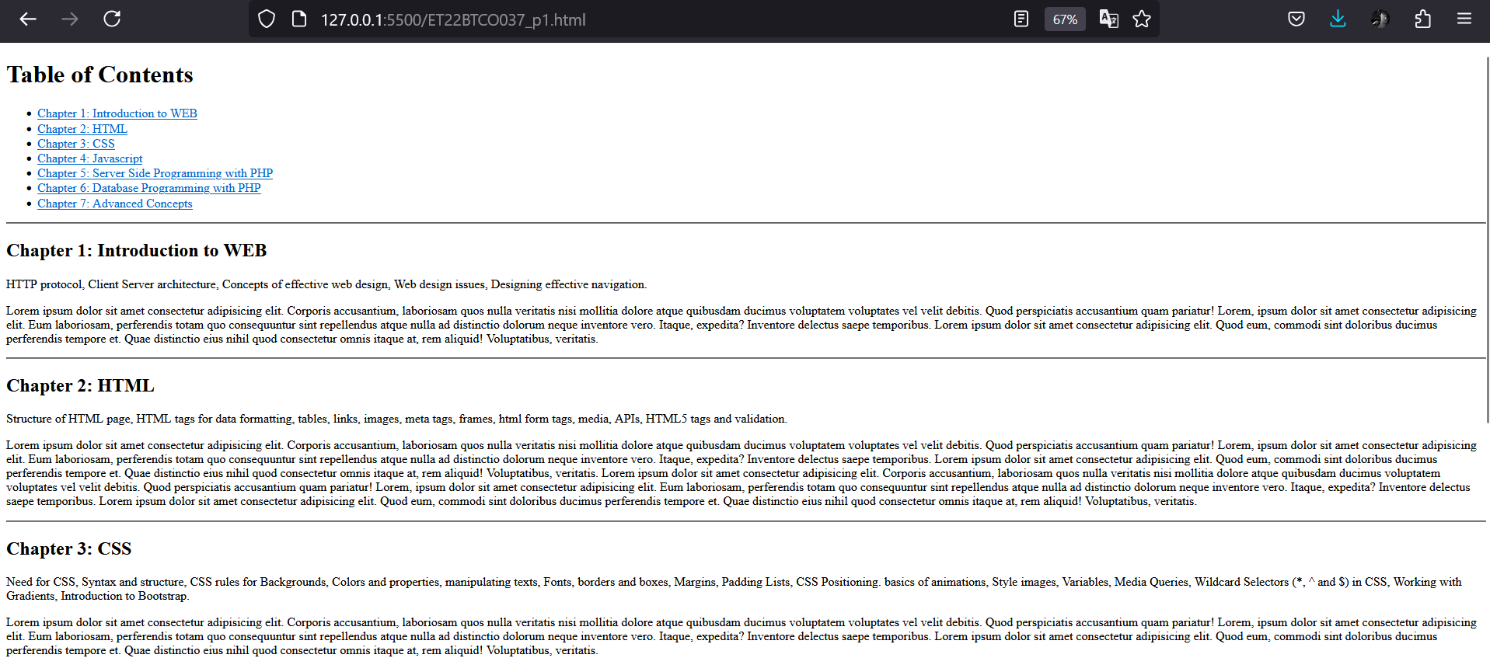

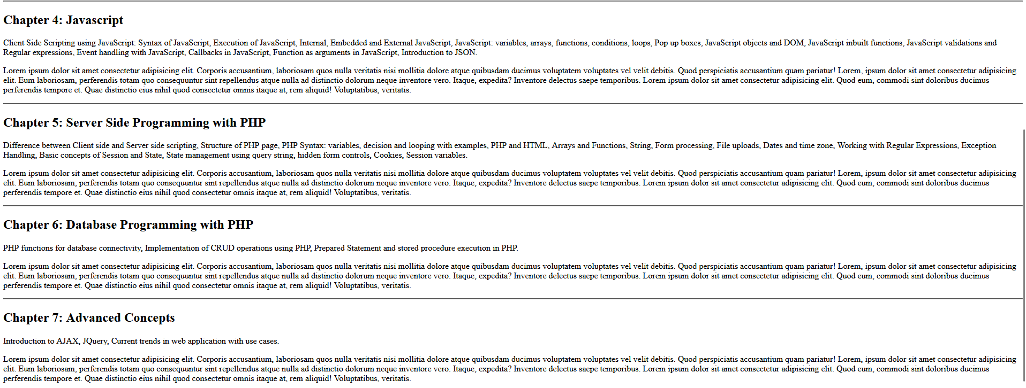

**Assignment 2:**

Implement any application to IMAGE MAP as discussed in class.

**Code:**

<!DOCTYPE html>

<html lang="en">

<head>

<meta charset="UTF-8">

<meta name="viewport" content="width=device-width, initial-scale=1.0">

<title>Image Map Example</title>

</head>

<body>

<h1>Image Map Example</h1>

<p>Click on different parts of the image to go to different links:</p>

<img src="solar_system.jpg" usemap="#solar-system-image-map">

<map name="solar-system-image-map">

<area target="_blank" alt="mercury" title="mercury" href="https://en.wikipedia.org/wiki/Mercury_(planet)" coords="149,214,18" shape="circle">

<area target="_blank" alt="sun" title="sun" href="https://en.wikipedia.org/wiki/Sun" coords="17,216,88" shape="circle">

<area target="_blank" alt="venus" title="venus" href="https://en.wikipedia.org/wiki/Venus" coords="217,209,29" shape="circle">

<area target="_blank" alt="earth" title="earth" href="https://en.wikipedia.org/wiki/Earth" coords="NaN" shape="circle">

<area target="_blank" alt="mars" title="mars" href="https://en.wikipedia.org/wiki/Mars" coords="404,209,22" shape="circle">

<area target="_blank" alt="jupiter" title="jupiter" href="https://en.wikipedia.org/wiki/Jupiter" coords="569,209,118" shape="circle">

<area target="_blank" alt="saturn" title="saturn" href="https://en.wikipedia.org/wiki/Saturn" coords="800,214,51" shape="circle">

<area target="_blank" alt="uranus" title="uranus" href="https://en.wikipedia.org/wiki/Uranus" coords="998,207,50" shape="circle">

<area target="_blank" alt="neptune" title="neptune" href="https://en.wikipedia.org/wiki/Neptune" coords="1144,214,48" shape="circle">

</map>

<p>Areas defined:</p>

<ul>

<li>Sun: Circle (coords="17,216,88")</li>

<li>Mercury: Circle (coords="149,214,18")</li>

<li>Venus: Circle (coords="217,209,29")</li>

<li>Earth: No coordinates available</li>

<li>Mars: Circle (coords="404,209,22")</li>

<li>Jupiter: Circle (coords="569,209,118")</li>

<li>Saturn: Circle (coords="800,214,51")</li>

<li>Uranus: Circle (coords="998,207,50")</li>

<li>Neptune: Circle (coords="1144,214,48")</li>

</ul>

</body>

</html>

**Output:**

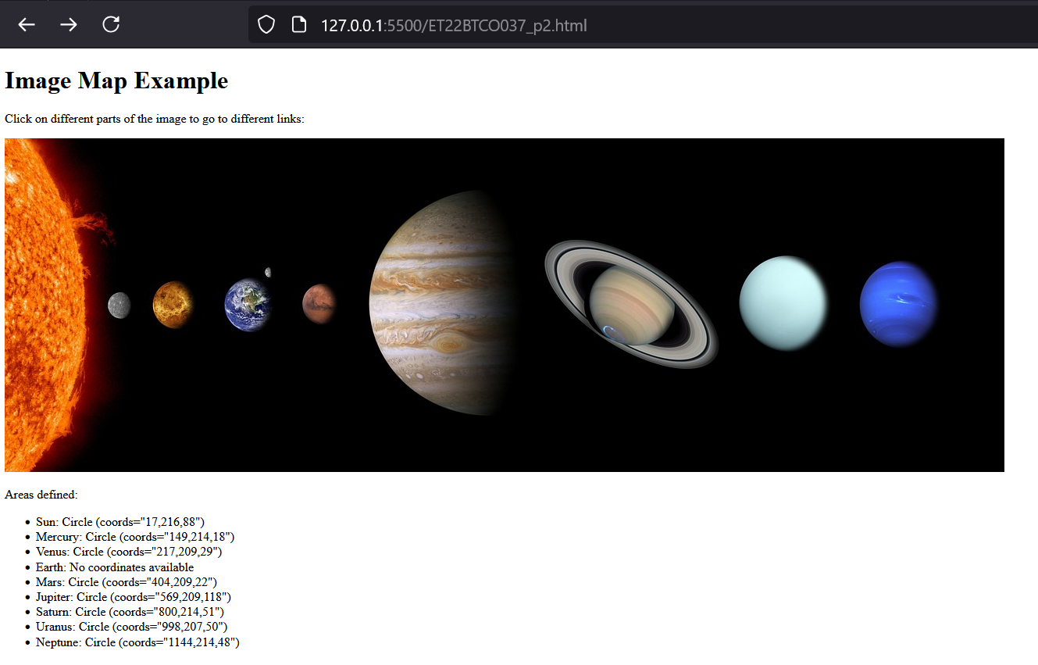

**Assignment 3:**

Create your class time table using HTML.

**Code:**

<!DOCTYPE html>

<html>

<head>

<style>

table, th, td {

border: 1px solid black;

border-collapse: collapse;

}

</style>

</head>

<body>

<table width="90%">

<tr>

<th colspan="10" align="center">,</th>

</tr>

<tr>

<th colspan="10" align="center">SARVAJANIK COLLEGE OF ENGINEERING & TECHNOLOGY, SURAT (042)</th>

</tr>

<tr>

<th colspan="10" align="center"><u>CLASS TIME TABLE (Effective From: 01/07/2024)</u></th>

</tr>

<tr align="left">

<th colspan="2">B.Tech-III CO (Div-I)</th>

<th>SEMESTER:</th>

<td align="center">V</td>

<th>YEAR:</th>

<th>2024-25</th>

<th></th>

<th>CLASS ROOM: </th>

<th colspan="2">C:203</th>

</tr>

<tr>

<th style="width:6%;">PERIODS & <br>Time</th>

<th style="width:10%;">1<br> 09:00-10:00</th>

<th style="width:10%;">2<br> 10:00-11:00</th>

<th style="width:2%;" rowspan="11" ><br>R<br>E<br>C<br>E<br>S<br>S<br></th>

<th style="width:10%;">3<br> 11:15-12:15</th>

<th style="width:10%;">4<br> 12:15-01:15</th>

<th style="width:2%;" rowspan="11"><br>R<br>E<br>C<br>E<br>S<br>S<br></th>

<th style="width:10%;">5<br> 02:00-03:00</th>

<th style="width:10%;">6<br> 03:00-04:00</th>

<th style="width:10%;">7<br> 04:00-05:00</th>

</tr>

<tr align="center">

<td rowspan="2">MON</td>

<td colspan="2">DMDW (B-I) (DK,AD1) - [CO-Ph-I]<br>

DMDW (B-II) (SG,AD3) - [CO-Ph-II]</td>

<td colspan="2">WT (Batch-A) (UD, JG)<br>

[CO-Ph-I]</td>

<td>AI</td>

<td>EO</td>

<td rowspan="2">SU H/M Theory</td>

</tr>

<tr align="center">

<td colspan="2">EAD (B-IV) (BP,JB) <br>[CO-PH-III]</td>

<td colspan="2">AI (Batch-B) (KR, NN) <br>[AI LAB]</td>

<td>NN</td>

<td>DLS</td>

</tr>

<tr align="center">

<td rowspan="2">TUES</td>

<td rowspan="2" colspan="2">IOE(A)</td>

<td colspan="2">AI (Batch-A) (NN, AD3) <br>[AI LAB]</td>

<td>EAD/DMDW <br>(C-201/C-203)</td>

<td>INS</td>

<td rowspan="2">SU H/M Theory</td>

</tr>

<tr align="center">

<td colspan="2">INS (Batch-B) (MM, BK) <br>[CO-Ph-IV]</td>

<td>BP/DK</td>

<td>BK</td>

</tr>

<tr align="center">

<td rowspan="2">WED</td>

<td>AI</td>

<td>EO(T)</td>

<td rowspan="2" style="vertical-align: middle; padding:20px;"><br>IOE<br><br></td>

<td rowspan="2" style="vertical-align: middle; padding:20px;"><br>IOE<br><br></td>

<td>INS</td>

<td>AI</td>

<td rowspan="2">SU H/M Theory</td>

</tr>

<tr align="center">

<td>NN</td>

<td>AUM,RMP,SYD</td>

<td>MM</td>

<td>NN</td>

</tr>

<tr align="center">

<td rowspan="2">THU</td>

<td rowspan="2" colspan="2">IOE(B)</td>

<td>EAD/DMDW <br>(C-202/C-203)</td>

<td>WT</td>

<td colspan="2">INS (Batch-A) (MM, BK)<br>[CO-Ph-II]</td>

<td rowspan="2">SU H/M Theory</td>

</tr>

<tr align="center">

<td>BP/DK</td>

<td>UD</td>

<td colspan="2">WT (Batch-B) (UD, AD3)<br>[CO-Ph-I]</td>

</tr>

<tr align="center">

<td rowspan="2">FRI</td>

<td rowspan="2" style="vertical-align: middle; padding:20px;"><br>IOE<br><br></td>

<td>EO</td>

<td>WT</td>

<td>INS</td>

<td>EAD/DMDW<br>(C-202/C-203)</td>

<td rowspan="2" colspan="2">SU H/M Lab</td>

</tr>

<tr align="center">

<td>SD</td>

<td>UD</td>

<td>BK</td>

<td>JB/SG<br><br></td>

</tr>

</table>

<table width="80%">

<tr>

<td colspan="9" align="center">** H/M = Honors/Minors **IOE= Institute Open Elective</td>

</tr>

<tr>

<th rowspan="3">Subject Code<br>.<br>.</th>

<td>DMDW:Data Mining and Data Warehousing</td>

<td>EO:Engineering Optimization</td>

<td></td>

</tr>

<tr>

<td>EAD:Enterprise Application Developmen</td>

<td>WT: Web Technologies</td>

<td>INS:Information and Network Security</td>

</tr>

<tr>

<td></td>

<td>AI:Artificial Intelligence</td>

<td></td>

</tr>

<tr>

<th rowspan="6">Faculty<br> Code:</th>

<td>MM: Prof. (Dr.) Mayuri Mehta</td>

<td>UD: Prof. Urmi Desai</td>

<td>BP: Prof. Bhavesh Patel</td>

</tr>

<tr>

<td>DK: Prof. (Dr.) Dipali Kasat</td>

<td>JG: Prof. Jaydeep Gheewala</td>

<td>JB: Prof. Jaydeep Barad</td>

</tr>

<tr>

<td>BK: Prof. (Dr.) Bintu Kadhiwala</td>

<td>SG: Prof. Snehal Gandhi</td>

<td>KR: Prof. (Dr.) Keyur Rana</td>

</tr>

<tr>

<td>NN: Prof. (Dr.) Nirali Nanavati</td>

<td>BP: Prof. Bhavesh Patel</td>

<td>AD1, AD2, AD3, AD4: Adhoc Faculty</td>

</tr>

<tr>

<td>DLS: Dhruvin Shukla</td>

<td>SD: Prof. Satish Dokiparti</td>

<td>AUM: Prof. Amit U. Mehta</td>

</tr>

<tr>

<td>RMP: Prof. Rahul M. Painter</td>

<td>SYD: Prof. (Dr.) Supriya Y. Deshmukh</td>

<td colspan="2"></td>

</tr>

</table>

<table width="80%">

<tr>

<th>Name of the teacher: </th>

<td colspan="5">Prof. Urmi Desai</td>

</tr>

<tr>

<td colspan="6"><br></td>

</tr>

<tr align="center">

<th colspan="2">Time Table Coordinator</th>

<th>Head Of the Department</th>

<th> Dean-Academic</th>

<th>Principal, SCET</th>

</tr>

<tr align="center">

<td colspan="2">Prof. Vasundhara Uchhula<br>Prof. Jayesh Chaudhary<br>Prof. Vandana Josh</td>

<td>Prof. (Dr.) Dipali Kasat</td>

<td>Prof.(Dr.) Maulin Joshi</td>

<td>Prof.(Dr.) Hiren Patel</td>

</tr>

</table>

</body>

</html>

**Output:**

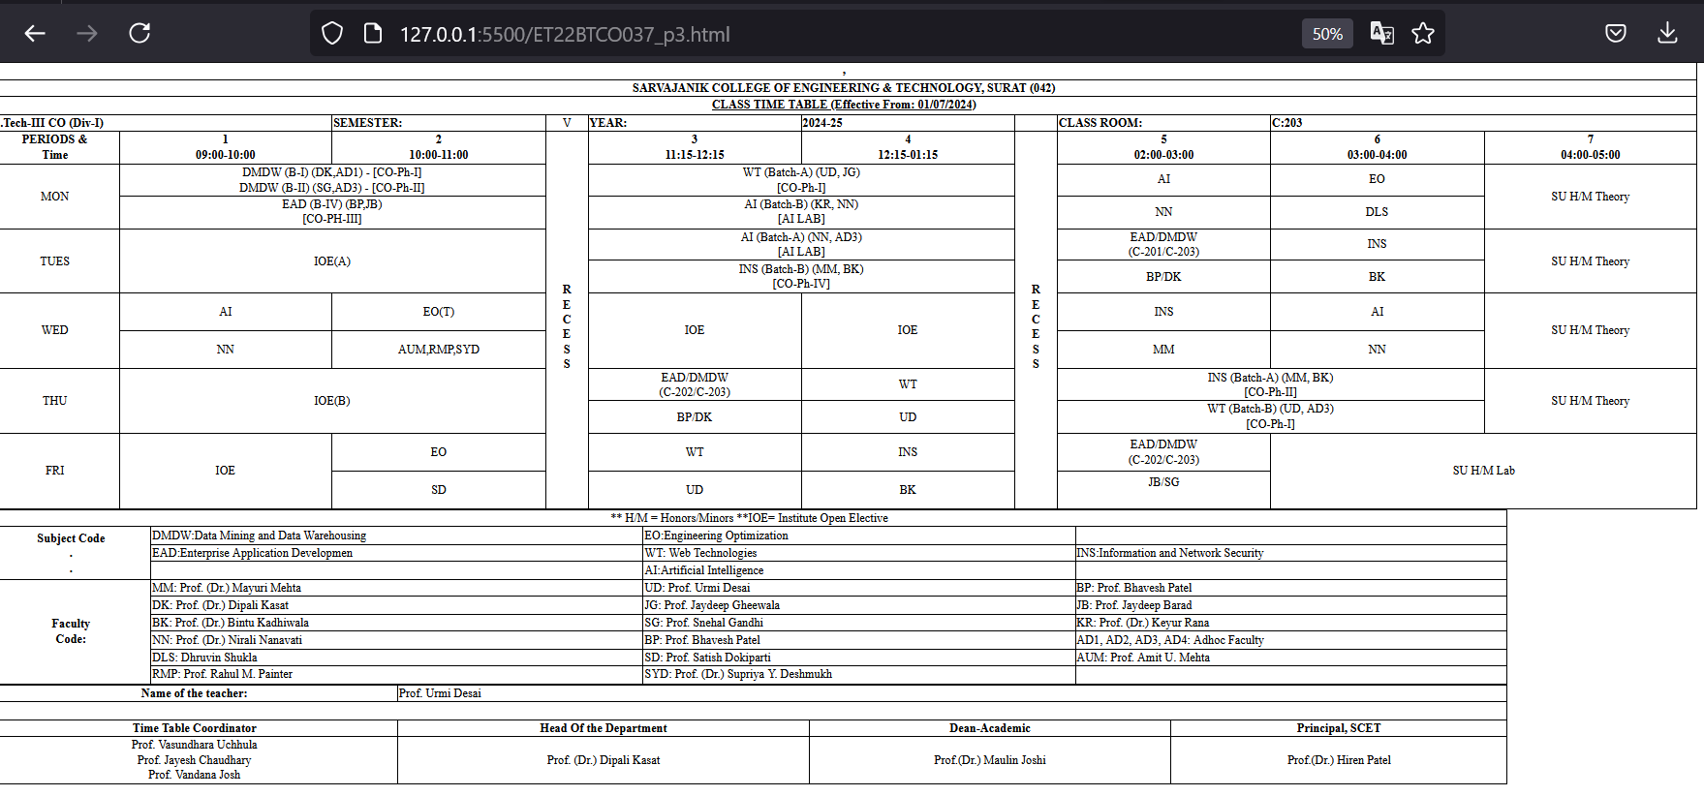

**Assignment 4**

Create our co-intra page layout with three different frame. Top frame,left frame and right frame. On left side frame put links for different subjects of your class in this semester. By clicking on these links syllabus of relevant subject will open on right side frame. use FRAMESET and FRAME tag.

**Code:**

**index.html**

<!DOCTYPE html>

<html>

<head>

<title>Frames Example</title>

</head>

<frameset rows="100px, *" frameborder="1">

<frame src="top_frame.html" name="topFrame" scrolling="no">

<frameset cols="200px, *">

<frame src="left_frame.html" name="leftFrame">

<frame src="welcome.html" name="rightFrame">

</frameset>

</frameset>

<noframes>

<body>

<p>Your browser does not support frames. Please upgrade your browser.</p>

</body>

</noframes>

</html>

**left_frame.html**

<!DOCTYPE html>

<html>

<head>

<title>Subjects</title>

</head>

<body>

<h6>ET22BTCO037 Hoi !!!</h6>

<ul>

<li><a href="subject/ins.html" target="rightFrame">INS</a></li>

<li><a href="subject/wt.html" target="rightFrame">WT</a></li>

<li><a href="subject/eo.html" target="rightFrame">EO</a></li>

<li><a href="subject/ead.html" target="rightFrame">EAD</a></li>

<li><a href="subject/ai.html" target="rightFrame">AI</a></li>

<li><a href="subject/robotics.html" target="rightFrame">Robotics</a></li>

</ul>

</body>

</html>

**welcome.html**

<!DOCTYPE html>

<html>

<head>

<title>Welcome</title>

</head>

<body>

<h2>Welcome to ET22BTCO037 Syllabus Page!</h2>

<p>Please select a subject from the left to view the syllabus.</p>

</body>

</html>

**subject/wt.html**

<!DOCTYPE html>

<html>

<head>

<title>WT</title>

</head>

<body>

<h2>Web Technology</h2>

<p><strong>1. Introduction to Web:</strong> This section covers the HTTP protocol, client-server architecture, concepts of effective web design, web design issues, and designing effective navigation. This is covered in 2 hours.</p>

<p><strong>2. HTML:</strong> This includes the structure of an HTML page, HTML tags for data formatting, tables, links, images, meta tags, frames, HTML form tags, media, APIs, HTML5 tags, and validation. This section is covered in 5 hours.</p>

<p><strong>3. CSS:</strong> Topics include the need for CSS, syntax and structure, CSS rules for backgrounds, colors and properties, manipulating texts, fonts, borders and boxes, margins, padding lists, CSS positioning, basics of animations, style images, variables, media queries, wildcard selectors (*, ^ and $) in CSS, working with gradients, and an introduction to Bootstrap. This is covered in 5 hours.</p>

<p><strong>4. JavaScript:</strong> This section includes client-side scripting using JavaScript: syntax of JavaScript, execution of JavaScript, internal, embedded, and external JavaScript, JavaScript variables, arrays, functions, conditions, loops, pop-up boxes, JavaScript objects and DOM, JavaScript inbuilt functions, JavaScript validations and regular expressions, event handling with JavaScript, callbacks in JavaScript, function as arguments in JavaScript, and an introduction to JSON. This section is covered in 6 hours.</p>

<p><strong>5. Server-Side Programming with PHP:</strong> This covers the difference between client-side and server-side scripting, the structure of a PHP page, PHP syntax (variables, decision and looping with examples), PHP and HTML, arrays and functions, string operations, form processing, file uploads, dates and time zones, working with regular expressions, exception handling, basic concepts of session and state, state management using query strings, hidden form controls, cookies, and session variables. This section is covered in 5 hours.</p>

<p><strong>6. Database Programming with PHP:</strong> This includes PHP functions for database connectivity, implementation of CRUD operations using PHP, prepared statements, and stored procedure execution in PHP. This section is covered in 4 hours.</p>

<p><strong>7. Advanced Concepts:</strong> This section introduces AJAX, jQuery, and current trends in web applications with use cases.</p>

</body>

</body>

</html>

**Output:**

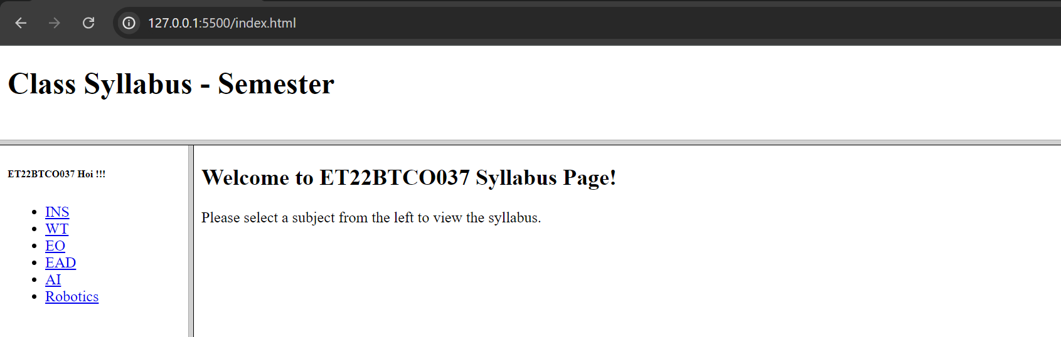

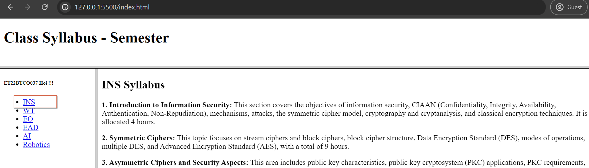

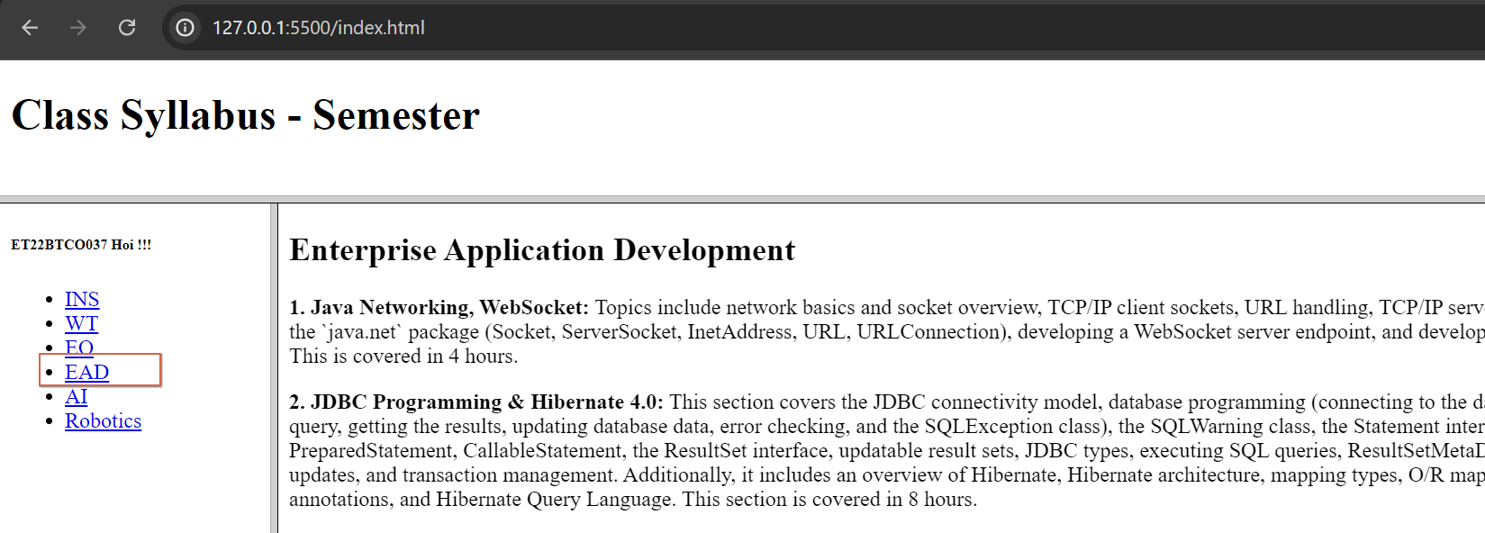

**Assignment 5:**

Create webpage as Given:

**Code:**

<!DOCTYPE html>

<html>

<head>

<title>Assignment 5</title>

</head>

<body>

<table border="1" cellspacing="2" align="center" width="auto" bgcolor="#fabdf9" style="border: 2px solid blue;"> <tr align="center">

<td colspan="2" style="border: 2px solid blue;"><h1>Registration Page</h1></td>

</tr>

<tr>

<td style="border: 2px solid blue;">Registration id:</td>

<td style="border: 2px solid blue;">

<input type="text" name="" id="">

</td>

</tr>

<tr>

<td style="border: 2px solid blue;">User Name:</td>

<td style="border: 2px solid blue;">

<input type="text">

</td>

</tr>

<tr>

<td style="border: 2px solid blue;">First Name:</td>

<td style="border: 2px solid blue;">

<input type="text">

</td>

</tr>

<tr>

<td style="border: 2px solid blue;">Last Name:</td>

<td style="border: 2px solid blue;">

<input type="text">

</td>

</tr>

<tr>

<td style="border: 2px solid blue;">Password:</td>

<td style="border: 2px solid blue;"><input type="password" name="" id=""></td>

</tr>

<tr>

<td style="border: 2px solid blue;">Gender</td>

<td style="border: 2px solid blue;">

<input type="radio" name="gender">Male

<input type="radio" name="gender">Female

</td>

</tr>

<tr>

<td style="border: 2px solid blue;">Date of Birth:</td>

<td style="border: 2px solid blue;">

<select name="" id="">

<option value="" label="Day"></option>

<option value="">1</option>

<option value="">2</option>

</select>

<select name="" id="">

<option value="" label="month"></option>

</select>

<select name="" id="">

<option value="" label="year"></option>

</select>

</td>

</tr>

<tr>

<td style="border: 2px solid blue;">Address:</td>

<td style="border: 2px solid blue;"> <textarea id="message" name="message" rows="3" cols="20"></textarea></td>

</tr>

<tr>

<td style="border: 2px solid blue;">City:</td>

<td style="border: 2px solid blue;">

<select name="" id="">

<option value="">Surat</option>

</select>

</td>

</tr>

<tr>

<td style="border: 2px solid blue;">State:</td>

<td style="border: 2px solid blue;">

<select name="" id="">

<option value="">Gujarat</option>

</select>

</td>

</tr>

<tr>

<td style="border: 2px solid blue;">Country:</td>

<td style="border: 2px solid blue;">

<select name="" id="">

<option value="">India</option>

</select>

</td>

</tr>

<tr>

<td style="border: 2px solid blue;">Hobbies:</td>

<td style="border: 2px solid blue;">

<input type="checkbox">Playing

<input type="checkbox">Editing

<input type="checkbox">Singing

</td>

</tr>

<tr>

<td style="border: 2px solid blue;">Mobile No:</td>

<td style="border: 2px solid blue;">

<input type="text">

</td>

</tr>

<tr>

<td style="border: 2px solid blue;">Attach C.V.:</td>

<td style="border: 2px solid blue;">

<input type="file" name="cvName" placeholder="Enter name of the file">

</td>

</tr>

<tr align="center">

<td colspan="2" style="border: 2px solid blue;">

<button>Submit</button>

<button>Reset</button>

</td>

</tr>

</table>

</body>

</html>

**Output:**

