**HTML Assignment No : 2**

**Date:** 22/07/2024

**Problem Statement:**

**Assignment 1:**

(i) Demonstrate the use of HTML media. (audio, video, youtube, plug-ins)

**Code:**

**ET22BTCO037_p1.html**

<!DOCTYPE html>

<html>

<head>

<title>Assignment_2</title>

</head>

<body>

<table>

<tr>

<th>

<video src="video1.mp4" controls width="500px"></video>

</th>

<th>

<iframe src="https://www.youtube.com/embed/tgbNymZ7vqY" contrls width="500px" height="280px"></iframe>

</th>

</tr>

</table>

<hr>

<audio src="audio.mp3" controls></audio><br><br>

<hr>

<object data="geo-location-api.html" type="text/html"></object>

<object data="temp_converter.html" type="text/html"></object>

</body>

</html>

**temp_converter.html**

<!DOCTYPE html>

<html>

<head>

<title>Temperature Converter</title>

</head>

<body>

<p>Convert Fahrenheit to Celsius:</p>

<input type="number" id="fahrenheit" placeholder="Fahrenheit">

<button onclick="convertToCelsius()">Convert to Celsius</button><br>

<p id="result"></p>

<script>

function convertToCelsius() {

var fahrenheit = document.getElementById("fahrenheit").value;

var celsius = (fahrenheit - 32) * 5 / 9;

document.getElementById("result").innerHTML = fahrenheit + "°F is " + celsius.toFixed(2) + "°C";

}

</script>

</body>

</html>

**geo-location-api.html**

<!DOCTYPE html>

<html>

<body>

<p>Click the button to get your coordinates.</p>

<button onclick="getLocation()">Try It</button>

<p id="demo"></p>

<script>

var x = document.getElementById("demo");

function getLocation() {

if (navigator.geolocation) {

navigator.geolocation.getCurrentPosition(showPosition);

} else {

x.innerHTML = "Geolocation is not supported by this browser.";

}

}

function showPosition(position) {

x.innerHTML = "Latitude: " + position.coords.latitude +

"<br>Longitude: " + position.coords.longitude;

}

</script>

</body>

</html>

**Output:**

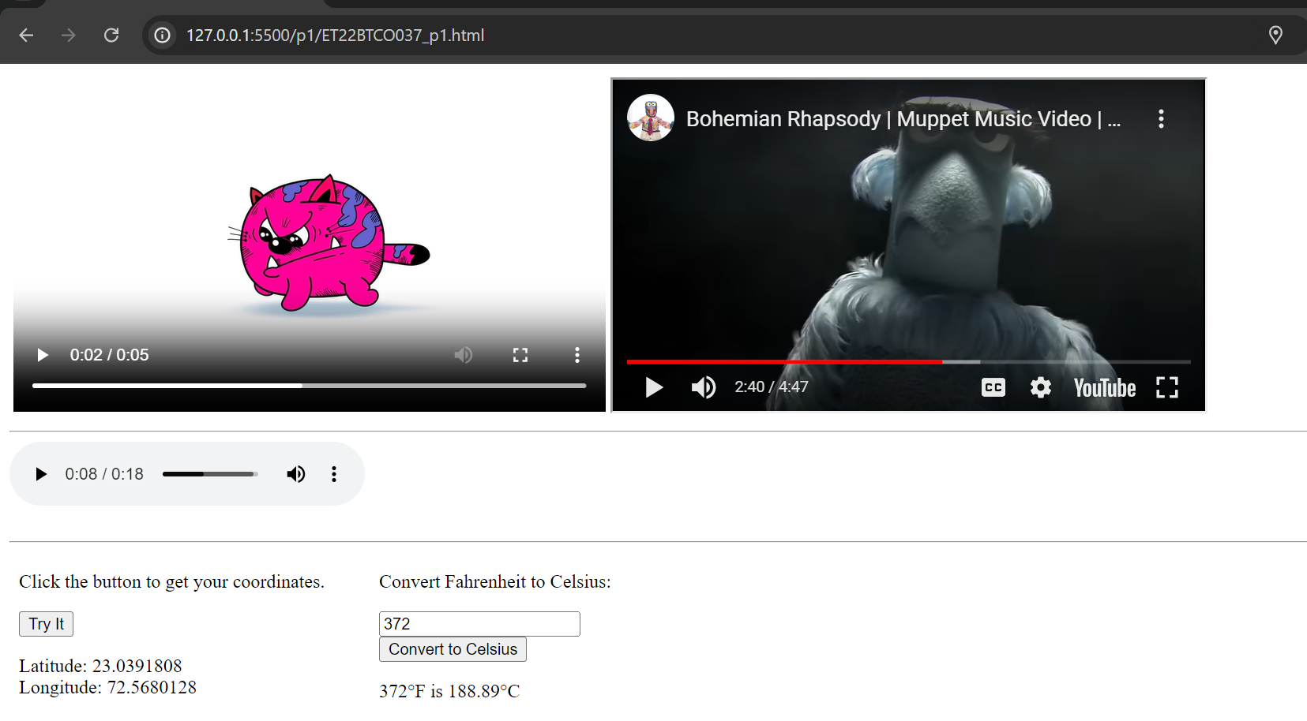

**Assignment 2:**

(ii) Implement drag and drop functionality and geo location by HTML API.

**Code:**

**ETBTCO037_p2.html**

<html>

<head>

<style>

#div1 {

width: 150px;

height: 150px;

padding: 10px;

border: 1px solid #aaaaaa;

}

</style>

<script>

function allowDrop(ev) {

ev.preventDefault();

}

function drag(ev) {

ev.dataTransfer.setData("text", ev.target.id);

}

function drop(ev) {

ev.preventDefault();

var data = ev.dataTransfer.getData("text");

ev.target.appendChild(document.getElementById(data));

}

</script>

</head>

<body>

<h1> drag and drop functionality</h1>

<p>Drag the image into the rectangle:</p>

<div id="div1" ondrop="drop(event)" ondragover="allowDrop(event)"></div>

<br>

<img id="drag1" src="image.jpg" draggable="true" ondragstart="drag(event)" width="150" height="150">

<h1>geo location by HTML API.</h1>

<p>Click the button to get your coordinates.</p>

<button onclick="getLocation()">Try It</button>

<p id="demo"></p>

<script>

var x = document.getElementById("demo");

function getLocation() {

if (navigator.geolocation) {

navigator.geolocation.getCurrentPosition(showPosition);

} else {

x.innerHTML = "Geolocation is not supported by this browser.";

}

}

function showPosition(position) {

x.innerHTML = "Latitude: " + position.coords.latitude +

"<br>Longitude: " + position.coords.longitude;

}

</script>

</body>

</html>

**Output:**

|  |  |
| --- | --- |