**Practical No : 01**

**Date:** 01/07/2024

**Problem Statement:**

Use the following Tags with their attributes as mentioned to test the HTML pages

- Test <h1> through <h6> tag

- Use <hr> and <br> tag for Line break and horizontal rule

- Use of <p> tag attribute align=”center”,........

- Use of <ins> and <del> tag

- Use of preformatted text by using tags such as <i>, <b>, <em>, <blink>, <sup>,

<big>, <strong>, <small>, <sub>, <pre>

- Usage of quotation, abbreviation and acronym tags

- Commenting the code using <!-- Text goes Here -- >

- Use of tag < body with attributes bgcolor=..., vlink=......, text=......,link=.....,

background=.... Etc

- Use of hyperlinks using anchor tag <a href=”URL” > ........</a> with attribute

Target . And also the use of anchor tag as to work as bookmark

- Use of <img> tag with attribute src, height, width, alt....

**Code:**

1. **h1 to h6**

**Syntax:** <h1 attributes="..."> ... </h1> through <h6 attributes="..."> ... </h6>

**Attributes:** align:Deprecated in HTML5.

**Description:** The <h1> to <h6> tags define headings, with <h1> being the highest level and <h6> the lowest.

1. **Hr**

**Syntax:** <hr attributes="...">

**Attributes:** align, noshade, size, width: Deprecated in HTML5.

**Description:** The <hr> tag represents a thematic break or horizontal rule in the document.

1. **Br**

**Syntax:** <br>....</br>

**Description:** The <br> tag inserts a line break.

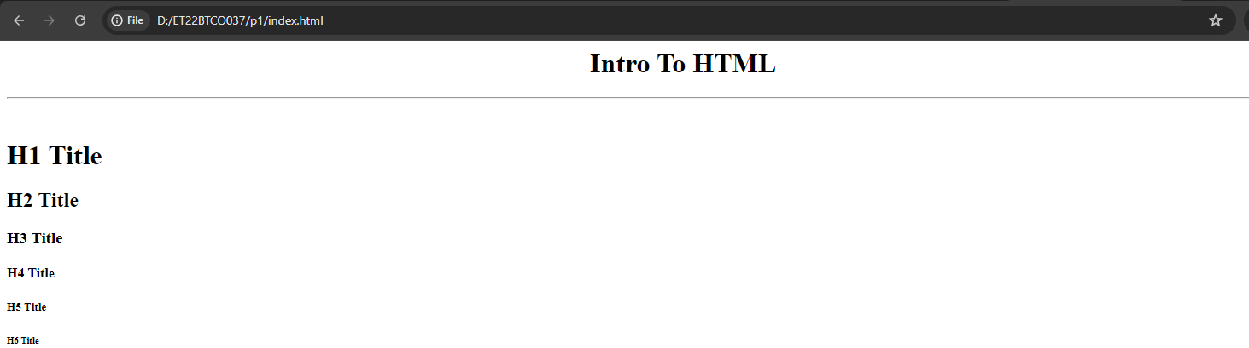

1. **Ins**

**Syntax:** <ins attributes="..."> ... </ins>

**Attributes:** cite, datetime

**Description:**The <ins> tag represents text that has been inserted into a document.

1. **Del**

**Syntax:** <del attributes="..."> ... </del>

**Attributes:** cite, datetime

**Description:** The <del> tag represents text that has been deleted from a document.

1. **I**

**Syntax:** <i> ... </i>

**Attributes:** None

**Description:** The <i> tag is used to italicize text or to denote a section of text in an alternate

voice or mood.

1. **B**

**Syntax:** <b> ... </b>

**Attributes:** None

**Description:** The <b> tag is used to bold text, without any extra emphasis or importance

1. **Blink**

**Syntax:** <blink> ... </blink>

**Attributes:** None

**Description:** The <blink> tag is used to make text blink. It is not supported in most modern browsers and is considered obsolete.

1. **Sup**

**Syntax:** <sup> ... </sup>

**Attributes:** None

**Description:** The <sup> tag defines superscript text, which is displayed slightly above the

normal text line.

1. **Big**

**Syntax:** <big> ... </big>

**Attributes:** None

**Description:** The <big> tag makes text slightly larger than the surrounding text. It is

deprecated in HTML5.

1. **Strong**

**Syntax:** <strong> ... </strong>

**Attributes:** None

**Description:** The <strong> tag is used to give strong importance to text, typically rendering

it is in bold.

1. **Small**

**Syntax:** <small> ... </small>

**Attributes:** None

**Description:** The <small> tag makes text smaller than the surrounding text.

1. **Sub**

**Syntax:** <sub> ... </sub>

**Attributes:** None

**Description:** The <sub> tag defines subscript text, which is displayed slightly below the

normal text line.

1. **Pre**

**Syntax:** <pre> ... </pre>

**Attributes:** None

**Description:** The <pre> tag defines preformatted text, preserving both spaces and line

breaks.

1. **<!.....>**

**Syntax:** <!-- Comment text here →

**Attributes:** None

**Description:** Comments in HTML are used to insert notes or explanations within the code

that are not rendered by the browser. They are useful for documenting your code,

making it easier for yourself or others to understand.

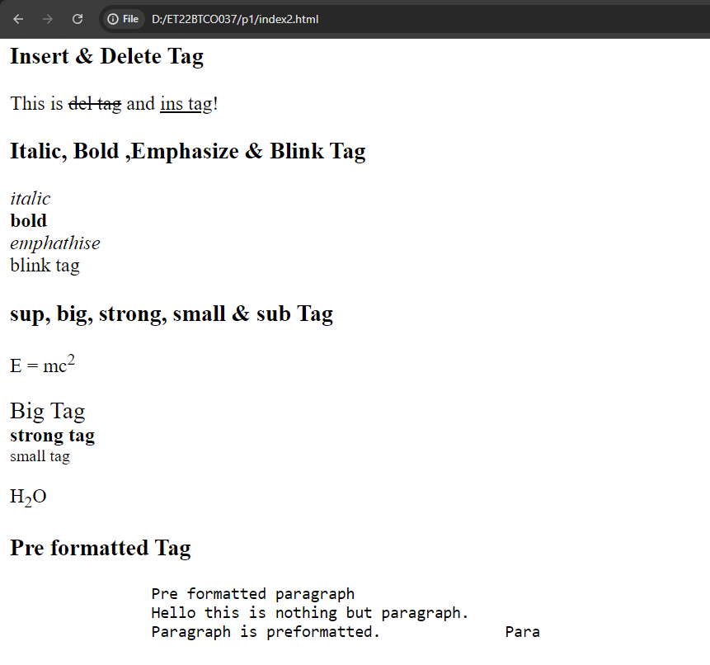

1. **a**

**Syntax:** <a attributes="..."> ... </a>

**Attributes:** href, target, rel, type, download

**Description:** The <a> tag defines a hyperlink.

1. **q**

**Syntax:** <q attributes="..."> ... </q>

**Attributes:** cite: URL of the source document or message.

**Description:** The <q> tag defines a short inline quotation

1. **abbr**

**Syntax:** <abbr attributes="..."> ... </abbr>

**Attributes:** title: Specifies the full text of the abbreviation.

**Description:** The <abbr> tag defines an abbreviation or acronym.

1. **Body**

**Syntax:** <body attributes="..."> ... </body>

**Attributes:** alink, background, bgcolor, link, text, vlink: Deprecated in HTML5.

**Description:** The <body> tag defines the main content of the HTML document that is

visible to users in the web browser

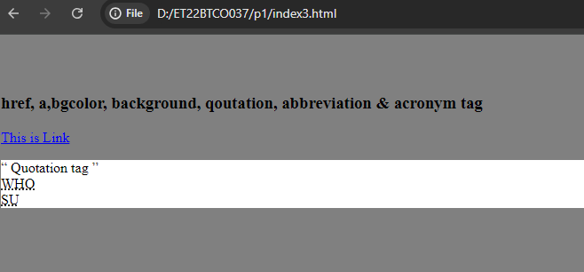

1. **img**

**Syntax:** <img attributes="...">

**Attributes:** src, alt, width, height, title

**Description:** The <img> tag is used to embed an image in a document.

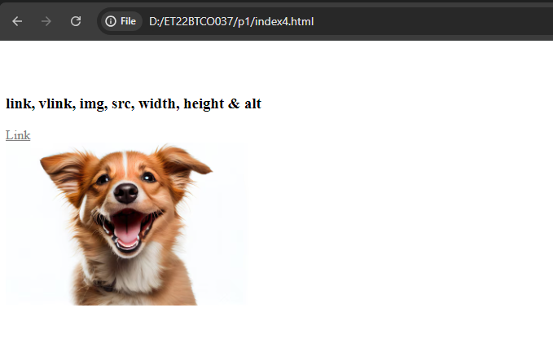

**Code 1:**

<html>

<head>

<title>Practise</title>

</head>

<body>

<p><b>Satya Nadella</b> is new <i>CEO</i> of Microsoft<p>

<p>Microsoft's founder and Chairman of board <b>Bill Gates</b> said <q><i>During this time of tranformation, there is no better to lead <del>Google</del> <ins>Microsoft</ins> than Satya Nandella</i></q></p>

<p>Example for small, sub & sup elements</p>

<p>The chemical formula for water is H<sub>2</sub>O</p>

<p>Einstein proposed the principle of relativity E=mc<sup>2</sup></p>

<p>copy rights reserved &copy</p>

</body>

</html>

**Output:**

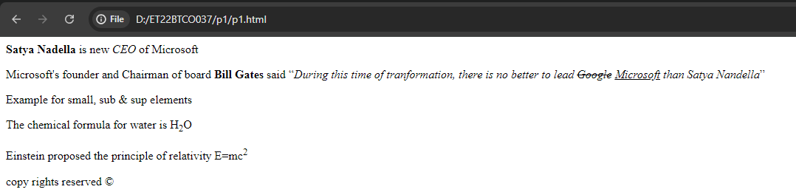

**Code 2:**

<html>

<head>

<title>Formatted Text</title>

</head>

<body>

<p>This is an example of <strong>some BOLD text.</strong></p>

<p>When you come over to my house, <strong>beware</strong> of the dog! Even though the word beware is displayed as bold, since it is marked using the &lt;strong&gt; element, the purpose is to mark it as important!</p>

<p>Would you like to spend the weekend sailing and fishing on my boat <em>Slice Of Life</em>?</p>

<p>My mom made a <em>small</em> mistake in leaving the door open and a sparrow <em>flew</em> in!</p>

<p>I like to drink H<sub>2</sub>O every day to keep me hydrated. My birthday is the 29<sup>th</sup> of February 1995.</p>

<p>While the bank robber was busy gathering the cash from the counter, my friend whispered in my ear, <q>Let's sneak out of here…</q> We slowly moved towards the door and then made a dash for it!</p>

<p><span style="background-color: yellow">This text is highlighted with a marker,</span> and this is not.</p>

<p>The quick brown fox jumps over the lazy <del>dog</del>.</p>

</body>

</html>

**Output:**

