**Practical No : 02**

**Date:** 08/07/2024

**Problem Statement:**

- Usage of ordered and unordered lists using <ul> and <ol> and also nesting of list

with attribute type=.....

- Table tag and associated tags: <table>, <td> , <tr>, <th> and attributes such as

border, colspan, rowspan, cellpadding, cellspacing, width, height, valign......etc,

- Demonstrate how to link a mail message

- Use of <font> tag with attributes <color>, <size>, <face> etc

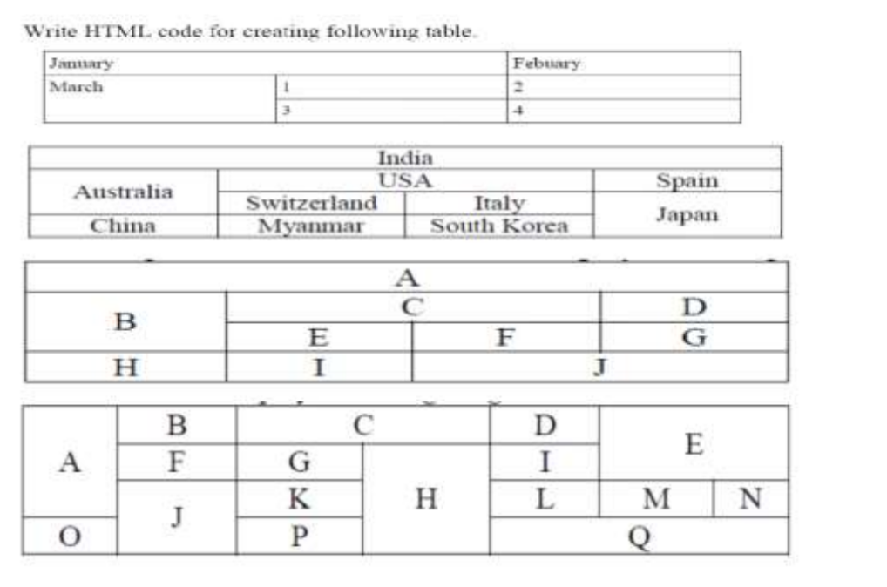

**HTML Tags:**

1. **Ordered List (<ol>):**

**Syntax:** <ol attributes="..."> ... </ol>

**Attributes:**

● reversed: Boolean attribute. If present, it specifies that the list order should be descending.

● start: Specifies the start value of the list.

● type: Specifies the kind of marker to use in the list (e.g., "1", "A", "a", "I",

"i").

**Description:** The <ol> tag defines an ordered list. An ordered list can be numerical or alphabetical.

1. **Unordered List (<ul>):**

**Syntax:** <ul attributes="..."> ... </ul>

**Attributes:**

type: Specifies the type of bullet to be used in the list (e.g., "disc", "circle", "square").

**Description:** The <ul> tag defines an unordered (bulleted) list.

1. **Table (<table>):**

**Syntax:** <table attributes="..."> ... </table>

**Attributes:**

● border: Specifies the width of the border around the table.

● cellpadding: Specifies the space between the cell wall and the cell content.

● cellspacing: Specifies the space between cells.

● summary: Provides a summary of the table’s purpose and structure for user

agents rendering to non-visual media such as speech and Braille.

● width: Specifies the width of the table.

**Description:** The <table> tag defines an HTML table.

1. **Table Row (<tr>):**

**Syntax:** <tr attributes="..."> ... </tr>

**Attributes:**

● align: Specifies the horizontal alignment of the content within a table row.

● bgcolor: Specifies the background color of the table row.

● valign: Specifies the vertical alignment of the content within a table row.

**Description:** The <tr> tag defines a row in an HTML table.

1. **Table Data (<td>):**

**Syntax:** <td attributes="..."> ... </td>

**Attributes:**

● align: Specifies the horizontal alignment of the content within a table cell.

● bgcolor: Specifies the background color of a table cell.

● colspan: Specifies the number of columns a cell should span.

● rowspan: Specifies the number of rows a cell should span.

● valign: Specifies the vertical alignment of the content within a table cell.

**Description:** The <td> tag defines a standard data cell in an HTML table.

1. **Table Header (<th>):**

**Syntax:** <th attributes="..."> ... </th>

**Attributes:**

● align: Specifies the horizontal alignment of the content within a table header cell.

● bgcolor: Specifies the background color of a table header cell.

● colspan: Specifies the number of columns a header cell should span.

● rowspan: Specifies the number of rows a header cell should span.

● scope: Specifies whether a header cell is a header for a column, row, or group

of columns or rows.

● valign: Specifies the vertical alignment of the content within a table header cell.

**Description:** The <th> tag defines a header cell in an HTML table.

1. **Mail Message Link (<a> for mail):**

**Syntax:** <a href="mailto:email@example.com"> ... </a>

**Attributes:**

● href: Specifies the email address to send the mail to, prefixed with mailto:.

● target: Specifies where to open the email client.

● title: Specifies extra information about an element (displayed as a tooltip).

**Description:** The <a> tag can also be used to define an email link using the mailto: scheme.

1. **Font (<font>):**

**Syntax:** <font attributes="..."> ... </font>

**Attributes:**

● color: Specifies the color of the text.

● face: Specifies the font face of the text.

● size: Specifies the size of the text.

**Description:** The <font> tag is used to define the font, color, and size of text

**Output:**

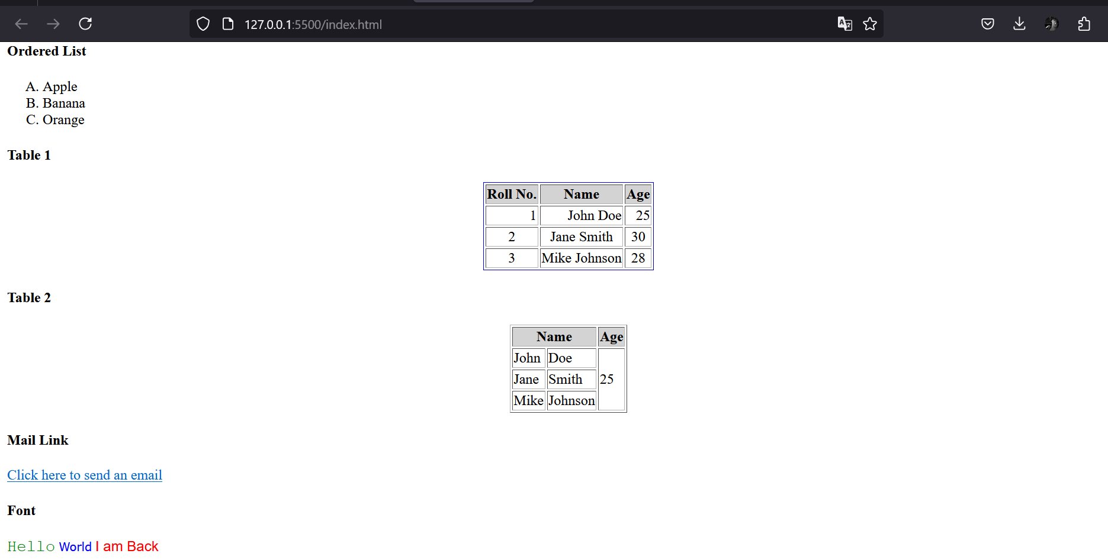

**Code :**

<html>

<head>

<title>Practical 2</title>

</head>

<body>

<table border="1" align="center" width="450" height="90" cellspacing="0">

<caption>Table 1</caption>

<tr>

<td colspan="2" align="left">January</td>

<td>Febuary</td>

</tr>

<tr>

<td rowspan="2">March</td>

<td width="33%">1</td>

<td>2</td>

</tr>

<tr>

<td>3</td>

<td>4</td>

</tr>

</table>

<br>

<table border="1" align="center" width="450" height="90" cellspacing="0">

<caption>Table 2</caption>

<tr align="center">

<td colspan="4">India</td>

</tr>

<tr align="center">

<td rowspan="2" width="25%">Australia</td>

<td colspan="2">USA</td>

<td width="25%">Spain</td>

</tr>

<tr align="center">

<td>Switzerland</td>

<td>Italy</td>

<td rowspan="2">Japan</td>

</tr>

<tr align="center">

<td>China</td>

<td>Myanmar</td>

<td>South Korea</td>

</tr>

</table>

<br>

<table border="1" align="center" width="450" height="90" cellspacing="0">

<caption>Table 3</caption>

<tr align="center">

<td colspan="4">A</td>

</tr>

<tr align="center">

<td rowspan="2" width="25%">B</td>

<td colspan="2">C</td>

<td width="25%">D</td>

</tr>

<tr align="center">

<td>E</td>

<td>F</td>

<td>G</td>

</tr>

<tr align="center">

<td>H</td>

<td>I</td>

<td colspan="2">J</td>

</tr>

</table>

<br>

<table border="1" align="center" width="450" height="90" cellspacing="0">

<caption>Table 4</caption>

<tr align="center">

<td rowspan="3">A</td>

<td>B</td>

<td colspan="2">C</td>

<td>D</td>

<td rowspan="2" colspan="2">E</td>

</tr>

<tr align="center">

<td>F</td>

<td>G</td>

<td rowspan="3">H</td>

<td>I</td>

</tr>

<tr align="center">

<td rowspan="2">J</td>

<td>K</td>

<td>L</td>

<td>M</td>

<td>N</td>

</tr>

<tr align="center">

<td>O</td>

<td>P</td>

<td colspan="3">Q</td>

</tr>

</table>

</body>

</html>

**Output:**

