

Mealy Database Handbook
Production foundation for student ordering canteen POS administration and shared services
POSTGRESQL  16 plus | SCHEMA  112 tables | STATUS  Verified foundation
Prepared 14 September 2026
Architecture reference and implementation guide

Purpose and main conclusion
This handbook explains the complete PostgreSQL database foundation created for Mealy. It is intended for product owners, backend engineers, POS integrators, administrators, testers, and operators who need one readable reference for what the schema covers and what remains to be implemented in application code.
Main conclusion. The database is a verified production-oriented foundation for a multi-campus food ordering platform. It covers student ordering, canteen POS, canteen and central administration, catalog customization, taxes, KOTs, tokens, payments, wallet, printing, audit, and reliability. A passing schema does not by itself make the product production-ready; backend authorization, calculations, provider integrations, concurrency tests, and policy decisions still need implementation or approval.

Document map
- Database at a glance
- Split payment capability
- System boundaries and tenant model
- Catalog pricing tax and inventory
- Orders tokens and kitchen operations
- Payments promotions wallet and settlement
- POS administration reliability and security
- Data invariants migrations and verification
- Production readiness and TBD decisions
- Complete table function and trigger catalogue

Database at a glance
The foundation uses framework-neutral append-only SQL migrations for PostgreSQL 16 and later. Monetary values use integer minor units, identifiers use UUIDs, timestamps are timezone-aware, and business events preserve immutable snapshots so historical orders do not change when a menu or tax rule changes.
Measure | Verified count | Purpose
Tables | 112 | Domain and operational records
Foreign keys | 215 | Relationship and tenant integrity
Check constraints | 305 | Allowed states ranges and value shapes
Indexes | 220 | Lookup uniqueness and operational performance
Functions | 11 | Scope checks numbering tokens transitions and event recording
Non internal triggers | 74 | Validation events and automatic updated timestamps
Migrations | 7 | Ordered schema seed function and constraint layers

Four product surfaces
Surface | Database coverage
Student ordering | Identity campus context menu cart checkout order tracking token collection wallet and feedback models
Canteen POS | Counter orders incoming orders KOT status payment receipt printer register shift and cash models
Canteen and central admin | Campuses canteens outlets staff roles features settings onboarding subscriptions and audit models
Shared backend | Pricing tax order identity sequences idempotency webhooks outbox and authoritative state transitions

Default feature posture
Class | Capabilities
Enabled core | Student ordering POS KOT tokens printing cash payment and multi POS
Modeled but disabled | Wallet coupons feedback inventory dine in reservations delivery subscriptions commissions and online payments
Scope rule | A modeled table is not launch approval; optional capabilities require an explicit product decision and canteen feature enablement

Split payment capability
Answer. Yes at the data-model level, with an important implementation qualification. An order may own multiple payment intents, each intent may use a different enabled payment method and amount, and the order payment state explicitly includes partially paid. This can represent cash plus UPI, wallet plus card, or other mixed tenders.
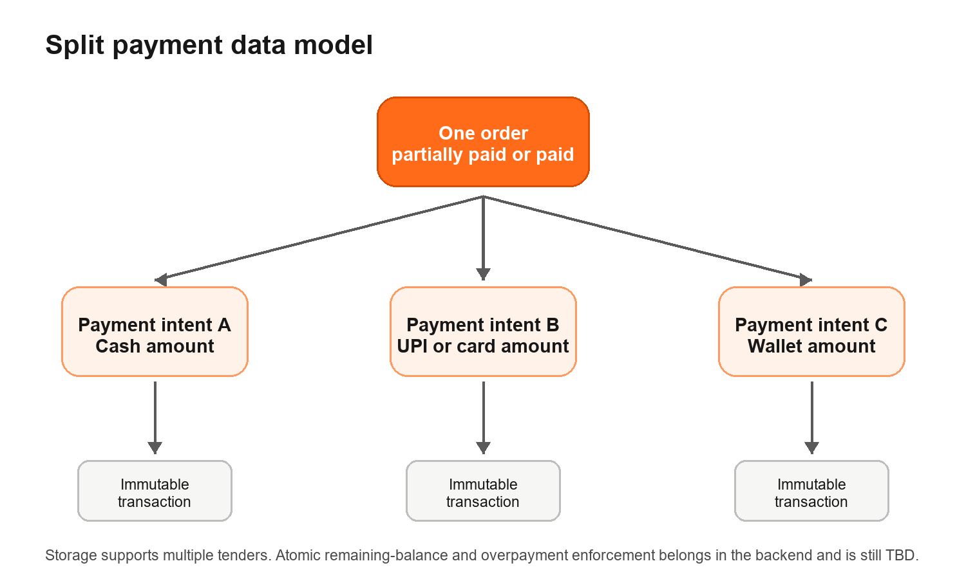

What is already supported
- Multiple payment_intents rows may reference the same order; there is no one-intent-per-order constraint.
- Each intent stores its own method configuration amount currency status provider reference and idempotency key.
- Immutable payment_transactions preserve authorization capture sale void refund chargeback and adjustment events.
- orders.payment_status supports unpaid pending partially_paid paid partially_refunded refunded failed and voided.
- Refunds may target a specific successful payment transaction, which enables tender-aware refund routing.
- Wallet ledger entries can reference both an order and a payment transaction.

What the backend must still enforce
Control | Required behavior | Status
Atomic balance | Lock or version the order while adding or capturing a tender and calculate the remaining amount server-side. | TBD implementation
Overpayment | Reject or explicitly authorize payments whose successful total exceeds the payable order total. | TBD policy
State derivation | Derive partially paid or paid from successful net captures rather than trusting a client-supplied status. | TBD implementation
Failure recovery | Define how expired failed or reversed tenders affect the remaining amount and retry experience. | TBD policy
Refund allocation | Define proportional manual or tender-priority refund allocation and ensure totals cannot exceed net captured value. | TBD policy
KOT timing | Decide whether KOT creation occurs before payment after first tender or only after full settlement. | Blocking product decision

Readiness classification. Split payment is structurally supported but not yet production-ready until these backend rules and tests are implemented.

System boundaries and tenant model
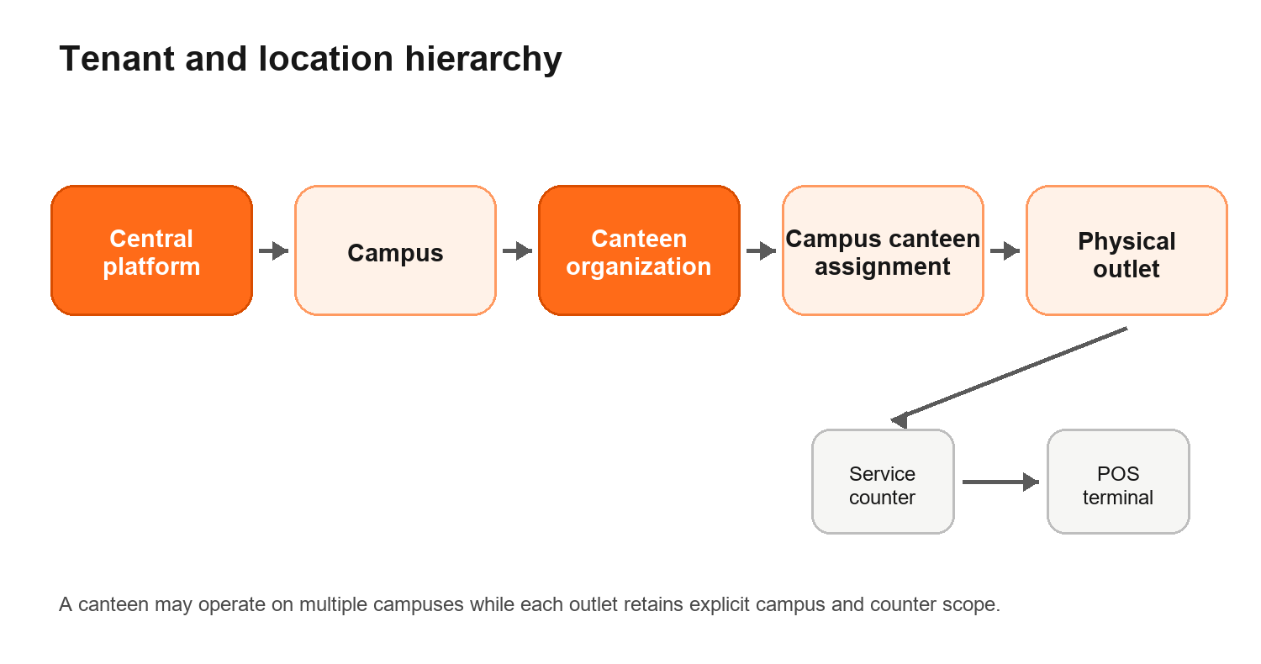
The canteen is the operating organization. A campus_canteens record assigns that canteen to a campus. Physical outlets belong to the assignment, counters belong to an outlet, and terminals are registered at the correct outlet and counter. This avoids treating a canteen brand and a physical serving location as the same entity.
Level | Responsibility
Platform | Global settings feature definitions system roles campus onboarding and cross-tenant governance
Campus | Campus profile timezone contact settings and canteen assignments
Canteen | Operating organization catalog ownership feature entitlements payment configuration and staff scope
Outlet | Physical operation hours closures menu publication pricing inventory kitchen printers registers and reporting scope
Counter | Pickup location daily token namespace and terminal association
Terminal | Registered POS device operational context and audit attribution

Identity authorization and feature control
- Global app users may have provider identities revocable sessions and expiring login challenges.
- Student profiles and campus memberships remain distinct from staff access.
- Staff authorization is modeled through scoped memberships roles permissions and membership-role assignments.
- Feature definitions and canteen_features allow optional modules to remain disabled until approved.
- Final runtime database grants and row-level security depend on the selected backend authentication framework and remain TBD.

Catalog pricing tax and inventory
Catalog data separates canonical products from outlet-specific selling conditions. A menu can be scheduled and assigned to outlets, categories can be hierarchical, and each item can expose variants plus add-on groups with explicit selection rules. Historical order lines copy the accepted names quantities and prices so later catalog edits do not rewrite a receipt or KOT.
Capability | Model coverage | Default scope
Menus and schedules | Menus menu outlets schedules categories and category ordering | Core
Items and variants | Canonical items media SKU dietary class preparation time variants and one default variant | Core
Add-ons | Modifier groups options min max free selections quantities item-level and variant-level assignment | Core
Outlet selling | Price overrides availability sold-out windows daily limits and channel-aware scheduled price rules | Core
Tax | Tax categories multiple effective rates inclusive pricing compound order and immutable order tax lines | Core
Service charges | Fixed or percentage charges by scope channel and effective period | Supported
Allergens | Allergen registry and item mappings | Supported
Inventory | Ingredients recipes balances versions and immutable movements | Optional disabled

Pricing rules that application code must own
- Select the active outlet menu schedule availability and price rule for the requested channel and time.
- Validate variant and modifier eligibility and min/max quantities before calculating totals.
- Apply tax component ordering inclusive-tax extraction discounts and service charges using approved rounding fixtures.
- Persist only server-calculated accepted snapshots on the order.
- Accounting approval for exact tax promotion and rounding precedence remains TBD before API implementation.

Orders tokens and kitchen operations
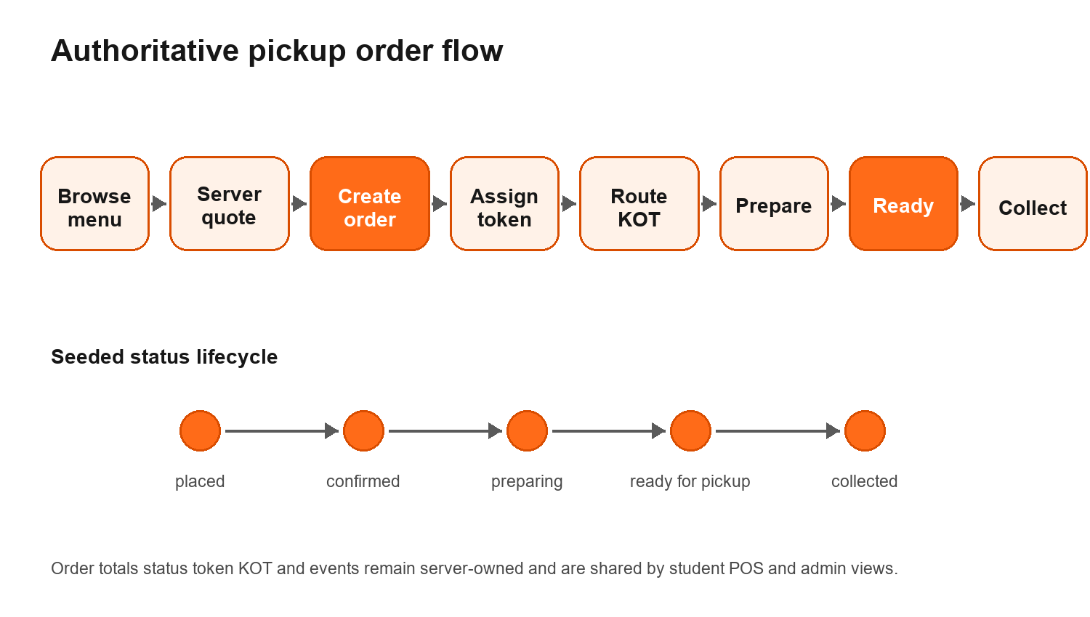
Student orders, POS-created counter orders, kiosk orders, administrative orders, and API orders use the same authoritative orders table. Each order receives an outlet-scoped daily order number. Pickup tokens are allocated atomically by service counter and business date, while KOTs route immutable item and modifier snapshots to kitchen stations.
Concern | Database behavior
Order identity | UUID plus atomic daily outlet order number and optimistic version
Financial snapshot | Subtotal discount tax charge total currency item variant modifier and pricing snapshots
Fulfillment | Pickup by default with modeled dine-in and delivery options disabled unless enabled
Token | Counter and service-date scoped sequence with prefix and idempotent allocation
KOT | Multiple tickets revisions kitchen station routing item modifiers and status events
Status | Data-driven transitions actor restrictions reason requirements full history and outbox publication

Implemented pickup baseline. placed to confirmed to preparing to ready for pickup to collected, with controlled rejection and cancellation paths. Final UI and business approval remains TBD.

Payments promotions wallet and platform finance
Payment configuration stores only secret-manager references and safe public configuration. Provider intent identifiers and transaction identifiers are unique when present, while idempotency keys protect retryable order-scoped actions. Refunds, wallet ledger entries, commission calculations, collections, payouts, and subscriptions are separate records so reconciliation does not depend on mutable order fields alone.
Area | Coverage
Payment methods | Cash UPI card Razorpay wallet bank transfer and other, scoped to canteen or outlet and channel
Intents | Order amount currency method provider lifecycle expiration failure details and idempotency
Transactions | Authorization capture sale void refund chargeback and adjustment events
Refunds | Order and optional transaction target reason provider reference status and request attribution
Promotions | Percentage fixed item fixed buy X get Y and free item definitions with codes and limits
Wallet | One balance per student and currency with versioning and immutable idempotent movements
Platform finance | Commission rules collections net payable payouts and payout allocation
Subscriptions | Plans canteen subscriptions billing lifecycle and included feature metadata

Wallet coupons commissions subscriptions and online payments are modeled but default disabled. Launch methods provider selection settlement timing and KOT timing remain product decisions.

POS administration reliability and security

POS and canteen operations
Area | Model coverage
Printing | Printers routes retryable jobs error details attempts and reprint-safe document linkage
Cash | Registers one active shift opening and closing balances movements and reconciliation
Receipts | Outlet sequences receipt numbers issue status and order association
Optional service | Dining areas tables reservations student addresses and delivery assignments
Engagement | Feedback item ratings push devices notification preferences and delivery state
Onboarding | Canteen setup checklist ownership completion and operational readiness steps

Reliability and traceability
- API idempotency records protect retryable creates and side effects.
- Webhook events store provider delivery identity processing status attempts and redacted payloads.
- Transactional outbox events are committed with domain changes and published later with retries.
- Audit logs retain actor scope request metadata action target and structured before/after context.
- Data-subject requests model privacy access correction export and deletion workflows.
- Login challenges separate expiring verification state from long-lived sessions.

Security boundary
Browsers and POS clients must never receive direct authority to calculate totals change payment state or mutate arbitrary tenant rows. The backend must derive scope from the authenticated principal, recalculate prices, verify payment signatures and webhooks, invoke database functions through least-privilege roles, and publish updates only after the transaction commits.

Data standards and enforced invariants
Standard | Implementation
Identifiers | UUID primary keys for distributed-safe entity identity; bigserial only for append-only event ordering where appropriate
Money | Integer minor units plus ISO three-character currency code; no floating-point money
Inventory | numeric 18 by 6 for precise ingredient quantities
Time | Timezone-aware timestamps and explicit business date for order token register and receipt sequences
History | Immutable order KOT tax charge discount payment inventory wallet and audit records
Concurrency | Atomic sequence functions idempotency keys unique provider IDs optimistic versions and row locks where required
Tenancy | Foreign keys scope-validation triggers and explicit campus canteen outlet counter relationships
Secrets | Only secret references are persisted in payment configuration; payloads are redacted before storage
Lifecycle | Check constraints plus data-driven status transitions and actor restrictions

Database functions
Function | Responsibility
set_updated_at | Maintains updated timestamps automatically.
validate_terminal_counter_scope | Prevents terminal and counter scope mismatch.
validate_order_scope | Validates campus canteen outlet counter terminal and actor relationships on orders.
validate_membership_role_scope | Prevents assigning a role outside a membership's scope.
validate_menu_outlet_scope | Prevents publishing a canteen menu to an unrelated outlet.
validate_item_modifier_scope | Prevents cross-canteen item and modifier assignment.
validate_promotion_code_scope | Prevents cross-canteen promotion and code relationships.
next_order_number | Allocates a concurrency-safe daily outlet order number.
allocate_order_token | Allocates an idempotent counter and date scoped token.
transition_order | Applies authorized version-aware order status transitions and history.
record_new_order | Creates the initial status event and transactional outbox record.

Migrations operations and verification

Migration layers
Order | Layer | Contents
001 | Foundation | Identity tenancy RBAC settings hours closures and feature control
002 | Catalog | Menus categories items variants modifiers pricing taxes allergens and inventory
003 | Orders | Carts orders snapshots sequences tokens stations KOTs and events
004 | Payments | Methods intents transactions refunds promotions wallet commissions payouts and subscriptions
005 | POS operations | Printers registers shifts receipts optional service feedback notifications and onboarding
006 | Reliability | Idempotency webhooks outbox audit privacy and login challenges
007 | Seeds and constraints | Default features roles permissions statuses validation functions triggers and indexes

Local operating workflow
Command | Purpose
Up | Starts PostgreSQL 16 Alpine using Docker Compose.
Migrate | Applies migrations in order and records their SHA 256 checksum in a ledger.
Verify | Runs the transactional schema smoke test and rolls fixture data back.
Status | Shows the database and migration state.
Logs | Shows container logs for diagnosis.
Down | Stops the local database; volume removal is an explicit separate choice.

Verification evidence
- All seven migrations replayed successfully from an empty PostgreSQL 16 Docker volume.
- A second migration run skipped all files after matching stored SHA 256 checksums.
- The smoke test created campus canteen outlet counter terminal catalog variant add-on tax order token transition history and outbox records transactionally.
- The smoke test verified idempotent token allocation and rejected an unauthorized status transition.
- Every table with updated_at has an automatic timestamp trigger.
- High-concurrency load testing and production restore testing remain future release gates.

Production readiness and TBD decisions
The schema is production-oriented and locally verified, but production readiness belongs to the complete system. The following work must be completed or approved before launch.
Area | Required decision or implementation | Status
Backend framework and runtime identity | Select framework session design database roles and whether row-level security is used. | TBD
Student authentication | Approve phone OTP Truecaller guest access or a subset with abuse controls. | Blocking for auth flow
Payment methods | Approve launch methods providers split tender behavior settlement and KOT timing. | Blocking for checkout
Tax and rounding | Approve calculation order inclusive extraction discount interaction and accounting fixtures. | Blocking for totals
Pickup lifecycle | Confirm seeded transitions cancellation rejection refund and no-show behavior. | Blocking for UI API
Optional features | Approve wallet coupons inventory feedback dine-in reservation delivery commissions and subscriptions individually. | Disabled by default
Realtime and jobs | Select event transport queue worker printer adapter retries and monitoring. | TBD
Deployment | Select hosting database storage CI backups restore monitoring alerts and incident ownership. | TBD
Compliance | Confirm Indian privacy tax invoice payment campus minor consent retention and deletion requirements. | TBD owner legal
Performance | Load test campus rush traffic simultaneous tokens payment retries KOT printing and stale POS clients. | Required before launch

Complete table catalogue
This catalogue lists every application table created by migrations 001 through 006. Migration 007 adds seed data functions triggers constraints and indexes but does not add application tables. Key fields omit universal identity and audit columns to keep the reference readable.

Identity tenant and platform control
Table | Purpose | Representative fields | References
schema_metadata | Records schema identity and database-level metadata. | singleton, schema_version, minimum_app_version | None
app_users | Stores the global user identity shared by students staff and administrators. | display_name, email, phone_e164, password_hash, status, preferred_locale | None
auth_identities | Links users to login providers and normalized external identifiers. | user_id, provider, provider_subject, provider_metadata, last_used_at | app_users
user_sessions | Stores revocable authenticated sessions and their security lifecycle. | user_id, token_hash, device_name, ip_address, user_agent, expires_at | app_users
campuses | Defines campuses managed by the central platform. | code, name, legal_name, status, timezone, currency_code | app_users
canteens | Defines canteen operating organizations independent of any one campus. | code, name, legal_name, tax_registration_number, status, support_email | app_users
campus_canteens | Assigns a canteen organization to a campus and anchors physical outlets. | campus_id, canteen_id, display_name, status, starts_at, ends_at | campuses, canteens
outlets | Represents a physical canteen outlet at a campus assignment. | campus_canteen_id, code, name, status, timezone, currency_code | campus_canteens
service_counters | Defines pickup or service counters within an outlet. | outlet_id, code, name, status, token_prefix, token_reset_timezone | outlets
pos_terminals | Registers POS devices and binds them to outlet and counter scope. | outlet_id, counter_id, code, name, device_fingerprint_hash, status | outlets, service_counters
student_profiles | Adds student-specific attributes to the global user account. | user_id, student_number, date_of_birth, dietary_preferences, marketing_opt_in | app_users
student_campus_memberships | Tracks student association or verification for a campus. | student_user_id, campus_id, campus_student_identifier, status, verified_at, valid_until | student_profiles, campuses
roles | Stores roles records used by the Mealy platform. | code, name, scope_type, is_system | None
permissions | Stores permissions records used by the Mealy platform. | code, description, risk_level | None
role_permissions | Stores role permissions records used by the Mealy platform. | role_id, permission_code | roles, permissions
access_memberships | Grants a user membership at platform campus canteen or outlet scope. | user_id, scope_type, campus_id, canteen_id, outlet_id, employee_code | app_users, campuses, canteens, outlets
membership_roles | Assigns scoped roles to access memberships. | membership_id, role_id, assigned_by, assigned_at | access_memberships, roles, app_users
feature_definitions | Stores feature definitions records used by the Mealy platform. | code, name, description, default_enabled, configuration_schema | None
canteen_features | Controls optional capabilities independently for each canteen. | canteen_id, feature_code, enabled, configuration, effective_from, effective_until | canteens, feature_definitions, app_users
platform_settings | Stores scoped configuration for platform. | key, value, is_public, schema_version, updated_by | app_users
campus_settings | Stores scoped configuration for campus. | campus_id, key, value, is_public, schema_version, updated_by | campuses, app_users
canteen_settings | Stores scoped configuration for canteen. | canteen_id, key, value, is_public, schema_version, updated_by | canteens, app_users
outlet_settings | Stores scoped configuration for outlet. | outlet_id, key, value, is_public, schema_version, updated_by | outlets, app_users
outlet_business_hours | Stores outlet business hours records used by the Mealy platform. | outlet_id, day_of_week, service_type, opens_at, closes_at, ordering_opens_minutes_before | outlets
outlet_closures | Stores outlet closures records used by the Mealy platform. | outlet_id, starts_at, ends_at, reason, created_by | outlets, app_users

Catalog pricing tax and inventory
Table | Purpose | Representative fields | References
media_assets | Stores media assets records used by the Mealy platform. | canteen_id, storage_key, public_url, mime_type, byte_size, width_px | canteens, app_users
menus | Defines canteen menus and their publication lifecycle. | canteen_id, code, name, description, status, sort_order | canteens, media_assets
menu_outlets | Publishes a menu to one or more permitted outlets. | menu_id, outlet_id, is_active, sort_order | menus, outlets
menu_schedules | Stores menu schedules records used by the Mealy platform. | menu_id, outlet_id, day_of_week, starts_at, ends_at, valid_from | menus, outlets
catalog_categories | Stores hierarchical food and beverage categories. | canteen_id, parent_id, code, name, description, image_asset_id | canteens, catalog_categories, media_assets
menu_categories | Stores menu categories records used by the Mealy platform. | menu_id, category_id, sort_order | menus, catalog_categories
tax_categories | Groups catalog items into tax treatment categories. | canteen_id, code, name, description | canteens
tax_rates | Stores effective-dated tax components including inclusive and compound rules. | canteen_id, code, name, authority, rate_basis_points, price_inclusive | canteens
tax_category_rates | Maps tax categories to their component rates. | tax_category_id, tax_rate_id | tax_categories, tax_rates
catalog_items | Stores canonical sellable items and their food metadata. | canteen_id, primary_category_id, tax_category_id, sku, name, short_description | canteens, catalog_categories, tax_categories, media_assets
catalog_item_categories | Stores catalog item categories records used by the Mealy platform. | item_id, category_id | catalog_items, catalog_categories
item_variants | Stores sizes or other sellable variants including the default variant. | item_id, sku, name, price_minor, is_default, status | catalog_items
modifier_groups | Defines add-on groups with selection and quantity rules. | canteen_id, code, name, description, minimum_selections, maximum_selections | canteens
modifier_options | Defines individual add-ons and their incremental price. | modifier_group_id, code, name, price_delta_minor, is_default, status | modifier_groups
item_modifier_groups | Assigns valid add-on groups to an item or a specific variant. | item_id, variant_id, modifier_group_id, minimum_override, maximum_override, sort_order | catalog_items, item_variants, modifier_groups
outlet_item_settings | Overrides item price availability and sold-out state per outlet. | outlet_id, item_id, is_available, is_visible_student, is_visible_pos, price_override_minor | outlets, catalog_items
outlet_variant_settings | Overrides variant price and availability per outlet. | outlet_id, variant_id, is_available, price_override_minor, sold_out_until | outlets, item_variants
price_rules | Stores scheduled channel-aware and outlet-aware price adjustments. | canteen_id, outlet_id, item_id, variant_id, channel, price_minor | canteens, outlets, catalog_items, item_variants
service_charges | Stores fixed or percentage service charges by scope and channel. | canteen_id, code, name, calculation_type, amount_minor, rate_basis_points | canteens, tax_categories
allergens | Stores allergens records used by the Mealy platform. | code, name | None
item_allergens | Stores item allergens records used by the Mealy platform. | item_id, allergen_code, presence | catalog_items, allergens
inventory_items | Defines ingredients or stock-managed supplies. | canteen_id, sku, name, unit, track_stock, low_stock_threshold | canteens
recipes | Maps catalog variants to inventory consumption quantities. | item_id, variant_id, modifier_option_id, inventory_item_id, quantity | catalog_items, item_variants, modifier_options, inventory_items
inventory_balances | Stores the current outlet inventory balance with versioning. | outlet_id, inventory_item_id, on_hand, reserved, version | outlets, inventory_items
inventory_movements | Provides the immutable inventory movement ledger. | outlet_id, inventory_item_id, movement_type, quantity_delta, reference_type, reference_id | outlets, inventory_items, app_users

Orders tokens and kitchen operations
Table | Purpose | Representative fields | References
order_status_definitions | Stores order status definitions records used by the Mealy platform. | code, label, is_terminal, is_customer_visible, sort_order | None
order_status_transitions | Stores order status transitions records used by the Mealy platform. | from_status, to_status, allowed_actor_types, requires_reason | order_status_definitions
carts | Stores an active or converted cart for student or POS checkout. | student_user_id, outlet_id, currency_code, status, version, expires_at | student_profiles, outlets
cart_items | Stores cart item selections before an order snapshot is created. | cart_id, item_id, variant_id, quantity, notes, unit_price_minor | carts, catalog_items, item_variants
cart_item_modifiers | Stores selected cart add-ons and quantities. | cart_item_id, modifier_group_id, modifier_option_id, quantity, unit_price_delta_minor | cart_items, modifier_groups, modifier_options
order_number_sequences | Allocates atomic daily order numbers per outlet. | outlet_id, business_date, next_value | outlets
token_sequences | Allocates atomic daily pickup tokens per service counter. | counter_id, service_date, next_value | service_counters
orders | Stores the authoritative order identity totals payment state and fulfillment state. | public_number, outlet_id, counter_id, terminal_id, student_user_id, created_by_user_id | outlets, service_counters, pos_terminals, student_profiles, app_users
order_items | Stores immutable item and variant snapshots accepted at checkout. | order_id, catalog_item_id, variant_id, sku_snapshot, item_name_snapshot, variant_name_snapshot | orders, catalog_items, item_variants
order_item_modifiers | Stores immutable selected add-on snapshots for each order item. | order_item_id, modifier_group_id, modifier_option_id, group_name_snapshot, option_name_snapshot, quantity | order_items, modifier_groups, modifier_options
order_tax_lines | Stores tax component snapshots and calculated amounts for an order. | order_id, order_item_id, tax_rate_id, name_snapshot, rate_basis_points, taxable_amount_minor | orders, order_items, tax_rates
order_charge_lines | Stores fee and service-charge snapshots for an order. | order_id, service_charge_id, name_snapshot, calculation_type, rate_basis_points, base_amount_minor | orders, service_charges
order_status_events | Records the append-only fulfillment status history. | order_id, from_status, to_status, actor_type, actor_user_id, reason_code | orders, order_status_definitions, app_users
order_tokens | Links an order to its counter-scoped pickup token. | order_id, counter_id, service_date, token_number, token_label, issued_at | orders, service_counters
kitchen_stations | Defines kitchen preparation destinations within an outlet. | outlet_id, code, name, status, display_order | outlets
item_station_routes | Routes catalog items to appropriate kitchen stations. | outlet_id, item_id, kitchen_station_id, priority | outlets, catalog_items, kitchen_stations
kots | Stores Kitchen Order Tickets and revision lifecycle. | order_id, kitchen_station_id, kot_number, revision, status, source | orders, kitchen_stations, app_users
kot_items | Stores KOT item snapshots and preparation status. | kot_id, order_item_id, quantity, item_name_snapshot, variant_name_snapshot, notes_snapshot | kots, order_items
kot_item_modifiers | Stores KOT add-on snapshots for kitchen visibility. | kot_item_id, option_name_snapshot, quantity | kot_items
kot_status_events | Records KOT lifecycle changes. | kot_id, kot_item_id, from_status, to_status, actor_user_id, reason_code | kots, kot_items, app_users

Payments promotions wallet and finance
Table | Purpose | Representative fields | References
payment_method_configs | Configures enabled payment methods per canteen or outlet using secret references. | canteen_id, outlet_id, method_code, display_name, provider, secret_reference | canteens, outlets
payment_intents | Represents an amount attempted through one payment method for an order. | order_id, payment_method_config_id, provider, provider_intent_id, idempotency_key, amount_minor | orders, payment_method_configs
payment_transactions | Stores immutable authorization capture sale refund and adjustment events. | payment_intent_id, transaction_type, provider_transaction_id, amount_minor, currency_code, status | payment_intents
refund_reasons | Stores refund reasons records used by the Mealy platform. | code, label, is_active | None
refunds | Tracks order refunds with idempotency and provider references. | order_id, payment_transaction_id, reason_code, provider_refund_id, idempotency_key, amount_minor | orders, payment_transactions, refund_reasons, app_users
promotions | Defines eligibility and value rules for canteen promotions. | canteen_id, name, description, promotion_type, value_minor, value_basis_points | canteens, app_users
promotion_codes | Defines redeemable codes associated with promotions. | canteen_id, promotion_id, code, usage_limit, status | canteens, promotions
order_discount_lines | Stores immutable discount snapshots accepted on an order. | order_id, order_item_id, promotion_id, promotion_code_snapshot, name_snapshot, amount_minor | orders, order_items, promotions
promotion_redemptions | Tracks promotion consumption and reversal per order. | promotion_id, promotion_code_id, order_id, student_user_id, discount_amount_minor, redeemed_at | promotions, promotion_codes, orders, student_profiles
wallets | Stores a student's versioned balance by currency. | student_user_id, currency_code, balance_minor, version, status | student_profiles
wallet_transactions | Provides the immutable idempotent wallet ledger. | wallet_id, transaction_type, amount_delta_minor, balance_after_minor, order_id, payment_transaction_id | wallets, orders, payment_transactions, app_users
commission_rules | Stores commission rules records used by the Mealy platform. | canteen_id, outlet_id, channel, calculation_type, amount_minor, rate_basis_points | canteens, outlets
platform_collections | Calculates platform and canteen settlement amounts for an order. | order_id, canteen_id, gross_collected_minor, commission_minor, gateway_fee_minor, tax_on_commission_minor | orders, canteens
payouts | Tracks payouts from the platform to a canteen. | canteen_id, provider, provider_payout_id, idempotency_key, amount_minor, currency_code | canteens, app_users
payout_collections | Allocates collected order proceeds into a payout. | payout_id, collection_id, amount_minor | payouts, platform_collections
subscription_plans | Stores subscription plans records used by the Mealy platform. | code, name, billing_period, price_minor, currency_code, included_features | None
canteen_subscriptions | Stores canteen subscriptions records used by the Mealy platform. | canteen_id, plan_id, status, starts_at, current_period_ends_at, cancelled_at | canteens, subscription_plans

POS administration and service operations
Table | Purpose | Representative fields | References
printers | Registers outlet printers and connection configuration. | outlet_id, code, name, printer_type, connection_config, paper_width_mm | outlets
printer_routes | Routes document types or stations to printers. | outlet_id, printer_id, document_type, kitchen_station_id, terminal_id, copies | outlets, printers, kitchen_stations, pos_terminals
print_jobs | Queues retryable KOT and receipt print work. | outlet_id, printer_id, order_id, kot_id, document_type, document_version | outlets, printers, orders, kots
cash_registers | Defines cash drawers or registers at an outlet. | outlet_id, terminal_id, code, name, status | outlets, pos_terminals
pos_shifts | Tracks register opening closing and reconciliation. | cash_register_id, opened_by, closed_by, opening_cash_minor, expected_closing_cash_minor, counted_closing_cash_minor | cash_registers, app_users
cash_movements | Records cash paid in paid out and corrective movements. | shift_id, order_id, movement_type, amount_minor, currency_code, reason | pos_shifts, orders, app_users
dining_areas | Stores dining areas records used by the Mealy platform. | outlet_id, code, name, sort_order, status | outlets
dining_tables | Stores dining tables records used by the Mealy platform. | dining_area_id, code, name, capacity, qr_token_hash, status | dining_areas
reservations | Stores reservations records used by the Mealy platform. | outlet_id, dining_table_id, student_user_id, guest_name, guest_phone_e164, party_size | outlets, dining_tables, student_profiles
student_addresses | Stores student addresses records used by the Mealy platform. | student_user_id, label, recipient_name, phone_e164, address_line_1, address_line_2 | student_profiles
delivery_assignments | Stores delivery assignments records used by the Mealy platform. | order_id, assigned_to_user_id, external_partner, external_reference, status, pickup_at | orders, app_users
receipt_sequences | Provides concurrency-safe numbering for receipt. | outlet_id, financial_year, next_value | outlets
receipts | Stores issued receipt references and order linkage. | order_id, receipt_number, receipt_type, financial_year, legal_snapshot, totals_snapshot | orders, app_users
feedback | Stores an order-level student feedback submission. | order_id, student_user_id, overall_rating, comment, status, submitted_at | orders, student_profiles, app_users
feedback_items | Stores item-specific ratings or comments within feedback. | feedback_id, order_item_id, rating, comment | feedback, order_items
push_devices | Registers notification-capable student devices. | user_id, platform, endpoint_hash, encrypted_subscription, status, last_seen_at | app_users
notification_preferences | Stores student notification-channel choices. | user_id, event_code, channel, enabled | app_users
notifications | Tracks notification content delivery state and retries. | user_id, order_id, event_code, title, body, data | app_users, orders
onboarding_checklists | Stores onboarding checklists records used by the Mealy platform. | canteen_id, step_code, status, completed_by, completed_at, notes | canteens, app_users

Reliability security and audit
Table | Purpose | Representative fields | References
api_idempotency_records | Prevents duplicate processing of retryable API operations. | scope_type, scope_id, operation, idempotency_key, request_hash, state | None
webhook_events | Protects provider webhook processing against replay and duplicate delivery. | provider, provider_event_id, event_type, signature_valid, payload_redacted, payload_hash | None
outbox_events | Queues events transactionally for reliable downstream publication. | aggregate_type, aggregate_id, event_type, event_version, payload, occurred_at | None
audit_logs | Records security-sensitive and administrative activity. | actor_user_id, actor_type, action, entity_type, entity_id, campus_id | app_users, campuses, canteens, outlets
data_subject_requests | Tracks privacy access correction or deletion requests. | user_id, request_type, status, verification_method, requested_at, due_at | app_users
login_challenges | Stores expiring OTP or login verification challenges. | channel, destination_hash, provider_reference, code_hash, purpose, attempts | None

Source and maintenance notes
The authoritative implementation is the ordered SQL under apps backend database migrations. The Markdown database architecture API security testing decisions and known issues documents explain policy and scope. If a schema migration changes behavior, these references and this handbook should be regenerated in the same change.
Reference | Project location
Database implementation | apps/backend/database/migrations
Migration runner | apps/backend/database/scripts/Invoke-Database.ps1
Schema smoke test | apps/backend/database/tests/schema_smoke_test.sql
Database guide | docs/DATABASE.md
Architecture | docs/ARCHITECTURE.md
Security | docs/SECURITY.md
Testing | docs/TESTING.md
Decisions and TBDs | docs/DECISIONS.md and docs/KNOWN_ISSUES.md

Document status: database foundation implemented and locally verified on 14 September 2026. Application APIs provider integrations and launch policies are not implied by schema presence and remain governed by the project decision log.

