**Compiler Design(18CSC304J)**

**Experiment 11**

**LEADING AND TRAILING**

Harsh Goel

RA1811003010185

**Aim:** To study and implement Leading and Trailing.

**Language: C++**

**Procedure:**

1. For Leading, check for the first non-terminal.
2. If found, print it.
3. Look for next production for the same non-terminal.
4. If not found, recursively call the procedure for the single non-terminal present before the comma or End Of Production String.
5. Include it's results in the result of this non-terminal.
6. For trailing, we compute same as leading but we start from the end of the production to the beginning.
7. Stop

**Code Snippet:**

#include <iostream>

#include <conio.h>

#include <stdio.h>

#include <string.h>

#include <stdlib.h>

int vars, terms, i, j, k, m, rep, count, temp = -1;

char var[10], term[10], lead[10][10], trail[10][10];

struct grammar

{

    int prodno;

    char lhs, rhs[20][20];

} gram[50];

using namespace std;

void get()

{

    cout << "\n------------- LEADING AND TRAILING ---------------\n";

    cout << "\nEnter the no. of variables : ";

    cin >> vars;

    cout << "\nEnter the variables : \n";

    for (i = 0; i < vars; i++)

    {

        cin >> gram[i].lhs;

        var[i] = gram[i].lhs;

    }

    cout << "\nEnter the no. of terminals : ";

    cin >> terms;

    cout << "\nEnter the terminals : ";

    for (j = 0; j < terms; j++)

        cin >> term[j];

    cout << "\n------------- PRODUCTION DETAILS -----------------\n";

    for (i = 0; i < vars; i++)

    {

        cout << "\nEnter the no. of production of " << gram[i].lhs << ":";

        cin >> gram[i].prodno;

        for (j = 0; j < gram[i].prodno; j++)

        {

            cout << gram[i].lhs << "->";

            cin >> gram[i].rhs[j];

        }

    }

}

void leading()

{

    for (i = 0; i < vars; i++)

    {

        for (j = 0; j < gram[i].prodno; j++)

        {

            for (k = 0; k < terms; k++)

            {

                if (gram[i].rhs[j][0] == term[k])

                    lead[i][k] = 1;

                else

                {

                    if (gram[i].rhs[j][1] == term[k])

                        lead[i][k] = 1;

                }

            }

        }

    }

    for (rep = 0; rep < vars; rep++)

    {

        for (i = 0; i < vars; i++)

        {

            for (j = 0; j < gram[i].prodno; j++)

            {

                for (m = 1; m < vars; m++)

                {

                    if (gram[i].rhs[j][0] == var[m])

                    {

                        temp = m;

                        goto out;

                    }

                }

            out:

                for (k = 0; k < terms; k++)

                {

                    if (lead[temp][k] == 1)

                        lead[i][k] = 1;

                }

            }

        }

    }

}

void trailing()

{

    int count = 0;

    for (i = 0; i < vars; i++)

    {

        for (j = 0; j < gram[i].prodno; j++)

        {

            count = 0;

            while (gram[i].rhs[j][count] != '\x0')

                count++;

            for (k = 0; k < terms; k++)

            {

                if (gram[i].rhs[j][count - 1] == term[k])

                    trail[i][k] = 1;

                else

                {

                    if (gram[i].rhs[j][count - 2] == term[k])

                        trail[i][k] = 1;

                }

            }

        }

    }

    for (rep = 0; rep < vars; rep++)

    {

        for (i = 0; i < vars; i++)

        {

            for (j = 0; j < gram[i].prodno; j++)

            {

                count = 0;

                while (gram[i].rhs[j][count] != '\x0')

                    count++;

                for (m = 1; m < vars; m++)

                {

                    if (gram[i].rhs[j][count - 1] == var[m])

                        temp = m;

                }

                for (k = 0; k < terms; k++)

                {

                    if (trail[temp][k] == 1)

                        trail[i][k] = 1;

                }

            }

        }

    }

}

void display()

{

    for (i = 0; i < vars; i++)

    {

        cout << "\nLEADING(" << gram[i].lhs << ") = ";

        for (j = 0; j < terms; j++)

        {

            if (lead[i][j] == 1)

                cout << term[j] << ",";

        }

    }

    cout << endl;

    for (i = 0; i < vars; i++)

    {

        cout << "\nTRAILING(" << gram[i].lhs << ") = ";

        for (j = 0; j < terms; j++)

        {

            if (trail[i][j] == 1)

                cout << term[j] << ",";

        }

    }

}

void main()

{

    get();

    leading();

    trailing();

    display();

    getch();

}

**Output Screenshots:**

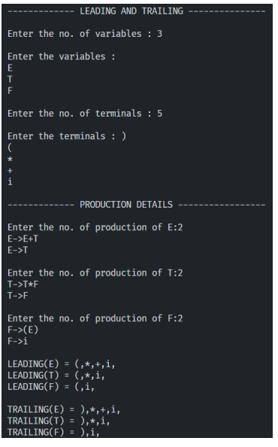

**Result:**

The code was successfully implemented and output was recorded.