**Compiler Design(18CSC304J)**

**Experiment 3**

**RE to NFA**

Harsh Goel

RA1811003010185

**Aim:** To study and perform regular expression to NFA conversion

**Language: C**

**Procedure:**

1. Create a file or select the file for performing the operations on.
2. For this, created a c file called master.c
3. Write the code in the c file
4. Run the code and perform the operations required.
5. Note the output and document it.

**Process:**

* Open the c file using open command in execute mode
* Input the regular expression
* Loop on the regular expression till its length
* Generate transition function
* Print the transition function .

**Code Snippet:**

#include<stdio.h>

#include<string.h>

int main()

{

    char reg[20];

    int q[20][3],i,j,len,a,b;

    for(a=0;a<20;a++)

    {

        for(b=0;b<3;b++)

        {

            q[a][b]=0;

        }

    }

    printf("%s","Enter the Regular Expression:            ");

    scanf("%s",reg);

    len=strlen(reg);

    i=0;

j=1;

    while(i<len)

    {

        if(reg[i]=='a'&&reg[i+1]!='|'&&reg[i+1]!='*')

        {

            q[j][0]=j+1;

            j++;

        }

        if(reg[i]=='b'&&reg[i+1]!='|'&&reg[i+1]!='*')

        {

            q[j][1]=j+1;

            j++;

        }

        if(reg[i]=='e'&&reg[i+1]!='|'&&reg[i+1]!='*')

        {

            q[j][2]=j+1;

            j++;

        }

        if(reg[i]=='a'&&reg[i+1]=='|'&&reg[i+2]=='b')

        {

            q[j][2]=((j+1)*10)+(j+3);

            j++;

            q[j][0]=j+1;

            j++;

            q[j][2]=j+3;

            j++;

            q[j][1]=j+1;

            j++;

            q[j][2]=j+1;

            j++;

            i=i+2;

        }

        if(reg[i]=='b'&&reg[i+1]=='|'&&reg[i+2]=='a')

        {

            q[j][2]=((j+1)*10)+(j+3);

            j++;

            q[j][1]=j+1;

            j++;

            q[j][2]=j+3;

            j++;

            q[j][0]=j+1;

            j++;

            q[j][2]=j+1;

            j++;

            i=i+2;

        }

        if(reg[i]=='a'&&reg[i+1]=='*')

        {

            q[j][2]=((j+1)*10)+(j+3);

            j++;

            q[j][0]=j+1;

            j++;

            q[j][2]=((j+1)*10)+(j-1);

            j++;

        }

        if(reg[i]=='b'&&reg[i+1]=='*')

        {

            q[j][2]=((j+1)*10)+(j+3);

            j++;

            q[j][1]=j+1;

            j++;

            q[j][2]=((j+1)*10)+(j-1);

            j++;

        }

        if(reg[i]==')'&&reg[i+1]=='*')

        {

            q[0][2]=((j+1)*10)+1;

            q[j][2]=((j+1)*10)+1;

            j++;

        }

        i++;

    }

    printf("Transition function \n");

    for(i=0;i<=j;i++)

    {

        if(q[i][0]!=0)

            printf("\n q[%d,a]-->%d",i,q[i][0]);

        if(q[i][1]!=0)

            printf("\n q[%d,b]-->%d",i,q[i][1]);

        if(q[i][2]!=0)

        {

            if(q[i][2]<10)

                printf("\n q[%d,e]-->%d",i,q[i][2]);

            else

                printf("\n q[%d,e]-->%d & %d",i,q[i][2]/10,q[i][2]%10);

        }

    }

    return 0;

}

**Output Screenshots:**

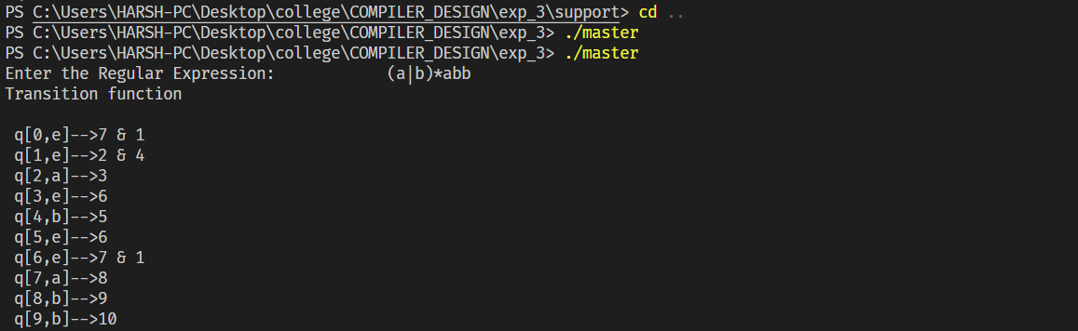

**Result:**

The code was successfully implemented in C and output was recorded. Hence, RE to NFA was successfully executed.