**Compiler Design(18CSC304J)**

**Experiment 4**

**NFA to DFA**

Harsh Goel

RA1811003010185

**Aim:** To study and perform NFA to DFA conversion

**Language: C**

**Procedure:**

1. Create a file or select the file for performing the operations on.
2. For this, created a c file called with extension as .c
3. Write the code in the c file
4. Run the code and perform the operations required.
5. Note the output and document it.
6. The NFA to DFA conversion will be verified

**Process:**

* Open the c file using open command in execute mode
* Declare the NFA expression using 2D array of int type
* Initialize the DFA expression with 1st variables same as NFA (initial value)
* Loop on the NFA till its length and perform conversion
* Print the DFA expression.

**Code Snippet:**

#include <stdio.h>

int main()

{

  int nfa[5][2];

    nfa[1][1]=12;

    nfa[1][2]=1;

    nfa[2][1]=0;

    nfa[2][2]=3;

    nfa[3][1]=0;

    nfa[3][2]=4;

    nfa[4][1]=0;

    nfa[4][2]=0;

    int dfa[10][2];

    int dstate[10];

    int i=1,n,j,k,flag=0,m,q,r;

    dstate[i++]=1;

    n=i;

    // Init DFA initial Stages

    dfa[1][1]=nfa[1][1];

    dfa[1][2]=nfa[1][2];

    // Print dfa initial

    printf("\nf(%d,a)=%d",dstate[1],dfa[1][1]);

    printf("\nf(%d,b)=%d",dstate[1],dfa[1][2]);

// Loop over the dfa

 for(j=1;j<n;j++)

    {

        if(dfa[1][1]!=dstate[j])

          flag++;

    }

    if(flag==n-1)

    {

        dstate[i++]=dfa[1][1];

        n++;

    }

    flag=0;

    for(j=1;j<n;j++)

    {

         if(dfa[1][2]!=dstate[j])

            flag++;

    }

    if(flag==n-1)

    {

         dstate[i++]=dfa[1][2];

         n++;

    }

    k=2;

    while(dstate[k]!=0)

    {

        m=dstate[k];

        if(m>10)

        {

            q=m/10;

            r=m%10;

        }

        if(nfa[r][1]!=0)

             dfa[k][1]=nfa[q][1]*10+nfa[r][1];

        else

            dfa[k][1]=nfa[q][1];

        if(nfa[r][2]!=0)

            dfa[k][2]=nfa[q][2]*10+nfa[r][2];

        else

            dfa[k][2]=nfa[q][2];

        printf("\nf(%d,a)=%d",dstate[k],dfa[k][1]);

        printf("\nf(%d,b)=%d",dstate[k],dfa[k][2]);

       flag=0;

        for(j=1;j<n;j++)

        {

         if(dfa[k][1]!=dstate[j])

          flag++;

        }

      if(flag==n-1)

     {

        dstate[i++]=dfa[k][1];

        n++;

     }

    flag=0;

    for(j=1;j<n;j++)

    {

         if(dfa[k][2]!=dstate[j])

            flag++;

    }

    if(flag==n-1)

    {

         dstate[i++]=dfa[k][2];

         n++;

    }

    k++;

    }

    return 0;

}

**Output Screenshots:**

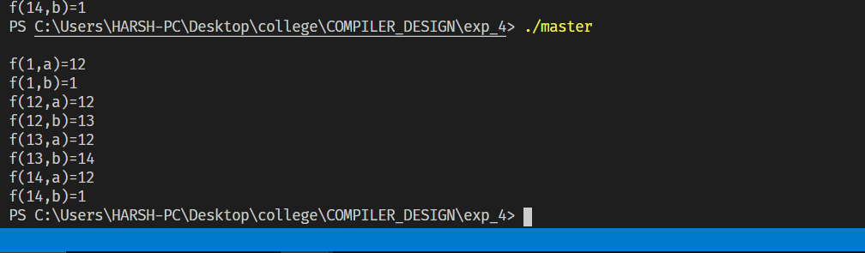

**Result:**

The code was successfully implemented in C and output was recorded. Hence, NFA to DFA was successfully executed.