**ARTIFICIAL INTELLIGENCE (18CSC305J) LAB**

EXPERIMENT 12

Development of ensemble model for an application

**Harsh Goel**

**RA1811003010185**

**CSE-C1**

**Aim:**

To Develop a model an ensemble model for an application.

**Language:** Python

**Theory:**

Ensemble learning helps improve machine learning results bycombining several models. This approach allows the production of betterpredictive performance compared to a single model. Basic idea is to learna set of classifiers (experts) and to allow them to vote.

**Problem Formulation and Algorithm:**

* Import the required libraries.
* Import the data file in the program.
* Clean the data.
* Find the required features on which the model predicts.
* Split the data into two parts say train_x and train_y
* Train the model using the data train_x and find the mean absolute error with the predicted value and train_y.
* We use random forest and decision trees algorithms to predict our model.
* A Random Forest is an ensemble technique capable of performing both regression and classification tasks with the use of multiple decision trees and a technique called Bootstrap and Aggregation, commonly known as bagging.

**Source Code:**

import pandas as pd

from sklearn.ensemble import RandomForestRegressor

from sklearn.metrics import mean_absolute_error

from sklearn.tree import DecisionTreeRegressor

from sklearn.metrics import mean_absolute_error

from sklearn.model_selection import train_test_split

melbourne_file_path = './melb_data.csv'

melbourne_data = pd.read_csv(melbourne_file_path)

melbourne_data.columns

melbourne_data = melbourne_data.dropna(axis=0)

y = melbourne_data.Price

melbourne_features = ['Rooms', 'Bathroom', 'Landsize', 'Lattitude',

'Longtitude']

X = melbourne_data[melbourne_features]

X.describe()

X.head()

# Define model. Specify a number for random_state to ensure same results each run

melbourne_model = DecisionTreeRegressor(random_state=1)

# Fit model

melbourne_model.fit(X, y)

print("Making predictions for the following 5 houses:")

print(X.head())

print("The predictions are")

print(melbourne_model.predict(X.head()))

predicted_home_prices = melbourne_model.predict(X)

mean_absolute_error(y, predicted_home_prices)

# split data into training and validation data, for both features and target

# # The split is based on a random number generator. Supplying a numeric value to

# the random_state argument guarantees we get the same split every time we

# run this script.

train_X, val_X, train_y, val_y = train_test_split(X, y, random_state =0)

# Define model

melbourne_model = DecisionTreeRegressor()

# Fit model

melbourne_model.fit(train_X, train_y)

# get predicted prices on validation data

val_predictions = melbourne_model.predict(val_X)

print(mean_absolute_error(val_y, val_predictions))

forest_model = RandomForestRegressor(random_state=1)

forest_model.fit(train_X, train_y)

melb_preds = forest_model.predict(val_X)

print(mean_absolute_error(val_y, melb_preds))

**Output Screenshots:**

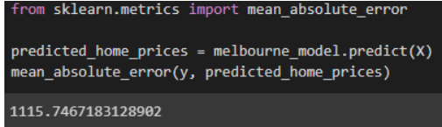

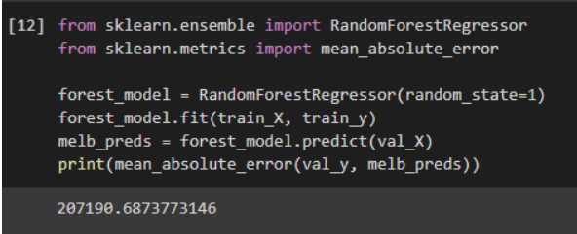

**Verification:**

From both the algorithms we can see the difference in the mean absolute error. The predictions made are nearby the data which are input, so we can verify the data is correctly predicted as it lies along the dataset provided.

**Result:** Hence, successfully implemented the problem and verified the output and document result.