**ARTIFICIAL INTELLIGENCE (18CSC305J) LAB**

EXPERIMENT 8

Implementation of Block World Problem

**Harsh Goel**

**RA1811003010185**

**CSE-C1**

**Aim:**

To implement Block World problem for an application.

**Problem Description:**

The blocks world has two kinds of components:

1) A table top with three places p, q, and r

2) A variable number of blocks A, B, C, etc., that can be arranged in places on the table or stacked on one another.

A legal move is to transfer a block from one place or block onto another place or block, with these restrictions:

• The moved block must not have another block on top of it.

• No other blocks are moved in the process.

**Problem Formulation:**

It is straightforward to think of a move in the blocks world as transferring from one place (the source) to another place (the destination). So the name of the block is not necessary to uniquely specify a move.

The three moves used in the example (see to the left) are:

* Move block from p to r.
* Move block from p to q.
* Move block from r to q.

The doMove method in the blocks world move class must return null if there is no block on the source place.

**Source Code:**

Language- **C++**

#include <iostream>

using namespace std;

struct point

{

    int x, y;

    point(int x, int y) : x(x), y(y)

    {

    }

};

struct line

{

    int a, b, c;

    line(int a, int b, int c) : a(a), b(b), c(c)

    {

    }

    line()

    {

    }

};

int evalPointOnLine(point p, line curLine)

{

    int eval = curLine.a * p.x +

               curLine.b * p.y +

               curLine.c;

    if (eval > 0)

        return 1;

    return -1;

}

int minJumpToReachDestination(point start,

                              point dest, line lines[], int N)

{

    int jumps = 0;

    for (int i = 0; i < N; i++)

    {

        int signStart = evalPointOnLine(start, lines[i]);

        int signDest = evalPointOnLine(dest, lines[i]);

        if (signStart * signDest < 0)

            jumps++;

    }

    return jumps;

}

int main()

{

    point start(1, 1);

    point dest(-2, -1);

    line lines[3];

    lines[0] = line(1, 0, 0);

    lines[1] = line(0, 1, 0);

    lines[2] = line(1, 1, -2);

    cout << minJumpToReachDestination(start, dest, lines, 3);

    return 0;

}

**Output Verification:**

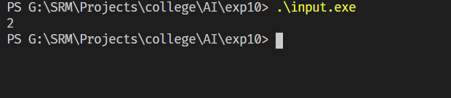

**Verification:**

lines[0] = line(1, 0, 0);

lines[1] = line(0, 1, 0);

lines[2] = line(1, 1, -2);

Source: 1,1

Destination : -2,-1

Minimum Jump : 2

**Result:** Hence, successfully implemented block world problem and verified the output and document result.