**ARTIFICIAL INTELLIGENCE (18CSC305J) LAB**

EXPERIMENT 6

MIN MAX ALGORITHM

**Harsh Goel**

**RA1811003010185**

**CSE-C1**

**Aim:**

To implement min max algorithm and verify result/output.

**Problem Description:**

Mini-max algorithm is a recursive or backtracking algorithm which is used in decision-making and game theory. It provides an optimal move for the player assuming that opponent is also playing optimally. Min-Max algorithm is mostly used for game playing in AI. Such as Chess, Checkers, tic-tac-toe, go, and various tow-players game. This Algorithm computes the minimax decision for the current state.

**Problem Formulation ( Tic Tac Toe) :**

In strategic games, instead of letting the program start the searching process in the very beginning of the game, it is common to use the opening books - a list of known and productive moves that are frequent and known to be productive while we still don't have much information about the state of game itself if we look at the board.

In the beginning, it is too early in the game, and the number of potential positions is too great to automatically decide which move will certainly lead to a better game state (or win).

However, the algorithm reevaluates the next potential moves every turn, always choosing what at that moment appears to be the fastest route to victory. Therefore, it won't execute actions that take more than one move to complete, and is unable to perform certain well known "tricks" because of that. If the AI plays against a human, it is very likely that human will immediately be able to prevent this.

**Psedu Code:**

1. function minimax(node, depth, maximizingPlayer) is
2. if depth ==0 or node is a terminal node then
3. return static evaluation of node
4. if MaximizingPlayer then
5. maxEva= -infinity
6. for each child of node do
7. eva= minimax(child, depth-1, false)
8. maxEva= max(maxEva,eva)
9. return maxEva
10. else
11. minEva= +infinity
12. for each child of node do
13. eva= minimax(child, depth-1, true)
14. minEva= min(minEva, eva
15. return minEva

**Source Code:**

Language- **Python**

class Game:

    def __init__(self):

        self.initialize_game()

    def initialize_game(self):

        self.current_state = [['.','.','.'],

                              ['.','.','.'],

                              ['.','.','.']]

        # Player X always plays first

        self.player_turn = 'X'

    def draw_board(self):

        for i in range(0, 3):

            for j in range(0, 3):

                print('{}|'.format(self.current_state[i][j]), end=" ")

            print()

        print()

    # Determines if the made move is a legal move

    def is_valid(self, px, py):

        if px < 0 or px > 2 or py < 0 or py > 2:

            return False

        elif self.current_state[px][py] != '.':

            return False

        else:

            return True

    # Checks if the game has ended and returns the winner in each case

    def is_end(self):

        # Vertical win

        for i in range(0, 3):

            if (self.current_state[0][i] != '.' and

                self.current_state[0][i] == self.current_state[1][i] and

                self.current_state[1][i] == self.current_state[2][i]):

                return self.current_state[0][i]

        # Horizontal win

        for i in range(0, 3):

            if (self.current_state[i] == ['X', 'X', 'X']):

                return 'X'

            elif (self.current_state[i] == ['O', 'O', 'O']):

                return 'O'

        # Main diagonal win

        if (self.current_state[0][0] != '.' and

            self.current_state[0][0] == self.current_state[1][1] and

            self.current_state[0][0] == self.current_state[2][2]):

            return self.current_state[0][0]

        # Second diagonal win

        if (self.current_state[0][2] != '.' and

            self.current_state[0][2] == self.current_state[1][1] and

            self.current_state[0][2] == self.current_state[2][0]):

            return self.current_state[0][2]

        # Is whole board full?

        for i in range(0, 3):

            for j in range(0, 3):

                # There's an empty field, we continue the game

                if (self.current_state[i][j] == '.'):

                    return None

        # It's a tie!

        return '.'

    # Player 'O' is max, in this case AI

    def max(self):

        # Possible values for maxv are:

        # -1 - loss

        # 0  - a tie

        # 1  - win

        # We're initially setting it to -2 as worse than the worst case:

        maxv = -2

        px = None

        py = None

        result = self.is_end()

        # If the game came to an end, the function needs to return

        # the evaluation function of the end. That can be:

        # -1 - loss

        # 0  - a tie

        # 1  - win

        if result == 'X':

            return (-1, 0, 0)

        elif result == 'O':

            return (1, 0, 0)

        elif result == '.':

            return (0, 0, 0)

        for i in range(0, 3):

            for j in range(0, 3):

                if self.current_state[i][j] == '.':

                    # On the empty field player 'O' makes a move and calls Min

                    # That's one branch of the game tree.

                    self.current_state[i][j] = 'O'

                    (m, min_i, min_j) = self.min()

                    # Fixing the maxv value if needed

                    if m > maxv:

                        maxv = m

                        px = i

                        py = j

                    # Setting back the field to empty

                    self.current_state[i][j] = '.'

        return (maxv, px, py)

    # Player 'X' is min, in this case human

    def min(self):

        # Possible values for minv are:

        # -1 - win

        # 0  - a tie

        # 1  - loss

        # We're initially setting it to 2 as worse than the worst case:

        minv = 2

        qx = None

        qy = None

        result = self.is_end()

        if result == 'X':

            return (-1, 0, 0)

        elif result == 'O':

            return (1, 0, 0)

        elif result == '.':

            return (0, 0, 0)

        for i in range(0, 3):

            for j in range(0, 3):

                if self.current_state[i][j] == '.':

                    self.current_state[i][j] = 'X'

                    (m, max_i, max_j) = self.max()

                    if m < minv:

                        minv = m

                        qx = i

                        qy = j

                    self.current_state[i][j] = '.'

        return (minv, qx, qy)

    def play(self):

        while True:

            self.draw_board()

            self.result = self.is_end()

            # Printing the appropriate message if the game has ended

            if self.result != None:

                if self.result == 'X':

                    print('The winner is X!')

                elif self.result == 'O':

                    print('The winner is O!')

                elif self.result == '.':

                    print("It's a tie!")

                self.initialize_game()

                return

            # If it's player's turn

            if self.player_turn == 'X':

                while True:

                    (m, qx, qy) = self.min()

                    print('Recommended move: X = {}, Y = {}'.format(qx, qy))

                    px = int(input('Insert the X coordinate: '))

                    py = int(input('Insert the Y coordinate: '))

                    (qx, qy) = (px, py)

                    if self.is_valid(px, py):

                        self.current_state[px][py] = 'X'

                        self.player_turn = 'O'

                        break

                    else:

                        print('The move is not valid! Try again.')

            # If it's AI's turn

            else:

                (m, px, py) = self.max()

                self.current_state[px][py] = 'O'

                self.player_turn = 'X'

g = Game()

g.play()

**TEST CASE:**

**Input from User and Output from User**

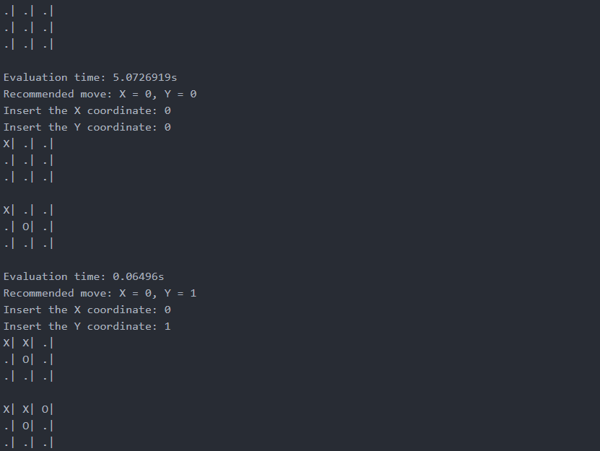

**Verification:**

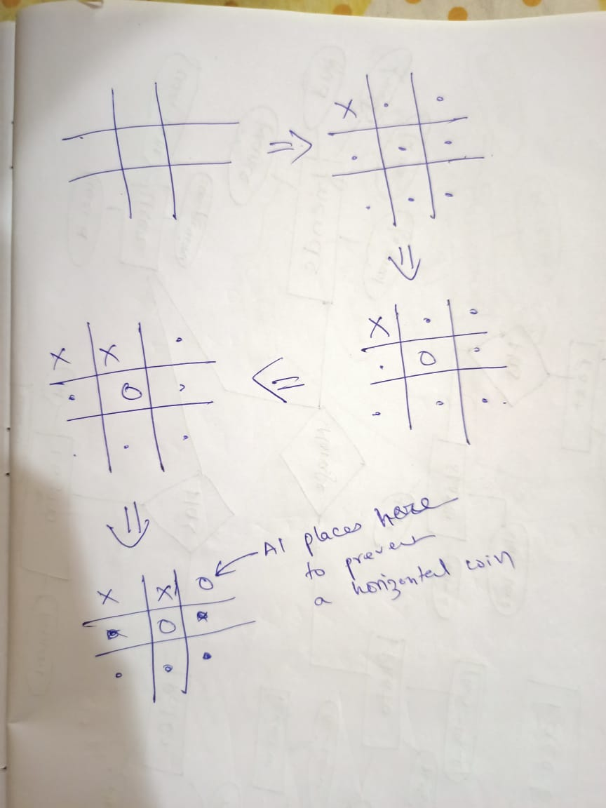

**Result:** Hence, successfully implemented both A* and Best First Search algorithms and verified test cases.