**ARTIFICIAL INTELLIGENCE (18CSC305J) LAB**

EXPERIMENT 8

Implementation of knowledge representation schemes

**Harsh Goel**

**RA1811003010185**

**CSE-C1**

**Aim:**

To implement knowledge representation schemes

**Problem Description:**

Humans are best at understanding, reasoning, and interpreting knowledge. Human knows things, which is knowledge and as per their knowledge they perform various actions in the real world. But how machines do all these things comes under knowledge representation and reasoning. Hence we can describe Knowledge representation as following:

Knowledge representation and reasoning (KR, KRR) is the part of Artificial intelligence which concerned with AI agents thinking and how thinking contributes to intelligent behavior of agents.

It is responsible for representing information about the real world so that a computer can understand and can utilize this knowledge to solve the complex real world problems such as diagnosis a medical condition or communicating with humans in natural language.

It is also a way which describes how we can represent knowledge in artificial intelligence. Knowledge representation is not just storing data into some database, but it also enables an intelligent machine to learn from that knowledge and experiences so that it can behave intelligently like a human.

Semantic networks are alternative of predicate logic for knowledge representation. In Semantic networks, we can represent our knowledge in the form of graphical networks. This network consists of nodes representing objects and arcs which describe the relationship between those objects. Semantic networks can categorize the object in different forms and can also link those objects. Semantic networks are easy to understand and can be easily extended.

**Problem Formulation:**

((canary (is-a bird)

(color yellow)

(size small))

(penguin (is-a bird)

(movement swim))

(bird (is-a vertebrate)

(has-part wings)

(reproduction egg-laying)))

**Source Code:**

Language- **Python**

nouns={0:"cat",1:"dog",2:"human",3:"whale",4:"dolphin",5:"pigeon",6:"eagle",7:"mammal",8:"bird",9:"animal"}

adj=[[0 for i in range(10)] for j in range(10)]

adj[0][7]=1

adj[1][7]=1

adj[2][7]=1

adj[3][7]=1

adj[4][7]=1

adj[5][8]=1

adj[6][8]=1

adj[7][9]=1

adj[8][9]=1

def dfs(v):

    print(nouns[v])

    vis[v]=1

    for i in range(10):

        if adj[v][i] and not vis[i]:

            dfs(i)

print("Implementation of 'is a' relation\n")

for i in range(7):

    print(f"Relation {i+1}")

    vis=[0 for i in range(10)]

    if vis[i]==0:

        vis[i]=1

        dfs(i)

**TEST CASE:**

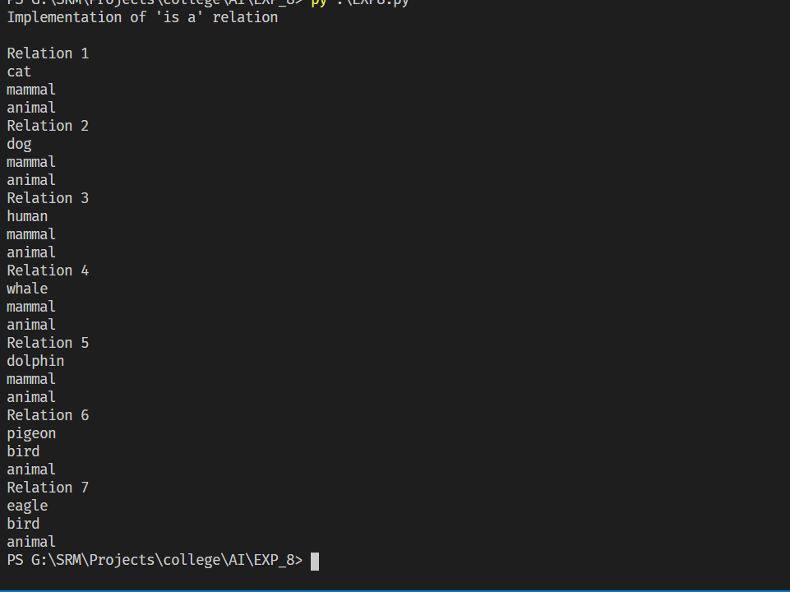

**Verification:**

Verifying Test Case 1

1. Cat is a mammal
2. Mammal is an animal
3. Hence, Cat is an animal

**Result:** Hence, successfully implemented knowledge representation schemes and verified the output and document result.