**ARTIFICIAL INTELLIGENCE (18CSC305J) LAB**

EXPERIMENT 11

Implementation of learning algorithms for an application

**Harsh Goel**

**RA1811003010185**

**CSE-C1**

**Aim:**

To Develop a model to implement learning algorithms for an application

**Language:** Python

**Theory:**

Decision Tree is a decision-making tool that uses a flowchart-like tree structure or is a model of decisions and all of their possible results, including outcomes, input costs and utility. It applies the learning algorithm

**Problem Formulation and Algorithm:**

* Import the required libraries.
* Import the data file in the program.
* Clean the data.
* Find the required features on which the model predicts.For eg. in our program we use -Rooms, Bathroom, Land Size, Latitude, Longitude from our data.
* We also have to find which field we have to predict. In our model we are predicting the price of the House.
* After that we import the libraries of the algorithm .Here we have imported Decision tree regression.
* We train our model with features and data then the predicted value is given by the model.

**Source Code:**

import pandas as pd

from sklearn.tree import DecisionTreeRegressor

melbourne_file_path = 'melb_data.csv'

melbourne_data = pd.read_csv(melbourne_file_path)

melbourne_data.columns

melbourne_data = melbourne_data.dropna(axis=0)

y = melbourne_data.Price

melbourne_features = ['Rooms', 'Bathroom', 'Landsize', 'Lattitude',

'Longtitude']

X = melbourne_data[melbourne_features]

X.describe()

X.head()

# Define model. Specify a number for random_state to ensure same results each run

melbourne_model = DecisionTreeRegressor(random_state=1)

# Fit model

melbourne_model.fit(X, y)

print("Making predictions for the following 5 houses:")

print(X.head())

print("The predictions are")

print(melbourne_model.predict(X.head()))

**Output Screenshots:**

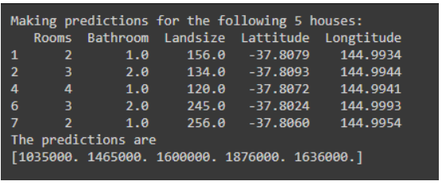

**Verification:**

The predictions made are nearby the data which are input, so we can verify the data is correctly predicted as it lies along the dataset provided.

**Result:** Hence, successfully implemented the problem and verified the output and document result.