# System Architecture – Digital Mental & Psychological Support Platform

The architecture of the proposed system ensures smooth interaction between students, AI-driven mental health tools, and counselors. Below is the high-level workflow:

1. 1. Students access the system via a Mobile/Web App.
2. 2. AI Chatbot (NLP + CBT-based) provides 24/7 conversational support.
3. 3. Mood Tracking & Sentiment Analysis captures emotional states and daily check-ins.
4. 4. Gamified Wellness Module encourages mindfulness and stress-relief activities.
5. 5. Crisis Detection & Alerts module flags high-risk cases.
6. 6. Backend API + Database manages secure storage and processing of data.
7. 7. Counselor/Admin Dashboard shows anonymized trends and critical alerts.

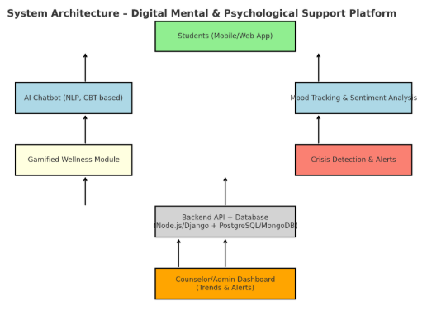

**🛣 Roadmap to Develop the System**

**Phase 1 – Problem Understanding & Requirement Gathering (2 weeks)**

* **User Research**: Interview students, counselors, faculty.
* **Define Use Cases**:
  + Chatbot for stress/anxiety support
  + Mood tracking & dashboards
  + Gamified wellness activities
  + Crisis alerts & counsellor integration
* **Finalize Features**: MVP (chatbot, mood log, crisis escalation) vs. advanced (voice analysis, gamification).

**Phase 2 – Architecture & Tech Stack (1–2 weeks)**

**🔹 Tech Stack**

* **Frontend**: React / Flutter (mobile app + web app for accessibility).
* **Backend**: Node.js / Django / Spring Boot (depending on team expertise).
* **Database**: PostgreSQL / MongoDB (user data + mood logs).
* **AI/NLP**:
  + Hugging Face Transformers / spaCy for chatbot & sentiment analysis
  + TensorFlow / PyTorch for advanced voice & facial emotion detection
* **Gamification**: Simple React/Flutter-based progress tracker with rewards.
* **Deployment**: AWS / GCP / Azure (or NIC Cloud for Govt).
* **Security**: OAuth2 / JWT for authentication; end-to-end encryption for sensitive chats.

**Phase 3 – Core Development (6–8 weeks)**

**🔹 Module 1 – AI Mental Health Chatbot**

* Intent detection using NLP (stress, anxiety, exam fear).
* Responses based on CBT techniques + curated mental health database.
* Multilingual support (English + Hindi + local language).

**🔹 Module 2 – Mood & Sentiment Analysis**

* Daily mood check-ins (emoji/text slider).
* Sentiment analysis of journals/chats.
* Trend visualization for users.

**🔹 Module 3 – Gamified Wellness**

* Mindfulness streaks, gratitude journaling, breathing exercises.
* Leaderboards or badge system for motivation.

**🔹 Module 4 – Crisis Detection & Alerts**

* Identify red-flag terms (“suicidal”, “hopeless”, “end it”).
* Trigger alert → route to counselor dashboard or 24x7 helpline.

**🔹 Module 5 – Counselor/College Dashboard**

* Anonymous trend reports (e.g., “40% students reporting exam stress this week”).
* Case management tool for counselors.

**Phase 4 – Testing & Feedback (2–3 weeks)**

* **User Testing** with students → usability feedback.
* **Security Testing** → ensure privacy, encryption.
* **AI Bias Check** → ensure chatbot doesn’t misguide or stigmatize.

**Phase 5 – Deployment & Scaling (2–4 weeks)**

* Deploy MVP on **cloud + Android app store**.
* Integrate with **college login systems** (SSO with ERP/ID).
* Scale to handle 10k+ concurrent student users.

**Phase 6 – Continuous Improvement (ongoing)**

* Collect anonymous feedback for AI chatbot improvement.
* Add advanced features → **voice tone analysis, facial micro-expression detection** (for hidden distress).
* Partner with **counseling services & UGC helplines** for real adoption.

**🚀 Final Deliverables (MVP in 3–4 months)**

✅ Student Mobile/Web App (chatbot + mood tracker + wellness gamification)  
✅ AI-powered mental health assistant (multilingual)  
✅ Crisis alerting system linked to counselors  
✅ Admin dashboard with anonymized analytics

👉 Would you like me to also **design a system architecture diagram (flow of data & modules)** so you can show it in SIH submission/presentation?