Q1)

<!DOCTYPE html>

<html lang="en">

<head>

<meta charset="UTF-8">

<meta name="viewport" content="width=device-width, initial-scale=1.0">

<title>Student Bio-Data Form</title>

<style>

body {

font-family: Arial, sans-serif;

background-color: #f4f4f4;

margin: 0;

padding: 0;

}

.container {

width: 50%;

margin: 50px auto;

padding: 20px;

background-color: #fff;

border-radius: 8px;

box-shadow: 0 2px 10px rgba(0, 0, 0, 0.1);

}

h1 {

text-align: center;

color: #333;

}

label {

display: block;

margin: 10px 0 5px;

color: #333;

}

input[type="text"], input[type="email"], input[type="number"], select {

width: 100%;

padding: 10px;

margin: 8px 0;

border: 1px solid #ddd;

border-radius: 4px;

}

.radio-group, .checkbox-group {

display: flex;

margin: 10px 0;

}

.radio-group label, .checkbox-group label {

margin-right: 20px;

}

.table-container {

margin: 20px 0;

}

table {

width: 100%;

border-collapse: collapse;

}

table, th, td {

border: 1px solid #ddd;

}

th, td {

padding: 8px;

text-align: center;

}

button {

background-color: #4CAF50;

color: white;

padding: 10px 15px;

border: none;

border-radius: 4px;

cursor: pointer;

width: 100%;

}

button:hover {

background-color: #45a049;

}

</style>

</head>

<body>

<div class="container">

<h1>Student Bio-Data Form</h1>

<form action="#" method="post">

<label for="name">Full Name</label>

<input type="text" id="name" name="name" required>

<label for="email">Email Address</label>

<input type="email" id="email" name="email" required>

<label for="dob">Date of Birth</label>

<input type="text" id="dob" name="dob" placeholder="DD/MM/YYYY" required>

<label for="phone">Phone Number</label>

<input type="number" id="phone" name="phone" required>

<div class="radio-group">

<label for="gender">Gender:</label>

<label>

<input type="radio" name="gender" value="Male" required> Male

</label>

<label>

<input type="radio" name="gender" value="Female"> Female

</label>

<label>

<input type="radio" name="gender" value="Other"> Other

</label>

</div>

<label for="address">Address</label>

<input type="text" id="address" name="address" required>

<label for="course">Course/Stream</label>

<input type="text" id="course" name="course" required>

<div class="checkbox-group">

<label>

<input type="checkbox" name="scholarship" value="Yes"> Apply for Scholarship

</label>

<label>

<input type="checkbox" name="hostel" value="Yes"> Apply for Hostel

</label>

</div>

<div class="table-container">

<table>

<thead>

<tr>

<th>Subject</th>

<th>Grade</th>

</tr>

</thead>

<tbody>

<tr>

<td>Mathematics</td>

<td><input type="text" name="math_grade"></td>

</tr>

<tr>

<td>Science</td>

<td><input type="text" name="science_grade"></td>

</tr>

<tr>

<td>English</td>

<td><input type="text" name="english_grade"></td>

</tr>

</tbody>

</table>

</div>

<button type="submit">Submit</button>

</form>

</div>

</body>

</html>

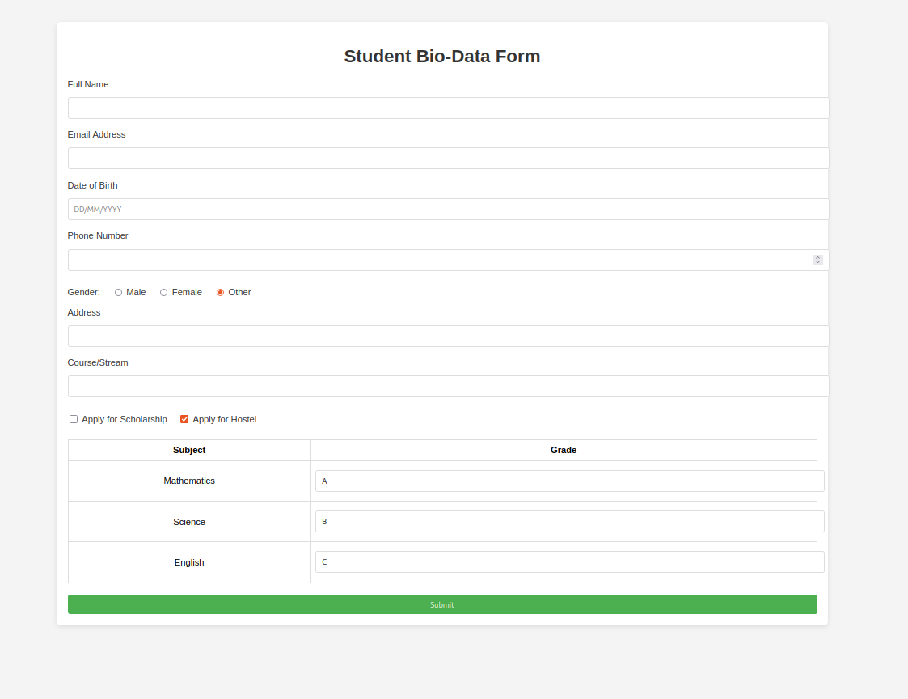

Q2)

<!DOCTYPE html>

<html lang="en">

<head>

<meta charset="UTF-8">

<meta name="viewport" content="width=device-width, initial-scale=1.0">

<title>Bootstrap Layout</title>

<!-- Link to Bootstrap CSS -->

<link href="https://stackpath.bootstrapcdn.com/bootstrap/4.5.2/css/bootstrap.min.css" rel="stylesheet">

<style>

body {

background-color: #f4f6f9;

}

.section {

padding: 30px;

margin-top: 20px;

border-radius: 8px;

}

.section h4 {

margin-bottom: 20px;

font-weight: bold;

text-align: center;

color: #343a40;

}

.btn-custom {

background-color: #007bff;

color: white;

transition: background-color 0.3s ease-in-out;

}

.btn-custom:hover {

background-color: #0056b3;

}

.input-group-text, .badge {

font-size: 1rem;

}

.input-group, .btn {

width: 100%;

}

.card {

margin-bottom: 30px;

box-shadow: 0px 4px 6px rgba(0,0,0,0.1);

border: none;

}

.carousel-control-prev-icon, .carousel-control-next-icon {

background-color: #007bff;

}

.section-content {

margin-top: 10px;

}

.section .input-group {

margin-bottom: 20px;

}

.badge {

font-size: 1.1rem;

}

.btn-group {

margin-top: 10px;

}

.container {

max-width: 1200px;

margin-top: 50px;

}

</style>

</head>

<body>

<div class="container">

<!-- Top Part -->

<div class="section bg-white">

<h2 class="text-center text-primary">Top Part: Groups, Badges, and Buttons</h2>

<div class="row">

<!-- Input Group Example -->

<div class="col-md-4">

<div class="card p-3">

<h4>Input Group</h4>

<div class="input-group mb-3">

<div class="input-group-prepend">

<span class="input-group-text" id="basic-addon1">@</span>

</div>

<input type="text" class="form-control" placeholder="Username" aria-label="Username" aria-describedby="basic-addon1">

</div>

</div>

</div>

<!-- Badges Example -->

<div class="col-md-4">

<div class="card p-3">

<h4>Badges</h4>

<p>This is a badge example: <span class="badge badge-primary">Primary</span></p>

<p><span class="badge badge-secondary">Secondary</span> <span class="badge badge-success">Success</span></p>

<p><span class="badge badge-danger">Danger</span> <span class="badge badge-warning">Warning</span></p>

</div>

</div>

<!-- Buttons Example -->

<div class="col-md-4">

<div class="card p-3">

<h4>Buttons</h4>

<button class="btn btn-primary btn-custom mb-2">Primary Button</button><br>

<button class="btn btn-secondary btn-custom mb-2">Secondary Button</button><br>

<button class="btn btn-success btn-custom">Success Button</button>

</div>

</div>

</div>

</div>

<!-- Bottom Part -->

<div class="section bg-white">

<h2 class="text-center text-primary">Bottom Part: Sections with Input Groups, Badges, and Buttons</h2>

<div class="row">

<!-- Section 1 -->

<div class="col-md-4">

<div class="card p-3">

<h4>Section 1</h4>

<div class="input-group mb-3">

<input type="text" class="form-control" placeholder="Input field" aria-label="Input field">

<div class="input-group-append">

<button class="btn btn-outline-secondary" type="button">Go</button>

</div>

</div>

<div class="section-content">

<span class="badge badge-warning">New</span>

<button class="btn btn-info mt-2">Info Button</button>

</div>

</div>

</div>

<!-- Section 2 -->

<div class="col-md-4">

<div class="card p-3">

<h4>Section 2</h4>

<div class="input-group mb-3">

<div class="input-group-prepend">

<span class="input-group-text" id="inputGroup-sizing-default">Text</span>

</div>

<input type="text" class="form-control" aria-label="Default" aria-describedby="inputGroup-sizing-default">

</div>

<div class="section-content">

<span class="badge badge-success">Active</span>

<button class="btn btn-danger mt-2">Danger Button</button>

</div>

</div>

</div>

<div class="col-md-4">

<div class="card p-3">

<h4>Section 3</h4>

<div class="input-group mb-3">

<input type="email" class="form-control" placeholder="Email" aria-label="Email">

<div class="input-group-append">

<button class="btn btn-outline-primary" type="button">Submit</button>

</div>

</div>

<div class="section-content">

<span class="badge badge-primary">Primary</span>

<button class="btn btn-warning mt-2">Warning Button</button>

</div>

</div>

</div>

</div>

</div>

</div>

<script src="https://code.jquery.com/jquery-3.5.1.slim.min.js"></script>

<script src="https://cdn.jsdelivr.net/npm/@popperjs/core@2.9.3/dist/umd/popper.min.js"></script>

<script src="https://stackpath.bootstrapcdn.com/bootstrap/4.5.2/js/bootstrap.min.js"></script>

</body>

</html>

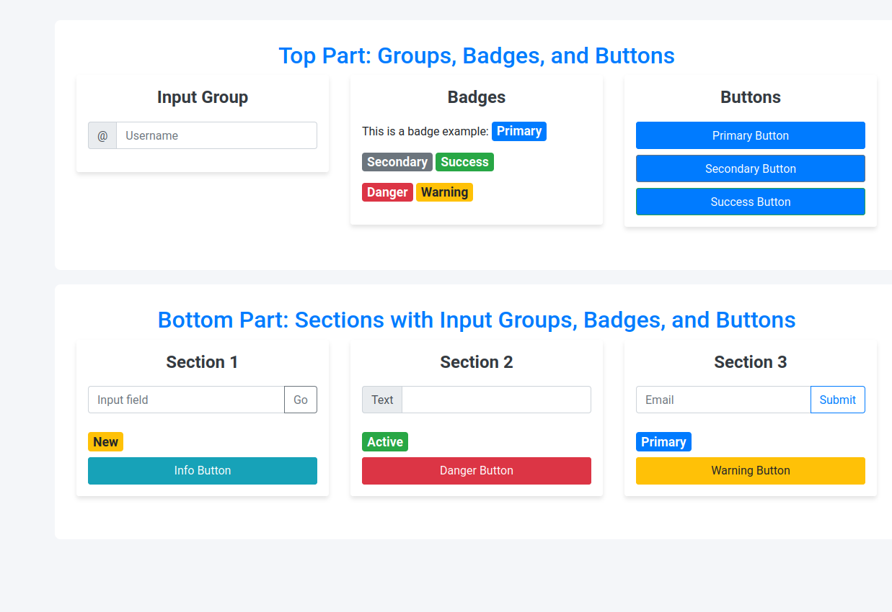

Q3)

<!DOCTYPE html>

<html lang="en">

<head>

<meta charset="UTF-8">

<meta name="viewport" content="width=device-width, initial-scale=1.0">

<title>Class Timetable</title>

<!-- Link to Bootstrap CSS -->

<link href="https://stackpath.bootstrapcdn.com/bootstrap/4.5.2/css/bootstrap.min.css" rel="stylesheet">

<!-- Optional: Link to Bootstrap Icons (for carousel navigation) -->

<link href="https://cdnjs.cloudflare.com/ajax/libs/bootstrap-icons/1.8.1/font/bootstrap-icons.min.css" rel="stylesheet">

<style>

.timetable {

margin-top: 20px;

background-color: #f8f9fa;

border-radius: 8px;

padding: 20px;

}

.carousel-item {

padding: 15px;

}

table {

width: 100%;

margin-bottom: 20px;

}

th, td {

text-align: center;

vertical-align: middle;

}

th {

background-color: #007bff;

color: white;

}

td {

background-color: #e9ecef;

}

.carousel-control-prev-icon, .carousel-control-next-icon {

background-color: #000; /* Custom color for carousel arrows */

}

</style>

</head>

<body>

<div class="container">

<h1 class="text-center my-4">Class Timetable</h1>

<!-- Carousel for Timetable Days -->

<div id="timetableCarousel" class="carousel slide" data-ride="carousel">

<div class="carousel-inner">

<!-- Monday Timetable -->

<div class="carousel-item active">

<h3 class="text-center">Monday</h3>

<div class="timetable">

<table class="table table-bordered">

<thead>

<tr>

<th>Time</th>

<th>Subject</th>

<th>Instructor</th>

</tr>

</thead>

<tbody>

<tr>

<td>9:00 AM - 10:00 AM</td>

<td>Mathematics</td>

<td>Mr. Smith</td>

</tr>

<tr>

<td>10:00 AM - 11:00 AM</td>

<td>Physics</td>

<td>Dr. Johnson</td>

</tr>

<tr>

<td>11:00 AM - 12:00 PM</td>

<td>Chemistry</td>

<td>Ms. Davis</td>

</tr>

</tbody>

</table>

</div>

</div>

<!-- Tuesday Timetable -->

<div class="carousel-item">

<h3 class="text-center">Tuesday</h3>

<div class="timetable">

<table class="table table-bordered">

<thead>

<tr>

<th>Time</th>

<th>Subject</th>

<th>Instructor</th>

</tr>

</thead>

<tbody>

<tr>

<td>9:00 AM - 10:00 AM</td>

<td>English</td>

<td>Mr. Brown</td>

</tr>

<tr>

<td>10:00 AM - 11:00 AM</td>

<td>Biology</td>

<td>Dr. Clark</td>

</tr>

<tr>

<td>11:00 AM - 12:00 PM</td>

<td>History</td>

<td>Ms. White</td>

</tr>

</tbody>

</table>

</div>

</div>

<!-- Wednesday Timetable -->

<div class="carousel-item">

<h3 class="text-center">Wednesday</h3>

<div class="timetable">

<table class="table table-bordered">

<thead>

<tr>

<th>Time</th>

<th>Subject</th>

<th>Instructor</th>

</tr>

</thead>

<tbody>

<tr>

<td>9:00 AM - 10:00 AM</td>

<td>Computer Science</td>

<td>Prof. Green</td>

</tr>

<tr>

<td>10:00 AM - 11:00 AM</td>

<td>Art</td>

<td>Mr. Taylor</td>

</tr>

<tr>

<td>11:00 AM - 12:00 PM</td>

<td>Philosophy</td>

<td>Dr. Williams</td>

</tr>

</tbody>

</table>

</div>

</div>

<!-- Thursday Timetable -->

<div class="carousel-item">

<h3 class="text-center">Thursday</h3>

<div class="timetable">

<table class="table table-bordered">

<thead>

<tr>

<th>Time</th>

<th>Subject</th>

<th>Instructor</th>

</tr>

</thead>

<tbody>

<tr>

<td>9:00 AM - 10:00 AM</td>

<td>Geography</td>

<td>Ms. Brown</td>

</tr>

<tr>

<td>10:00 AM - 11:00 AM</td>

<td>Psychology</td>

<td>Dr. Evans</td>

</tr>

<tr>

<td>11:00 AM - 12:00 PM</td>

<td>Music</td>

<td>Mr. Harris</td>

</tr>

</tbody>

</table>

</div>

</div>

<!-- Friday Timetable -->

<div class="carousel-item">

<h3 class="text-center">Friday</h3>

<div class="timetable">

<table class="table table-bordered">

<thead>

<tr>

<th>Time</th>

<th>Subject</th>

<th>Instructor</th>

</tr>

</thead>

<tbody>

<tr>

<td>9:00 AM - 10:00 AM</td>

<td>Physical Education</td>

<td>Mr. Jones</td>

</tr>

<tr>

<td>10:00 AM - 11:00 AM</td>

<td>Drama</td>

<td>Ms. White</td>

</tr>

<tr>

<td>11:00 AM - 12:00 PM</td>

<td>Economics</td>

<td>Dr. Davis</td>

</tr>

</tbody>

</table>

</div>

</div>

<!-- Saturday Timetable -->

<div class="carousel-item">

<h3 class="text-center">Saturday</h3>

<div class="timetable">

<table class="table table-bordered">

<thead>

<tr>

<th>Time</th>

<th>Subject</th>

<th>Instructor</th>

</tr>

</thead>

<tbody>

<tr>

<td>9:00 AM - 10:00 AM</td>

<td>Statistics</td>

<td>Prof. Taylor</td>

</tr>

<tr>

<td>10:00 AM - 11:00 AM</td>

<td>Philosophy</td>

<td>Dr. Davis</td>

</tr>

<tr>

<td>11:00 AM - 12:00 PM</td>

<td>French</td>

<td>Ms. Campbell</td>

</tr>

</tbody>

</table>

</div>

</div>

</div>

<!-- Carousel Controls -->

<a class="carousel-control-prev" href="#timetableCarousel" role="button" data-slide="prev">

<span class="carousel-control-prev-icon" aria-hidden="true"></span>

<span class="sr-only">Previous</span>

</a>

<a class="carousel-control-next" href="#timetableCarousel" role="button" data-slide="next">

<span class="carousel-control-next-icon" aria-hidden="true"></span>

<span class="sr-only">Next</span>

</a>

</div>

</div>

<!-- Bootstrap JS and dependencies -->

<script src="https://code.jquery.com/jquery-3.5.1.slim.min.js"></script>

<script src="https://cdn.jsdelivr.net/npm/@popperjs/core@2.9.3/dist/umd/popper.min.js"></script>

<script src="https://stackpath.bootstrapcdn.com/bootstrap/4.5.2/js/bootstrap.min.js"></script>

</body>

</html>

