Q1)

<!DOCTYPE html>

<html lang="en">

<head>

<meta charset="UTF-8">

<meta name="viewport" content="width=device-width, initial-scale=1.0">

<title>Centered Div with Table and Image</title>

<style>

body {

display: flex;

justify-content: center;

align-items: center;

height: 100vh;

margin: 0;

background-color: #f0f0f0;

}

.container {

background-color: #4CAF50;

width: 60%;

padding: 20px;

text-align: center;

border-radius: 10px;

box-shadow: 0px 0px 15px rgba(0, 0, 0, 0.1);

position: relative;

}

table {

width: 100%;

border-collapse: collapse;

margin-bottom: 20px;

}

table, th, td {

border: 1px solid black;

}

th, td {

padding: 10px;

text-align: center;

}

tr:nth-child(odd) {

background-color: #f2f2f2;

}

tr:nth-child(even) {

background-color: #d9d9d9;

}

img {

width: 100%;

height: 150px;

object-fit: cover;

margin-top: 20px;

transition: transform 2s ease-in-out;

}

button {

display: block;

margin: 20px auto;

padding: 10px 20px;

font-size: 16px;

cursor: pointer;

background-color: #008CBA;

color: white;

border: none;

border-radius: 5px;

}

button:hover {

background-color: #005f73;

}

</style>

</head>

<body>

<div class="container" id="container">

<table id="table">

<thead>

<tr>

<th>Header 1</th>

<th>Header 2</th>

<th>Header 3</th>

</tr>

</thead>

<tbody>

<tr>

<td>Data 1</td>

<td>Data 2</td>

<td>Data 3</td>

</tr>

<tr>

<td>Data 4</td>

<td>Data 5</td>

<td>Data 6</td>

</tr>

<tr>

<td>Data 7</td>

<td>Data 8</td>

<td>Data 9</td>

</tr>

</tbody>

</table>

<img id="myImage" src="image.jpg" alt="Placeholder Image">

<button onclick="moveTableAndImage()">Move Right to Left</button>

</div>

<script>

function moveTableAndImage() {

const table = document.getElementById('table');

const image = document.getElementById('myImage');

table.style.transform = 'translateX(-100%)';

image.style.transform = 'translateX(-100%)';

}

</script>

</body>

</html>

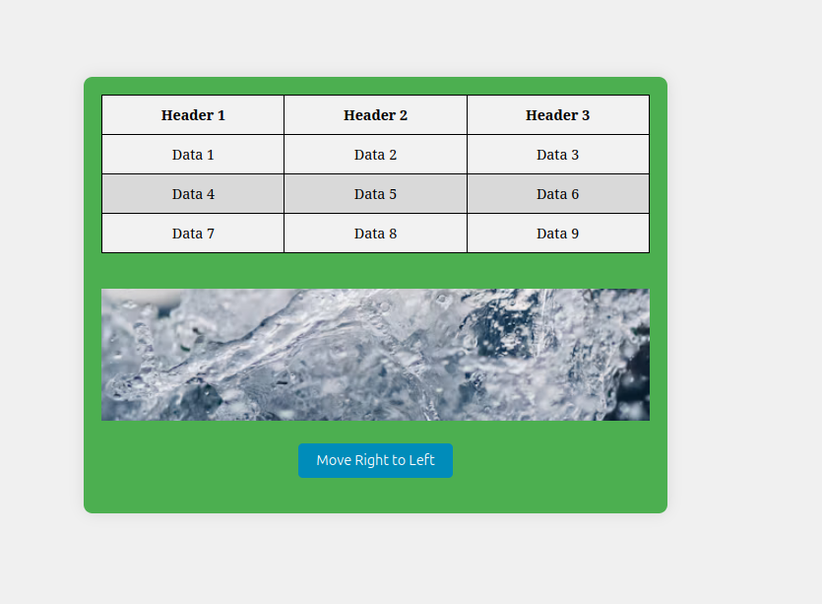

Q2)

<!DOCTYPE html>

<html lang="en">

<head>

<meta charset="UTF-8">

<meta name="viewport" content="width=device-width, initial-scale=1.0">

<title>Basic Calculator</title>

<script src="https://code.jquery.com/jquery-3.6.0.min.js"></script> <!-- Include jQuery -->

<style>

body {

font-family: Arial, sans-serif;

display: flex;

justify-content: center;

align-items: center;

height: 100vh;

background-color: black;

margin: 0;

}

.calculator {

background-color: grey;

padding: 20px;

border-radius: 10px;

box-shadow: 0 0 15px rgba(0, 0, 0, 0.1);

width: 300px;

}

input[type="text"] {

width: 97%;

height: 40px;

font-size: 18px;

text-align: right;

margin-bottom: 20px;

padding: 5px;

border: 1px solid black;

border-radius: 5px;

background-color: lightcyan;

}

.button-row {

display: flex;

justify-content: space-between;

margin-bottom: 10px;

}

button {

width: 60px;

height: 60px;

font-size: 20px;

border: none;

background-color: #f1f1f1;

border-radius: 5px;

cursor: pointer;

transition: background-color 0.3s;

}

button:hover {

background-color: #ddd;

}

.equal-button {

background-color: #4CAF50;

color: white;

}

.equal-button:hover {

background-color: #45a049;

}

.clear-button {

background-color: #f44336;

color: white;

}

.clear-button:hover {

background-color: #e53935;

}

</style>

</head>

<body>

<div class="calculator">

<input type="text" id="display" readonly>

<div class="button-row">

<button class="btn" data-value="7">7</button>

<button class="btn" data-value="8">8</button>

<button class="btn" data-value="9">9</button>

<button class="btn" data-value="+">+</button>

</div>

<div class="button-row">

<button class="btn" data-value="4">4</button>

<button class="btn" data-value="5">5</button>

<button class="btn" data-value="6">6</button>

<button class="btn" data-value="-">-</button>

</div>

<div class="button-row">

<button class="btn" data-value="1">1</button>

<button class="btn" data-value="2">2</button>

<button class="btn" data-value="3">3</button>

<button class="btn" data-value="\*">\*</button>

</div>

<div class="button-row">

<button class="btn" data-value="0">0</button>

<button class="clear-button" id="clear">C</button>

<button class="equal-button" id="equal">=</button>

<button class="btn" data-value="/">/</button>

</div>

</div>

<script>

$(document).ready(function() {

$('.btn').click(function() {

var value = $(this).data('value');

$('#display').val($('#display').val() + value);

});

$('#clear').click(function() {

$('#display').val('');

});

$('#equal').click(function() {

try {

var result = eval($('#display').val());

$('#display').val(result);

} catch (error) {

$('#display').val('Error');

}

});

});

</script>

</body>

</html>

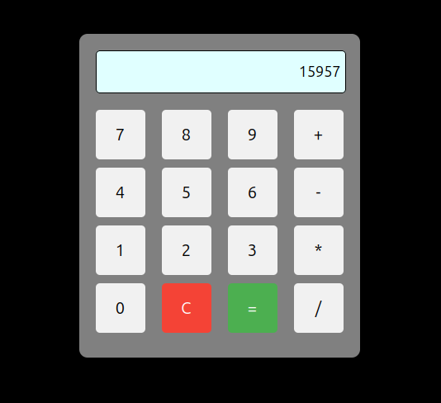

Q3)

<!DOCTYPE html>

<html lang="en">

<head>

<meta charset="UTF-8">

<meta name="viewport" content="width=device-width, initial-scale=1.0">

<title>Birthday Card Designer</title>

<script src="https://code.jquery.com/jquery-3.6.0.min.js"></script>

<style>

body {

font-family: Arial, sans-serif;

}

#container {

display: flex;

}

#controls {

width: 300px;

padding: 10px;

border-right: 2px solid #ccc;

}

#card {

width: 300px;

height: 400px;

border: 2px solid black;

text-align: center;

padding: 20px;

display: flex;

flex-direction: column;

justify-content: center;

align-items: center;

background-color: yellow;

}

.border-none {

border: none;

}

.border-double {

border: 5px double black;

}

.border-solid {

border: 5px solid black;

}

img {

width: 100px;

height: auto;

}

</style>

</head>

<body>

<div id="container">

<div id="controls">

<label>Choose a background color:</label>

<select id="bgColor">

<option value="yellow">Yellow</option>

<option value="pink">Pink</option>

<option value="lightblue">Light Blue</option>

</select><br><br>

<label>Choose a font:</label>

<select id="fontFamily">

<option value="Verdana">Verdana</option>

<option value="Arial">Arial</option>

<option value="Times New Roman">Times New Roman</option>

</select><br><br>

<label>Specify a numeric font size:</label>

<input type="number" id="fontSize" value="25"><br><br>

<label>Choose a border style:</label><br>

<input type="radio" name="borderStyle" value="none" checked> None

<input type="radio" name="borderStyle" value="double"> Double

<input type="radio" name="borderStyle" value="solid"> Solid<br><br>

<input type="checkbox" id="addImage" checked> Add the Default Picture<br><br>

<label>Enter the greeting text below:</label><br>

<textarea id="greetingText" rows="3">Happy Birthday, and many more</textarea><br><br>

<button id="updateCard">Update</button>

</div>

<div id="card">

<p id="greeting">Happy Birthday, and many more</p>

<img id="cakeImage" src="https://files.creamats.com/cache/products/images/2/j/a/600x600/0/5/673f3ddc07046fac67f1033e99bae8821ef675/80605-birthday-stamp.webp" alt="Birthday Cake">

</div>

</div>

<script>

$(document).ready(function () {

$('#updateCard').click(function () {

$('#card').css('background-color', $('#bgColor').val());

// Update font style and size

$('#greeting').css({

'font-family': $('#fontFamily').val(),

'font-size': $('#fontSize').val() + 'px'

});

// Update border style

let borderClass = $('input[name="borderStyle"]:checked').val();

$('#card').removeClass('border-none border-double border-solid').addClass('border-' + borderClass);

// Update greeting text

$('#greeting').text($('#greetingText').val());

// Toggle image

if ($('#addImage').is(':checked')) {

$('#cakeImage').show();

} else {

$('#cakeImage').hide();

}

});

});

</script>

</body>

</html>

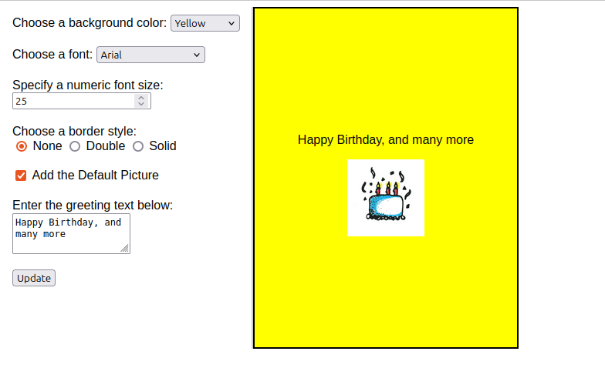

Q4)

<!DOCTYPE html>

<html lang="en">

<head>

<meta charset="UTF-8">

<meta name="viewport" content="width=device-width, initial-scale=1.0">

<title>Bill Generator</title>

<script src="https://code.jquery.com/jquery-3.6.0.min.js"></script> <!-- Include jQuery -->

<style>

body {

font-family: Arial, sans-serif;

display: flex;

justify-content: center;

align-items: center;

height: 100vh;

background-color: #f4f4f9;

margin: 0;

}

.container {

background-color: #fff;

padding: 30px;

border-radius: 10px;

box-shadow: 0 0 15px rgba(0, 0, 0, 0.1);

width: 350px;

text-align: center;

}

h2 {

margin-bottom: 20px;

}

select, input[type="number"], button {

width: 100%;

padding: 10px;

margin-bottom: 15px;

font-size: 16px;

border-radius: 5px;

border: 1px solid #ccc;

}

button {

background-color: #4CAF50;

color: white;

border: none;

cursor: pointer;

}

button:hover {

background-color: #45a049;

}

.checkbox-group {

display: flex;

justify-content: space-between;

margin-bottom: 15px;

}

.checkbox-group label {

font-size: 16px;

}

.checkbox-group input {

width: auto;

}

</style>

</head>

<body>

<div class="container">

<h2>Generate Bill</h2>

<label for="product">Select Product:</label>

<select id="product">

<option value="HP">HP</option>

<option value="Nokia">Nokia</option>

<option value="Samsung">Samsung</option>

<option value="Motorola">Motorola</option>

<option value="Apple">Apple</option>

</select>

<div class="checkbox-group">

<label>

<input type="checkbox" id="mobile"> Mobile

</label>

<label>

<input type="checkbox" id="laptop"> Laptop

</label>

</div>

<label for="quantity">Quantity:</label>

<input type="number" id="quantity" value="1" min="1">

<button id="produceBill">Produce Bill</button>

</div>

<script>

$(document).ready(function() {

$('#produceBill').click(function() {

const product = $('#product').val();

const isMobileChecked = $('#mobile').prop('checked');

const isLaptopChecked = $('#laptop').prop('checked');

const quantity = parseInt($('#quantity').val());

let totalAmount = 0;

const prices = {

"HP": 500,

"Nokia": 200,

"Samsung": 300,

"Motorola": 250,

"Apple": 1000

};

totalAmount = prices[product] \* quantity;

if (isMobileChecked) {

totalAmount += 100 \* quantity;

}

if (isLaptopChecked) {

totalAmount += 500 \* quantity;

}

alert('Total Amount: $' + totalAmount);

});

});

</script>

</body>

</html>

