Q1) Write a simple poem and represent it as a web page. Give a title for the poem.

Make rhyming words in the poem as bold.

<!DOCTYPE html>

<html lang="en">

<head>

<meta charset="UTF-8">

<meta name="viewport" content="width=device-width, initial-scale=1.0">

<title> A small Poem</title>

<style>

h1 {

margin-top: 0;

text-align: center;

padding-top: 20px;

}

p {

margin-top: 40px;

text-align: center;

padding: 20px;

border-radius: 5px;

width: 80%;

max-width: 600px;

margin-left: auto;

margin-right: auto;

}

</style>

</head>

<body>

<h1>Twinkle Twinkle</h1>

<div>

<p>

Twinkle, twinkle, little <strong>star</strong>, <br>

How I wonder what you <strong>are</strong>! <br>

Up above the world so <strong>high</strong>, <br>

Like a diamond in the <strong>sky</strong>. <br><br>

When the blazing <strong>sun</strong> is gone, <br>

When he nothing shines <strong>upon</strong>, <br>

Then you show your little <strong>light</strong>, <br>

Twinkle, twinkle, all the <strong>night</strong>. <br><br>

Then the trav'ller in the <strong>dark</strong>, <br>

Thanks you for your tiny <strong>spark</strong>, <br>

He could not see which way to <strong>go</strong>, <br>

If you did not twinkle <strong>so</strong>. <br><br>

In the dark blue sky you <strong>keep</strong>, <br>

And often thro' my curtains <strong>peep</strong>, <br>

For you never shut your <strong>eye</strong>, <br>

Till the sun is in the <strong>sky</strong>. <br><br>

'Tis your bright and tiny <strong>spark</strong>, <br>

Lights the trav'ller in the <strong>dark</strong>: <br>

Tho' I know not what you <strong>are</strong>, <br>

Twinkle, twinkle, little <strong>star</strong>. <br>

</p>

</div>

</body>

<html>

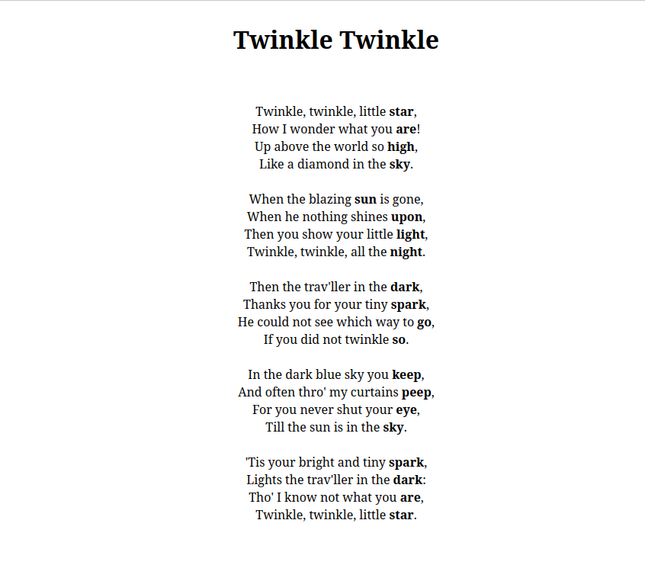Q2) Assume you have brought a new car. Write down the list of additional

accessories you need for the car as an unordered list in HTML. Also, list the

travel plans on the car as an ordered list.

<!DOCTYPE html>

<html lang="en">

<head>

<meta charset="UTF-8">

<meta name="viewport" content="width=device-width, initial-scale=1.0">

<title>New Car Accessories and Travel Plans</title>

</head>

<style>

</style>

<body>

<h2>Additional Accessories for My New Car</h2>

<p>

<ul>

<li>Seat Covers</li>

<li>Car Floor Mats</li>

<li>Car Phone Mount</li>

<li>Bluetooth Adapter</li>

<li>Rearview Camera</li>

<li>Sunshades</li>

<li>Trunk Organizer</li>

<li>Car Cover</li>

<li>Portable Jump Starter</li>

<li>First Aid Kit</li>

</ul>

</p>

<h2>My Travel Plans with the New Car</h2>

<ol>

<li>Weekend road trip to the mountains</li>

<li>Visit to the beach for a week</li>

<li>Cross-country drive to explore national parks</li>

<li>Day trips to nearby cities</li>

<li>Long drive to a family reunion</li>

</ol>

</body>

<html>

Q3) 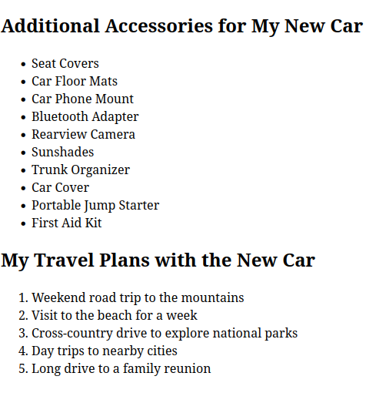 Complete the following website name “Share your Winter Vacation Videos”.

The required video files are located inside the compressed folder “Week 1

Assignment Files/Media/”.

<!DOCTYPE html>

<html lang="en">

<head>

<meta charset="UTF-8">

<meta name="viewport" content="width=device-width, initial-scale=1.0">

<title>Mountain Videos</title>

<style>

body {

font-family: Arial, sans-serif;

margin: 0;

padding: 0;

}

.navbar {

background-color: #333;

overflow: hidden;

display: flex;

justify-content: space-between;

align-items: center;

padding: 14px 20px;

}

.navbar .navbar-text {

color: white;

font-size: 18px;

}

.dropdown {

position: relative;

}

.dropdown button {

background-color: #333;

color: white;

border: none;

font-size: 20px;

cursor: pointer;

}

.dropdown button:hover {

background-color: #ddd;

color: black;

}

.dropdown-content {

display: none;

position: absolute;

background-color: #333;

min-width: 160px;

z-index: 1;

}

/\* Dropdown item styling \*/

.dropdown-content a {

color: white;

padding: 12px 16px;

text-decoration: none;

display: block;

}

.dropdown-content a:hover {

background-color: #ddd;

color: black;

}

.dropdown:hover .dropdown-content {

display: block;

}

.video-container {

display: flex;

justify-content: space-between;

flex-wrap: wrap;

margin: 20px;

}

h1 {

text-align: center;

margin-top: 20px;

font-size: 30px;

color: #333;

}

</style>

</head>

<body>

<h1>Mountain Videos</h1>

<div class="navbar">

<div class="navbar-text">Share with your friends</div>

<div class="dropdown">

<button class="dropbtn">...</button>

<div class="dropdown-content">

<a href="#profile">Profile</a>

<a href="#settings">Settings</a>

<a href="#logout">Logout</a>

</div>

</div>

</div>

<div class="video-container">

<iframe src="video.mp4" title="Mountain Video 1" frameborder="0" allow="accelerometer; autoplay; encrypted-media; gyroscope; picture-in-picture" allowfullscreen></iframe>

<iframe src="video1.mp4" title="Mountain Video 2" frameborder="0" allow="accelerometer; autoplay; encrypted-media; gyroscope; picture-in-picture" allowfullscreen></iframe>

<iframe src="video2.mp4" title="Mountain Video 3" frameborder="0" allow="accelerometer; autoplay; encrypted-media; gyroscope; picture-in-picture" allowfullscreen></iframe>

</div>

</body>

</html>

