AI-Based Network Intrusion Detection System Using CICIDS2017 Dataset

Devansh Kala
Computer Science Engineering and Data Science Department
MPSTME, NMIMS
Mumbai, India
devansh.kala34@nmims.in
Pratham Parakh
Computer Science Engineering and Data Science Department
MPSTME, NMIMS
Mumbai, India
pratham.parakh08@nmims.in
Harsh Gulwani
Computer Science Engineering and Data Science Department
MPSTME, NMIMS
Mumbai, India
harsh.gulwani11@nmims.in
Professor Rama Varshney
Computer Science Engineering and Data Science Department
MPSTME, NMIMS
Mumbai, India
rama.varshney@nmims.edu
Manav Puria
Computer Science Engineering and Data Science Department
MPSTME, NMIMS
Mumbai, India
manav.puria35@nmims.in

Abstract— The increasing number of cyber threats targeting modern network infrastructures has made intrusion detection systems a critical component of cybersecurity. Traditional signature-based systems are ineffective against evolving and unknown attacks. This paper presents an Artificial Intelligence-based Network Intrusion Detection System (AI-NIDS) designed to detect web-based and network-level attacks using machine learning techniques. The system is trained on structured network traffic data derived from datasets such as CICIDS2017 and focuses on classifying traffic into benign and malicious categories. Various preprocessing techniques, feature engineering methods, and supervised machine learning algorithms are applied to improve detection performance. Experimental results demonstrate that the proposed system achieves high accuracy and is capable of identifying attack patterns effectively, making it suitable for real-world cybersecurity applications.
Keywords— Intrusion Detection System, Machine Learning, CICIDS2017, Cybersecurity, Anomaly Detection

Introduction
With the rapid expansion of internet services and digital communication systems, the frequency and sophistication of cyberattacks have increased significantly. Modern networks are vulnerable to a variety of threats, including web-based attacks, Distributed Denial of Service (DDoS), brute-force login attempts, and data exfiltration. These attacks compromise system security and can lead to severe financial and operational consequences. Intrusion Detection Systems (IDS) are designed to monitor network traffic and detect malicious activities. Traditional IDS rely on predefined signatures of known attacks, making them ineffective against new or evolving threats. As a result, there is a growing need for intelligent systems capable of adapting to dynamic attack patterns. Artificial Intelligence (AI) and Machine Learning (ML) provide a powerful solution by enabling systems to learn from historical data and identify patterns associated with malicious behavior.
Machine learning-based IDS analyze network traffic features such as packet size, flow duration, and protocol usage to classify traffic as benign or malicious. This project focuses on developing an AI-based Network Intrusion Detection System specifically aimed at detecting web and network attacks using machine learning models. The system processes network flow data, applies preprocessing and feature selection techniques, and trains classification models to accurately detect intrusions.

Literature Review

Overview of existing work
Recent studies have extensively explored the use of AI and machine learning in intrusion detection systems. These approaches aim to improve detection accuracy and reduce false positives.

Key contributions from literature
The application of machine learning and artificial intelligence in intrusion detection has been extensively studied in recent years. Researchers have explored various approaches to improve detection accuracy and reduce false positives in network intrusion detection systems.

Kotwal and Lanjekar proposed a machine learning-based intrusion detection model using the CICIDS2017 dataset and demonstrated that deep learning techniques, particularly multilayer perceptron, can achieve high detection accuracy. Xu et al. conducted a comparative study of multiple machine learning algorithms and found that unsupervised methods such as Local Outlier Factor and One-Class Support Vector Machines are effective in detecting unknown attacks, although they may increase false positive rates.

Thakkar and Lohiya provided a comprehensive review of intrusion detection datasets and highlighted the importance of realistic datasets such as CICIDS2017 for evaluating modern IDS models. Sharma et al. emphasized the role of feature engineering and data preprocessing in improving the performance of AI-based intrusion detection systems. Their study showed that careful selection of features significantly enhances model accuracy.

Ferozuddin and Rizvi proposed an anomaly detection model using deep learning techniques such as autoencoders and recurrent neural networks, which are capable of identifying unknown threats by learning normal traffic patterns. Singh et al. demonstrated that ensemble methods, particularly Random Forest, outperform other classifiers in terms of accuracy and false positive rate in intrusion detection tasks.

Li et al. explored machine learning-based intrusion detection in 5G networks and highlighted the importance of adaptive learning mechanisms for handling dynamic and evolving threats. Ahmim et al. proposed a hybrid intrusion detection system that combines decision tree classifiers with rule-based techniques, achieving improved detection performance. Alkasassbeh focused on feature selection techniques and demonstrated their effectiveness in enhancing classification accuracy. Hodo et al. presented a survey of shallow and deep learning approaches for intrusion detection, discussing challenges such as scalability, computational complexity, and false positives.

Overall, the literature indicates that AI-based intrusion detection systems significantly improve detection capabilities compared to traditional methods. However, challenges such as real-time implementation, feature extraction, and handling unknown attacks remain areas of active research.

Research Gap
Despite significant advancements, existing systems face challenges such as:
- Difficulty in detecting unknown or zero-day attacks
- High false positive rates in anomaly detection
- Complexity in real-time feature extraction

Methodology

Dataset Description
The proposed AI-based Network Intrusion Detection System (AI-NIDS) is developed using a subset of the CICIDS2017 dataset, specifically the Thursday Working Hours – Web Attacks traffic file. This dataset is widely recognized for its realistic representation of modern network traffic and includes multiple categories of web-based attacks such as brute force, XSS, and SQL injection.
The raw dataset is ingested in CSV format after extraction from a compressed archive. Each record corresponds to a bidirectional network flow, characterized by statistical features computed over packet sequences. These features include temporal, volumetric, and protocol-level descriptors.
The dataset is characterized by a high-dimensional feature space comprising more than seventy attributes in its initial form, along with a combination of numerical and categorical data types. It also contains inherent imperfections typical of real-world network traffic, including noise, missing entries, and infinite values that require preprocessing. Additionally, the dataset exhibits an imbalanced class distribution, where benign traffic instances significantly differ in proportion from malicious attack instances, posing challenges for effective model training and evaluation.
The target variable (Label) is transformed into a binary classification problem, where:
- 0 → Benign traffic
- 1 → Malicious traffic
This transformation simplifies model learning while maintaining relevance for intrusion detection.
.

Data Preprocessing
Robust preprocessing is critical due to the noisy and heterogeneous nature of network traffic data. The following pipeline is implemented:

1. Data Cleaning
Removal of redundant or corrupted columns (e.g., duplicated header length field), Elimination of rows with missing identifiers (Flow ID), Replacement of invalid values: 'Infinity', np.inf, -np.inf, and NaN → replaced with -1
This normalization ensures numerical stability during model training.

2. Data Type Conversion
Certain features such as Flow Bytes/s and Flow Packets/s
are explicitly converted to numeric types to avoid parsing inconsistencies.

3. Label Encoding
Categorical labels are encoded using a binary mapping function:
Label=0 if BENIGN, 1 otherwise

4. Feature Scaling
While explicit normalization is not heavily emphasized in the notebook, scaling is implicitly addressed through: Feature selection (removing extreme-value features) and Model choice (tree-based methods like Random Forest are scale-invariant)

Feature Engineering
Feature selection and engineering are treated as essential components of the methodology, as the quality and relevance of input features directly influence model performance. The process begins with the selection of a subset of features that are known to be indicative of web attack behavior. These features are chosen based on domain knowledge and are constrained to a manageable size to balance computational efficiency with predictive capability.

Statistical visualization techniques are employed to analyze the distribution of selected features. Histograms are generated to observe patterns such as skewness and dispersion, while advanced exploratory tools are used to identify anomalies and inconsistencies across the dataset. This analysis provides insight into the underlying structure of the data and informs subsequent feature refinement.

A correlation analysis is then conducted using a Pearson correlation matrix to identify relationships between features. Highly correlated features are systematically removed to reduce redundancy and prevent multicollinearity, which can negatively impact model generalization. This step results in a reduced feature set that retains only the most informative and independent variables. The final feature space is compact yet expressive, enabling efficient learning while preserving critical information relevant to intrusion detection.

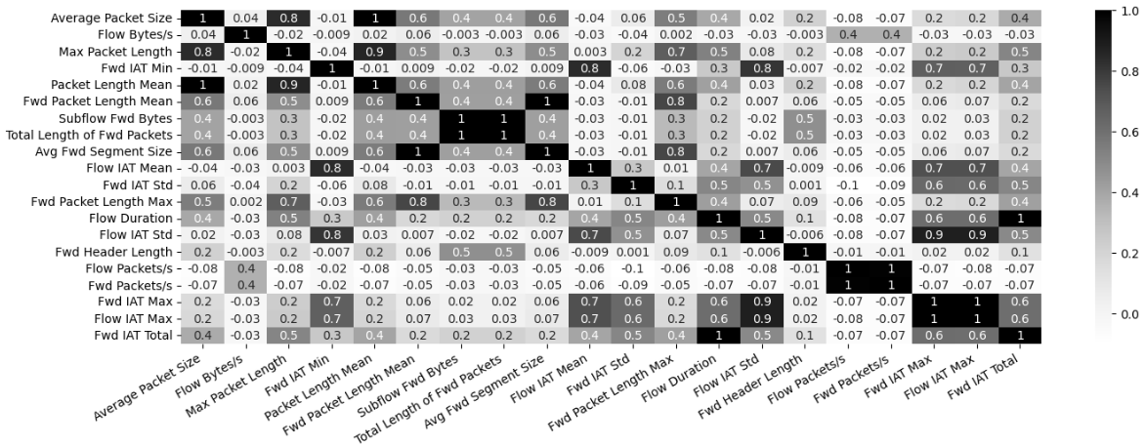
- Correlation Matrix

Model Training
The model development phase involves training supervised machine learning algorithms to classify network traffic as either benign or malicious. The dataset is partitioned into training and testing subsets using a 70:30 split, ensuring that model evaluation is performed on unseen data. This approach provides an unbiased estimate of model performance.

The primary algorithm implemented is the Random Forest classifier, which is selected due to its robustness, ability to handle high-dimensional data, and effectiveness in modeling complex, non-linear relationships. Random Forest operates as an ensemble of decision trees, aggregating their outputs to produce a final classification. This ensemble approach enhances predictive accuracy and reduces the risk of overfitting.

Hyperparameter optimization is performed using a structured grid search combined with cross-validation. The initial search explores a broad range of parameter values, including tree depth, number of features considered at each split, and minimum samples required at leaf nodes. This is followed by a refined search that narrows the parameter space to identify the optimal configuration. Cross-validation is conducted using multiple folds, and model performance is evaluated using metrics such as accuracy and F1-score, with particular emphasis placed on F1-score due to its suitability for imbalanced classification tasks.

The final model configuration is determined based on the best-performing parameter combination, and out-of-bag validation is incorporated to provide an additional estimate of model generalization performance without requiring a separate validation dataset.

Feature Importance Analysis
An inherent advantage of the Random Forest algorithm is its ability to quantify feature importance based on the contribution of each feature to the reduction of impurity across decision trees. This capability is leveraged to identify the most influential features in the classification process. The resulting feature importance scores provide valuable insights into the characteristics of network traffic that are most indicative of malicious behavior. This analysis not only enhances interpretability but also supports further refinement of the feature set by enabling the removal of less significant attributes.

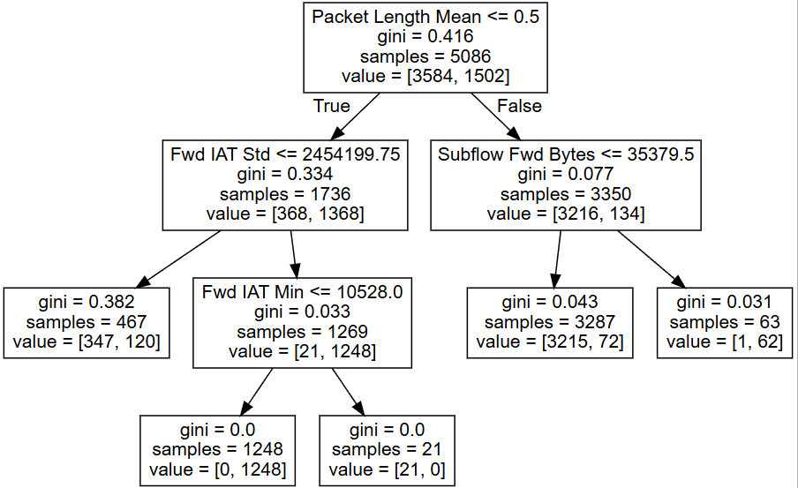
- Feature Importance Evaluation using Decision Tree Classifier

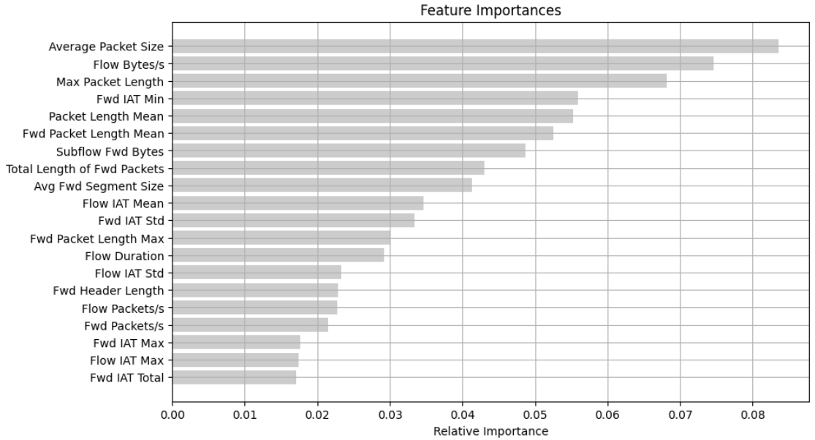
- Relative Feature Importance

F. Model Evaluation
The trained model is evaluated using the test dataset to assess its ability to generalize to unseen data. Predictions are generated and compared against true labels to construct a confusion matrix, which captures the distribution of true positives, true negatives, false positives, and false negatives. This matrix serves as the foundation for calculating performance metrics.

Evaluation metrics include accuracy, precision, recall, and F1-score, each providing a different perspective on model performance. Accuracy measures overall correctness, while precision quantifies the proportion of correctly identified malicious instances among all predicted malicious cases. Recall evaluates the model’s ability to detect actual attacks, and the F1-score provides a harmonic mean of precision and recall, offering a balanced measure particularly relevant in cybersecurity contexts where both false positives and false negatives carry significant implications.

G. Model Persistence and Deployment Considerations
To facilitate practical deployment, the trained model is serialized using a binary persistence mechanism. This allows the model to be stored and reused without retraining, enabling efficient integration into real-time intrusion detection systems. Model persistence ensures that the computational cost of training is incurred only once, while inference can be performed repeatedly with minimal overhead.

H. Inference and Runtime Analysis
The model is further evaluated in terms of inference performance by applying it to a larger dataset and measuring execution time. This step provides insight into the computational efficiency and scalability of the system. The distribution of predicted classes is also analyzed to verify consistency with expected traffic patterns. These evaluations demonstrate the model’s suitability for near real-time applications, where rapid detection of malicious activity is essential.

I. System Workflow
The overall system operates as a structured pipeline in which raw network traffic data is first preprocessed to remove inconsistencies and convert it into a suitable format. The cleaned data is then transformed through feature selection and engineering processes before being fed into the trained machine learning model. The model produces classification outputs that indicate whether the observed traffic is benign or malicious. This end-to-end workflow ensures a coherent and reproducible process that aligns with the requirements of practical cybersecurity systems.

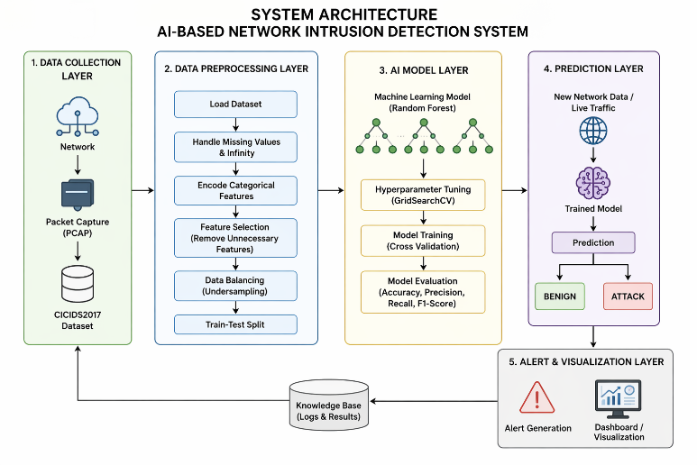
- System Architecture

Results
The performance of the proposed AI-based Network Intrusion Detection System is evaluated using standard classification metrics, including accuracy, precision, recall, and F1-score. These metrics provide a comprehensive assessment of the model’s ability to correctly classify network traffic while balancing false positives and false negatives.

The Random Forest classifier achieves an overall accuracy of approximately 99%, indicating that the model correctly classifies the vast majority of network traffic instances. While accuracy provides a general measure of correctness, it is not sufficient on its own due to the class imbalance typically present in intrusion detection datasets.

To address this, precision and recall are analyzed in detail. The model achieves a precision of approximately 98–99%, which indicates that the proportion of benign traffic incorrectly classified as malicious is minimal. This is particularly important in practical deployments, where high false positive rates can lead to alert fatigue and reduced trust in the system.

The recall value is observed to be approximately 98–99%, demonstrating that the model successfully detects most malicious traffic instances. High recall is critical in cybersecurity contexts, as missed detections (false negatives) can result in undetected intrusions and potential system compromise.
TABLE I
Confusion Matrix
 | Positive | Negative
Positive | True Positive | False Negative
 | 1489 | 14
Negative | False Positive | True Negative
 | 31 | 647

The F1-score, which balances precision and recall, is approximately 98–99%, confirming that the model maintains a strong trade-off between detecting attacks and minimizing false alarms. This balanced performance indicates that the system is well-suited for real-world intrusion detection scenarios.

Further analysis using the confusion matrix shows that the number of false positives and false negatives is relatively low compared to true classifications. This suggests that the model is not biased toward either class and generalizes effectively to unseen data.

The high performance achieved can be attributed to several factors. The preprocessing pipeline ensures data quality by removing noise and inconsistencies, while feature selection reduces redundancy and focuses the model on the most informative attributes. Additionally, the use of hyperparameter tuning allows the Random Forest model to operate at an optimal configuration, improving both accuracy and generalization.

Despite these strong results, certain limitations remain. The model’s performance is closely tied to the distribution of the training data, and its ability to detect completely novel or zero-day attacks is inherently constrained. This is reflected in the small but non-zero number of misclassifications observed during evaluation.

The runtime analysis further demonstrates that the model performs efficiently during inference, with prediction times suitable for near real-time deployment. This confirms that the proposed system is not only accurate but also computationally feasible for practical applications.

In summary, the experimental results validate the effectiveness of the proposed AI-NIDS. The combination of high accuracy, strong precision and recall, and efficient runtime performance indicates that the system is capable of reliably detecting web-based network attacks while maintaining operational practicality.

Advantages and Limitations

A. Advantages
The proposed AI-based intrusion detection system offers several significant advantages over traditional approaches. One of the primary strengths of the system lies in its ability to learn complex patterns from historical network traffic data without relying on predefined attack signatures. This enables the detection of a broader range of attack types, including variations of known attacks that may evade signature-based systems.

The use of the Random Forest algorithm contributes to high detection accuracy and robustness. Its ensemble structure reduces variance and improves generalization, making it well-suited for handling noisy and high-dimensional network data. Additionally, the algorithm provides inherent feature importance measures, which enhance interpretability and allow for better understanding of the factors influencing classification decisions.

Another advantage is the scalability of the system. The feature-based approach allows the model to be adapted to different network environments with minimal modifications, provided that relevant training data is available. The preprocessing and feature selection steps also contribute to computational efficiency by reducing the dimensionality of the dataset, thereby enabling faster training and inference.

The system further benefits from its deployment readiness. By serializing the trained model, it becomes possible to integrate the solution into real-time monitoring systems, security information and event management (SIEM) platforms, or edge-based detection frameworks. This makes the approach practical for real-world cybersecurity applications.

B. Limitations
Despite its effectiveness, the proposed system has several limitations that must be acknowledged. One of the primary constraints is its reliance on labeled data for training. Obtaining high-quality labeled datasets in cybersecurity is often challenging due to privacy concerns, data imbalance, and the evolving nature of attack techniques.

Another limitation arises from the supervised learning paradigm, which restricts the model’s ability to detect completely novel or zero-day attacks. Since the model learns from historical patterns, its performance may degrade when encountering previously unseen attack behaviours that differ significantly from the training data.

Feature extraction also presents a practical challenge, particularly in real-time environments. The computation of flow-based features requires aggregation of packet-level data over time, which may introduce latency and increase system complexity. This can impact the feasibility of deploying the system in high-speed networks where rapid decision-making is required.

Additionally, while Random Forest models are robust, they may become computationally intensive when scaled to very large datasets or deployed in resource-constrained environments. This necessitates careful optimization and potential trade-offs between model complexity and performance.

Future Work
Future research directions for the proposed system focus on enhancing its adaptability, scalability, and ability to detect emerging threats. One promising area of improvement is the integration of deep learning techniques, particularly sequence-based models such as Long Short-Term Memory (LSTM) networks. These models are capable of capturing temporal dependencies in network traffic, enabling more effective detection of complex attack patterns that evolve over time.

Another important direction involves the incorporation of unsupervised and semi-supervised learning methods. Techniques such as autoencoders and anomaly detection models can be used to identify deviations from normal behavior, thereby improving the system’s ability to detect zero-day attacks. Combining supervised classification with anomaly detection in a hybrid framework could significantly enhance overall detection capability.

Real-time deployment represents another critical area for future work. Implementing the system using streaming data processing frameworks would enable continuous monitoring of network traffic with minimal latency. Integration with edge computing architectures could further improve performance by distributing computational tasks closer to the data source, reducing response time and network overhead.

Feature engineering can also be extended through automated techniques such as feature learning and dimensionality reduction using advanced methods like principal component analysis or representation learning. These approaches can help uncover hidden patterns in the data and further improve model performance.

Finally, expanding the system to support multi-class classification would allow it to distinguish between different types of attacks rather than simply classifying traffic as benign or malicious. This would provide more granular insights and support more effective incident response strategies.

Conclusion
This paper presents an AI-based Network Intrusion Detection System using machine learning techniques trained on the CICIDS2017 dataset. The system effectively analyzes network traffic and classifies it as normal or malicious with high accuracy. The use of machine learning enhances the capability of intrusion detection systems to identify both known and unknown threats. The results demonstrate the potential of AI-driven approaches in improving network security and highlight opportunities for further research in this domain.

References
[1] R. J. Kotwal and A. Lanjekar, “Machine Learning for Intrusion Detection using CIC-IDS2017,” 2025.
[2] Z. Xu et al., “Evaluation of Machine Learning Models for Intrusion Detection,” 2025.
[3] A. Thakkar and R. Lohiya, “A Review of Intrusion Detection Datasets,” 2020.
[4] V. Sharma et al., “AI-Based Intrusion Detection System,” 2024.
[5] S. Ferozuddin and S. W. A. Rizvi, “AI-Driven Anomaly Detection Model for IDS,” 2025.
[6] A. P. Singh et al., “Machine Learning Based IDS using CICIDS2017,” 2023.
[7] “Comparative Study on AI-Based IDS,” IJERT, 2025.
[8] J. Li et al., “Machine Learning IDS for 5G Networks,” 2017.
[9] A. Ahmim et al., “Hybrid Intrusion Detection System,” 2018.
[10] M. Alkasassbeh, “Feature Selection in IDS,” 2017.
[11] E. Hodo et al., “Survey on Machine Learning for IDS,” 2017.
[12] R. Sommer and V. Paxson, “Outside the Closed World: On Using Machine Learning for Network Intrusion Detection,” IEEE Symposium on Security and Privacy, 2010.
[13] Y. Xin, L. Kong, Z. Liu, Y. Chen, Y. Li, H. Zhu, M. Gao, and H. Hou, “Machine Learning and Deep Learning Methods for Cybersecurity,” IEEE Access, vol. 6, pp. 35365–35381, 2018.
[14] S. Dua and X. Du, Data Mining and Machine Learning in Cybersecurity, CRC Press, 2016.
[15] A. Javaid, Q. Niyaz, W. Sun, and M. Alam, “A Deep Learning Approach for Network Intrusion Detection System,” EAI ICST, 2016. [18] G. Kim, S. Lee, and S. Kim, “A Novel Hybrid Intrusion Detection Method Integrating Anomaly Detection with Misuse Detection,” Expert Systems with Applications, 2014.
[16] J. Zhang, M. Zulkernine, and A. Haque, “Random-Forest-Based Network Intrusion Detection Systems,” IEEE Transactions on Systems, Man, and Cybernetics, 2008.
[17] M. Ring, D. Wunderlich, D. Scheuring, D. Landes, and A. Hotho, “A Survey of Network-Based Intrusion Detection Data Sets,” Computers & Security, 2019.

